Field Mapper Tool
Functional Document & User Manual
Version 1.0
November 18, 2025

Table of Contents
- Introduction
- Getting Started
- Step-by-Step Workflow
- Understanding Results
- Advanced Features
- Exporting and Reports
- Troubleshooting
- Glossary

1. Introduction

1.1 What is Field Mapper Tool?
Field Mapper Tool is a desktop application that compares annexure field definitions with JSON data files. It helps you validate that your JSON data contains all the required fields defined in your annexure documentation.

1.2 Who Should Use This Document?
- Data validation teams
- Quality assurance personnel
- Database administrators
- Data migration specialists
- Anyone comparing JSON data with annexure schemas

1.3 What You Will Learn
- How to load annexure fields
- How to select and process JSON files
- How to interpret comparison results
- How to view detailed logs and reports
- How to export results for analysis

2. Getting Started

2.1 System Requirements
Note: This application executable (.exe) is designed for Windows operating systems only.
- Windows 10 or later
- Minimum 2 GB RAM
- 100 MB free disk space

2.2 Launching the Application
To launch the Field Mapper Tool:
How to Launch:
- Navigate to the dist/ folder
- Double-click FieldMapper.exe
- The application window will open

2.3 Application Interface Overview
The Field Mapper Tool interface consists of:
- Annexure Fields Selection section (top left)
- JSON Folder Configuration section (top right)
- Comparison Results area (center)
- Processing Status bar (bottom)
- Action buttons (bottom)

3. Step-by-Step Workflow
Follow these steps to compare your annexure fields with JSON data. Screenshots are provided for each step to guide you through the process.

Step 1: Select Annexure
Actions:
- Locate the "Select Annexure" dropdown in the top-left section
- Click the dropdown to see available annexures
- Select your target annexure (e.g., "Pharmacokinetic Database")
- Click the "Load Annexure Fields" button
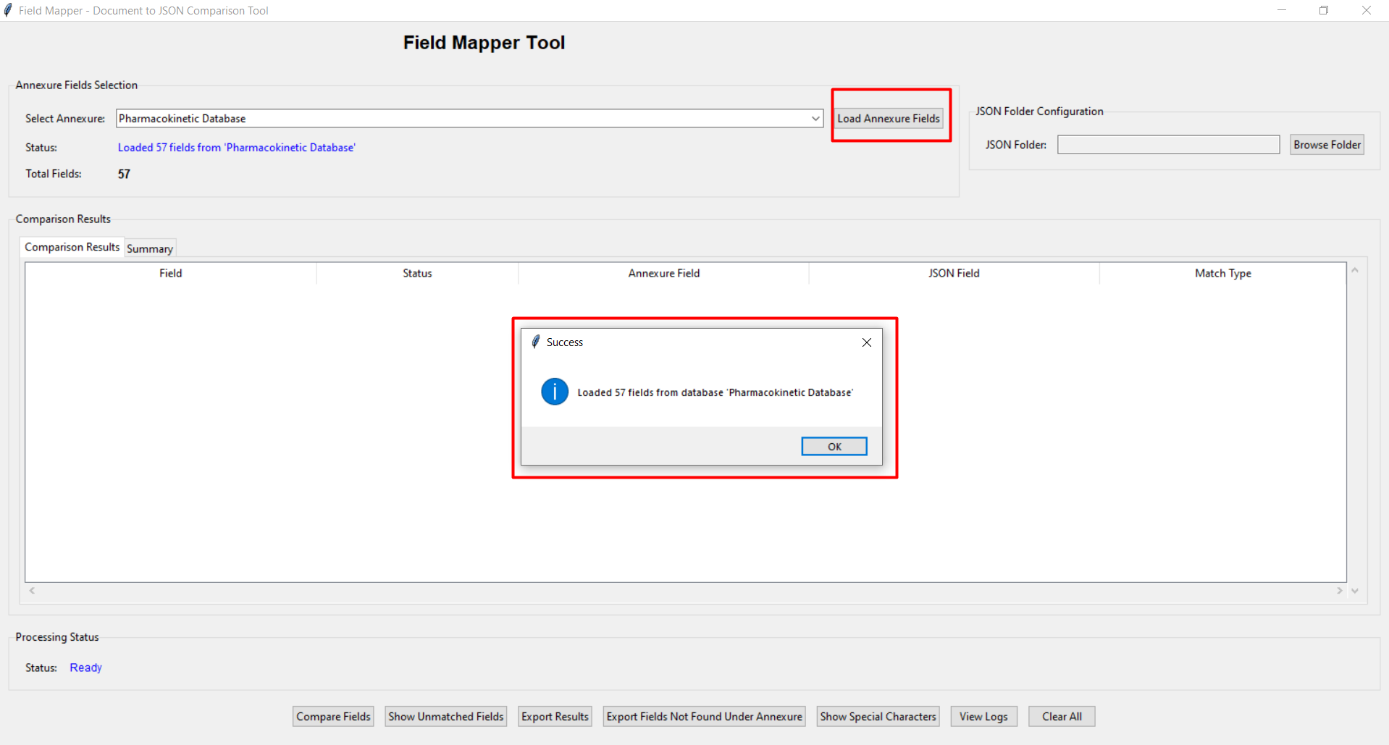Shows the annexure dropdown and "Load Annexure Fields" button highlighted
What Happens:
- The system loads all field definitions from the selected annexure
- A success message appears: "Loaded 57 fields from database 'Pharmacokinetic Database'"
- The Status field updates to show the number of fields loaded
- Total Fields counter displays the count (e.g., 57)
Expected Result:
You will see a popup message confirming the fields have been loaded successfully.

Step 2: Select JSON Folder
Actions:
- Look at the "JSON Folder Configuration" section on the right
- Click the "Browse Folder" button
- Navigate to the folder containing your JSON files
- Select the folder and click "Select Folder"
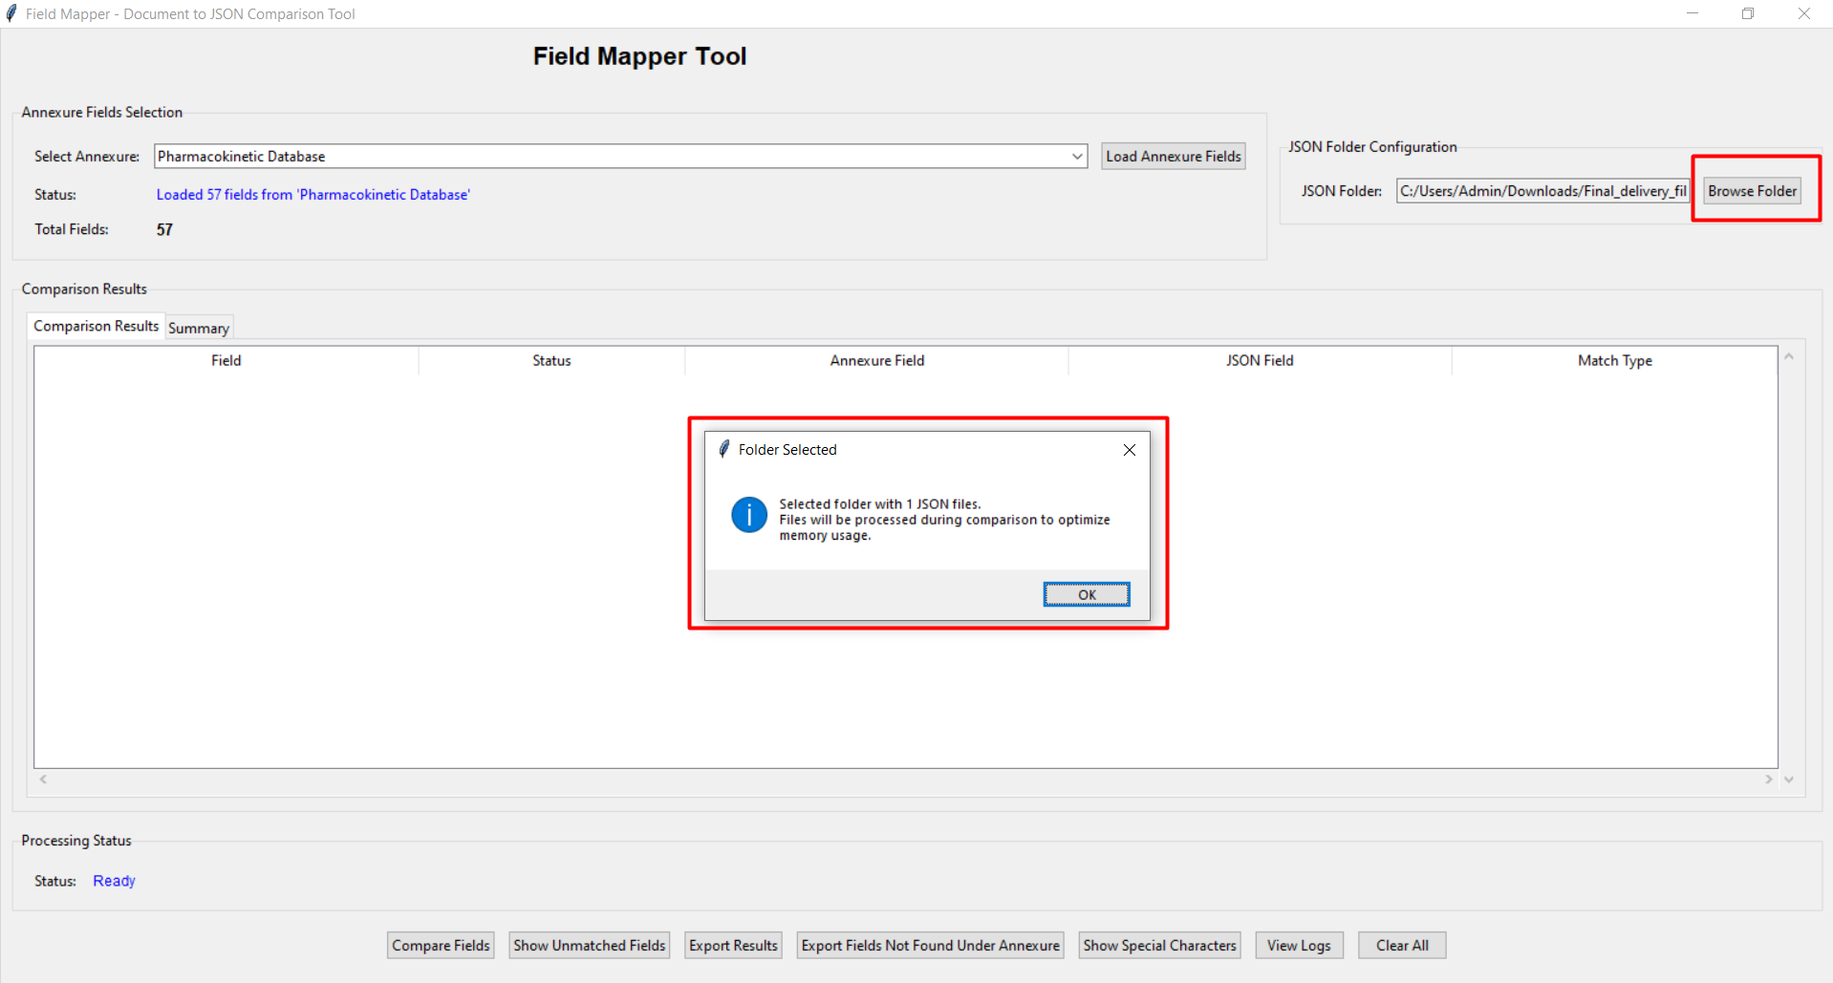Shows the JSON folder path filled in and the folder selection dialog
What Happens:
- The selected folder path appears in the "JSON Folder" field
- Example: C:/Users/Admin/Downloads/Final_delivery_fil
- The system scans the folder for JSON files
- A confirmation message shows how many JSON files were found
- Message: "Selected folder with 1 JSON files. Files will be processed during comparison..."
Important Notes:
- The folder can contain multiple JSON files
- All JSON files in the folder will be processed
- Subfolders are not scanned automatically
- Only .json files are processed

Step 3: Start Comparison
Actions:
- Ensure both annexure fields and JSON folder are loaded
- Click the "Compare Fields" button at the bottom of the window
- Wait for the processing to complete
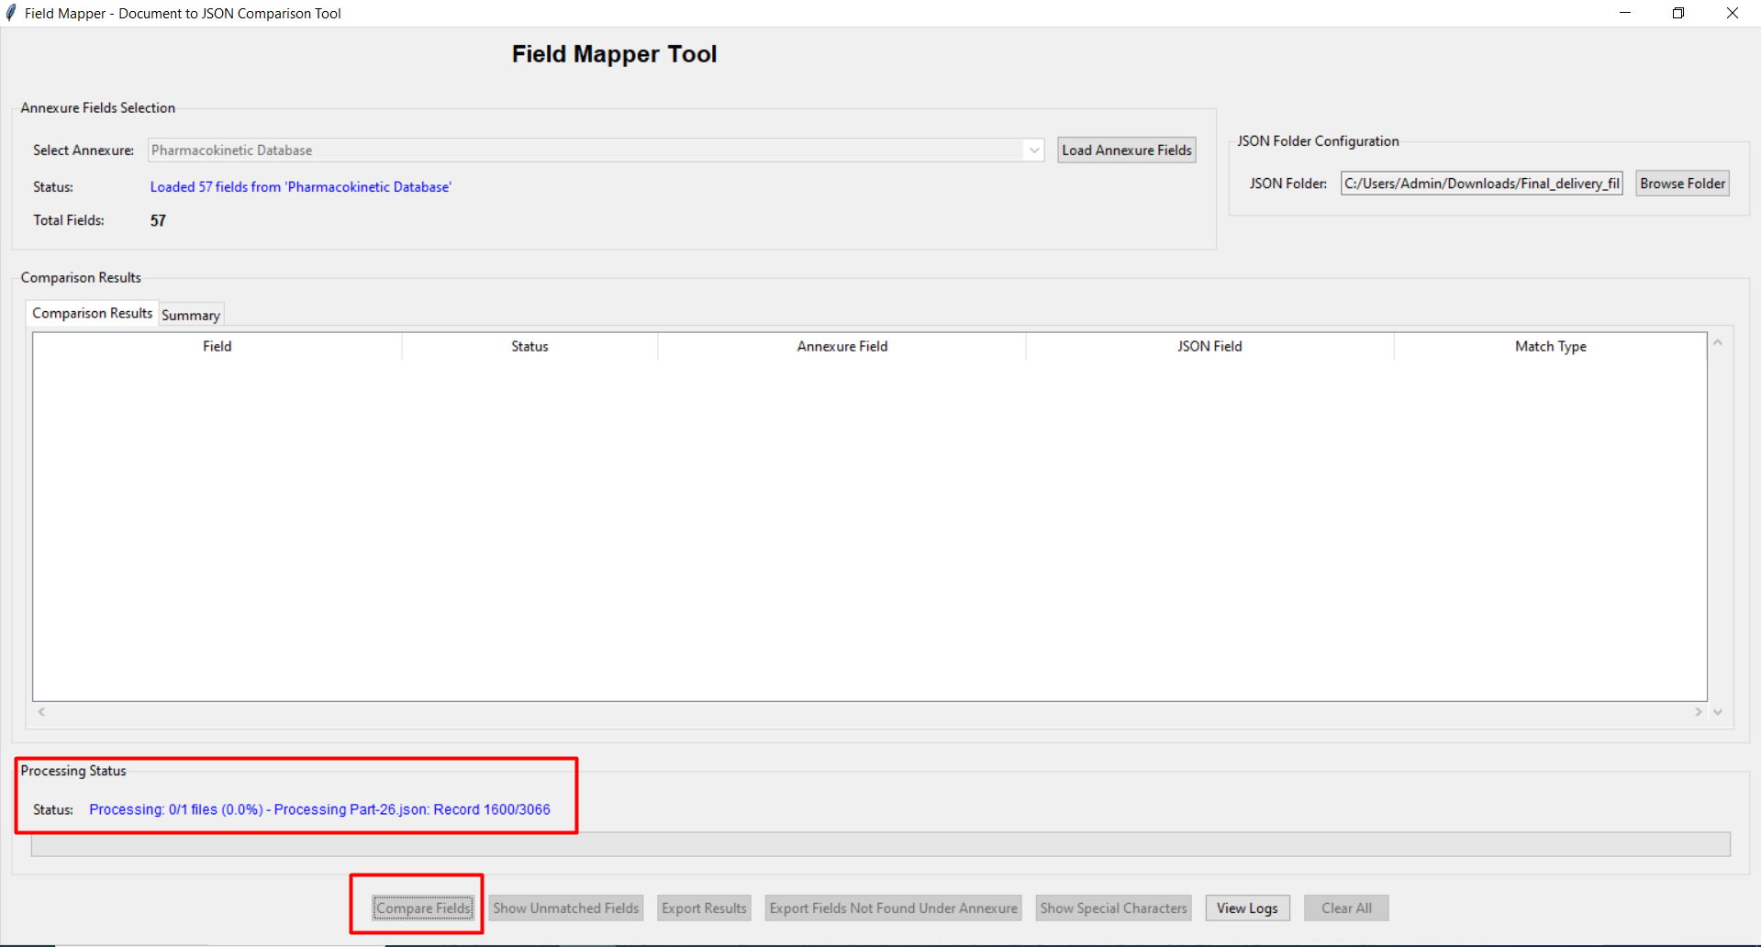Shows the "Compare Fields" button and processing status message
What Happens:
- The Processing Status shows: "Processing: 0/1 files (0.0%) - Starting comparison..."
- The system reads each JSON file in the folder
- Field names are extracted from the JSON data
- Each field is compared with the annexure definition
- Matching algorithm runs (exact match + fuzzy match)
- Progress updates appear: "Processing: 1/1 files (100.0%) - Displaying results..."
Processing Time:
Processing time depends on:
- Number of JSON files (more files = more time)
- Size of each JSON file (larger files take longer)
- Complexity of JSON structure (nested objects take longer)
- Typical time: 1-5 seconds per file

Step 4: Review Comparison Results
Actions:
- Wait for the "Comparison Complete" popup to appear
- Click "OK" to close the popup
- Review the results in the "Comparison Results" tab
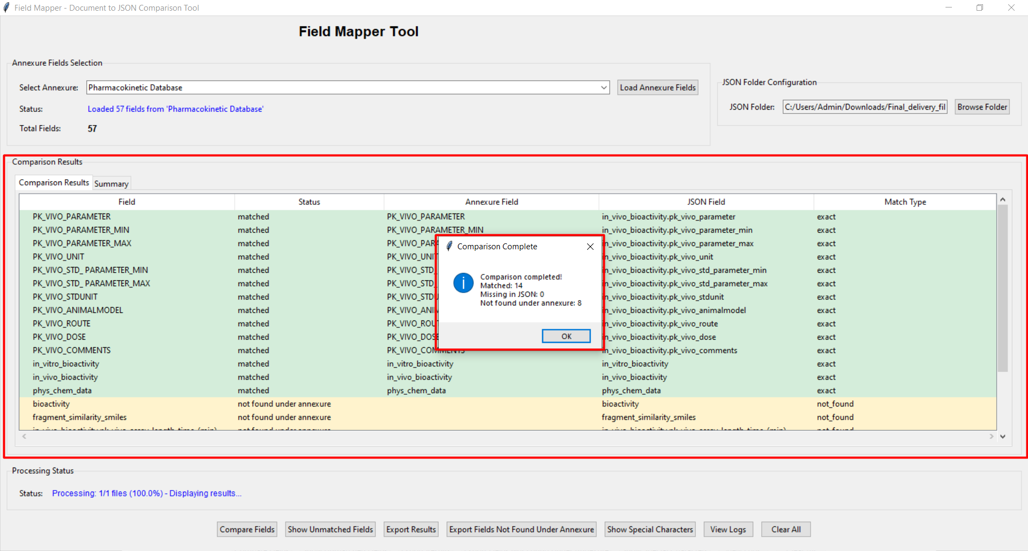Shows the comparison complete popup with statistics and the results table
Understanding the Popup:
The popup shows key statistics:
- Comparison completed!
- Matched: 14 (fields found in both annexure and JSON)
- Missing in JSON: 0 (annexure fields not found in JSON)
- Not found under annexure: 8 (JSON fields not in annexure)
- Total Compared: 22 (total unique fields checked)

Results Table Columns:
Column | Description
Field | The field name being compared
Status | Match status (matched, not found under annexure)
Annexure Field | Field name from annexure definition
JSON Field | Field name from JSON file
Match Type | exact (100% match) or fuzzy (similarity score)
Color Coding:
- Green background: Matched fields (exact match)
- Light yellow/cream: Fields not found under annexure (in JSON but not in annexure)
- Red background: Fields in annexure but not in JSON (missing data)

Step 5: View Summary Statistics
Actions:
- Click the "Summary" tab next to "Comparison Results"
- Review the detailed statistics
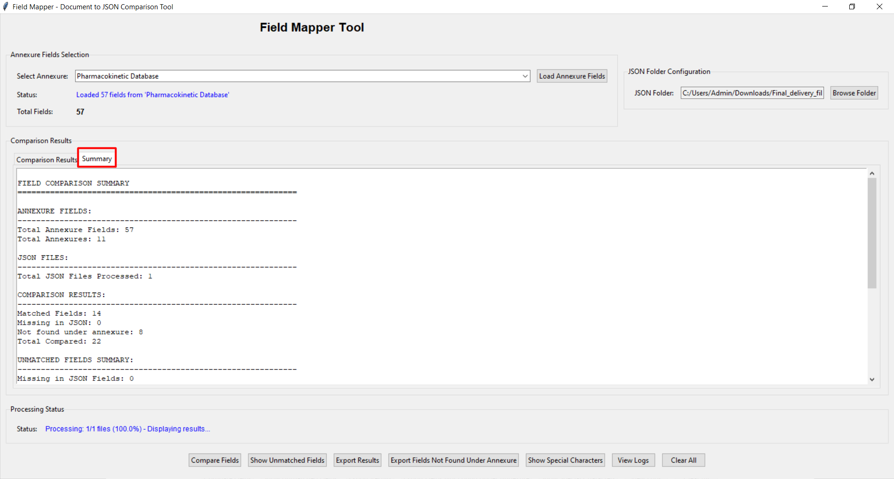Shows the Summary tab with detailed field comparison statistics
Summary Statistics Explained:
ANNEXURE FIELDS:
- Total Annexure Fields: Total number of fields defined in the annexure (e.g., 57)
- Total Annexures: Number of different annexure categories (e.g., 11)
JSON FILES:
- Total JSON Files Processed: Number of JSON files compared (e.g., 1)
COMPARISON RESULTS:
- Matched Fields: Fields found in both annexure and JSON (e.g., 14)
- Missing in JSON: Annexure fields not found in JSON data (e.g., 0)
- Not Found under annexure: JSON fields not in annexure definition (e.g., 8)
- Total Compared: Total unique fields checked (e.g., 22)
UNMATCHED FIELDS SUMMARY:
- Missing in JSON Fields: Shows count (e.g., 0)
- This indicates data quality - lower is better

Step 6: View Detailed Logs
Actions:
- Look at the bottom-right corner for "View Logs" button
- Click the dropdown arrow to see log options
- Select the log type you want to view
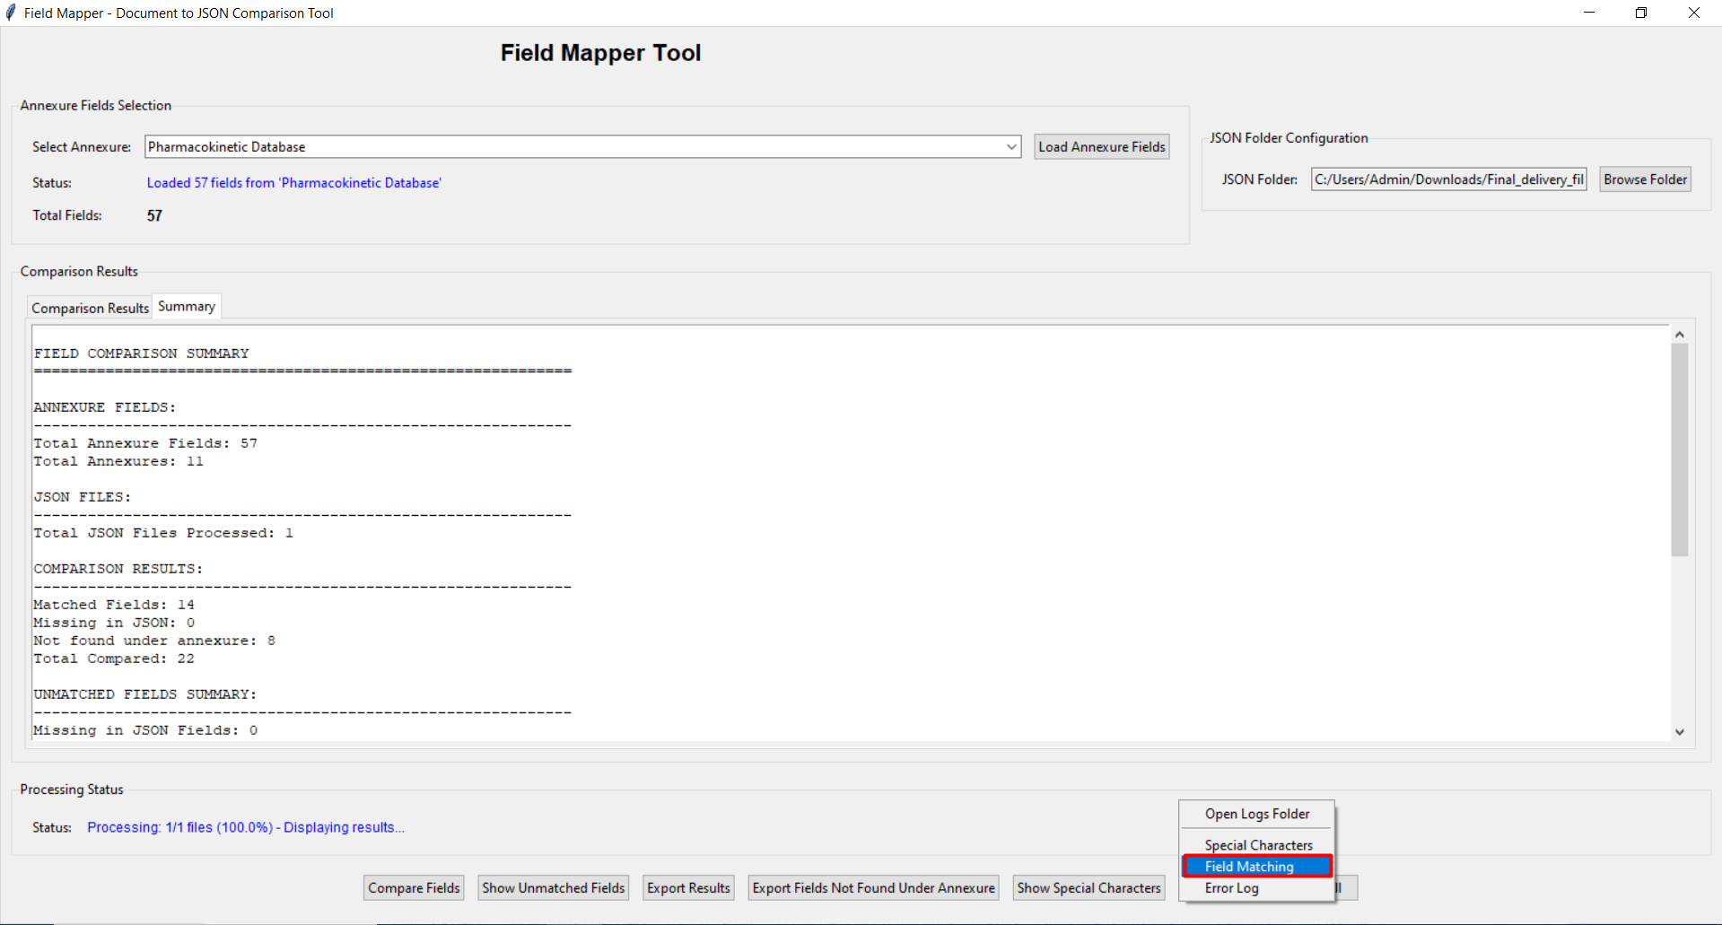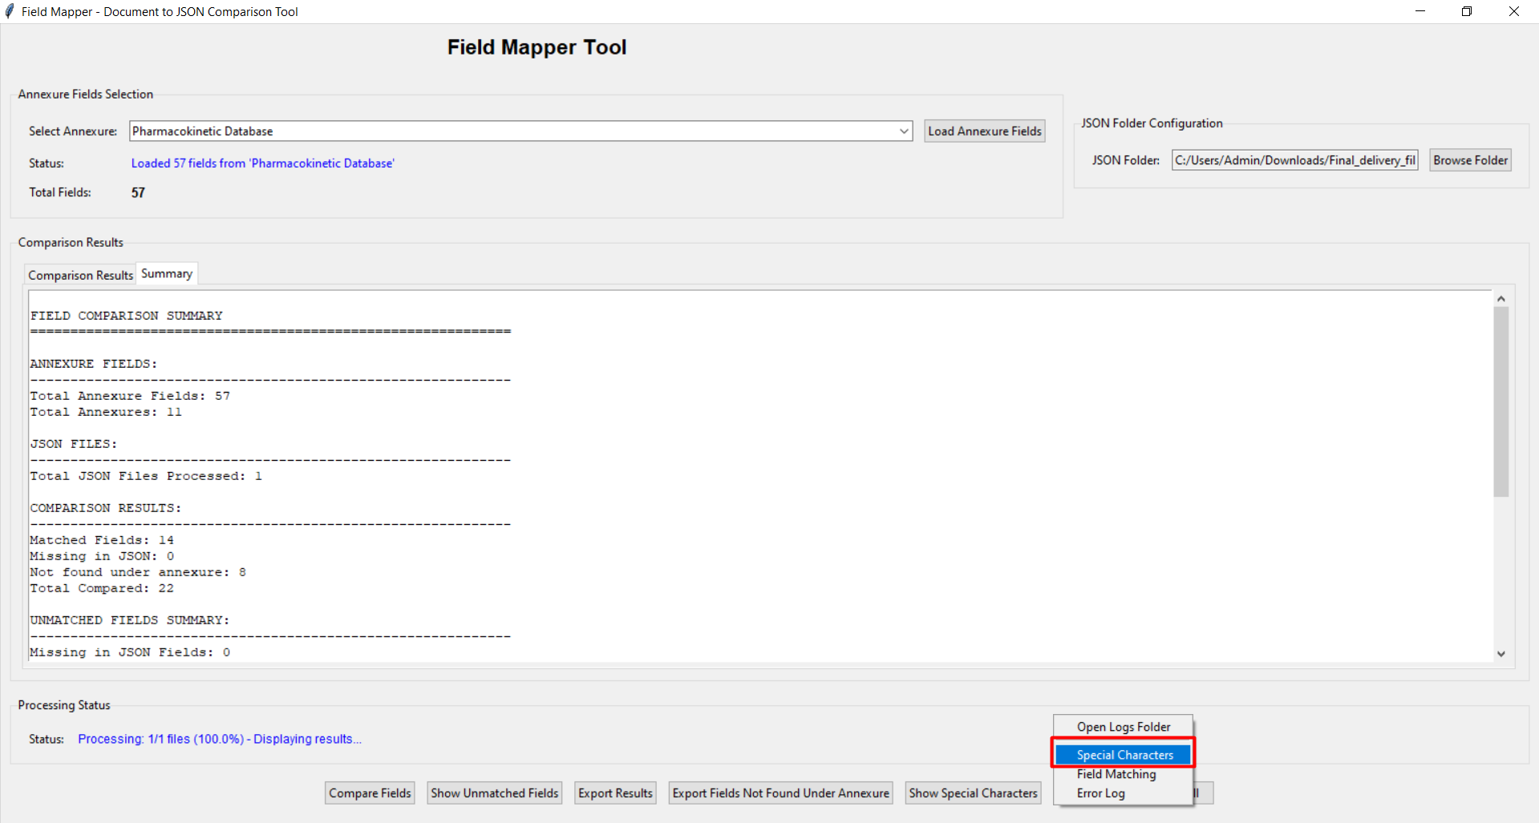Shows the View Logs dropdown menu with options: Special Characters, Field Matching, Error Log

Available Log Types:
1. Field Matching Log
- Contains detailed field-by-field comparison results
- Shows exact matches, fuzzy matches, and unmatched fields
- Includes similarity scores for fuzzy matches
- Filename format: {Annexure}_field_matching_{timestamp}.log
2. Special Characters Log
- Lists fields containing special characters in their values
- Shows which special characters were found
- Includes sample values and line numbers
- Helps identify data quality issues
- Filename format: {Annexure}_special_chars_{timestamp}.log
3. Error Log
- Contains any errors or warnings during processing
- Includes stack traces for debugging
- Shows file paths and line numbers
- Filename format: {Annexure}_errors_{timestamp}.log
Opening Logs:
- Click "Open Logs Folder" to open the logs directory
- Select specific log type from dropdown to view that log
- Logs open in your default text editor
- All logs are timestamped for version tracking

4. Understanding Results

4.1 Match Types Explained
Exact Match
- Field names match exactly after normalization
- Normalization removes: spaces, underscores, hyphens, dots
- Case is ignored (unless case-sensitive mode is enabled)
- Example: "PK_VIVO_PARAMETER" matches "in_vivo_bioactivity.pk_vivo_parameter"
- Most reliable match type

Fuzzy Match
- Field names are similar but not exactly the same
- Uses similarity scoring algorithm (0.0 to 1.0)
- Default threshold: 0.8 (80% similarity)
- Shows similarity score: e.g., "fuzzy (0.88)"
- Example: "bioactivity_technique" ~ "bioactivity.uniprot" = 0.88
- May include false positives - review carefully
Not Found
- No match found in comparison
- Could indicate: missing field, typo, or renamed field
- Review manually to determine cause

4.2 Status Types
Status | Meaning | Color
matched | Field found in both annexure and JSON | Green
not found under annexure | Field in JSON but not in annexure | Yellow/Cream
missing in JSON | Field in annexure but not in JSON | Red

4.3 Interpreting Results
Good Results (High Quality Data):
- High number of matched fields (green)
- Low or zero "Missing in JSON" count
- Few "Not found under annexure" entries
Concerns to Review:
- Many "Missing in JSON" entries → incomplete data
- Many "Not found under annexure" entries → extra fields or typos
- Fuzzy matches with low scores (< 0.85) → potential false matches
- Special characters in field values → data quality issues

5. Advanced Features

5.1 Batch Processing
When you select a folder with multiple JSON files, the tool automatically processes all files in batch mode:
- Each file is compared against the same annexure
- Individual results are generated for each file
- Summary combines results from all files
- Logs show file-specific details
- Progress indicator shows file count: "Processing: 1/5 files (20%)"

5.3 Special Character Detection
The tool automatically checks field values for special characters:
- Detects: brackets, symbols (@#$%^&*), special characters
- Excludes: HELM, SMILES, MolStructure fields (configurable)
- Results shown in Special Characters log
- Includes line numbers for easy location
- Shows sample values with problematic characters

5.4 Viewing Unmatched Fields
Use the action buttons to filter results:
- "Show Unmatched Fields" → Shows only non-matching fields
- "Export Fields Not Found Under Annexure" → Exports JSON-only fields
- "Show Special Characters" → Opens special characters log
- Use these to focus on problem areas

6. Exporting and Reports

6.1 Export Results
Click "Export Results" button to save comparison data:
- Choose format: JSON or Text
- Select save location
- File includes all comparison details
- Filename includes timestamp
- Can be imported into Excel or other tools

6.2 Export Unmatched Fields
Click "Export Fields Not Found Under Annexure":
- Exports only fields found in JSON but not in annexure
- Useful for identifying extra fields or typos
- Can be used to update annexure definitions
- Saves as text file with field list

6.3 Log Files
All log files are saved in the logs/ directory:
- Automatically created for each comparison
- Timestamped for version tracking
- Three types: Field Matching, Special Characters, Errors
- Can be archived for audit purposes
- Plain text format - easy to read and share

7. Troubleshooting

7.1 Common Issues
Issue: No annexures appear in dropdown
Solution:
- Check that configuration files exists
- Verify Python syntax in config file
- Restart the application
- Check error log for details
Issue: JSON file not recognized
Solution:
- Ensure file has .json extension
- Validate JSON syntax online (jsonlint.com)
- Check file is not empty
- Try opening in text editor to verify content
- Check file encoding (should be UTF-8)
Issue: No matches found
Solution:
- Verify correct annexure is selected
- Check if JSON file structure is needed for nested data
- Review field names in both sources
- Try lowering similarity threshold (if using fuzzy match)
- Check if fields are in null/empty categories
Issue: Processing takes too long
Solution:
- Check JSON file size (very large files take time)
- Reduce number of files in folder
- Close other applications to free memory
- Check error log for issues
- Be patient - 1000+ fields may take 10-30 seconds
Issue: Many fuzzy matches with low scores
Solution:
- Review fuzzy matches manually
- Many low-score matches may be false positives
- Consider disabling fuzzy matching
- Or increase similarity threshold to 0.9
- Edit configuration in the comparison engine

7.2 Getting Help
- Check error log: logs/{Annexure}_errors_{timestamp}.log
- Check the documentation folder
- Refer to this user manual
- Contact support team with log files attached
- Include screenshot of issue if possible

8. Glossary
Term | Definition
Annexure | Database schema or field definition document
Field | A data element or column name
JSON | JavaScript Object Notation - a data format
Match | When a field is found in both annexure and JSON
Exact Match | Field names match exactly (after normalization)
Fuzzy Match | Field names are similar (uses similarity scoring)
Similarity Score | Number from 0.0 to 1.0 indicating match quality
Normalization | Removing spaces, underscores, etc. for comparison
Missing in JSON | Field defined in annexure but not in JSON data
Not found under annexure | Field in JSON but not in annexure
Special Character | Non-alphanumeric character (e.g., @, #, $)
HELM | Hierarchical Editing Language for Macromolecules
SMILES | Simplified Molecular Input Line Entry System
Batch Processing | Processing multiple files at once
Log File | Text file containing detailed processing information

Appendix: Button Reference
Button | Function
Load Annexure Fields | Loads field definitions from selected annexure
Browse Folder | Opens folder browser to select JSON files location
Compare Fields | Starts the field comparison process
Show Unmatched Fields | Filters results to show only non-matching fields
Export Results | Saves comparison results to file (JSON or Text)
Export Fields Not Found Under Annexure | Exports list of JSON fields not in annexure
Show Special Characters | Opens log file showing fields with special characters
View Logs | Dropdown to access different log files
Open Logs Folder | Opens the logs directory in file explorer
Clear All | Clears all results and resets the application

End of Document
For technical support or questions about this document, please refer to the Technical Documentation or contact your system administrator.
Document Version: 1.0
Last Updated: November 18, 2025

