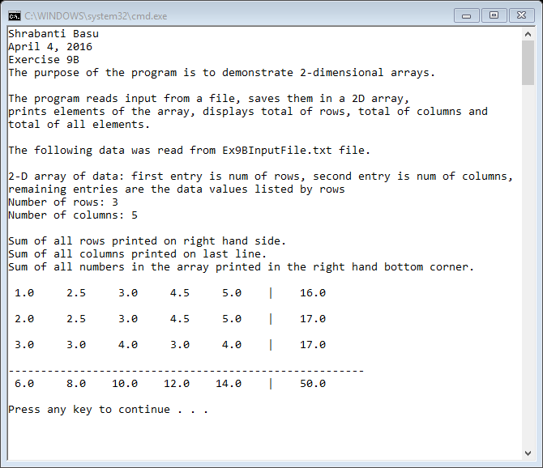

//Shrabanti Basu

//April 4, 2016

//Exercise 9B

//The purpose of the program is to demonstrate 2-dimensional arrays

#include <iostream>

#include <fstream>

#include <string>

#include <iomanip>

using namespace std;

int main()

{

cout << "Shrabanti Basu\n";

cout << "April 4, 2016\n";

cout << "Exercise 9B\n";

cout << "The purpose of the program is to demonstrate 2-dimensional arrays.\n\n";

cout << "The program reads input from a file, saves them in a 2D array,\n"

<< "prints elements of the array, displays total of rows, total of columns and\n"

<< "total of all elements.\n\n";

//number of rows and columns for the array

const int ROWS = 10;

const int COLS = 10;

ifstream inputFile; //input file

string info; //save file info

int rowsin = 0, colsin = 0; //to store number of rows and columns from input file; initialized to zero

cout << setprecision(1) << fixed << showpoint;

//create array

float numbers[ROWS][COLS];

//accumulators to store total of rows, columns and all elements

float rowsTotal = 0.0,

colsTotal = 0.0,

total = 0.0;

inputFile.open("Ex9BInputFile.txt");

if (inputFile)

{

cout << "The following data was read from Ex9BInputFile.txt file.\n\n";

//read and print file information

getline(inputFile, info);

cout << info << endl;

getline(inputFile, info);

cout << info << endl;

//read and print number of rows and columns

inputFile >> rowsin;

inputFile >> colsin;

cout << "Number of rows: " << rowsin << endl;

cout << "Number of columns: " << colsin << endl << endl;

cout << "Sum of all rows printed on right hand side.\n";

cout << "Sum of all columns printed on last line.\n";

cout << "Sum of all numbers in the array printed in the right hand bottom corner.\n\n";

//read each element from file, store them in an array

//print each array element

//keep track of total of all elements

//count row totals and print them

for (int i = 0; i < rowsin; i++)

{

rowsTotal = 0.0;

for (int j = 0; j < colsin; j++)

{

inputFile >> numbers[i][j];

cout << setw(4) << numbers[i][j] << " ";

rowsTotal += numbers[i][j];

total += numbers[i][j];

}

cout << "| " << rowsTotal << endl;

cout << endl;

}

cout << "-------------------------------------------------------" << endl;

//get column totals and print them

for (int i = 0; i < colsin; i++)

{

colsTotal = 0.0;

for (int j = 0; j < rowsin; j++)

{

colsTotal += numbers[j][i];

}

cout << setw(4) << colsTotal << " ";

}

//print the total of all elements

cout << "| " << setw(4) << total << endl << endl;

}

else

{

cout << "Error opening file.\n\n";

}

return 0;

}