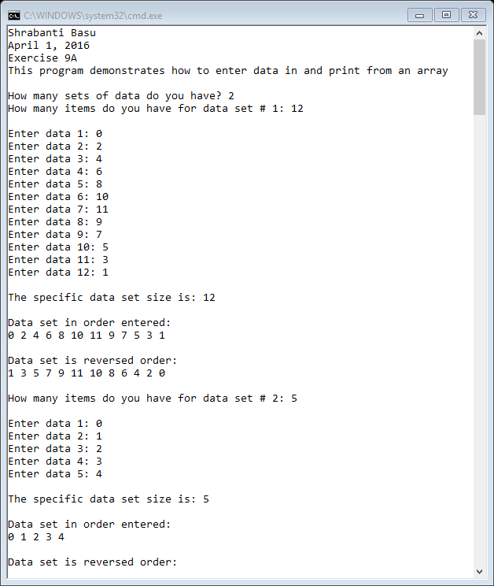

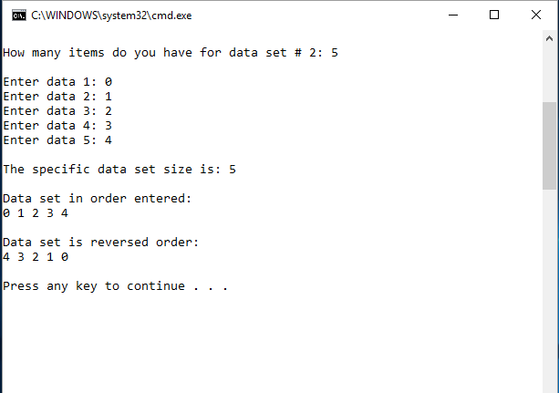

//Shrabanti Basu

//April 1, 2016

//Exercise 9A

//This program demonstrates how to enter data in and print from an array

#include <iostream>

using namespace std;

int main()

{

cout << "Shrabanti Basu\n";

cout << "April 1, 2016\n";

cout << "Exercise 9A\n";

cout << "This program demonstrates how to enter data in and print from an array\n\n";

//create array that can hold 50 elements

int myNumbers[50];

int nsets; //number of iterations for the loop

int ncount; //number of items to store in the array for each iteration of the outer loop

cout << "How many sets of data do you have? ";

cin >> nsets;

for (int i = 1; i <= nsets; i++)

{

//for current iteration how many items do you have

cout << "How many items do you have for data set # " << i << ": ";

cin >> ncount;

cout << endl;

for (int j = 0; j < ncount; j++)

{

cout << "Enter data " << j + 1 << ": ";

cin >> myNumbers[j];

}

cout << "\nThe specific data set size is: " << ncount << endl << endl;

cout << "Data set in order entered:\n";

for (int p = 0; p < ncount; p++)

cout << myNumbers[p] << " ";

cout << "\n\nData set is reversed order:\n";

for (int q = (ncount-1); q >= 0; q--)

cout << myNumbers[q] << " ";

cout << endl << endl;

}

return 0;

}