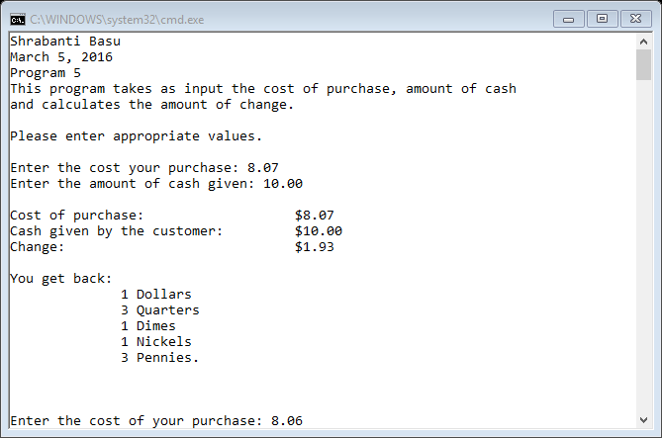

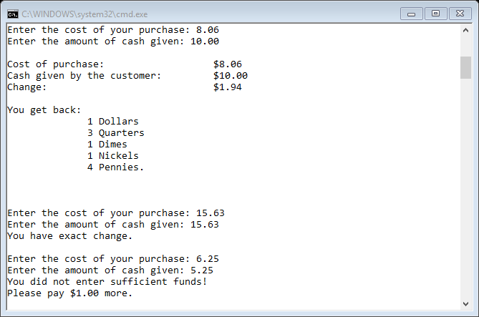

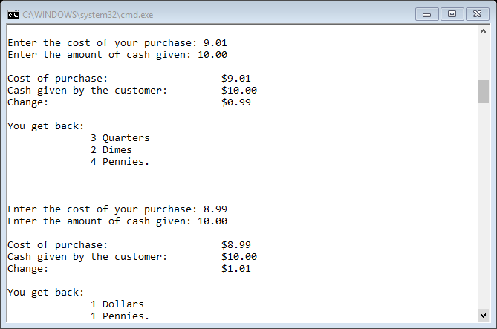

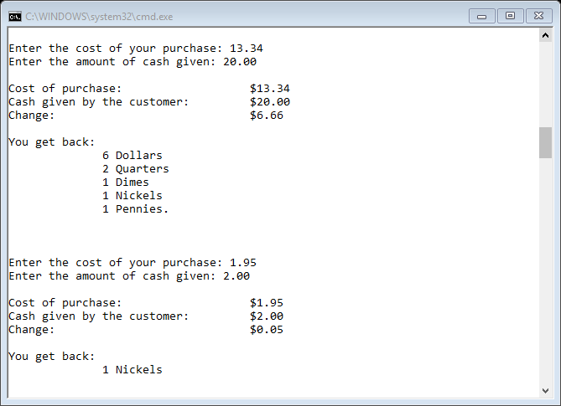

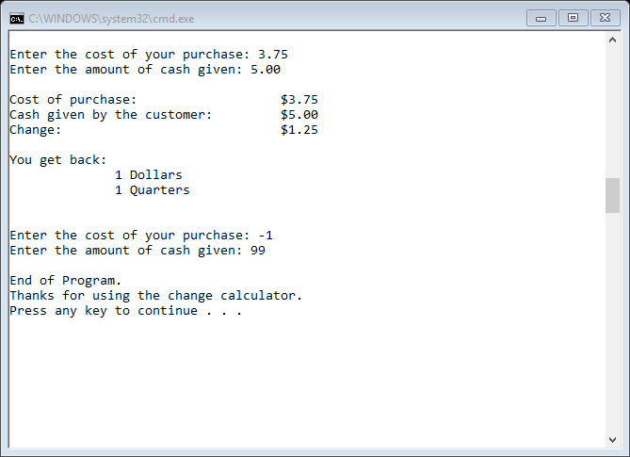

//Shrabanti Basu

//Mar 5, 2016

// Program 5

//This program demostrates a change calculator.

//The program asks user to enter the cost of purchase, and the amount of cash given,

//and then calculates change and prints with an appropriate message with denominations.

#include <iostream>

#include <iomanip> //needed for output formatting

using namespace std;

int main()

{

cout << "Shrabanti Basu\n";

cout << "March 5, 2016\n";

cout << "Program 5\n";

cout << "This program takes as input the cost of purchase, amount of cash\n"

<< "and calculates the amount of change.\n\n";

cout << "Please enter appropriate values.\n\n";

const double FUDGE_FACTOR = 0.000001; //declare a consant variable and add it to the change

double costOfPurchase, cashGiven, change; // to store cost of purchase; cash amount given; change amount

int dollars, quarters, dimes, nickles, pennies; //to store denominations of coins

int temp, remainder; //to hold integer value of change (in pennies), and value returned from modulus operator

cout << setprecision(2) << fixed << showpoint;

cout << "Enter the cost your purchase: ";

cin >> costOfPurchase;

cout << "Enter the amount of cash given: ";

cin >> cashGiven;

do

{

while (costOfPurchase < 0 || cashGiven < 0)

{

//prompt user until proper input is given for the first iteration of the loop

cout << "Please enter a valid input.\n";

cout << "Enter the cost your purchase: ";

cin >> costOfPurchase;

cout << "Enter the amount of cash given: ";

cin >> cashGiven;

}

//Display appropriate message if cost of purchase is more than cash given by the customer

if (costOfPurchase > cashGiven)

{

cout << "You did not enter sufficient funds!\n";

cout << "Please pay $" << costOfPurchase - cashGiven << " more.\n\n";

}

//display message if no change is due

else if (costOfPurchase == cashGiven)

cout << "You have exact change.\n\n";

/*

If the customer gets change back,

the program calculates and displays proper change

*/

else

{

//calculate the change and print on screen

change = cashGiven - costOfPurchase;

//display cost, cash given and change in appropriate format

cout << endl;

cout << "Cost of purchase:\t " << setw(10) << "$" << costOfPurchase << endl;

cout << "Cash given by the customer:" << setw(10) << "$" << cashGiven << endl;

cout << "Change:\t\t\t " << setw(10) << " $" << change << endl << endl;

/*

We add the fudge factor to the change variable to get rid of any approximation errors

and multiply it by 100 to convert into pennies and save the integer part in the temp variable.

We then sequentially divide the temp variable and perform modular operations by 100, 25, 10, and 5 to

get the values for dollars, quarters, dimes, nickels, and pennies.

*/

temp = (change + FUDGE_FACTOR) * 100;

dollars = temp / 100; //amount in dollars

remainder = temp % 100; //rest of the amount in pennies

quarters = remainder / 25; //amount in quarters

remainder = remainder % 25; //rest of the amount in pennies

dimes = remainder / 10; //amount in dimes

remainder = remainder % 10; //rest of the amount in pennies

nickles = remainder / 5; //amount in nickels

remainder = remainder % 5; //rest of the amount in pennies, this is the final amount of pennies

pennies = remainder;

//if there is any denomination of a coin, only then print it

cout << "You get back: \n";

if (dollars > 0)

cout << "\t " << dollars << " Dollars" << endl;

if (quarters > 0)

cout << "\t " << quarters << " Quarters" << endl;

if (dimes > 0)

cout << "\t " << dimes << " Dimes" << endl;

if (nickles > 0)

cout << "\t " << nickles << " Nickels" << endl;

if (pennies)

cout << "\t " << pennies << " Pennies.\n\n";

cout << endl << endl;

}

//Get user input again and repeat the loop if values are non-negative

cout << "Enter the cost of your purchase: ";

cin >> costOfPurchase;

cout << "Enter the amount of cash given: ";

cin >> cashGiven;

} while (costOfPurchase >= 0 && cashGiven >= 0);

cout << "\nEnd of Program.\n";

cout << "Thanks for using the change calculator." << endl;

return 0;

}