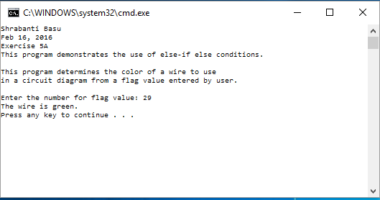

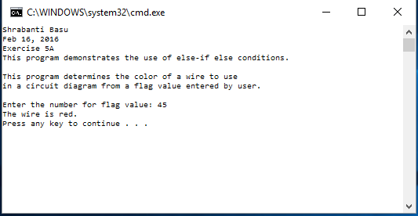

//Shrabanti Basu

//Feb 16, 2016

//Exercise 5A

//This program demonstrates the use of else-if else conditions.

#include <iostream>

using namespace std;

int main()

{

cout << "Shrabanti Basu\n";

cout << "Feb 16, 2016\n";

cout << "Exercise 5A\n";

cout << "This program demonstrates the use of else-if else conditions.\n\n";

cout << "This program determines the color of a wire to use\n"

<< "in a circuit diagram from a flag value entered by user.\n\n";

int flagValue;

cout << "Enter the number for flag value: ";

cin >> flagValue;

if (flagValue < 10)

cout << "The wire is white.\n";

else if (flagValue < 30)

cout << "The wire is green.\n";

else if (flagValue < 40)

cout << "The wire is blue.\n";

else

cout << "The wire is red.\n";

return 0;

}