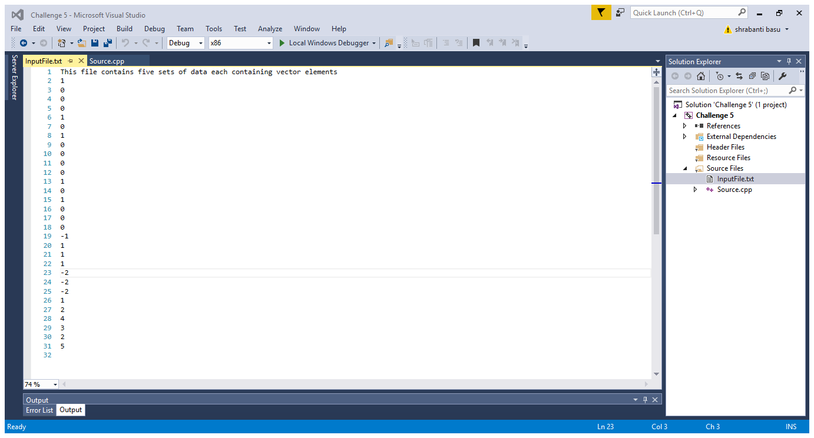

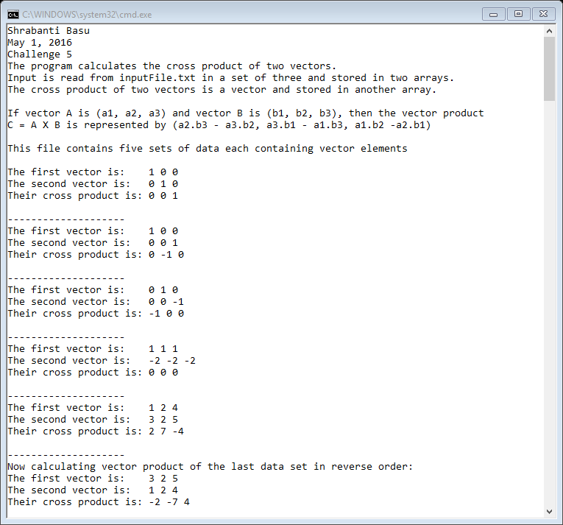

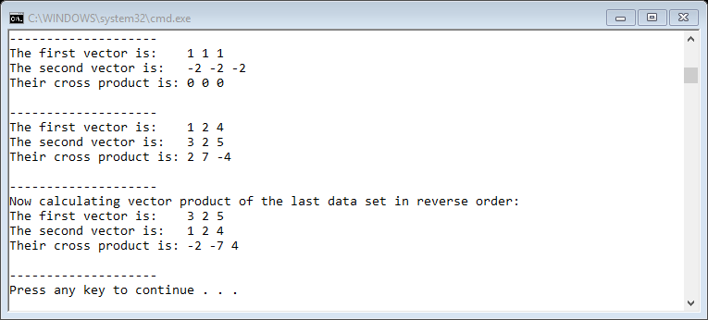

//Shrabanti Basu

//May 1, 2016

//Challenge 5

//The program calculates the cross product of two vectors.

#include <iostream>

#include <fstream>

#include <string>

#include <iomanip>

using namespace std;

//array size set to 3, because cross product is defined in the domain R^3

const int SIZE = 3;

//function prototype

void crossProduct(int[], int[]);

int main()

{

cout << "Shrabanti Basu\n";

cout << "May 1, 2016\n";

cout << "Challenge 5\n";

cout << "The program calculates the cross product of two vectors.\n";

cout << "Input is read from inputFile.txt in a set of three and stored in two arrays.\n"

<< "The cross product of two vectors is a vector and stored in another array.\n\n";

cout << "If vector A is (a1, a2, a3) and vector B is (b1, b2, b3), then the vector product\n"

<< "C = A X B is represented by (a2.b3 - a3.b2, a3.b1 - a1.b3, a1.b2 -a2.b1)\n\n";

//declare two arrays to store data read from file

int numbers1[SIZE], numbers2[SIZE];

ifstream inFile;

inFile.open("InputFile.txt"); //open file

string str; //to store line of string

if (inFile.fail())

{

cout << "Error opening file.\n";

}

else

{

//read first line of input and print

getline(inFile, str, '\n');

cout << str << endl << endl;

for (int i = 0; i < SIZE; i++)

inFile >> numbers1[i];

for (int j = 0; j < SIZE; j++)

inFile >> numbers2[j];

do

{

//call vector product

crossProduct(numbers1, numbers2);

for (int i = 0; i < SIZE; i++)

inFile >> numbers1[i];

for (int j = 0; j < SIZE; j++)

inFile >> numbers2[j];

} while (!(inFile.eof()));

//call vector product again with the last data set, now in reverse order

cout << "Now calculating vector product of the last data set in reverse order:\n";

crossProduct(numbers2, numbers1);

inFile.close(); //close file

}

return 0;

}

//function definition of cross product

//It takes two vector (arrays) and prints their elements,

//calculates cross products and prints them

void crossProduct(int arr1[], int arr2[])

{

int result[SIZE]; //to store the cross product of the two vectors passed through arr1[], arr2[]

cout << "The first vector is:\t";

for (int i = 0; i < SIZE; i++)

cout << arr1[i] << " ";

cout << endl;

cout << "The second vector is:\t";

for (int i = 0; i < SIZE; i++)

cout << arr2[i] << " ";

cout << endl;

//calculate elements of the vector array and store them in an array

result[0] = (arr1[1] \* arr2[2]) - (arr1[2] \* arr2[1]);

result[1] = (arr1[2] \* arr2[0]) - (arr1[0] \* arr2[2]);

result[2] = (arr1[0] \* arr2[1]) - (arr1[1] \* arr2[0]);

//print the cross product

cout << "Their cross product is:\t";

for (int i = 0; i < SIZE; i++)

cout << result[i] << " ";

cout << endl << "\n--------------------" << endl;

}