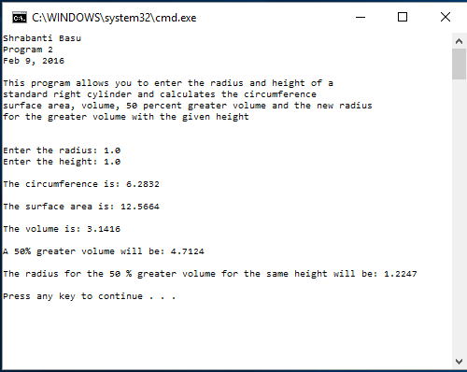

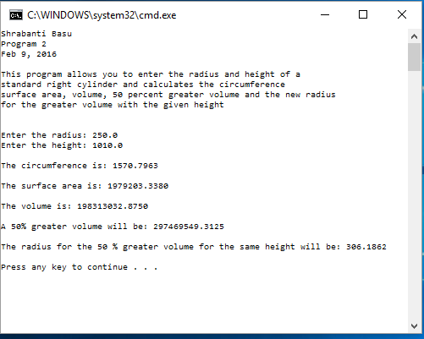

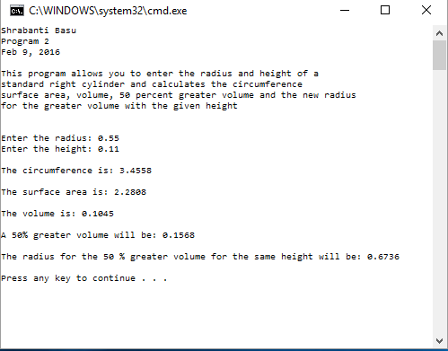

//Shrabanti Basu

//Feb 9, 2016

//Program 2

/\*

This program finds out the circumference, surface area and

volume of a standard right cylinder from radius and height.

It also calculates what would be a 50% greater volume and

the radius associated with a 50% greater volume.\*/

#include <iostream>

#include <iomanip> //for output formatting

using namespace std;

int main()

{

cout << "Shrabanti Basu\n";

cout << "Program 2\n";

cout << "Feb 9, 2016\n\n";

cout << "This program allows you to enter the radius and height of a \n"

<< "standard right cylinder and calculates the circumference\n"

<< "surface area, volume, 50 percent greater volume and the new radius\n"

<< "for the greater volume with the given height\n\n\n";

//Variable Declaration

const double PI = 3.1415926;

double radius, //radius

height, //height

circumference, //circumference

surfaceArea, //surface area

volume, //volume

greaterVolume, //50% greater volume

greaterRadius; //radius for 50% greater volume if height remains same

//Get user input

cout << "Enter the radius: ";

cin >> radius;

cout << "Enter the height: ";

cin >> height;

//Calculations

circumference = 2 \* PI \* radius;

surfaceArea = 2 \* PI \* radius \* (radius + height);

volume = PI \* radius \* radius \* height;

greaterVolume = 1.5 \* volume; //50% greater volume is volume plus 0.5 times volume

greaterRadius = sqrt(greaterVolume / (PI \* height)); //squareroot of new volume divided by PI times height

cout << endl;

cout << setprecision(4) << fixed; //print 4 digits after the decimal point

cout << "The circumference is: " << circumference << endl << endl;

cout << "The surface area is: " << surfaceArea << endl << endl;

cout << "The volume is: " << volume << endl << endl;

cout << "A 50% greater volume will be: " << greaterVolume << endl << endl;

cout << "The radius for the 50 % greater volume for the same height will be: " << greaterRadius

<< endl << endl;

return 0;

}