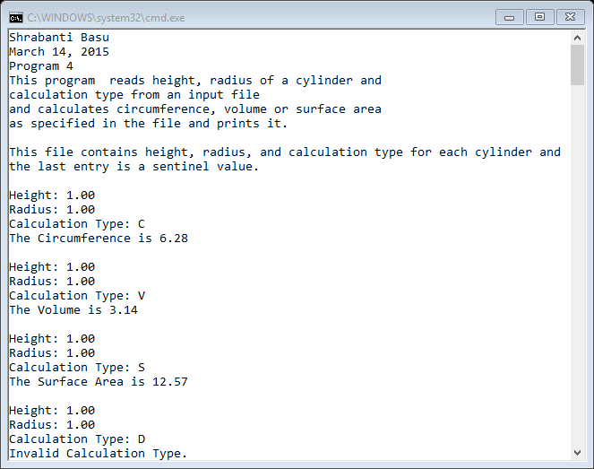

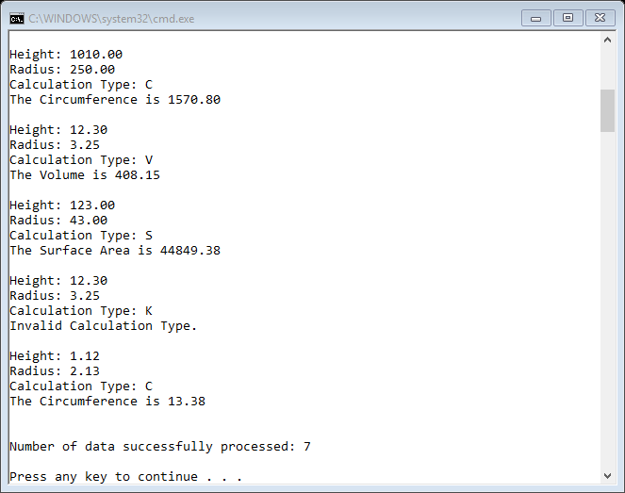

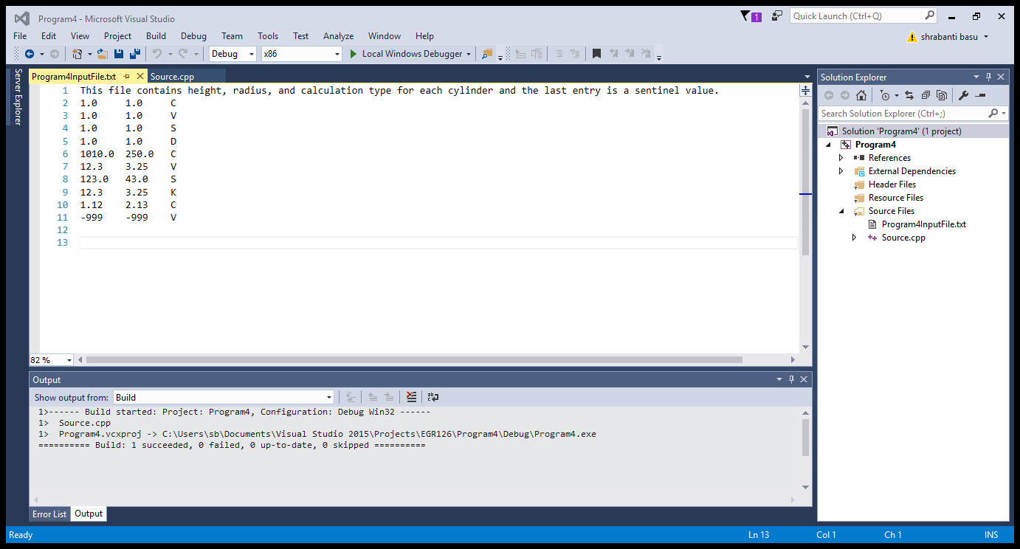

//Shrabanti Basu

//March 14, 2015

//Program 4

/\*

This program reads height, radius of a cylinder and calculation type from an input file

and calculates circumference, volume or surface area as specified in the file

and prints it.

\*/

#include <iostream>

#include <iomanip>

#include <fstream>

#include <string>

using namespace std;

int main()

{

cout << "Shrabanti Basu\n";

cout << "March 14, 2015\n";

cout << "Program 4\n";

cout << "This program reads height, radius of a cylinder and \n"

<< "calculation type from an input file\n"

<< "and calculates circumference, volume or surface area \n"

<< "as specified in the file and prints it.\n\n";

fstream inputFile; // declare file stream object

double height, radius; //to store the height and radius of a file

char ch; //to store the calculation type

string input; //to store the file information

double circumference, volume, surfaceArea; //to save circumference, volume, surfaceArea

int counter = 0; //to store total numbers of successful data processed

const double PI = 3.1415926; //to store the value of PI

inputFile.open("Program4Inputfile.txt", ios::in); //open fstream object in input mode

cout << setprecision(2) << fixed << showpoint;

if (inputFile)

{

getline(inputFile, input, '\n'); //read file info

cout << input << endl << endl; //print file info

//read input for first entry

inputFile >> height;

inputFile >> radius;

inputFile >> ch;

do

{

switch (ch)

{

case 'c':

case 'C':

circumference = 2 \* PI \* radius;

cout << "Height: " << height << endl;

cout << "Radius: " << radius << endl;

cout << "Calculation Type: " << ch << endl;

cout << "The Circumference is " << circumference << endl << endl;

counter++; //counter incremented

break;

case 'v':

case 'V':

cout << "Height: " << height << endl;

cout << "Radius: " << radius << endl;

cout << "Calculation Type: " << ch << endl;

volume = PI \* radius \* radius \* height;

cout << "The Volume is " << volume << endl << endl;

counter++; //counter incremented

break;

case 's':

case 'S':

cout << "Height: " << height << endl;

cout << "Radius: " << radius << endl;

cout << "Calculation Type: " << ch << endl;

surfaceArea = 2 \* PI \* radius \* (radius + height);

cout << "The Surface Area is " << surfaceArea << endl << endl;

counter++; //counter incremented

break;

default:

cout << "Height: " << height << endl;

cout << "Radius: " << radius << endl;

cout << "Calculation Type: " << ch << endl;

cout << "Invalid Calculation Type.\n\n";

break;

}

//read further input and repeat calculation for valid numbers

inputFile >> height;

inputFile >> radius;

inputFile >> ch;

} while (height != -999 || radius != -999);

//close file

inputFile.close();

}

else

{

//if input file not opened, display error message

cout << "Error opening file.\n\n";

}

//print how many data were processed successfully

cout << "\nNumber of data successfully processed: " << counter << endl << endl;

return 0;

}