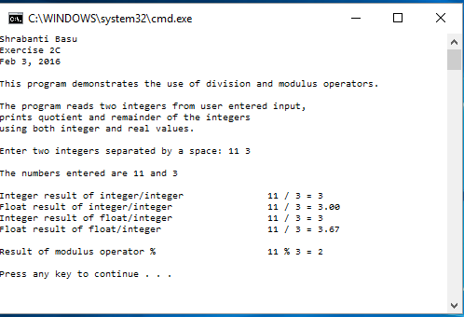

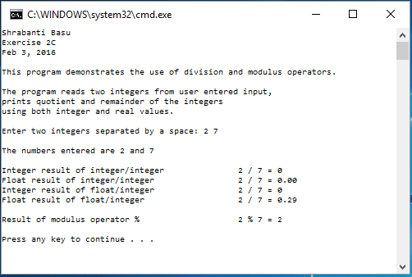

//Shrabanti Basu

//Exercise 2C

//Feb 3, 2016

/\*

This program reads two integer values from screen,

prints the quotient and remainders using both integer and real values.

\*/

#include <iostream>

#include <iomanip>

using namespace std;

int main()

{

cout << "Shrabanti Basu\n";

cout << "Exercise 2C\n";

cout << "Feb 3, 2016\n\n";

cout << "This program demonstrates the use of division and modulus operators.\n\n";

cout << "The program reads two integers from user entered input,\n";

cout << "prints quotient and remainder of the integers\n";

cout << "using both integer and real values.\n\n";

cout << setprecision(2) << fixed; //prints two decimal places after float output

int num1, num2; //stores user input

int iresult; //stores result of division

float fresult; //stores result of division

cout << "Enter two integers separated by a space: ";

cin >> num1 >> num2;

cout << endl << "The numbers entered are " << num1 << " and " << num2 << endl << endl;

iresult = num1 / num2;

cout << "Integer result of integer/integer \t\t" << num1 << " / " << num2 << " = " << iresult << endl;

fresult = num1 / num2;

cout << "Float result of integer/integer \t\t" << num1 << " / " << num2 << " = " << fresult << endl;

iresult = (float) num1 / num2;

cout << "Integer result of float/integer\t\t\t" << num1 << " / " << num2 << " = " << iresult << endl;

fresult = (float)num1 / num2;

cout << "Float result of float/integer\t\t\t" << num1 << " / " << num2 << " = " << fresult << endl << endl;

iresult = num1 % num2;

cout << "Result of modulus operator %\t\t\t" << num1 << " % " << num2 << " = " << iresult << endl << endl;

return 0;

}