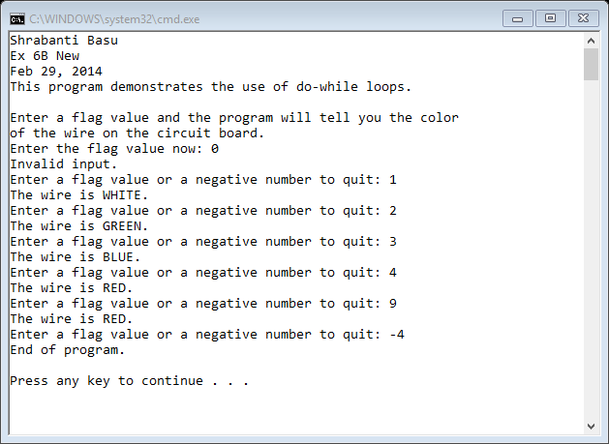

//Shrabanti Basu

//Feb 29, 2014

//Ex 6B New

//This program demonstrates the use of do-while loop.

/\* The do-while loop executes at least once.

If the user enters a negative number at the first iteration of the do-while loop,

the program prompts the user to enter a valid flag value.

After the first iteration, if the user enters a negative value, the program ends.\*/

#include <iostream>

using namespace std;

int main()

{

cout << "Shrabanti Basu\n";

cout << "Ex 6B New\n";

cout << "Feb 29, 2014\n";

cout << "This program demonstrates the use of do-while loops.\n\n";

int number; //to store the flag value entered by the user

cout << "Enter a flag value and the program will tell you the color\n"

<< "of the wire on the circuit board.\n";

cout << "Enter the flag value now: ";

cin >> number; //get user input

do

{

//this inner while loop checks that the user has not entered a negative value

//in the first iteration of the do-while loop

while (number < 0)

{

cout << "That was not a valid number. Enter a valid flag value: ";

cin >> number;

}

switch (number)

{

//check for different flag values entered by user

case 0:

cout << "Invalid input.\n";

break;

case 1:

cout << "The wire is WHITE.\n";

break;

case 2:

cout << "The wire is GREEN.\n";

break;

case 3:

cout << "The wire is BLUE.\n";

break;

default:

cout << "The wire is RED.\n";

}

//prompt the user to enter a flag value once again

//if a non-negative number is entered the do-while loop executes

//if a negative number is entered at this point the program terminates

cout << "Enter a flag value or a negative number to quit: ";

cin >> number;

} while (number >= 0);

cout << "End of program.\n\n";

return 0;

}