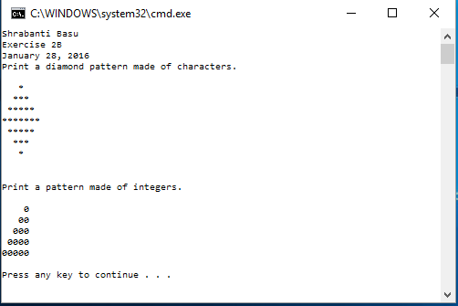

//Shrabanti Basu

//Exercise 2B

//January 28, 2016

/\*

This program prints two patterns -

the first pattern is made of characters

and the second pattern is made of integers

\*/

#include <iostream>

using namespace std;

/\* I shall directly print the asterisk symbols within

quotation marks to print the first pattern. No char variables shall be declared.

An integer variable is declared to hold the value 0 that will be used to make the pattern.

\*/

int main()

{

int number = 0;

cout << "Shrabanti Basu\n";

cout << "Exercise 2B\n";

cout << "January 28, 2016\n";

cout << "Print a diamond pattern made of characters.\n\n";

cout << " \* \n";

cout << " \*\*\* \n";

cout << " \*\*\*\*\* \n";

cout << "\*\*\*\*\*\*\*\n";

cout << " \*\*\*\*\* \n";

cout << " \*\*\* \n";

cout << " \* \n";

cout << endl << endl;

cout << "Print a pattern made of integers.\n\n";

cout << " " << number << endl;

cout << " " << number << number << endl;

cout << " " << number << number << number << endl;

cout << " " << number << number << number << number << endl;

cout << number << number << number << number << number<< endl << endl;

return 0;

}