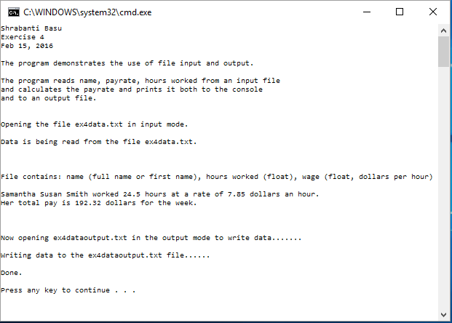

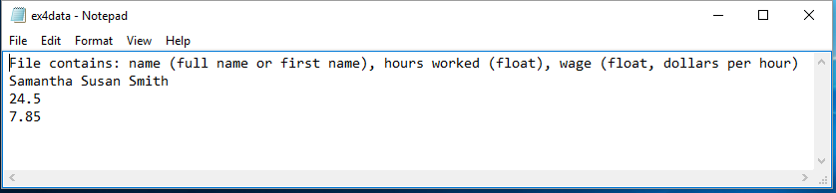

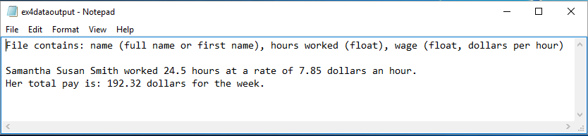

//Shrabanti Basu

//Exercise 4

//Feb 15, 2016

//The program demonstrates the use of a file input and file output.

#include <iostream>

#include <fstream>

#include <string>

#include <iomanip>

using namespace std;

int main()

{

cout << "Shrabanti Basu\n";

cout << "Exercise 4\n";

cout << "Feb 15, 2016\n\n";

cout << "The program demonstrates the use of file input and output.\n\n";

cout << "The program reads name, payrate, hours worked from an input file\n"

<< "and calculates the payrate and prints it both to the console\n"

<< "and to an output file.\n\n\n";

fstream dataFileIn, dataFileOut; //declare two fstream objects to use with input and output files

//declare input file with path

string inputFile = "C:\\Users\\sb\\Documents\\Visual Studio 2015\\Projects\\EGR126\\ex4data.txt";

//declare output file with path

string outputFile = "C:\\Users\\sb\\Documents\\Visual Studio 2015\\Projects\\EGR126\\ex4dataoutput.txt";

string info, name; //to store file information and name

float rate, hours; //to store pay rate and hours worked

float total; //total pay

cout << "Opening the file ex4data.txt in input mode.\n\n";

dataFileIn.open(inputFile, ios::in);

// check if file opens and perform necessary calculations

if (dataFileIn)

{

cout << "Data is being read from the file ex4data.txt.\n\n\n\n";

//get the file information

getline(dataFileIn, info);

//get employee full name, hours and payrate

getline(dataFileIn, name);

dataFileIn >> hours;

dataFileIn >> rate;

//calculate pay

total = hours \* rate;

//print all information to console

cout << info << endl << endl;

cout << name << " worked " << hours << " hours at a rate of " << rate

<< " dollars an hour.\n";

cout << "Her total pay is " << setprecision(2) << fixed << total << " dollars for the week.\n\n\n\n";

cout << "Now opening ex4dataoutput.txt in the output mode to write data.......\n\n";

//open output file

dataFileOut.open(outputFile, ios::out);

//check if file opened properly before performing operations

if (dataFileOut)

{

cout << "Writing data to the ex4dataoutput.txt file......\n\n";

dataFileOut << info << endl << endl;

dataFileOut << name << " worked " << hours << " hours at a rate of " << rate

<< " dollars an hour.\n";

dataFileOut << "Her total pay is: " << setprecision(2) << fixed << total << " dollars for the week.\n\n";

cout << "Done." << endl << endl;

}

else

{

cout << "Cannot open ex4dataoutput.txt file.\n\n";

}

}

else

{

cout << "Error opening file.\n";

}

return 0;

}