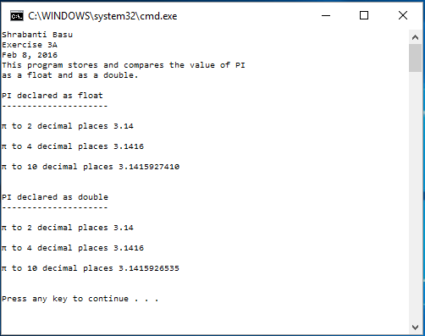

//Shrabanti Basu

//Exercise 3A

//Feb 8, 2016

/\* This program stores the value of PI as a float and as a double

and print the values for 2, 4, and 10 decimal places.

The difference in accuracy for float and double values

are to be noted.

A double data type can hold a greater range of values than a float does.

Therefore, when we print 10 digits after the decimal point a double data type

shows more accuracy.

\*/

#include <iostream>

#include <iomanip> // needed for output formatting

using namespace std;

int main()

{

cout << "Shrabanti Basu\n";

cout << "Exercise 3A\n";

cout << "Feb 8, 2016\n";

cout << "This program stores and compares the value of PI\n";

cout << "as a float and as a double.\n\n";

char ch = 227; //to hold the ASCII code for PI

float PIf = 3.1415926535F; // to hold the value of PI as a float

double PId = 3.1415926535; //to hold the value of PI as a double

//setprecision(int) << fixed is used to show the number of digits

//after the decimal point specified by the integer value int

cout << "PI declared as float\n";

cout << "---------------------\n\n";

cout << ch << " to 2 decimal places " << setprecision(2) << fixed << PIf << endl << endl;

cout << ch << " to 4 decimal places " << setprecision(4) << fixed << PIf << endl << endl;

cout << ch << " to 10 decimal places " << setprecision(10) << fixed << PIf << endl << endl << endl;

cout << "PI declared as double\n";

cout << "---------------------\n\n";

cout << ch << " to 2 decimal places " << setprecision(2) << fixed << PId << endl << endl;

cout << ch << " to 4 decimal places " << setprecision(4) << fixed << PId << endl << endl;

cout << ch << " to 10 decimal places " << setprecision(10) << fixed << PId << endl << endl << endl;

return 0;

}