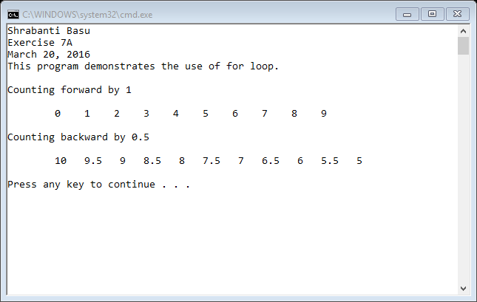

//Shrabanti basu

//Exercise 7A

//March 20, 2016

//This program demonstrates the use of for loop

#include <iostream>

using namespace std;

int main()

{

cout << "Shrabanti Basu\n";

cout << "Exercise 7A\n";

cout << "March 20, 2016\n";

cout << "This program demonstrates the use of for loop.\n\n";

cout << "Counting forward by 1\n\n";

cout << "\t";

//The for loop counts forward and prints integer values from 0 to 9

//with an increment of 1

for (int i = 0; i < 10; i++)

{

cout << i << " ";

}

cout << "\n\nCounting backward by 0.5\n\n";

cout << "\t";

//The for loop counts backward and prints double values from 10 to 5

//with a decrement of 0.5

for (double i = 10; i >=5; i -= 0.5)

{

cout << i << " ";

}

cout << endl << endl;

return 0;

}