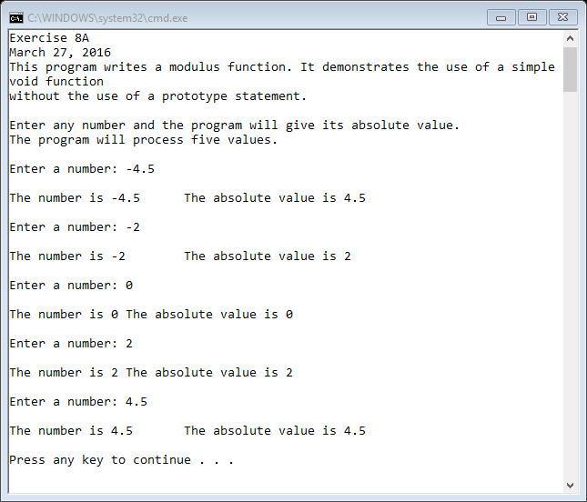

//Shrabanti Basu

//Exercise 8A

//March 27

//This program writes a modulus function without the use of prototype statement

#include <iostream>

using namespace std;

//Function definition

//The myModulus functions takes a double type variable as its argument and

//prints its absolute value on screen

void myModulus(double num)

{

//print the number and its absolute value

cout << "\nThe number is " << num << "\t";

cout << "The absolute value is " << (num >= 0 ? num : ((-1) \* num)) << endl << endl;

}

int main()

{

cout << "Shrabanti Basu\n";

cout << "Exercise 8A\n";

cout << "March 27, 2016\n";

cout << "This program writes a modulus function. It demonstrates the use of a simple void function\n"

<< "without the use of a prototype statement.\n\n";

cout << "Enter any number and the program will give its absolute value.\n";

cout << "The program will process five values.\n\n";

double number; //to store the user entered number

//the for loop let user enter numbers five times

for (int i = 0; i < 5; i++)

{

cout << "Enter a number: ";

cin >> number;

myModulus(number); //call the myModulus function

}

return 0;

}