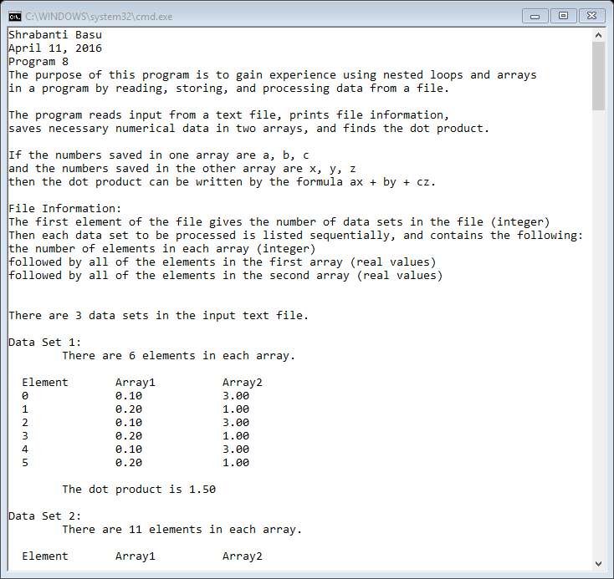

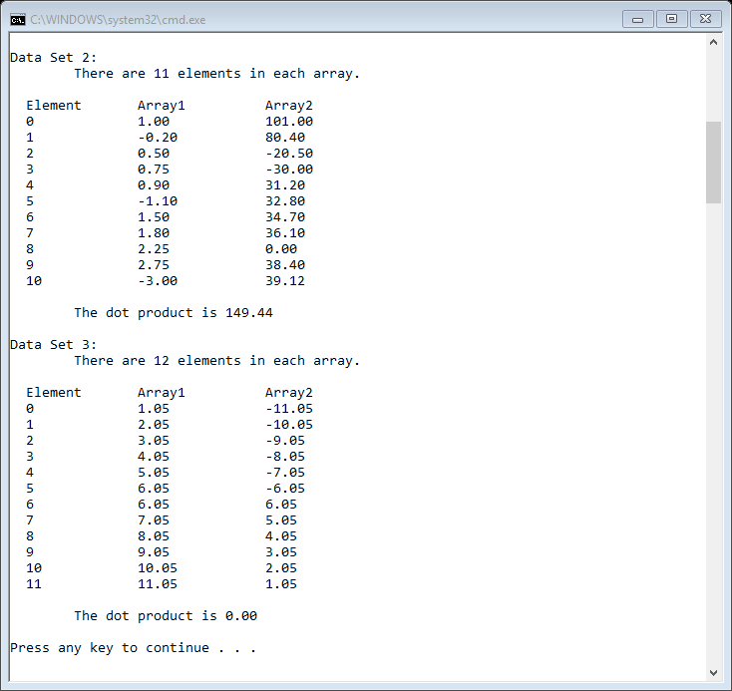

//Shrabanti Basu

//April 11, 2016

//Program 8

//The purpose of this program is to gain experience using nested loops and arrays in a program

//by reading, storing, and processing data from a file

#include <iostream>

#include <fstream>

#include <string>

#include <iomanip>

using namespace std;

int main()

{

cout << "Shrabanti Basu\n";

cout << "April 11, 2016\n";

cout << "Program 8\n";

cout << "The purpose of this program is to gain experience using nested loops and arrays\n"

<< "in a program by reading, storing, and processing data from a file.\n\n";

cout << "The program reads input from a text file, prints file information,\n"

<< "saves necessary numerical data in two arrays, and finds the dot product.\n\n";

cout << "If the numbers saved in one array are a, b, c\n"

<< "and the numbers saved in the other array are x, y, z\n"

<< "then the dot product can be written by the formula ax + by + cz.\n\n";

const int INPUT_LINES = 5; //number of lines of input which is 5 for this file

ifstream inputFile; //input file oject

inputFile.open("P8InputFIle.txt"); //open input file

string str; //to store string read from the file

int dataSets = 0; //to store number of datasets

int numElements = 0; //to store the number of elements in each array for a dataset

float array1[50], array2[50]; // arrays of float numbers with a maximum capacity of 50 elements

float total; //accumulator

cout << setprecision(2) << showpoint << fixed;

if (inputFile)

{

cout << "File Information: \n";

//read the first five lines from the file and print them to console

for (int line = 1; line <= INPUT_LINES; line++)

{

getline(inputFile, str);

cout << str << endl;

}

cout << endl << endl;

//read the number of datasets and print

inputFile >> dataSets;

cout << "There are " << dataSets << " data sets in the input text file.\n\n";

//the outer loop iterates for every data set

for (int counter = 1; counter <= dataSets; counter++)

{

total = 0.0; //initialize total to 0.0 at the beginning of each iteration

cout << "Data Set " << counter << ": " << endl;

//read the number of elements in each array

inputFile >> numElements;

cout << "\tThere are " << numElements << " elements in each array.\n\n";

//run the inner loop for the number of elements that will be saved in the array

//enter data in array1 and array2 using two separate loops

for (int i = 0; i < numElements; i++)

{

inputFile >> array1[i];

}

for (int i = 0; i < numElements; i++)

{

inputFile >> array2[i];

}

//get the elements for each array and multiply them

//accumulate the product in the total variable

cout << " Element \tArray1 \tArray2 " << endl;

for (int i = 0; i < numElements; i++)

{

cout << " " << i << "\t\t" << array1[i] << "\t\t" << array2[i] << endl;

total += array1[i] * array2[i];

}

//if the total is less than a certain fractional value then print 0

//this avoids printing negative zero, for very small fractional values

//with 2 decimal places

cout << endl;

cout << "\tThe dot product is " << (total < abs(0.001) ? 0 : total) << "\n\n";

}

}

//if input file did not open correctly, print error message

else

{

cout << "Error opening file.\n\n";

}

return 0;

}