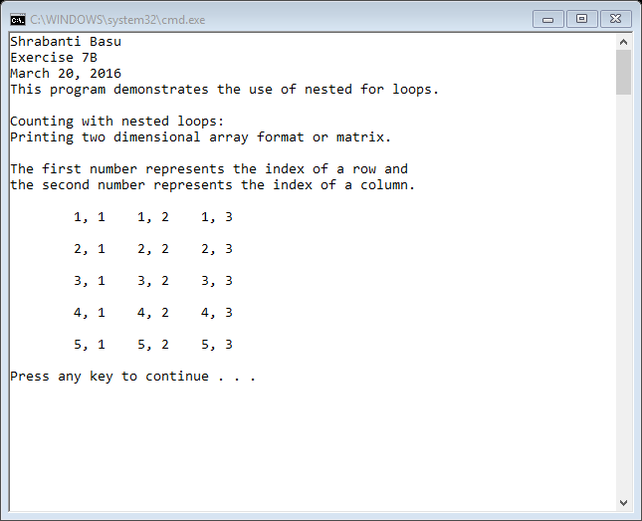

//Shrabanti basu

//Exercise 7B

//March 20, 2016

//This program demonstrates the use of for loops

#include <iostream>

using namespace std;

int main()

{

cout << "Shrabanti Basu\n";

cout << "Exercise 7B\n";

cout << "March 20, 2016\n";

cout << "This program demonstrates the use of nested for loops.\n\n";

cout << "Counting with nested loops:\n";

cout << "Printing two dimensional array format or matrix.\n\n";

cout << "The first number represents the index of a row and\n";

cout << "the second number represents the index of a column.\n\n";

//The counter i in the outer loop repesents the number of rows in the matrix (1 to 5).

//The counter j in the inner loop represents the number of columns in the matrix (1 to 3).

cout << "\t";

for (int i = 1; i <= 5; i++)

{

for (int j = 1; j <= 3; j++)

{

cout << i << ", " << j << "\t";

}

cout << endl << endl << "\t";

}

cout << "\r"; // to move cursor to the beginning of the line

return 0;

}