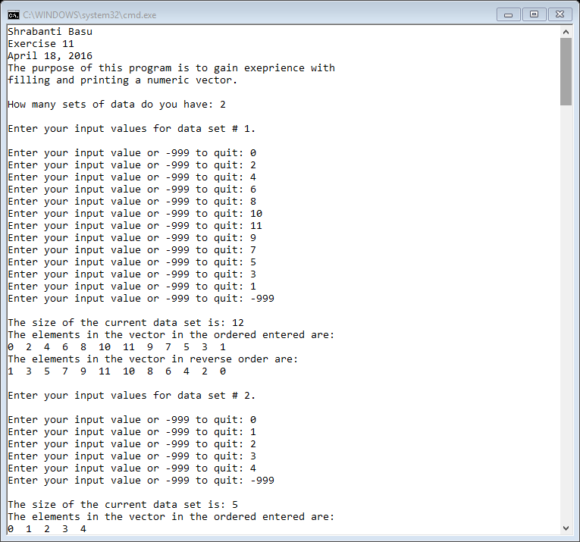

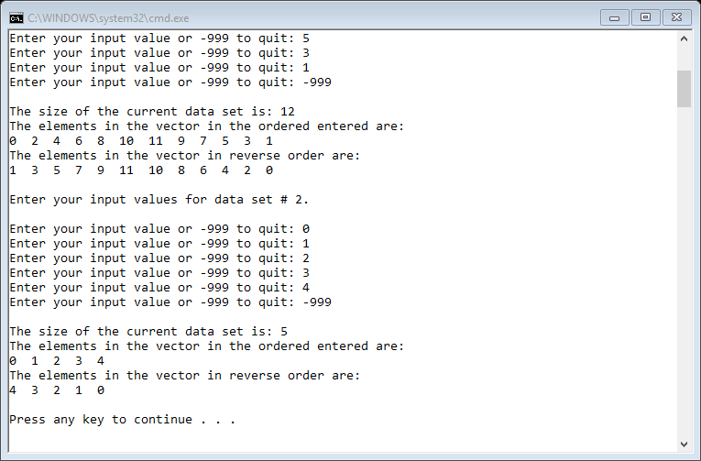

//Shrabanti Basu

//Exercise 11

//April 18, 2016

//The purpose of this program is to gain experience with filling and printing a numeric vector

#include <iostream>

#include <vector> //for the vector class

using namespace std;

//function prototypes

void printVectors(vector<int>);

void printInReverse(vector<int>);

int main()

{

cout << "Shrabanti Basu\n";

cout << "Exercise 11\n";

cout << "April 18, 2016\n";

cout << "The purpose of this program is to gain exeprience with\n"

<< "filling and printing a numeric vector.\n\n";

//declare a vector to hold integers

vector<int> numbers;

int nsets; //number of data sets the user has

int input; //to store user entered input

cout << "How many sets of data do you have: ";

cin >> nsets;

cout << endl;

for (int i = 1; i <= nsets; i++)

{

cout << "Enter your input values for data set # " << i << ".\n\n";

//get user input or -999 to quit

cout << "Enter your input value or -999 to quit: ";

cin >> input;

while (input != -999)

{

numbers.push_back(input);

cout << "Enter your input value or -999 to quit: ";

cin >> input;

}

//print the size of the vector

cout << "\nThe size of the current data set is: " << numbers.size() << endl;

//the call the printVectors function and the printInReverse function to print the elements of the vector

printVectors(numbers);

printInReverse(numbers);

cout << endl;

//clear the vector and make it ready for next data set

numbers.clear();

}

return 0;

}

//function definition

//the function takes take a vector parameter and prints its contents in the current order

void printVectors(vector<int> v)

{

cout << "The elements in the vector in the ordered entered are:\n";

for (int i = 0; i < v.size(); i++)

{

cout << v[i] << " ";

}

cout << endl;

}

//function definition

//the function takes take a vector parameter and prints its contents in reverse order

void printInReverse(vector<int> v)

{

cout << "The elements in the vector in reverse order are:\n";

for (int i = v.size(); i > 0; i--)

cout << v[i - 1] << " ";

cout << endl;

}