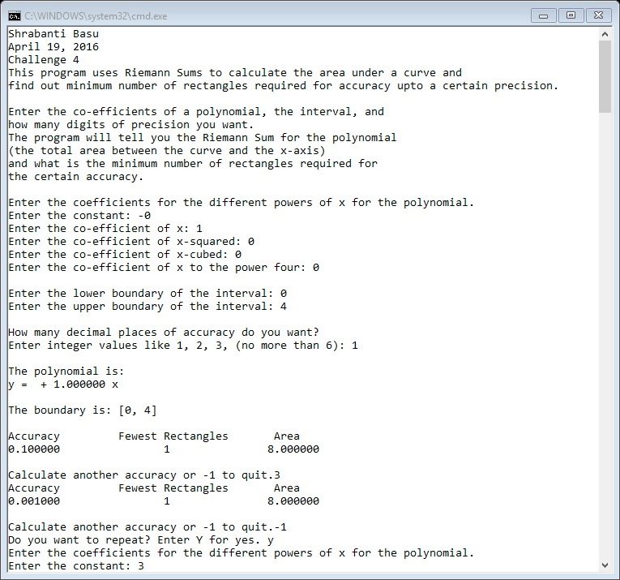

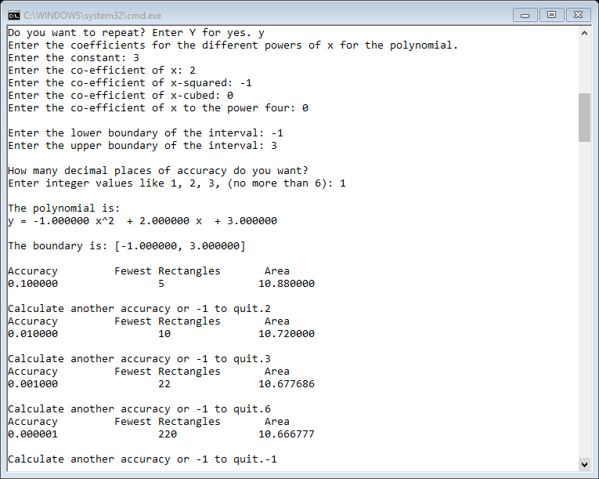

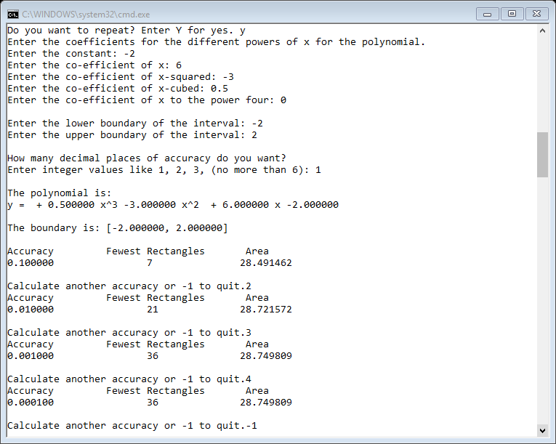

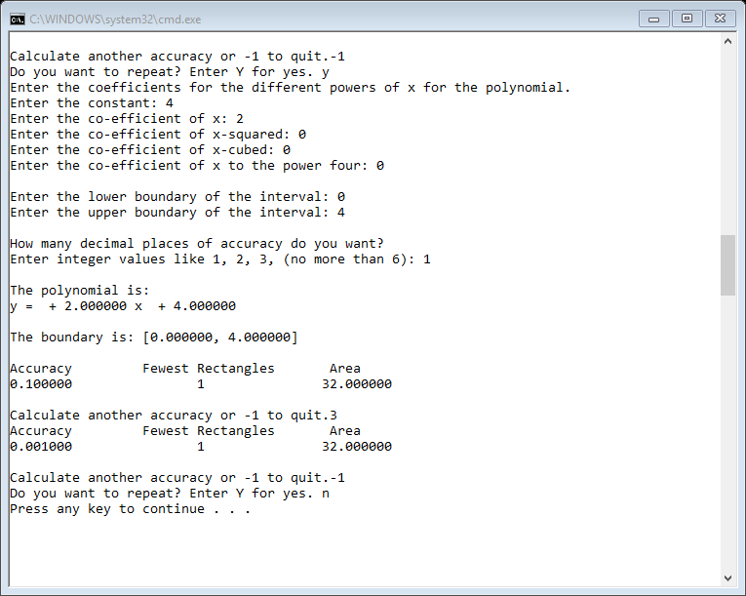

//Shrabanti Basu

//April 19, 2016

//Challenge 4

//This program uses Riemann Sums to calculate the area under a curve and

//find out minimum number of rectangles required for accuracy upto a certain precision.

#include <iostream>

#include <iomanip>

#include <cstdlib>

#include <cmath>

#include <string>

using namespace std;

//function prototype

double RiemannSum(double, double, double, double, double, double, double, int);

int main()

{

cout << "Shrabanti Basu\n";

cout << "April 19, 2016\n";

cout << "Challenge 4\n";

cout << "This program uses Riemann Sums to calculate the area under a curve and\n"

<< "find out minimum number of rectangles required for accuracy upto a certain precision.\n\n";

cout << "Enter the co-efficients of a polynomial, the interval, and \n"

<< "how many digits of precision you want.\n"

<< "The program will tell you the Riemann Sum for the polynomial\n"

<< "(the total area between the curve and the x-axis)\n"

<< "and what is the minimum number of rectangles required for\n"

<< "the certain accuracy.\n\n";

double a0 = 0, a1 = 0, a2 = 0, a3 = 0, a4 = 0; //define and initialize variables to store coefficients

double lowerInt = 0.0, upperInt = 0.0; //to store lower and upper points of the interval

char choice; //user choice

do

{

//get co-efficients for the polynomial from user

cout << "Enter the coefficients for the different powers of x for the polynomial.\n";

cout << "Enter the constant: ";

cin >> a0;

cout << "Enter the co-efficient of x: ";

cin >> a1;

cout << "Enter the co-efficient of x-squared: ";

cin >> a2;

cout << "Enter the co-efficient of x-cubed: ";

cin >> a3;

cout << "Enter the co-efficient of x to the power four: ";

cin >> a4;

//build the polynomial string from user entered values

string str = "y = ";

if (a4 > 0)

str += to_string(a4) + " x^4 ";

if (a4 < 0)

str += to_string(a3) + " x^4 ";

if (a3 > 0)

str += " + " + to_string(a3) + " x^3 ";

if (a3 < 0)

str += to_string(a3) + " x^3 ";

if (a2 > 0)

str += " + " + to_string(a2) + " x^2 ";

if (a2 < 0)

str += to_string(a2) + " x^2 ";

if (a1 > 0)

str += " + " + to_string(a1) + " x ";

if (a1 < 0)

str += to_string(a1) + " x ";

if (a0 > 0)

str += " + " + to_string(a0);

if (a0 < 0)

str += to_string(a0);

//get the boundaries for area calculation

cout << "\nEnter the lower boundary of the interval: ";

cin >> lowerInt;

cout << "Enter the upper boundary of the interval: ";

cin >> upperInt;

//declare variables to be used in the do-while loop for calling the Riemann Sum function

int numRect = 0; //to store number of rectangles inititalized to zero

int userInput; //to store how many places of accuracy the user wants for Riemann Sum calculation

double diff; //to store the absolute difference between two areas calculated with N and (N + 1) rectangles

double accuracy; //to store accuracy

double area1 = 0.0, area2 = 0.0; //to hold areas with N and N+1 rectangles

//a constant variable set to 1.

//This will be used divided by user input and used for accuracy calculation

const double VALUE = 1.0;

//get user input for accuracy

cout << "\nHow many decimal places of accuracy do you want?\n"

<< "Enter integer values like 1, 2, 3, (no more than 6): ";

cin >> userInput;

//print the polynomial and the boundaries

cout << "\nThe polynomial is:\n";

cout << str;

cout << endl;

cout << "\nThe boundary is: [" << lowerInt << ", " << upperInt << "]\n\n";

do {

accuracy = VALUE / pow(10.0, userInput);

//show decimal points for 2, 3, 4, etc digits as specified by the user

cout << setprecision(6) << fixed << showpoint;

//Call the Riemann Sum function and calculate areas initially for 1 and 2 rectangles

//If the difference of the two areas does not have requierd accuracy, then increase the number of rectangles

//and call the Riemann sum until desired accuracy is reached.

do

{

numRect++;

area1 = RiemannSum(a0, a1, a2, a3, a4, lowerInt, upperInt, numRect);

numRect++;

area2 = RiemannSum(a0, a1, a2, a3, a4, lowerInt, upperInt, numRect);

diff = abs(area1 - area2);

numRect--; //decrement number of rectangle so it goes back to the proper consecutive rectangle when the loop iterates

} while (diff >= accuracy);

cout << "Accuracy \t Fewest Rectangles \t Area \n";

cout << accuracy << "\t\t" << numRect << "\t\t" << area1 << endl;

cout << endl;

cout << "Calculate another accuracy or -1 to quit.";

cin >> userInput;

numRect = 0; //to set to zero for another accuracy calculation

} while (userInput > 0);

cout << "Do you want to repeat? Enter Y for yes. ";

cin >> choice;

} while (choice == 'Y' || choice == 'y');

return 0;

}

//RiemannSum() Function Definition

//The function takes coefficients (p0 to p4), for the polynomial, lower and upper limits(l, u)

//and the number of rectangles to be used to calculate the Riemann Sum.

//p0 to p4, l, u are all entered by the user.

//For this program n is programmer defined inside the main function.

//The midpoint of each rectangle (x coordinate) and corresponding y coordinate are derived.

//The sums of each rectangle is added to an accumulator to calculate the total area.

//This total area is returned to the calling function.

double RiemannSum(double p0, double p1, double p2, double p3, double p4, double l, double u, int n)

{

double deltax = 0.0; //total interval divided by number of rectangles (width of one rectangle)

double x = 0.0; //x coordinate of midpoints

double y = 0.0; //to hold y value associated with each x

double area = 0.0; //to hold area of a rectangle

double total = 0.0; //total area of all the rectangles (accumulator)

//Calculate the area with n rectangles

deltax = (u - l) / n;

//set the inital value of x outside the range so it starts

//at the proper point for the first iteration of the innermost loop

x = l - (deltax / 2);

//calculate the area for n rectangles and add them

for (int i = 1; i <= n; i++)

{

x = x + deltax;

y = p0 + (p1 * x) + p2 * pow(x, 2.0) + p3 * pow(x, 3.0) + p4 * pow(x, 4.0);

area = abs(deltax * y);

total += area;

}

return total;

}