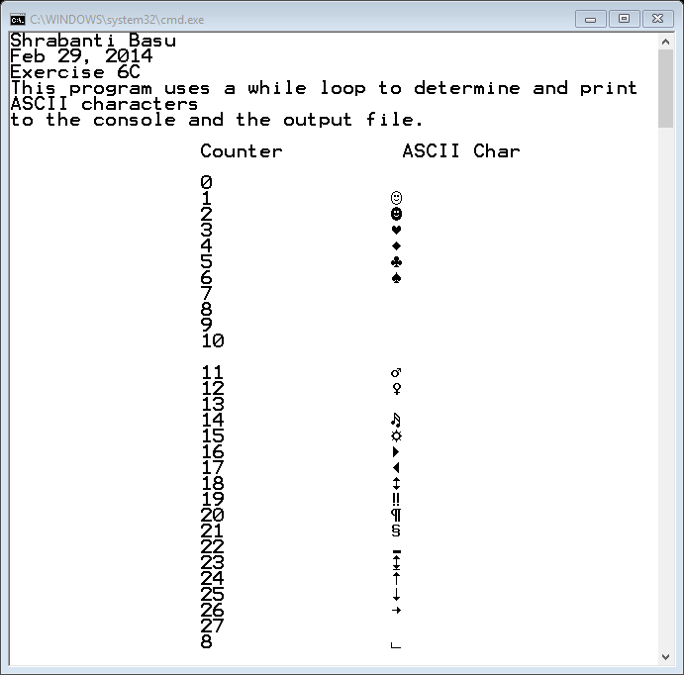

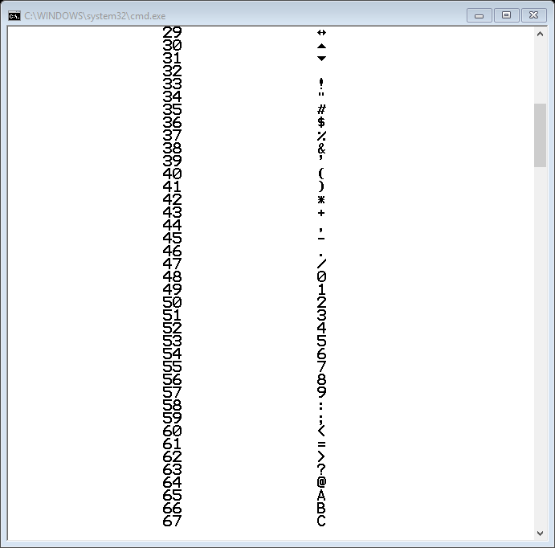

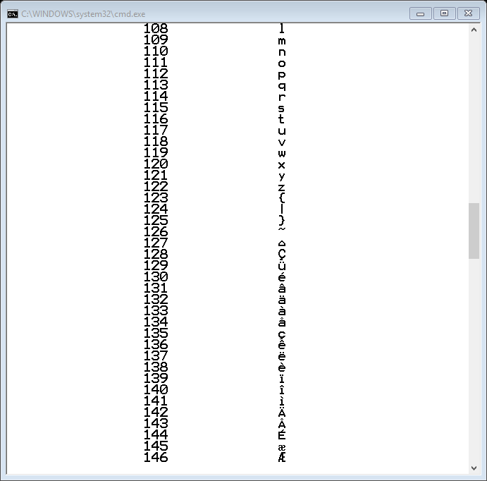

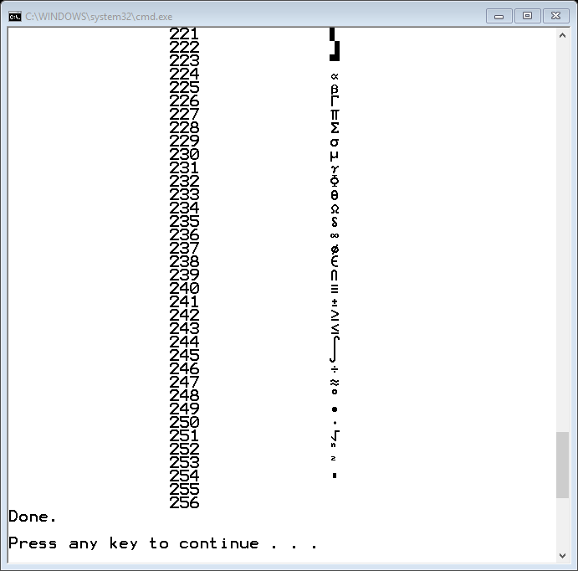

File Output

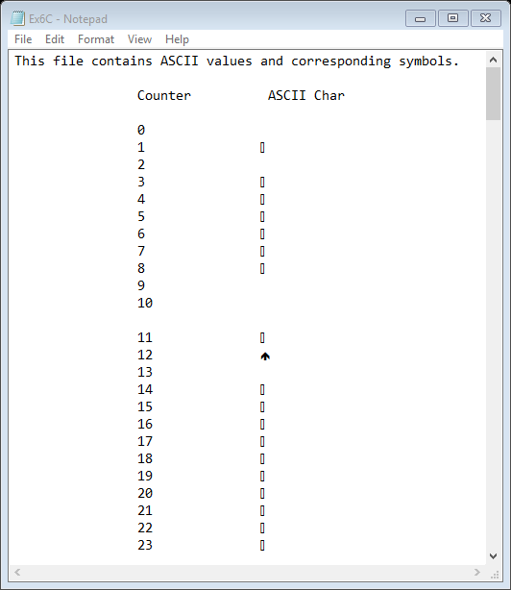

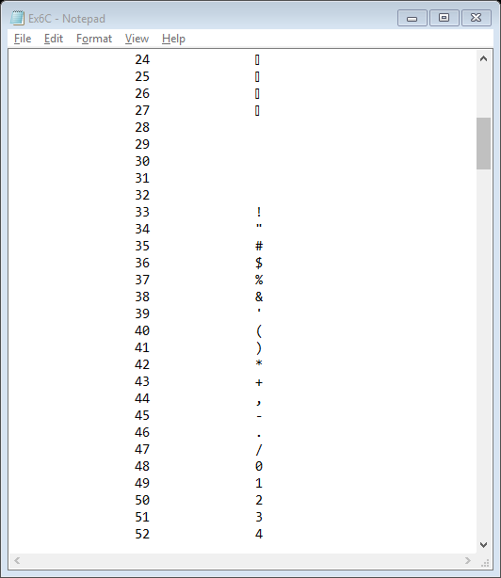

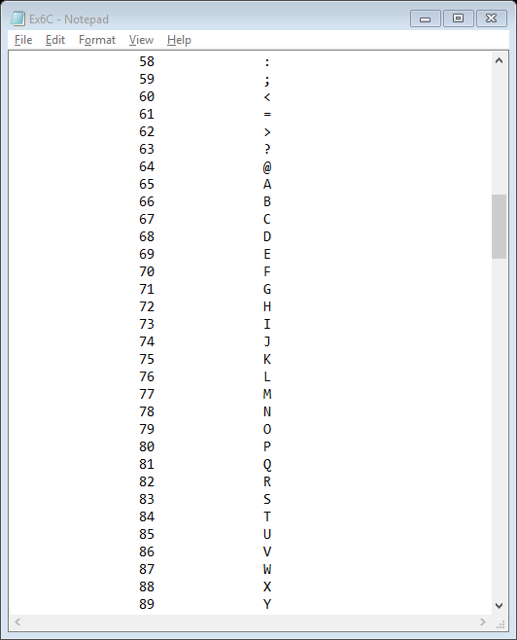

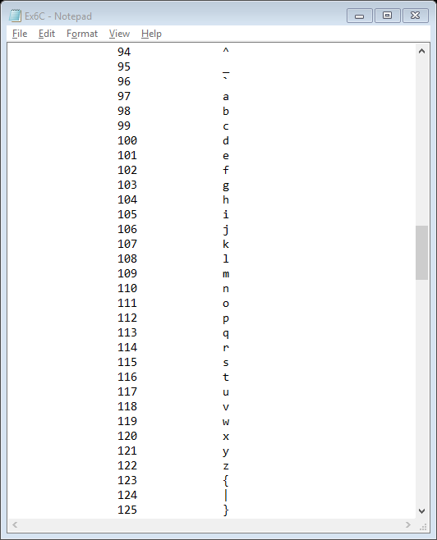

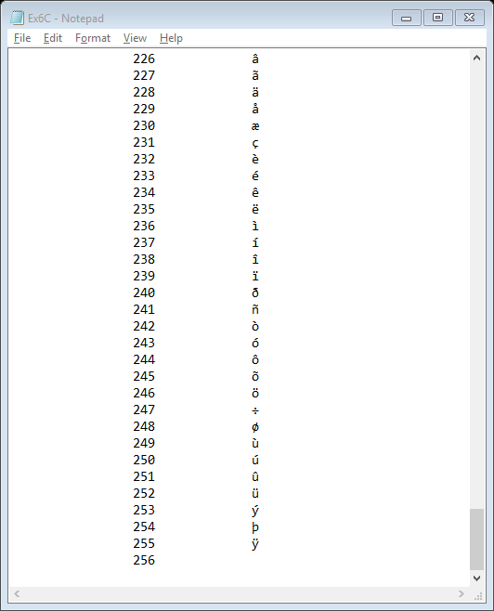

//Shrabanti Basu

//Feb 29, 2014

//Exercise 6C

//This program uses a while loop to determine and print ASCII characters

#include <iostream>

#include <fstream> //for file object

using namespace std;

int main()

{

cout << "Shrabanti Basu\n";

cout << "Feb 29, 2014\n";

cout << "Exercise 6C\n";

cout << "This program uses a while loop to determine and print ASCII characters\n"

<< "to the console and the output file.\n\n";

int number = 0; //counter set to zero

//create and open output file

ofstream outputFile;

outputFile.open("Ex6C.txt");

//check for file error to display or write appropriate message

if (outputFile.fail())

{

cout << "File Error. Cannot write to file 'Ex6C.txt'.\n";

}

else

{

//write to file

outputFile << "This file contains ASCII values and corresponding symbols.\n\n";

outputFile << "\t\tCounter\t\t ASCII Char\n\n";

}

cout << "\t\tCounter\t\t ASCII Char\n\n"; //print to console

//write characters corresponding to ASCII values from 0 to 256 on console and in output file

//the integers are cast to char type to print ASCII symbols

while (number <= 256)

{

cout << "\t\t" << number << "\t\t" << static_cast<char>(number) << endl;

if (outputFile) //check here again if file opened properly

{

outputFile << "\t\t" << number << "\t\t" << static_cast<char>(number) << endl;

}

number++; //increment counter

}

outputFile.close(); //close file

cout << "Done.\n\n";

return 0;

}