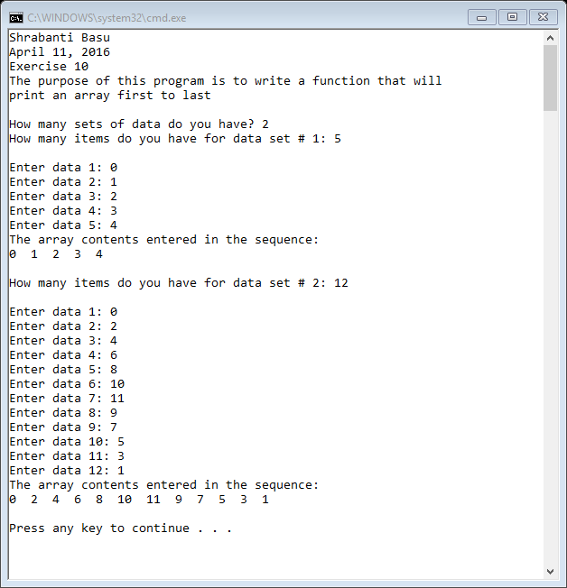

//Shrabanti Basu

//April 11, 2016

//Exercise 10

//The purpose of this program is to write a function that will

//print an array first to last

#include <iostream>

using namespace std;

//function prototype

void printArray(int[], int);

int main()

{

cout << "Shrabanti Basu\n";

cout << "April 11, 2016\n";

cout << "Exercise 10\n";

cout << "The purpose of this program is to write a function that will\n"

<< "print an array first to last\n\n";

//create array that can hold 50 elements

int myNumbers[50];

int nsets; //number of iterations for the loop

int ncount; //number of items to store in the array for each iteration of the outer loop

cout << "How many sets of data do you have? ";

cin >> nsets;

for (int i = 1; i <= nsets; i++)

{

//for current iteration how many items do you have

cout << "How many items do you have for data set # " << i << ": ";

cin >> ncount;

cout << endl;

for (int j = 0; j < ncount; j++)

{

cout << "Enter data " << j + 1 << ": ";

cin >> myNumbers[j];

}

//call the printArray function

printArray(myNumbers, ncount);

}

return 0;

}

//definition of printArray

//the printArray function takes an integer array and an

//integer as parameters, and prints the contents

//saved in the array

void printArray(int arr[], int num)

{

cout << "The array contents entered in the sequence: \n";

for (int i = 0; i < num; i++)

{

cout << arr[i] << " ";

}

cout << endl << endl;

}