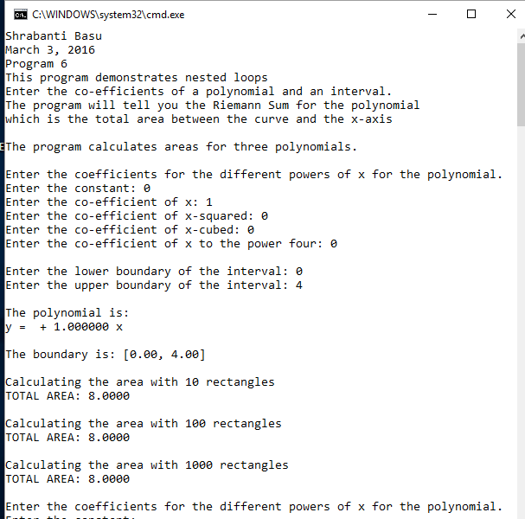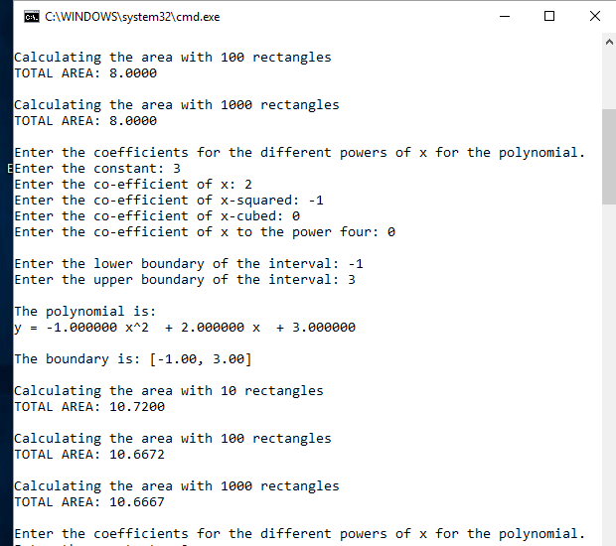

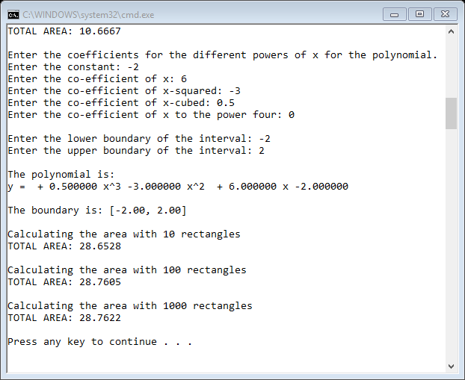

//Shrabanti Basu

//March 3, 2016

//Program 6

//This program demonstrates nested loops.

//It calculates the Riemann Sum from the co-efficients of a polynomial and range entered by the user.

//It calculates the area with 10, 100 and 1000 rectangles for each iteration of the outermost loop.

#include <iostream>

#include <iomanip>

#include <cstdlib>

#include <cmath>

#include <string>

using namespace std;

int main()

{

cout << "Shrabanti Basu\n";

cout << "March 3, 2016\n";

cout << "Program 6\n";

cout << "This program demonstrates nested loops\n";

cout << "Enter the co-efficients of a polynomial and an interval.\n"

<< "The program will tell you the Riemann Sum for the polynomial\n"

<< "which is the total area between the curve and the x-axis\n\n";

cout << "The program calculates areas for three polynomials.\n\n";

double a0 = 0, a1 = 0, a2 = 0, a3 = 0, a4 = 0; //define and initialize variables to store coefficients

double lowerInt = 0.0, upperInt = 0.0; //to store lower and upper points of the interval

double deltax = 0.0; //total interval divided by number of rectangles (width of one rectangle)

double x = 0.0; //x coordinate of midpoints

double y = 0.0; //to hold y value associated with each x

double area = 0.0; //to hold area of a rectangle

double total = 0.0; //total area of all the rectangles (accumulator)

//run the outermost loop three times

for (int i = 1; i <= 3; i++)

{

//get co-efficients for the polynomial

cout << "Enter the coefficients for the different powers of x for the polynomial.\n";

cout << "Enter the constant: ";

cin >> a0;

cout << "Enter the co-efficient of x: ";

cin >> a1;

cout << "Enter the co-efficient of x-squared: ";

cin >> a2;

cout << "Enter the co-efficient of x-cubed: ";

cin >> a3;

cout << "Enter the co-efficient of x to the power four: ";

cin >> a4;

//build the polynomial string from user entered values

string str = "y = ";

if (a4 > 0)

str += to_string(a4) + " x^4 ";

if (a4 < 0)

str += to_string(a3) + " x^4 ";

if (a3 > 0)

str += " + " + to_string(a3) + " x^3 ";

if (a3 < 0)

str += to_string(a3) + " x^3 ";

if (a2 > 0)

str += " + " + to_string(a2) + " x^2 ";

if (a2 < 0)

str += to_string(a2) + " x^2 ";

if (a1 > 0)

str += " + " + to_string(a1) + " x ";

if (a1 < 0)

str += to_string(a1) + " x ";

if (a0 > 0)

str += " + " + to_string(a0);

if (a0 < 0)

str += to_string(a0);

//get the boundaries for area calculation

cout << "\nEnter the lower boundary of the interval: ";

cin >> lowerInt;

cout << "Enter the upper boundary of the interval: ";

cin >> upperInt;

//print the polynomial and the boundaries

cout << "\nThe polynomial is:\n";

cout << str;

cout << endl;

cout << setprecision(2) << fixed << showpoint; //formatting to print the polynomial

cout << "\nThe boundary is: [" << lowerInt << ", " << upperInt << "]\n";

//the inner loop decides the number of rectangles to be 10, 100, 1000

//for the first iteration the number of rectangles is 10 which

//is incremented in each iteration of the outer loop by 10 times

for (int n = 10; n <= 1000; n *= 10)

{

//initialize all values to zero for every iteration of this loop

x = 0.0, y = 0.0, area = 0.0, deltax = 0.0, total = 0.0;

//formatting to print the area

cout << setprecision(4) << fixed << showpoint;

//Calculate the area with n rectangles

cout << "\nCalculating the area with " << n << " rectangles\n";

deltax = (upperInt - lowerInt) / n;

//set the inital value of x outside the range so it starts

//at the proper point for the first iteration of the innermost loop

x = lowerInt - (deltax / 2);

//the innermost loop divides the area in n (10, 100, 1000) rectangles

for (int i = 1; i <= n; i++)

{

x = x + deltax;

y = a0 + (a1 * x) + a2 * pow(x, 2.0) + a3 * pow(x, 3.0) + a4 * pow(x, 4.0);

area = abs(deltax * y);

total += area;

}

//print total area:

cout << "TOTAL AREA: " << total << endl;

}

cout << endl;

}

return 0;

}