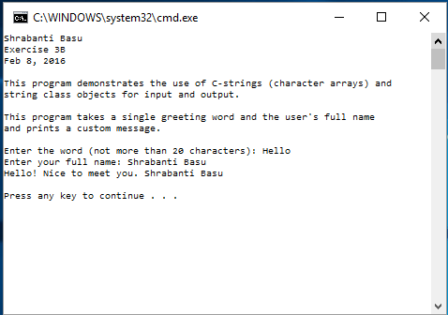

//Shrabanti Basu

//Exercise 3B

//Feb 8, 2016

/\*

This program demonstrates the use of C-strings (character arrays) and

string class objects for input and output.

\*/

#include <iostream>

#include <string> //for the string class

using namespace std;

int main()

{

cout << "Shrabanti Basu\n";

cout << "Exercise 3B\n";

cout << "Feb 8, 2016\n\n";

cout << "This program demonstrates the use of C-strings (character arrays) and\n";

cout << "string class objects for input and output.\n\n";

//Declare a char array that will hold 20 characters of user input

//The one extra character is for the null terminator

char word[21];

//Declare a string object to store a string

string phrase;

//Loop control variable to iterate through the values of the char array.

int count = 0;

cout << "This program takes a single greeting word and the user's full name\n";

cout << "and prints a custom message.\n\n";

//Prompt the user to enter a single word

//that will be stored in the word array.

cout << "Enter the word (not more than 20 characters): ";

cin.getline(word, 21);

//Prompt the user to enter the full name which will be

//a phrase and store it in the string variable.

cout << "Enter your full name: ";

getline(cin, phrase);

//Print a custom message to the user

while (word[count] != '\0') //iterate through the char array

{

cout << word[count];

count++;

}

cout << "! Nice to meet you. "; //print custom message

cout << phrase << endl << endl; //print name

return 0;

}