Good Data.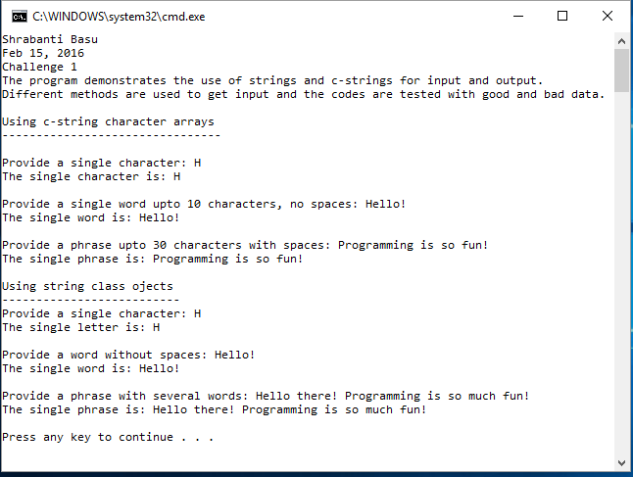

Bad Data

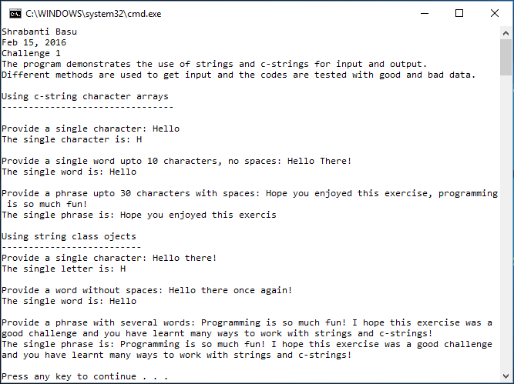

//Shrabanti Basu

//Feb 22 2016

//Challenge 1

//The program demonstrates the use of strings and c-strings for input and output

//and verifies code using good and bad data

#include <iostream>

#include <string>

using namespace std;

int main()

{

cout << "Shrabanti Basu\n";

cout << "Feb 15, 2016\n";

cout << "Challenge 1\n";

cout << "The program demonstrates the use of strings and c-strings for input and output.\n";

cout << "Different methods are used to get input and the codes are tested with good and bad data.\n\n";

//declare size of character arrays for words and phrases

const int WORD_SIZE = 10;

const int PHRASE_SIZE = 30;

//declare char variable and char arrays to hold words and phrases

char letter;

char word[WORD_SIZE];

char phrase[PHRASE_SIZE];

//declare string variables to hold characters, words, phrases

string letterInput;

string wordInput;

string phraseInput;

cout << "Using c-string character arrays\n";

cout << "--------------------------------\n\n";

//the following codes use c-strings

//get a single character and clear buffer

cout << "Provide a single character: ";

cin >> letter;

cin.ignore(20, '\n');

cout << "The single character is: " << letter << endl << endl;

//get a single word and clear buffer

cout << "Provide a single word upto 10 characters, no spaces: ";

cin >> word;

cin.ignore(20, '\n');

cout << "The single word is: " << word << endl << endl;

//get a single phrase upto 30 characters and clear buffer

cout << "Provide a phrase upto 30 characters with spaces: ";

cin.get(phrase, PHRASE_SIZE, '\n');

cin.ignore(50, '\n');

cout << "The single phrase is: " << phrase << endl << endl;

cout << "Using string class ojects\n";

cout << "--------------------------\n";

//the following codes use string class

//get a single character using a string

cout << "Provide a single character: ";

cin >> letterInput; //get the first word of the string string

cin.ignore(30, '\n'); //clear buffer

cout << "The single letter is: " << letterInput.at(0) << endl << endl; //print the first character of the string

//get a single word and clear buffer

cout << "Provide a word without spaces: ";

cin >> wordInput;

cout << "The single word is: " << wordInput << endl << endl;

cin.ignore(30, '\n');

//get the entire phrase

cout << "Provide a phrase with several words: ";

getline(cin, phraseInput);

cout << "The single phrase is: " << phraseInput << endl << endl;

return 0;

}