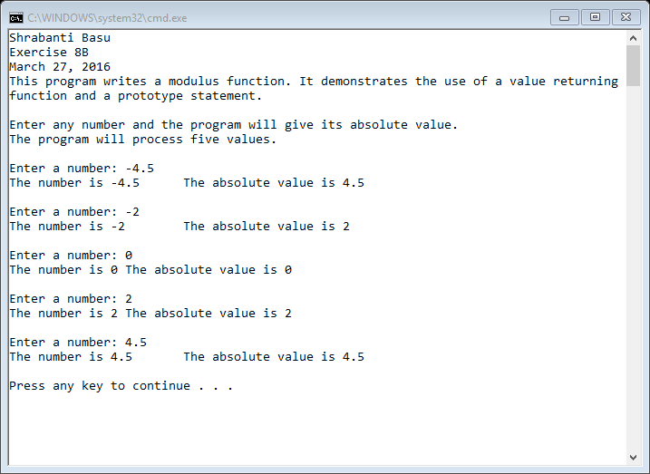

//Shrabanti Basu

//Exercise 8B

//March 27, 2016

//This program writes a modulus function.

//It also demonstrates a prototype statement

//and a value returning function.

#include <iostream>

using namespace std;

//Function prototype

double myModulus(double);

int main()

{

cout << "Shrabanti Basu\n";

cout << "Exercise 8B\n";

cout << "March 27, 2016\n";

cout << "This program writes a modulus function. It demonstrates the use of a value returning\n"

<< "function and a prototype statement.\n\n";

cout << "Enter any number and the program will give its absolute value.\n";

cout << "The program will process five values.\n\n";

double number; //to store the user entered number

double absValue; //to store the absolute value of the number

//the for loop let user enter numbers five times

for (int i = 0; i < 5; i++)

{

cout << "Enter a number: ";

cin >> number;

//call the myModulus function and store its returning value in the absValue variable

absValue = myModulus(number);

//print the number and the absolute value

cout << "The number is " << number << "\t";

cout << "The absolute value is " << absValue << "\n\n";

}

return 0;

}

//myModulus function definition

//The myModulus functions takes a double type variable as its argument and

//returns its absolute value to the calling function

double myModulus(double num)

{

double modValue; //declare a local variable to store the absolute value

//print the number and its absolute value

modValue = num >= 0 ? num : (-1) \* num;

return modValue;

}