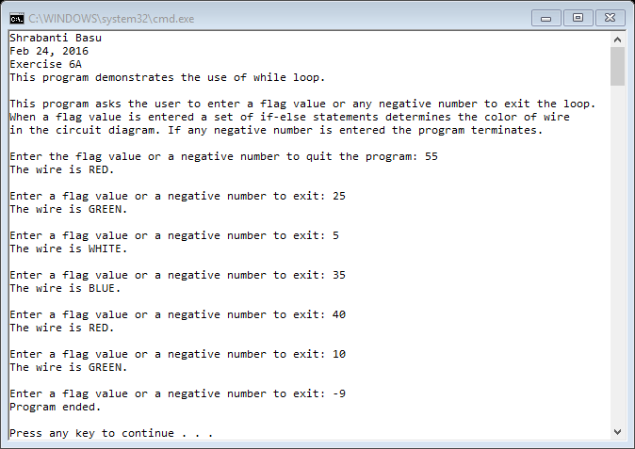

//Shrabanti Basu

//Feb 24, 2016

//Exercise 6A

//This program demonstrates the use of while loop.

#include <iostream>

using namespace std;

int main()

{

cout << "Shrabanti Basu\n";

cout << "Feb 24, 2016\n";

cout << "Exercise 6A\n";

cout << "This program demonstrates the use of while loop.\n\n";

cout << "This program asks the user to enter a flag value or any negative number to exit the loop.\n"

<< "When a flag value is entered a set of if-else statements determines the color of wire\n"

<< "in the circuit diagram. If any negative number is entered the program terminates.\n\n";

int flagValue;

cout << "Enter the flag value or a negative number to quit the program: ";

cin >> flagValue;

while (flagValue >= 0)

{

if (flagValue < 10)

cout << "The wire is WHITE.\n\n";

else if (flagValue < 30)

cout << "The wire is GREEN.\n\n";

else if (flagValue < 40)

cout << "The wire is BLUE.\n\n";

else

cout << "The wire is RED.\n\n";

//Prompt the user to enter another input

cout << "Enter a flag value or a negative number to exit: ";

cin >> flagValue;

}

cout << "Program ended.\n\n";

return 0;

}