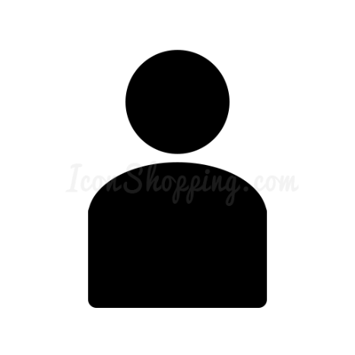**Cordova-project 2APPAI – 2WT - 3IoT**

**Brief description of the app**

Describe briefly (approximately  10 lines) the project you are going to develop.

**Screenshots**

A screen capture of each tab in your app

**Used Cordova plug-ins**

Describe which plug-ins you use and why you need them.

**Infopage about the app**

URL where you can download the app (apk-file).

**Source code**

Attach the source code of each document (HTML, CSS, own JS, ...).