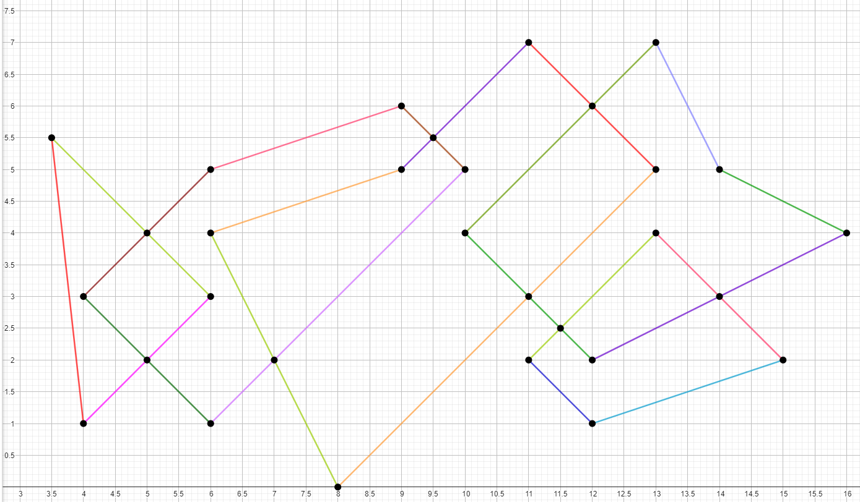Тест 1. Пересечения в концевых точках, в середине отрезка, концевая точка лежит на середине отрезка

Отрезки: [(3.5, 5.5), (4, 1)], [(3.5, 5.5), (6, 3)], [(4, 3), (6, 1)],[(6, 1), (10, 5)], [(4, 3), (6, 5)], [(4, 1), (6, 3)], [(6, 5), (9, 6)], [(9, 6), (10, 5)], [(6, 4), (9, 5)], [(6, 4), (8, 0)], [(9, 5), (11, 7)], [(8, 0), (13, 5)], [(10, 4), (13, 7)], [(11, 7), (13, 5)], [(10, 4), (12, 2)], [(11, 2), (13, 4)], [(11, 2), (12, 1)], [(12, 1), (15, 2)], [(12, 2), (16, 4)], [(13, 4), (15, 2)], [(13, 7), (14, 5)], [(14, 5), (16, 4)]

Точки пересечения: (3.5, 5.5), (4, 3), (4, 1), (5, 4), (5, 2), (6, 5), (6, 4), (6, 3), (6, 1), (7, 2), (8, 0), (9, 6), (9, 5), (9.5, 5.5) (10, 5), (10, 4), (11, 7), (11, 3), (11, 2), (11.5, 2.5), (12, 6), (12, 2), (12, 1), (13, 7), (13, 4), (14, 5), (14, 3), (15, 2), (16, 4)

Тест 2. Пересечение нескольких отрезков в одной точке

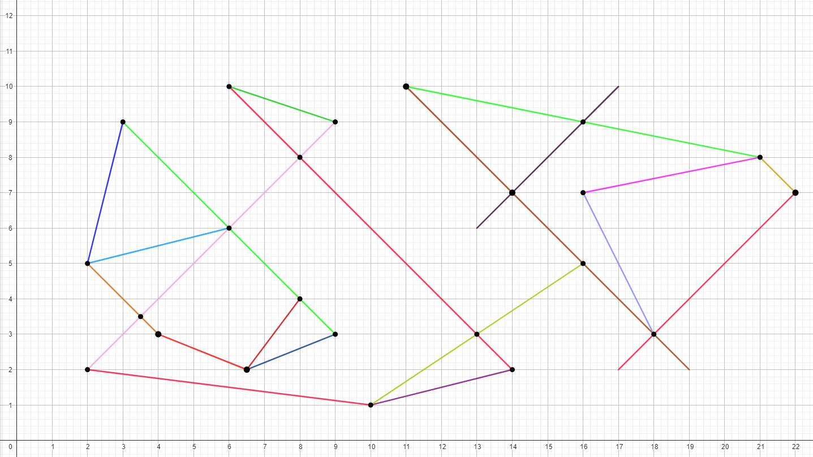

Отрезки: [(2, 2), (9, 9)], [(3, 9), (9, 3)], [(2, 5), (6, 6)], [(6, 10), (14, 2)], [(6.5, 2), (8, 4)], [(6.5, 2), (9, 3)], [(2, 5), (3, 9)], [(2, 2), (10, 1)], [(10, 1), (14, 2)], [(6, 10), (9, 9)], [(10, 1), (16, 5)], [(11, 10), (19, 2)], [(13, 6), (17, 10)], [(16, 7), (18, 3)], [(11, 10), (21, 8)], [(16, 7), (21, 8)], [(17, 2), (22, 7)], [(21, 8), (22, 7)], [(2, 5), (4, 3)], [(4, 3), (6.5, 2)]

Точки пересечения: (2, 2), (2, 5), (3, 9), (3.5, 3.5), (4, 3), (6, 6), (6, 10), (6.5, 2), (8, 8), (8, 4), (9, 9), (9, 3), (10, 1), (11, 10), (13, 3), (14, 7), (14, 2), (16, 9), (16, 7), (16, 5), (18, 3), (21, 8), (22, 7)

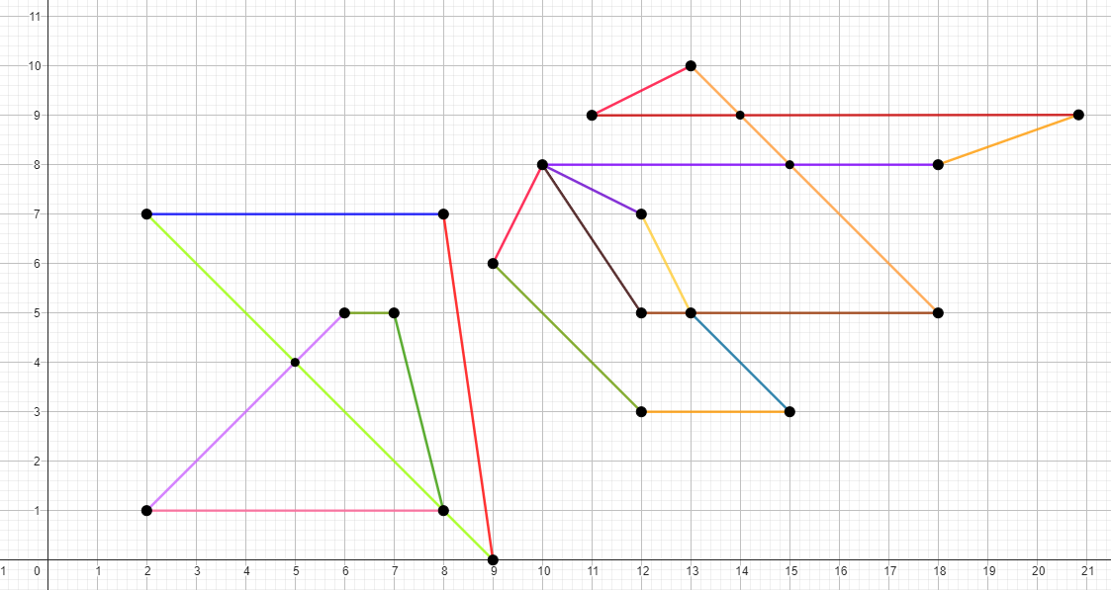Тест 3. Пересечения с горизонтальными линиями

Отрезки: [(2, 1), (6, 5)], [(6, 5), (7, 5)], [(7, 5), (8, 1)], [(2, 1), (8, 1)], [(2, 7), (9, 0)], [(2, 7), (8, 7)], [(8, 7), (9, 0)], [(9, 6), (10, 8)], [(10, 8), (12, 7)], [(12, 7), (13, 5)], [(13, 5), (15, 3)], [(12, 3), (15, 3)], [(9, 6), (12, 3)], [(12, 5), (18, 5)], [(10, 8), (18, 8)], [(13, 10), (18, 5)], [(11, 9), (21, 9)], [(11, 9), (13, 10)], [(18, 8), (21, 9)], [(10, 8), (12, 5)]

Точки пересечения: (2, 7) (2, 1), (5, 4), (6, 5), (7, 5), (8, 1), (8, 7), (9, 0), (9, 6), (10, 8), (11, 9), (12, 7), (12, 5), (12, 3), (13, 10), (13, 5), (14, 9), (15, 8), (15, 3), (18, 8), (18, 5), (21, 9)

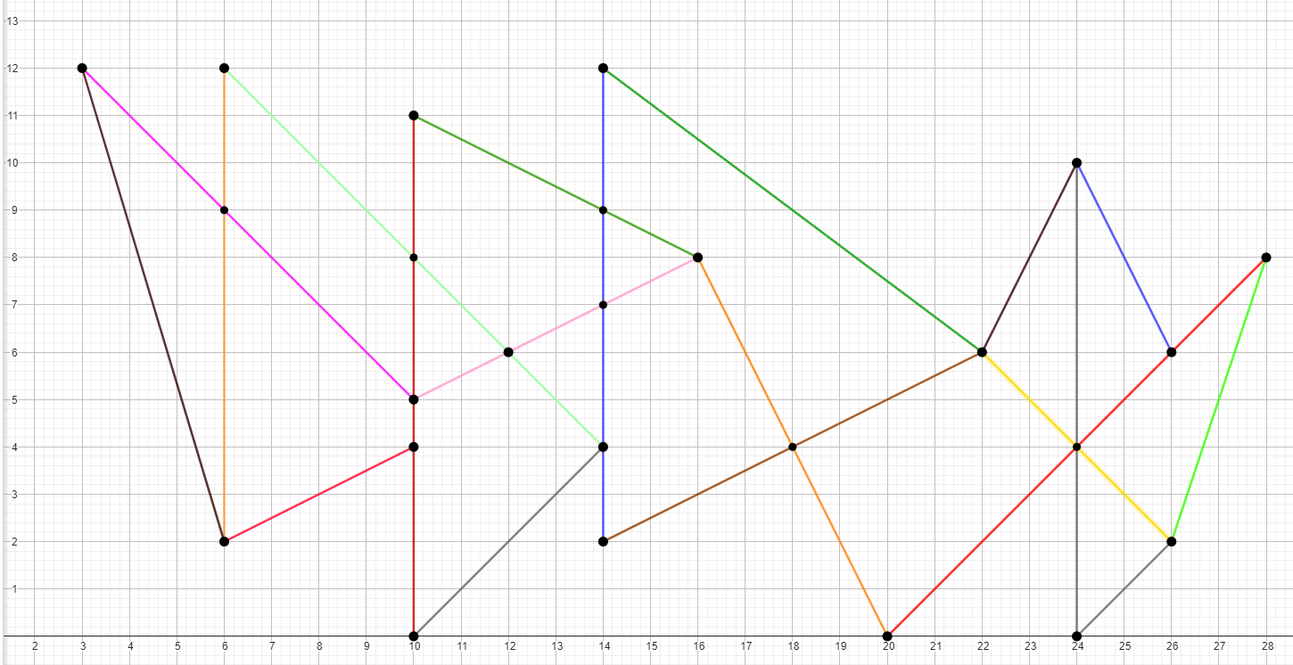Тест 4. Пересечения с вертикальными линиями

Отрезки: [(3, 12), (6, 2)], [(3, 12), (10, 5)], [(6, 2), (10, 4)], [(6, 12), (6, 2)], [(6, 12), (14, 4)], [(10, 11), (10, 0)], [(10, 11), (16, 8)], [(10, 5), (16, 8)], [(10, 0), (14, 4)], [(14, 12), (14, 2)], [(14, 12), (22,6)], [(16, 8), (20, 0)], [(14, 2), (22, 6)], [(22, 6), (24, 10)], [(22, 6), (26, 2)], [(20, 0), (28, 8)], [(24, 10), (24, 0)], [(24, 10), (26, 6)], [(24, 0), (26, 2)], [(26, 2), (28, 8)]

Точки пересечения: (3, 12), (6, 2), (6, 9), (6, 12), (10, 11), (10, 5), (10, 4), (10, 0), (10, 8), (12, 6), (14, 12), (14, 9), (14, 7), (14, 4), (14, 2), (16, 8), (18, 4), (20, 0), (22, 6), (24, 10), (24, 4), (24, 0), (26, 6), (26, 2), (28, 8)

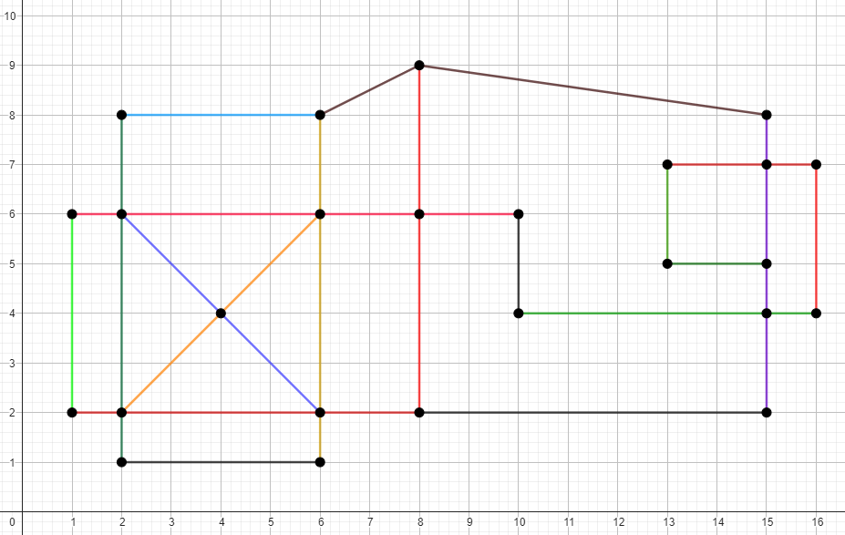Тест 5. Ортогональный случай

Отрезки: [(1, 6), (1, 2)], [(1, 6), (10, 6)], [(1, 2), (8, 2)], [(2,8), (2, 1)], [(6, 8), (6, 1)], [(2, 8), (6, 8)], [(2, 1), (6, 1)], [(8, 9), (8, 2)], [(6, 8), (8, 9)], [(10, 4), (16, 4)], [(10, 6), (10, 4)], [(15, 8), (15, 2)], [(8, 2), (15, 2)], [(8, 9), (15, 8)], [(16, 7), (16, 4)], [(13, 7), (16, 7)], [(13, 7), (13, 5)], [(13, 5), (15, 5)], [(2, 6), (6, 2)], [(2, 2), (6, 6)]

Точки пересечения: (1, 6), (1, 2), (2, 8), (2, 6), (2, 2), (2, 1), (4, 4), (6, 8), (6, 6), (6, 2), (6, 1), (8, 9), (8, 6), (8, 2), (10, 6), (10, 4), (13, 7), (13, 5), (15, 8), (15, 7), (15, 5), (15, 4), (15, 2), (16, 7), (16, 4)

Тест 6. Ортогональный случай

Отрезки: [(1, 6), (1, 2)], [(2, 10), (2, 2)], [(3, 8), (3, 4)], [(5, 11), (5, 5)], [(8, 8), (8, 5)], [(8, 5), (8, 3)], [(9, 10), (9, 4)], [(11, 5), (11, 3)], [(12, 11), (12, 6)], [(1, 2), (2, 2)], [(8, 3), (11, 3)], [(3, 4), (9, 4)], [(5, 5), (8, 5)], [(8, 5), (11, 5)], [(1, 6), (12, 6)], [(3, 8), (8, 8)], [(2, 10), (9, 10)], [(5, 11), (12, 11)]

Точки пересечения: (1, 6), (1, 2), (2, 10), (2,6), (2, 2), (3, 8), (3, 6), (3, 4), (5, 11), (5, 10), (5, 8) (5, 6), (5, 5), (8, 8), (8, 6), (8, 5), (8, 4), (8, 3), (9, 10), (9, 6),  (9, 5), (9, 4), (11, 5), (11, 3), (12, 11), (12, 6)

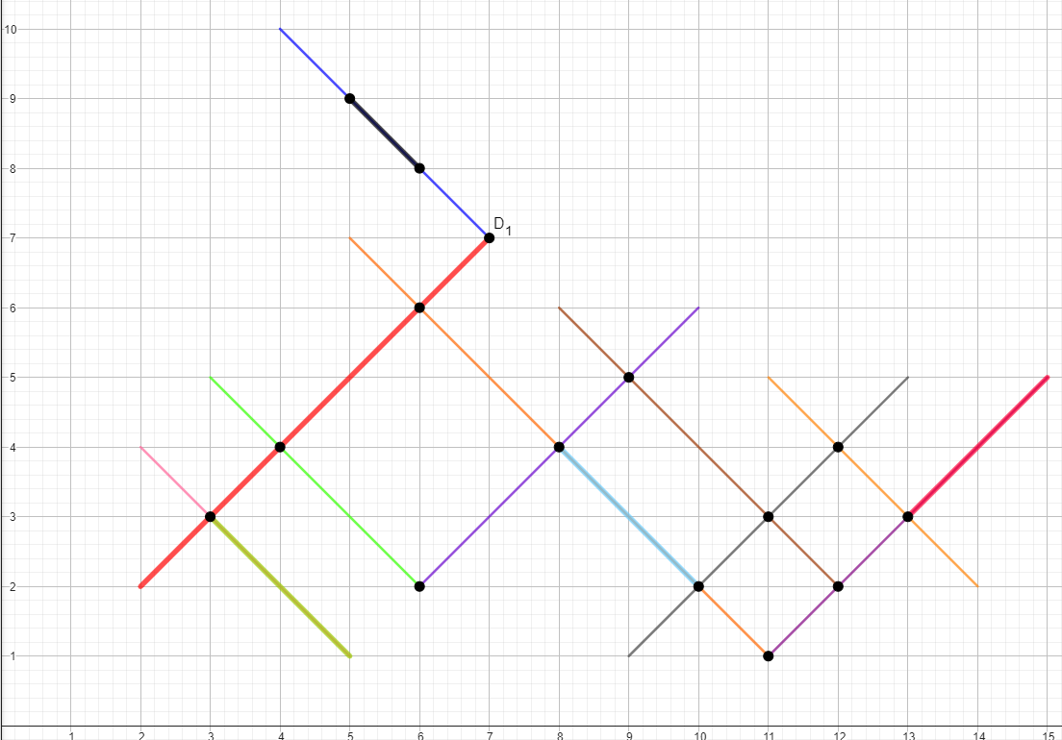Тест 7. Наложение

2

2

3

2

Отрезки: [(2, 2), (7, 7)], [(2, 2), (7, 7)], [(2, 4), (5, 1)], [(3, 3), (5, 1)], [(3, 5), (6, 2)], [(4, 10), (7, 7)], [(5, 9), (6, 8)], [(5, 7), (11, 1)], [(8, 4), (10, 2)], [(8, 4), (10, 2)], [(6, 2), (10, 6)], [(8, 6), (12, 2)], [(9, 1), (13, 5)], [(11, 5), (14, 2)], [(11, 1), (15, 5)], [(13, 3), (15, 5)]

Пересечения: (3, 3), [(3, 3), (5, 1)], [(2, 2), (7, 7)], [(5, 9), (6, 8)], (4, 4), (6, 6), (6, 2), (7, 7), [(8, 4), (10, 2)], (8, 4), (9, 5), (10, 2), (11, 3), (11, 1), (12, 4), (12, 2), (13, 3), [(13, 3), (15, 5)]

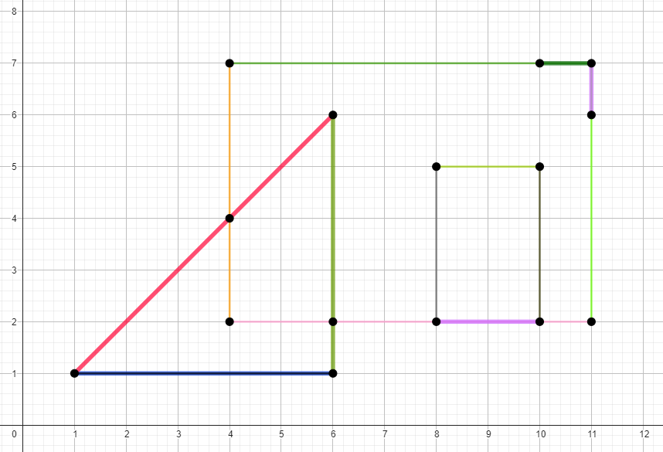Тест 8. Наложение, ортогональность

3

2

3

2

2

3

Отрезки: [(1, 1), (6, 6)], [(1, 1), (6, 6)], [(1, 1), (6, 6)], [(1, 1), (6, 1)], [(6, 6), (6, 1)], [(1, 1), (6, 1)], [(6, 6), (6, 1)], [(4, 2), (4, 7)], [(4, 7), (11, 7)], [(4, 2), (11, 2)], [(11, 7), (11, 2)], [(10, 7), (11, 7)], [(11, 7), (11, 6)], [(11, 7), (11, 6)], [(8, 2), (10, 2)], [(8, 2), (10, 2)], [(8, 5), (8, 2)], [(8, 5), (10, 5)], [(10, 5), (10, 2)]

Пересечения: (1, 1), (4, 7), (4, 4), (4, 2), (6, 6), (6, 2), (6, 1), (8, 5), (10, 5), (11, 7), (11, 2), [(1, 1), (6, 6)], [(1, 1), (6, 1)], [(6, 6), (6, 1)], [(8, 2), (10, 2)], [(10, 7), (11, 7)], [(11, 7), (11, 6)]