${Current date and time}

$**{Plumber name}** $**{Plumber surname}**

**Reg No:** $**{RegNo}**

${Delivery address street},

${Delivery address suburb},

${Delivery address city},

${Delivery address province},

${Delivery address area code}

**PIRB REGISTRATION CONFIRMATION**

This letter serves to confirm the registration status for:

**Name& Surname:** ${Plumber name} ${Plumber surname}

**Registration No:** ${RegNo}

**Designation Registered as:** ${Designation}

**Specialisation Registered as:** ${Specialization}

**Registration Period valid from:** ${Expiration date start} – ${Expiration date end}

${Card}

Please be advised that PIRB can change the registration status without notice to the recipient of this letter. An online verification can also be made on our website www.pirb.co.za to confirm a PIRB registration.

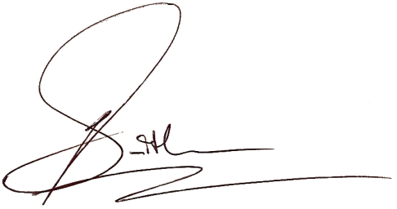Yours Faithfully,

Lea Smith

PIRB Chairman