Preq. for Agentic AI Project:

1. Python
2. Integration of LLM Models
3. Knowledge about DuckDuckGo, YFinancial
4. Working with GenAI Application

Take Complete GenAI Course form Udemy -Krish Naik

KrishNaik Live classes

**First Agentic AI with Phidata**

<https://www.phidata.com/>

login to Phidata and copy API key and paste it in to .env file

Documentation: <https://docs.phidata.com/introduction>

<https://groq.com/>

Click on Dev Console

Login and create groq api key

Copy and update in .env file

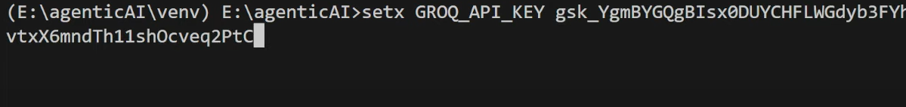

<https://openai.com/>

<https://platform.openai.com/api-keys>



create open ai key