**Overall: 3.0**

**Culture and values: 3.2**

**Work life balance: 2.9**

**Senior management: 3.1**

**Comp and benefits: 3.2**

**Career opportunities: 3.1**

**Name of the Organization:** IDFC Bank

**Headquarters:** Mumbai

**Industry:** Banking

**Company Overview:**

IDFC Bank Ltd. ([Infrastructure Development Finance Company](https://en.wikipedia.org/wiki/Infrastructure_Development_Finance_Company)) is an Indian [banking](https://en.wikipedia.org/wiki/Banking) company with headquarters in [Mumbai](https://en.wikipedia.org/wiki/Mumbai) that forms part of [IDFC](https://en.wikipedia.org/wiki/IDFC), an integrated infrastructure finance company. The bank started operations on 1st October 2015. IDFC received a universal banking licence from the [Reserve Bank of India](https://en.wikipedia.org/wiki/Reserve_Bank_of_India) (RBI) in July 2015. The bank serves corporate and private customers in India including the infrastructure sector that IDFC specialized in from its founding in 1997. The bank also aims to provide services to people in rural areas and to the self-employed.

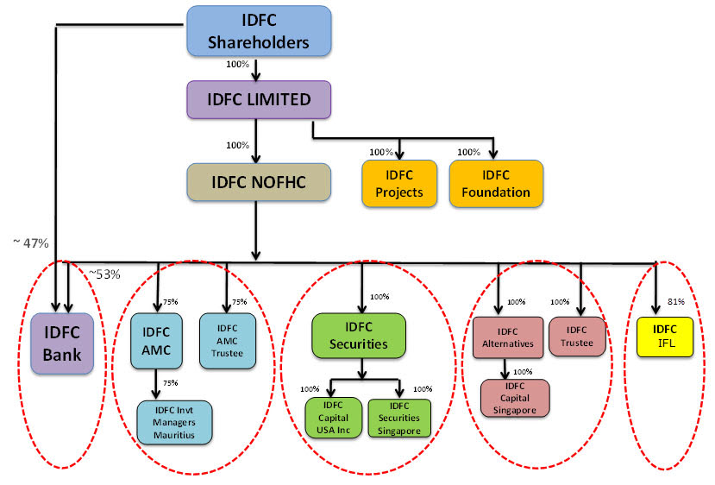

**Simplified Corporate Structure as on October 2015 On the eve of starting Bank Operations**

**Vision:**

**Business Vision:** To deliver banking anytime, anywhere at scale by using technology to relentlessly drive efficiency and set new standards of customer experience and convenience.

**Institutional Vision:** We serve therefore we are. We are committed to serve all stakeholders that include our customers, community, country & colleagues.

**Service Philosophy:**

Simple

First time right

Quick and consistent

Thoughtful

Personal

Anytime, anywhere

**Core values**:

Balance

Collaboration

Drive

Honesty

**Goals:**

* The starting position would be to become a more complete financier to the country’s Infrastructure sector.
* IDFC Bank will use its existing relationship managers to extend their product portfolio to the wider corporate sector and leverage existing relationships to serve the government at different levels, including at the level of the municipality.
* IDFC Bank will target the demands arising from accelerating urbanisation to meet the aspiration of urban, middle and rural India for credit and home ownership.
* IDFC Bank will also focus on the rapidly expanding needs of the rural economy and small businesses that will be the drivers of job creation in the country.
* Lastly, with no legacy workforce or branch network, IDFC Bank is well positioned to take advantage of recent advances in technology to give customers a distinctive and better experience. Customer service would be at the heart of IDFC Bank’s value proposition.

## CEO: [Mr. Sunil Kakar](http://www.idfc.com/our-firm/sunil-kakar.htm)

**News:**

# IDFC Bank aims to triple branches, increase POS by 100% in 36 months

# IDFC Bank Q1 profit rises 65%, bad loans ratio falls y/y