Story 14. [On Go Live, when codes go from being struck-thru/deleted to being deleted/inactive/won’t appear in XML output, there should be a flag added that a parent/child range has been affected. This flag should cause the user to open the code in Code Classification to fix the error now present in the parent and/or child range.]

Summary

1. When we will click on Go Live Button, system start scanning all the classification with their start code and end code. Once it completes the scan, it displays the list of all classifications with their end code and start code, wherein start code or end code is deleted. Please note that, deleted code will display in red.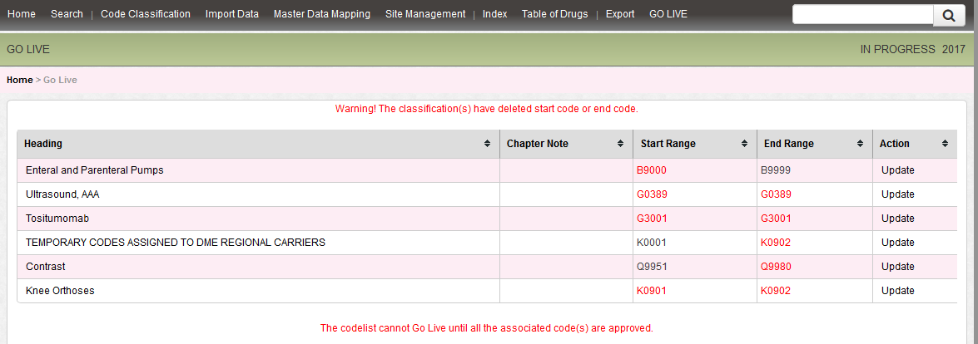
2. To go live we have to correct the displayed classification headings with correct start code and end code with the help of Update Link.
3. Once you click on the “Update button”, it will open in new tab, and therein we have to update the classification and save. Once you complete this task, return back to previous screen (above mentioned) and then we have to approve all codes, if required.
4. Then we can go live and deleted code will not appear in exported XML.