
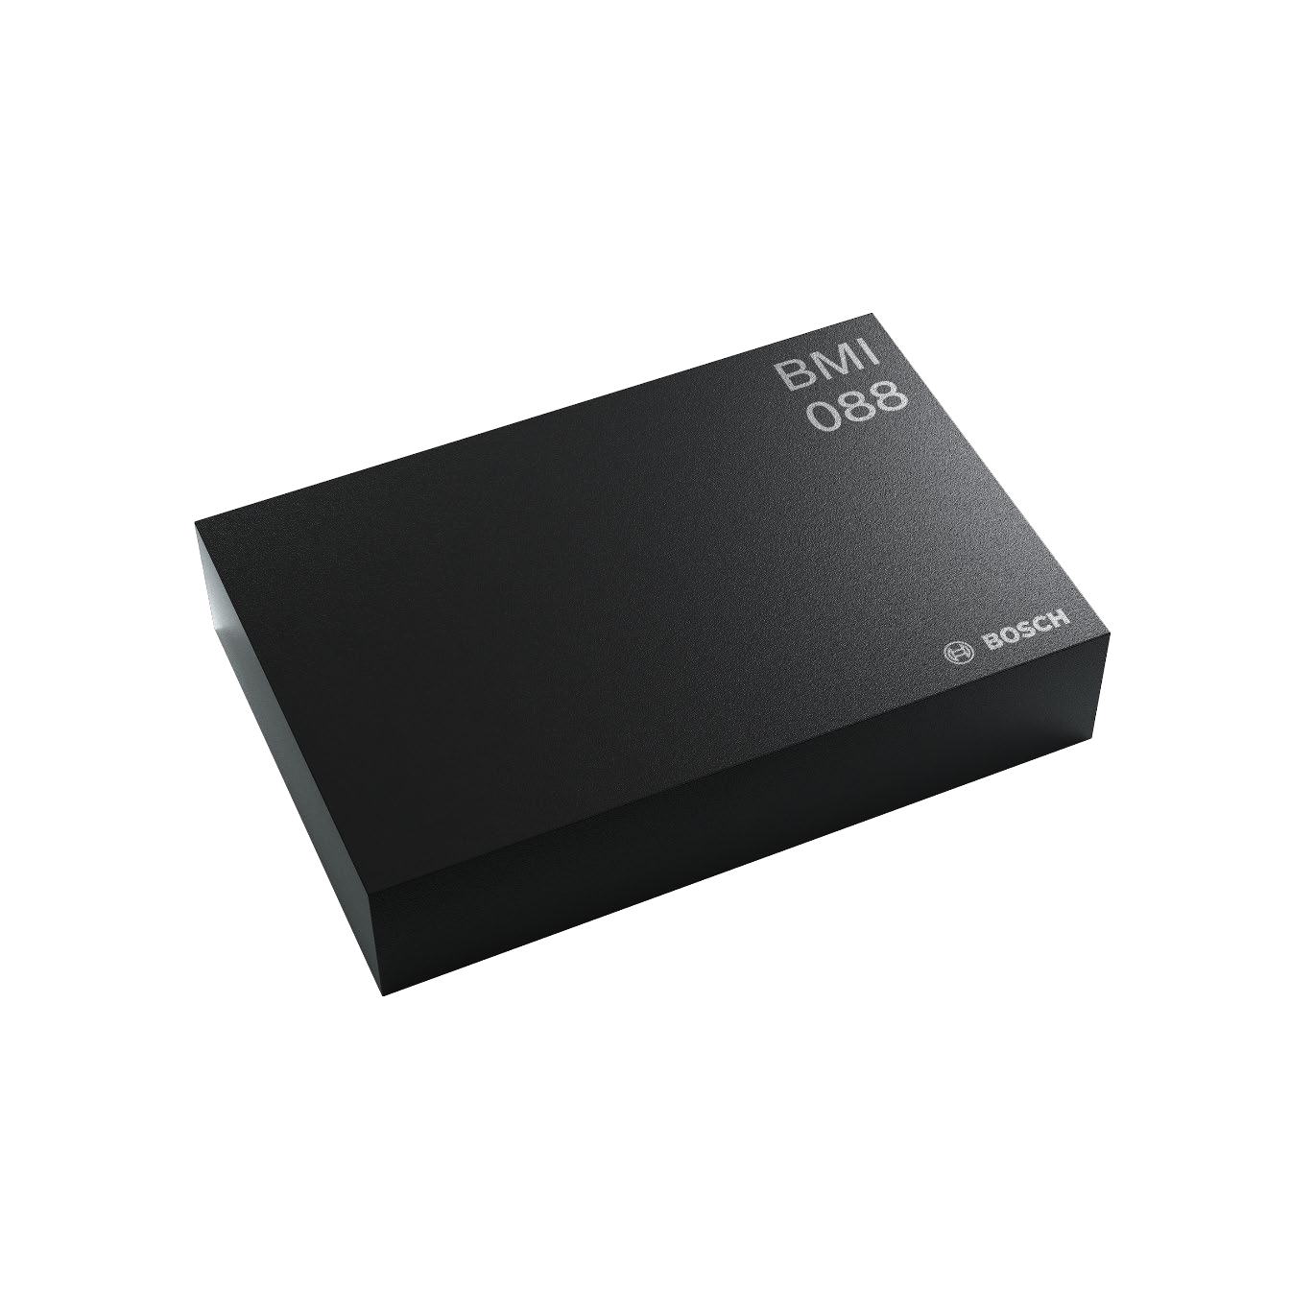


BMI088
6-axis Motion Tracking for
High-performance Applications

BMI088: Data Sheet

Document revision
1.8

Document release date
January 2022

Document number
BST-BMI088-DS000-18
Technical reference code
0 273 141 365
Notes
Data and descriptions in this document are subject to change without
notice. Product photos and pictures are for illustration purposes only
and may differ from the real product appearance


2 |
62
Bosch Sensortec | BMI088 Data sheet
Basic Description

BMI088 is an inertial measurement unit (IMU) for the detection of movements and rotations in 6 degrees
of freedom (6DoF). It combines the functionality of two inertial sensors in one device: an advanced
triaxial 16-bit gyroscope and a versatile, leading-edge triaxial 16-bit accelerometer.

BMI088 is designed to meet all requirements for high performance consumer applications in harsh
vibration environments such as those encountered in drones and robotics applications. The IMU is
designed to effectively suppress vibrations above a few hundred Hz that could occasionally occur due
to resonances on the pcb or the structure of the total system.

The sensor has an extended measurement range of up to ±24g to avoid signal clipping under strong
signal exposure.

An evaluation circuitry (ASIC) converts the output of the micro-electro-mechanical sensing structures
(MEMS), which are developed, produced and tested in BOSCH facilities. The corresponding chip-sets
are packed into one single LGA 3.0mm x 4.5mm x 0.95mm housing. For optimum system integration,
BMI088 is fitted with digital interfaces (SPI or I2C), offering a wide VDDIO voltage range from 1.2V to
3.6V. To provide maximum performance and reliability, each device is tested and is ready-to-use
calibrated.

To increase flexibility, both gyroscope and accelerometer can not only be operated individually, but tied
together for data synchronization purposes. The on-chip features comprise FIFOs for acceleration and
gyroscope data and interrupt controllers.

The BMI088 has an excellent temperature behavior with an outstanding low temperature coefficient of
the offset (TCO) and temperature coefficient of the sensitivity (TCS).
Modifications reserved | Data subject to change without notice
Document number: BST-BMI088-DS000-18
Revision_1.8_012022




3 |
62
Bosch Sensortec | BMI088 Data sheet
Index of Contents

Basic Description .................................................................................................................................. 2

1.
Specification ..................................................................................................................................... 7

1.1
Electrical Specifications ............................................................................................................. 7

Electrical Specifications: Accelerometer/Gyroscope ................................................ 8

1.2
Accelerometer Specifications .................................................................................................... 9

1.3
Gyroscope Specifications ........................................................................................................ 10

1.4
Temperature Sensor Specifications ......................................................................................... 11

1.5
Absolute Maximum Ratings ..................................................................................................... 12

2.
Block Diagram ................................................................................................................................ 13

3.
Quick Start Guide – Device Initialization ..................................................................................... 13

4.
Functional Description .................................................................................................................. 14

4.1
Power Management and Power Modes .................................................................................. 14

4.1.1
Power Modes: Accelerometer ................................................................................. 14

4.1.2
Power Modes: Gyroscope ...................................................................................... 15

4.2
Sensor Data ............................................................................................................................. 15

4.3
Sensor Time............................................................................................................................. 16

4.4
Output Data Rate (ODR) and Low-pass Filter ......................................................................... 16

4.4.1
Accelerometer ......................................................................................................... 16

4.4.2
Gyroscope .............................................................................................................. 16

4.5
Range Settings ........................................................................................................................ 16

4.6
Self-test .................................................................................................................................... 16

4.6.1
Accelerometer ......................................................................................................... 17

4.6.2
Gyroscope .............................................................................................................. 17

4.7
New Data Interrupt .................................................................................................................. 18

4.7.1
Accelerometer ......................................................................................................... 18

4.7.2
Gyroscope .............................................................................................................. 18
Modifications reserved | Data subject to change without notice
Document number: BST-BMI088-DS000-18
Revision_1.8_012022



4 |
62
Bosch Sensortec | BMI088 Data sheet

4.8
Soft-Reset ................................................................................................................................ 18

4.8.1
Soft-Reset Accelerometer ....................................................................................... 18

4.9
FIFO ......................................................................................................................................... 19

4.9.1
FIFO operating modes ............................................................................................ 19

4.9.2
FIFO interrupts ........................................................................................................ 19

4.9.3
Accelerometer sensor FIFO buffer ......................................................................... 19

4.9.4
Gyroscope sensor FIFO buffer ............................................................................... 22

5.
Register Maps ................................................................................................................................. 24

5.1
Communication with the sensor .............................................................................................. 24

5.2
Register Map: Accelerometer .................................................................................................. 25

5.3
Register Description: Accelerometer ....................................................................................... 26

5.3.1
Register 0x00: ACC_CHIP_ID ................................................................................ 26

5.3.2
Register 0x02: ACC_ERR_REG ............................................................................. 26

5.3.3
Register 0x03: ACC_STATUS ................................................................................ 26

5.3.4
Register 0x12 – 0x17: ACC data ............................................................................ 27

5.3.5
Register 0x18 – 0x1A: Sensortime data ................................................................. 27

5.3.6
Register 0x1D: ACC_INT_STAT_1 ......................................................................... 27

5.3.7
Register 0x22 – 0x23: Temperature sensor data.................................................... 28

5.3.8
Register 0x24-0x25: FIFO_LENGTH ...................................................................... 28

5.3.9
Register 0x26: FIFO_DATA .................................................................................... 28

5.3.10
Register 0x40: ACC_CONF .................................................................................... 29

5.3.11
Register 0x41: ACC_RANGE ................................................................................. 30

5.3.12
Register 0x45: FIFO_DOWNS ............................................................................... 30

5.3.13
Register 0x46 – 0x47: FIFO_WTM ......................................................................... 30

5.3.14
Register 0x48: FIFO_CONFIG_0 ........................................................................... 31

5.3.15
Register 0x49: FIFO_CONFIG_1 ........................................................................... 31

5.3.16
Register 0x53: INT1_IO_CONF .............................................................................. 32

5.3.17
Register 0x54: INT2_IO_CONF .............................................................................. 33

5.3.18
Register 0x58: INT1_INT2_MAP_DATA ................................................................. 33

5.3.19
Register 0x6D: ACC_SELF_TEST ......................................................................... 34

5.3.20
Register 0x7C: ACC_PWR_CONF ......................................................................... 34
Modifications reserved | Data subject to change without notice
Document number: BST-BMI088-DS000-18
Revision_1.8_012022



5 |
62
Bosch Sensortec | BMI088 Data sheet

5.3.21
Register 0x7D: ACC_PWR_CTRL .......................................................................... 34

5.3.22
Register 0x7E: ACC_SOFTRESET ........................................................................ 35

5.4
Register Map: Gyroscope ........................................................................................................ 36

5.5
Register Description: Gyroscope ............................................................................................. 37

5.5.1
Register 0x00: GYRO_CHIP_ID ............................................................................. 37

5.5.2
Register 0x02 – 0x07: Rate data ............................................................................ 37

5.5.3
Register 0x0A: GYRO_INT_STAT_1 ...................................................................... 38

5.5.4
Register 0x0E: FIFO_STATUS ............................................................................... 38

5.5.5
Register 0x0F: GYRO_RANGE .............................................................................. 39

5.5.6
Register 0x10: GYRO_BANDWIDTH ..................................................................... 39

5.5.7
Register 0x11: GYRO_LPM1 .................................................................................. 40

5.5.8
Register 0x14: GYRO_SOFTRESET ..................................................................... 40

5.5.9
Register 0x15: GYRO_INT_CTRL .......................................................................... 40

5.5.10
Register 0x16: INT3_INT4_IO_CONF .................................................................... 41

5.5.11
Register 0x18: INT3_INT4_IO_MAP ...................................................................... 41

5.5.12
Register 0x1E: FIFO_WM_ENABLE ...................................................................... 42

5.5.13
Register 0x34: FIFO_EXT_INT_S .......................................................................... 42

5.5.14
Register 0x3C: GYRO_SELF_TEST ...................................................................... 42

5.5.15
Register 0x3D: FIFO_CONFIG_0 ........................................................................... 43

5.5.16
Register 0x3E: FIFO_CONFIG_1 ........................................................................... 43

5.5.17
Register 0x3F: FIFO_DATA .................................................................................... 43

6.
Digital Interface .............................................................................................................................. 44

6.1
Serial Peripheral Interface (SPI) .............................................................................................. 45

6.1.1
SPI interface of gyroscope part .............................................................................. 47

6.1.2
SPI interface of accelerometer part ........................................................................ 48

6.2
Inter-Integrated Circuit (I²C) ..................................................................................................... 48

7.
Pin-out and Connection Diagram ................................................................................................. 52

7.1
Pin-out ..................................................................................................................................... 52

7.2
Connection diagram SPI .......................................................................................................... 53

2
7.3
Connection diagram I
C .......................................................................................................... 53
Modifications reserved | Data subject to change without notice
Document number: BST-BMI088-DS000-18
Revision_1.8_012022



6 |
62
Bosch Sensortec | BMI088 Data sheet

8.
Package ........................................................................................................................................... 54

8.1
Outline Dimensions ................................................................................................................. 54

8.2
Landing pattern ........................................................................................................................ 55

8.3
Sensing axes orientation ......................................................................................................... 56

8.4
Marking .................................................................................................................................... 57

8.4.1
Mass production samples ....................................................................................... 57

8.4.2
Engineering samples .............................................................................................. 57

8.5
PCB layout and soldering guidelines ....................................................................................... 57

8.6
Handling instructions ............................................................................................................... 58

8.7
Tape and Reel specification ..................................................................................................... 58

8.7.1
Orientation within the reel ....................................................................................... 59

8.8
Environmental safety ............................................................................................................... 59

8.8.1
Halogen content ...................................................................................................... 59

9.
Legal Disclaimer ............................................................................................................................. 60

9.1
Engineering samples ............................................................................................................... 60

9.2
Product use .............................................................................................................................. 60

9.3
Application examples and hints ............................................................................................... 60

10.
Document History and Modification ............................................................................................ 61

Modifications reserved | Data subject to change without notice
Document number: BST-BMI088-DS000-18
Revision_1.8_012022



7 |
62
Bosch Sensortec | BMI088 Data sheet
1. Specification

If not stated otherwise, the given values are over lifetime and full performance temperature and voltage
σ
ranges, minimum/maximum values are ±3
.
1.1
Electrical Specifications
Table 1: Electrical parameter specification
Parameter
Symbol
Condition
Min
Max
Unit
Supply Voltage
VDD

2.4
V
Internal Domains
3.6
Supply Voltage
VDDIO

1.2
V
I/O Domain
3.6
Voltage Input
V

SPI & I²C

-
IL,a
Low Level
0.3VDDIO
Voltage Input
V

SPI & I²C
-
IH,a
0.7VDDIO
High Level

Voltage Output
V

I
<= 2mA, SPI

-
OL,a
OL
0.23VDDIO
Low Level
Voltage Output

V
OH
High Level
I
<= 2mA, SPI

-
OH
0.8VDDIO
Operating

T

A
Temperature
-40
+85
°C

Modifications reserved | Data subject to change without notice
Document number: BST-BMI088-DS000-18
Revision_1.8_012022




8 |
62
Bosch Sensortec | BMI088 Data sheet

Electrical Specifications: Accelerometer/Gyroscope

Table 2: Electrical parameter specification accelerometer
Parameter
Symbol
Condition
Min
Typ
Max
Units
Total Supply

=3.0V,
µA
DD
I
Current in
Normal mode
VDD = VDDIO

150
25°C, g

FS4g

Total Supply

VDD = VDDIO
=3.0V,
3
µA

I
DDsum
Current in
Suspend Mode

25°C

Power-up time
t

Time to first valid

ms
s_up
sample from suspend
mode

1

Table 3: Electrical parameter specification gyroscope
Parameter
Symbol
Condition
Min
Typ
Max
Unit
Supply Current in
= 3.0V,

5

mA
I

VDD = VDDIO
DD
Normal Mode

25°C, ODR =1kHz
Supply Current in

µA
I
DDsum
25
Suspend Mode
VDD = VDDIO
= 3.0V,

25°C

Supply Current in

I

VDD = VDDIO
= 3.0V,

DDdsum
Deep Suspend
Mode

25°C
<5
µA
Start-up time
t

to ±1º/s of final value;

30

ms
su
from power-off
Wake-up time
t

From suspend- and

30

ms
wusm
deep suspend-modes
Wake-up time
t

From fast power-up

10

ms
wufpm
mode

Modifications reserved | Data subject to change without notice
Document number: BST-BMI088-DS000-18
Revision_1.8_012022



9 |
62
Bosch Sensortec | BMI088 Data sheet
1.2
Accelerometer Specifications
Table 4: Accelerometer specifications
Parameter
Symbol
Condition
Min
Typ
Max
Units
Acceleration Range
g

g
FS3g
±3

Selectable
g

g
FS6g
via serial digital interface
±6

g

FS12g

±12
g
g

±24
g
FS24g

Sensitivity
S

g
, T
=25°C

10920
LSB/g
3g
FS3g
A

S

g
, T
=25°C

5460
LSB/g
6g
FS6g
A

S

g
, T
=25°C

LSB/g
12g
FS12g
A
2730
S

, T
=25°C

1365
24g
g
FS24g
A

LSB/g
Sensitivity
TCS

%/K
Temperature Drift
0.002

Zero-g Offset
Off
Nominal VDD and VDDIO,

mg

20
25°C, g

FS6g
Zero-g Offset

mg/K
TCO

Temperature Drift
<0.2

Output Data Rate
ODR

12.5

1600
Hz
Bandwidth range
BW
3dB cut-off frequency of
5

Hz
the accelerometer
depends on ODR and
OSR
280
(245 for
Z axis)
Nonlinearity
NL
best fit straight line, g

%FS
FS3g
0.5
Output Noise

g
, T
√
=25°C

Hz
rms
n
Density
FS3g
A
Nominal VDD supplies
Normal mode
190
(Z-axis)

160
µg/
(X- & Y-
axis)
Cross Axis
S
relative contribution

0.5
%
Sensitivity
between any two of the
three axes

Alignment Error
E

relative to package outline
A

0.5

°

Modifications reserved | Data subject to change without notice
Document number: BST-BMI088-DS000-18
Revision_1.8_012022



10 |
62
Bosch Sensortec | BMI088 Data sheet
1.3
Gyroscope Specifications
Table 5: Gyroscope specifications
Parameter
Symbol
Condition
Min
Typ
Max
Unit
Range
R

°/s
FS125
R

FS250

125
Selectable

°/s
250
via serial digital interface
R

°/s
FS500

500
R

°/s
FS1000

1000
R

°/s
FS2000
2000

LSB/°/s

Ta=25°C, R

FS125

262.144

Sensitivity

Ta=25°C, R

LSB/°/s
FS250
131.072

Ta=25°C, R

65.536
LSB/°/s
FS500

Ta=25°C, R

LSB/°/s
FS1000
32.768

Ta=25°C, R

16.384

FS2000
LSB/°/s
Sensitivity

Ta=25°C, R

±1
%
FS2000
tolerance

Sensitivity Change
Nominal VDD supplies
TCS

over Temperature
-40°C ≤ T
≤ +85°C
±0.03
%/K
A
R

FS2000

Sensitivity
T
=25°C,
S

<0.4
A
VDD
Supply Volt. Drift
VDD
≤ VDD ≤ VDD

min
max

%/V
best fit straight line
Nonlinearity
NL

±0.05

%FS
R
R

FS1000,
FS2000
Sensitivity to
g-Sensitivity

°/s/g
acceleration stimuli in
all three axis
(frequency <20kHz)

0.1
Ω
Ω
Off

Zero-rate Offset

±1
°/s
x
y
Nominal VDD supplies
Ω

=25°C, slow and fast
and
z
T
A
offset cancellation off

Zero-rate Offset
Nominal VDD supplies
TCO

°/s per K
Change over
±0.015
-40°C ≤ T
≤ +85°C
A
Temperature
R

FS2000

T
=25°C,
Zero-rate Offset

<0.1

A
Ω
Off

VDD
Supply Volt. Drift
VDD
≤ VDD ≤ VDD

min
max
°/s /V
rms, BW=47Hz
Output Noise
n

0.1
°/s
rms
(@ 0.014°/s/√Hz)

Modifications reserved | Data subject to change without notice
Document number: BST-BMI088-DS000-18
Revision_1.8_012022



11 |
62
Bosch Sensortec | BMI088 Data sheet
523
Bandwidth BW
f

Hz
-3dB

230
116
64
47
32
23
12
Data rate
2000

Hz
(set of x,y,z rate)

1000

400
200
100
Data rate tolerance

%
(set of x,y,z rate)
±0.3

Cross Axis
Sensitivity to stimuli in

±1
%
Sensitivity
non-sense-direction

1.4
Temperature Sensor Specifications
Table 6: Temperature sensor specifications
Parameter
Symbol
Condition
Min
Typ
Max
Units
Temperature Sensor

150
°C
T

S
Measurement Range
-104
Temperature Sensor
dT

K/LSB
S
Slope
0.125

Temperature Sensor

at 25°C

K
S
OT
Offset error
±1

Modifications reserved | Data subject to change without notice
Document number: BST-BMI088-DS000-18
Revision_1.8_012022



12 |
62
Bosch Sensortec | BMI088 Data sheet
1.5
Absolute Maximum Ratings
Table 7: Absolute maximum ratings
Parameter
Condition
Min
Max
Units
Voltage at Supply Pin
VDD Pin
V
-0.3
4

VDDIO
Pin
-0.3
4

V
Voltage at any Logic Pin
Non-Supply Pin
-0.3
VDDIO+0.3
V
Passive Storage Temp. Range
≤ 65% rel. H.
-50
+150
°C

Duration ≤ 200µs

10,000
g
Mechanical Shock
Duration ≤ 1.0ms

2,000
g
Free fall

1.8
m
onto hard surfaces
ESD
HBM, at any Pin

2
kV
CDM

500
V
MM

200
V

Note: Stress above these limits may cause damage to the device. Exceeding the specified electrical
limits may affect the device reliability or cause malfunction.

Modifications reserved | Data subject to change without notice
Document number: BST-BMI088-DS000-18
Revision_1.8_012022

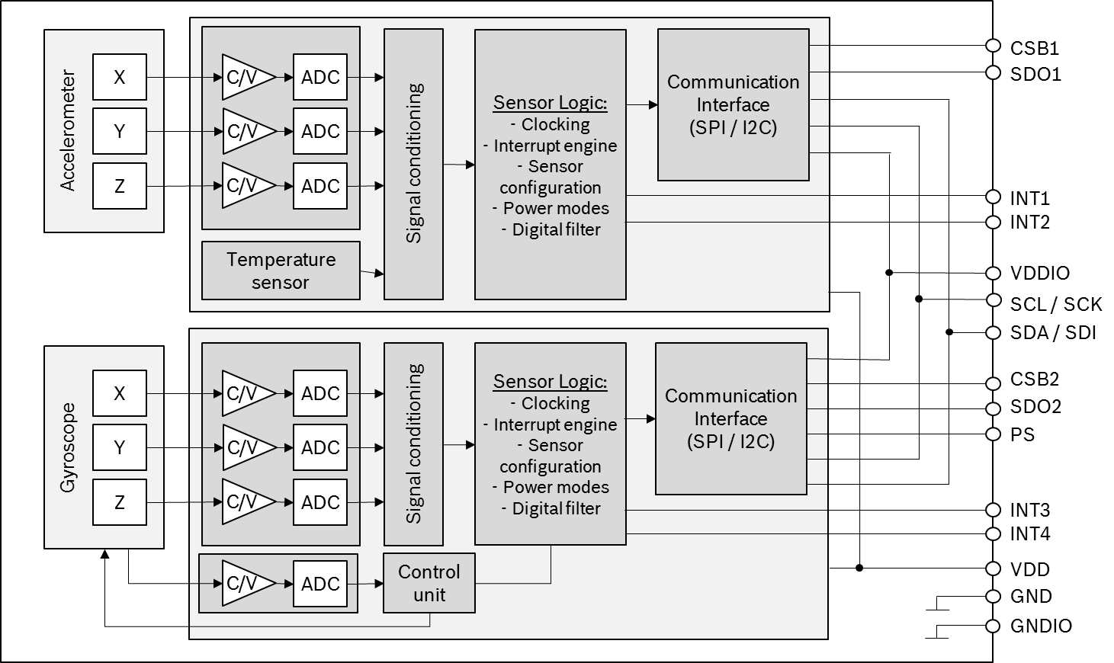


13 |
62
Bosch Sensortec | BMI088 Data sheet
2.
Block Diagram
Figure 1 shows the basic building blocks of the BMI088:

Figure 1: Block diagram of BMI088

3.
Quick Start Guide – Device Initialization
For a proper device initialization, the following steps should be considered:
•

The user must decide on the interface (I2C or SPI) already during HW design: with the PS pin
the user determines which interface the sensor should listen to (see chapter 6).
•

The gyroscope part of the BMI088 initializes its I/O pins according to the selection given by the
PS pin.
•

The accelerometer part starts in I2C mode. It will stay in I2C mode until it detects a rising edge
on the CSB1 pin (chip select of the accelerometer), on which the accelerometer part switches
to SPI mode and stays in this mode until the next power-up-reset.
•

To change the accelerometer to SPI mode in the initialization phase, the user could perform a
dummy SPI read operation, e.g. of register ACC_CHIP_ID (the obtained value will be invalid).
After the POR the gyroscope is in normal mode, while the accelerometer is in suspend mode. To switch
the accelerometer into normal mode, the user must perform the following steps:
a.
Power up the sensor
b.
Wait 1 ms
c.
Enter normal mode by writing ‘4’ to ACC_PWR_CTRL
d.
Wait for 450 microseconds

Modifications reserved | Data subject to change without notice
Document number: BST-BMI088-DS000-18
Revision_1.8_012022



14 |
62
Bosch Sensortec | BMI088 Data sheet
4.
Functional Description
4.1
Power Management and Power Modes
The BMI088 has two distinct power supply pins:

•

VDD is the main power supply for the internal blocks
•

VDDIO is a separate power supply pin mainly used for the supply of the interface

There are no limitations on the voltage levels of both pins relative to each other, as long as each of them
lies within its operating range. Furthermore, the device can be completely switched off (VDD = 0V) while
keeping the VDDIO supply on (VDDIO > 0V) or vice versa.

When the VDDIO supply is switched off, all interface pins (CSB, SDI, SCK, PS) must be kept close to
GND
potential.
IO

The device contains a power-on reset (POR) generator. It resets the logic part and the register values
after powering-on VDD and VDDIO. This means that all application specific settings which are not equal
to the default settings (refer to 6.2 register map accelerometer and to 8.2 register map gyroscope), must
be changed back to their designated values after POR.

Please note: the POR resets also the interface. For the gyroscope part, the interface is defined by the
voltage level on the PS pin. The interface of the accelerometer part is defined by the voltage level of the
CSB1 pin at the moment when the POR is initiated (see chapter 3).

Power Modes: Accelerometer
4.1.1
The power state of the BMI088 accelerometer is controlled through the register ACC_PWR_CTRL. The
register ACC_PWR_CTRL enables and disables the accelerometer and the temperature sensor.

To enter normal mode, the value 0x04 must be written to ACC_PWR_CTRL.

To enter suspend mode, register ACC_PWR_CTRL must be cleared.

Note: The sensor is in suspend mode after reset (POR or soft-reset), thus the user actively needs to
enter normal mode in order to obtain acceleration values.
Note: After POR or soft-reset, the acceleration sensor needs up to 1ms boot time (t
)
s_up

Modifications reserved | Data subject to change without notice
Document number: BST-BMI088-DS000-18
Revision_1.8_012022



15 |
62
Bosch Sensortec | BMI088 Data sheet
Power Modes: Gyroscope
4.1.2
The gyroscope has 3 different power modes. Besides normal mode, which represents the fully
operational state of the device, there are 2 energy saving modes: suspend mode and deep-suspend
mode.

After power-up gyro is in normal mode so that all parts of the device are held powered-up and data
acquisition is performed continuously.

In suspend mode the whole analog part is powered down. No data acquisition is performed. While in
suspend mode the latest rate data and the content of all configuration registers are kept. The registers
can still be read (though they are not updated).

Suspend mode is entered by writing 0x80 to the register GYRO_LPM1. It can be left by writing 0x00 to
GYRO_LPM1 or by a soft reset (see 4.8).

Although write access to registers is supported at the full interface clock speed (SCL or SCK), a waiting
period must be inserted between two consecutive write cycles (please refer also to section 9.2.1).

In deep suspend mode the device reaches the lowest possible power consumption. Only the interface
section is kept alive. No data acquisition is performed and the content of the configuration registers is
lost.

Deep suspend mode is entered by writing 0x20 to the register GYRO_LPM1. It can be left by writing
0x00 to GYRO_LPM1 or by a soft reset (see 4.8).

Please note, that all application specific settings, which are not equal to the default settings, must be re-
set to its designated values after leaving deep-suspend mode.

Note: after POR or soft-reset, or when switching between the different power modes, the gyroscope
sensor needs up to 30ms time to reach the new state. Any communication with the sensor during this
time should be avoided.

4.2
Sensor Data
The width of the gyroscope and accelerometer sensor data is 16 bits (11 bits for the temperature sensor)
given in two’s complement representation.
The bits for each axis are split into an MSB upper part and an LSB lower part. Reading the sensor data
registers shall always start with the LSB part. In order to ensure the integrity of the sensor data, the
content of an MSB register is locked by reading the corresponding LSB register (shadowing procedure).

For details regarding the registers and the interpretation of the data found in these registers see:
•

chapter 5.5.2 for the gyroscope part
•

chapter 5.3.4 or the accelerometer part
•

chapter 5.3.7 for the temperature sensor

2
The burst-access mechanism provides an efficient way to read out the angular rate data in I
C or SPI
mode. During a burst-access, the sensor automatically increments the starting read address after each
2
C bus with an up to 50% reduced data
byte. The burst-access allows data to be transferred over the I
density. The sensor data (angular rate or acceleration data) in all read-out registers is locked as long as
the burst read access is active. Reading the sensor data registers of each gyroscope and accelerometer
part in burst read access mode ensures that the sensor values in all readout registers belong to the
same sample.

Modifications reserved | Data subject to change without notice
Document number: BST-BMI088-DS000-18
Revision_1.8_012022



16 |
62
Bosch Sensortec | BMI088 Data sheet
4.3
Sensor Time
The accelerometer part of BMI088 has a built-in counter with a width of 24 bits. It increments periodically
with a resolution of 39.0625µs. Details can be found in chapter 5.3.5.

4.4
Output Data Rate (ODR) and Low-pass Filter
The sensor signals from the acceleration sensor and gyroscope analog front-end are each routed
through a low-pass filter.

Accelerometer
4.4.1
The 3db cut-off frequency of the digital low-pass filter depends on the chosen ODR as well as on the
over-sampling-ratio (OSR). Both can be configured in register ACC_CONF. The following table lists the
possible options:

Table 8: 3dB cutoff frequency of the accelerometer according to ODR and OSR settings in
ACC_CONF register
Accelerometer
Normal
OSR2
OSR4
ODR [Hz]
(acc_bwp = 0xA)
(acc_bwp = 0x9)
(acc_bwp = 0x8)
12.5
5 Hz
2 Hz
1 Hz
25
10 Hz
5 Hz
3 Hz
50
20 Hz
9 Hz
5 Hz
100
40 Hz
19 Hz
10 Hz
200
80 Hz
38 Hz
20 Hz
400
145 Hz
75 Hz
40 Hz
800
230 Hz
140 Hz
80 Hz
(200 Hz for z channel)

1600
280 Hz
234 Hz
145 Hz
(245 Hz for z channel)
(215 Hz for z channel)

Gyroscope
4.4.2
The user can choose between 8 different ODR and low pass filter bandwidth settings (see section 5.5.6).

4.5
Range Settings
The measurement range can be set through the registers described in section 5.3.11 for the
accelerometer and in section 5.5.5 for the gyroscope.

4.6
Self-test
The BMI088 incorporates a self-test feature for both the accelerometer and the gyroscope, indicating
whether the sensor is still ok.

Modifications reserved | Data subject to change without notice
Document number: BST-BMI088-DS000-18
Revision_1.8_012022



17 |
62
Bosch Sensortec | BMI088 Data sheet
Accelerometer
4.6.1
The self-test feature allows for checking the sensor functionality by applying electrostatic forces to the
sensor core instead of external accelerations. By physically deflecting the seismic mass, the entire signal
path of the sensor is tested. Activation of the self-test results in a static offset in the acceleration data.
Any external acceleration or gravitational force, which is applied to the sensor during a self-test, will be
observed in the sensor output as a superposition of the acceleration and the self-test signal. This means
that the self-test signal depends on the orientation of the sensor. To overcome this, the full self-test
procedure should be performed under static circumstances, e.g. when the part is not excited to any
acceleration except gravity.

The recommended self-test procedure is as follows:
1)
Set ±24g range by writing 0x03 to register ACC_RANGE (0x41)
2)
Set ODR=1.6kHz, continuous sampling mode, “normal mode” (norm_avg4) by writing 0xA7 to
register ACC_CONF (0x40)
•

Continuous filter function: set bit7 in ACC_CONF
•

“normal avg4 mode”: ACC_CONF |= 0x02<<4
•

ODR=1.6kHz: ACC_CONF |= 0x0C
3)
Wait for > 2 ms
4)
Enable the positive self-test polarity (i.e. write 0x0D to register ACC_SELF_TEST (0x6D))
5)
Wait for > 50ms
6)
Read the accelerometer offset values for each axis (positive self-test response)
7)
Enable the negative self-test polarity (i.e. write 0x09 to register ACC_SELF_TEST (0x6D))
8)
Wait for > 50ms
9)
Read the accelerometer offset values for each axis (negative self-test response)
10) Disable the self-test (i.e. write 0x00 to register ACC_SELF_TEST (0x6D))
11) Calculate difference of positive and negative self-test response and compare with the expected
values (see table below)
12) Wait for > 50ms to let the sensor settle to normal mode steady state operation

Table 9: Accelerometer self-test: resulting minimum difference signal between positive and negative
self-test signal
x-axis signal
y-axis signal
z-axis signal
≥1000 mg
≥1000 mg
≥500 mg

It is recommended to perform a reset of the device after a self-test has been performed, since the self-
test response also affects the interrupt generation. If the reset cannot be performed, the following
sequence must be kept to prevent unwanted interrupt generation: disable interrupts, change parameters
of interrupts, wait for at least 50ms, and enable desired interrupts.

Gyroscope
4.6.2
A built-in self-test facility of the gyro does not deflect the mechanical MEMS structure (as the
accelerometer self-test does), but this test also provides a quick way to determine if the gyroscope is
operational within the specified conditions.

To trigger the self-test, bit #0 (‘bite_trig’) in address GYRO_SELF_TEST must be set. When the test is
finished, bit #1 (‘bist_rdy’) will be set by the gyro and the test result can then be found in bit #2 (‘bist_fail’).
A ‘0’ indicates that the test was passed without issues. If a failure occurred, the bit ‘bist_fail’ will be set
to ‘1’.

A further test which is running continuously in the background can be checked by reading bit #4 in
address GYRO_SELF_TEST. Proper sensor function is indicated if the bit is set to ‘1’.
Modifications reserved | Data subject to change without notice
Document number: BST-BMI088-DS000-18
Revision_1.8_012022



18 |
62
Bosch Sensortec | BMI088 Data sheet
4.7
New Data Interrupt
Both accelerometer and gyroscope part offer a new data ready interrupt, which fires whenever a new
data sample set is complete and made available in the corresponding sensor data registers. This allows
a low latency data readout.

Accelerometer
4.7.1
The new data interrupt flag can be found in the register ACC_INT_STAT_1 (bit #7). It is set whenever
new data is available in the data registers and cleared automatically.

The interrupt can be mapped to the interrupt pins INT1 and/or INT2 in register INT1_INT2_MAP_DATA.

Both
interrupt
pins
INT1
and
INT2
can
be
configured
regarding
their
electrical
behavior
(see
INT1_IO_CONF and INT2_IO_CONF).

Gyroscope
4.7.2
The gyroscope provides a new data interrupt, which will generate an interrupt every time after storing a
new value of z-axis angular rate data in the data register. The interrupt is cleared automatically after
280-400 µs.

In contrast to the accelerometer part, for the gyro the new data interrupt must be explicitly enabled by
writing 0x80 to the register GYRO_INT_CTRL.

The interrupt can be mapped to the interrupt pins INT3 and/or INT4 in register INT3_INT4_IO_MAP.

Both
interrupt
pins
INT3
and
INT4
can
be
configured
regarding
their
electrical
behavior
(see
INT3_INT4_IO_CONF).

4.8
Soft-Reset
A soft-reset can be initiated at any time
•

for
the
accelerometer
part
by
writing
the
command
soft-reset
(0xB6)
to
register
ACC_SOFTRESET (see 5.3.22)
•

for
the
gyroscope
part
by
writing
the
command
soft-reset
(0xB6)
to
register
GYRO_SOFTRESET (see 5.5.8)

The soft-reset performs a fundamental reset to the device, which is largely equivalent to a power cycle.
Following a delay, all user configuration settings are overwritten with their default state (setting stored
in the NVM) wherever applicable. This command is functional in all operation modes but must not be
performed while NVM writing operation is in progress.

Soft-Reset Accelerometer
4.8.1
Soft reset timing:
In I2C mode, the rising edge of the SCL line for the ACK bit of the soft reset transfer determines the
reception of soft reset. The execution of the soft rest is delayed by 0.5 – 1us if the sensor is not in
advanced power save mode i.e. PWR_CONF.adv_power_save=0b0.
The execution of the soft reset causes that the SDA line to be released immediately by the device,
independent of the state of the SCL line.
Modifications reserved | Data subject to change without notice
Document number: BST-BMI088-DS000-18
Revision_1.8_012022



19 |
62
Bosch Sensortec | BMI088 Data sheet
If the host requires an explicit I2C ACK for the soft reset (i.e. SDA line remains low while the SCL line
is
high)
the
host
must
put
the
sensor
in
advance
power
save
mode
(PWR_CONF.adv_power_save=0b1), disable the sensor (PWR_CTRL.acc_en=0b0) and the auxillary
interface (PWR_CTRL.aux_en=0b0) before issuing a soft reset.

4.9
FIFO
BMI088 offers two integrated FIFO (First In, First Out) buffers for accelerometer and gyroscope sensor
signals, helping the user to reduce or even omit time critical read access to the sensor in order to obtain
data with a high timing precision.
FIFO operating modes
4.9.1
The FIFO can be operated in different modes: FIFO (or stop-at-full) mode and STREAM mode.

•

FIFO or stop-at-full mode: In FIFO or stop-at-full mode, the sensor values are stored in the
FIFO buffer subsequently until it is full.

•

STREAM mode: The STREAM mode works like the FIFO mode with the difference that once
the buffer is full, the oldest data in the FIFO will be overwritten with the newest data from the
sensor.
FIFO interrupts
4.9.2
The FIFO buffers support two different types of interrupts:

•

Watermark interrupt: Triggered, when the fill level of the FIFO buffer reaches a user-defined
level.
•

FIFO-full interrupt: Triggered, when the FIFO is full.
Accelerometer sensor FIFO buffer
4.9.3
The accelerometer part of BMI088 has an integrated 1024 byte data FIFO. The FIFO captures data
from the data registers in frames, and each frame contains only one sample of a sensor.

4.9.3.1 Enabling FIFO and selecting the mode
The FIFO for accelerometer sensor data is enabled by setting bit #6 in register 0x49 (see 5.3.15).
4.9.3.1.1
Mode selection
When STREAM mode is desired, then the bit #0 in register 0x48 has to be cleared (set to ‘0’) (default
value on power up reset, see 5.3.14).

For FIFO or stop-at-full mode, bit #0 has to be set to ‘1’ in register 0x48.

4.9.3.1.2
FIFO data sampling rate
The input data rate to the FIFO is the same as the configured ODR of the sensor. However, it can be
k
reduced selecting a down-sampling factor of 2
with k=[0, 1, … 7]. The factor k must be written to bits
#4-6 of register 0x45 (see 5.3.12).

4.9.3.1.3
FIFO synchronization with external interrupts (tag application) for the accel
If the INT1 and/or INT2 pin is configured as input pin (by setting int2_io in register INT2_IO_CTRL
and/or setting int1_io in register INT1_IO_CTRL), signals on these pins can also be recorded in the
FIFO, and the frames are “tagged” accordingly. Therefore the pins need to be activated for FIFO
recording in register FIFO_CONFIG_1 (see 5.3.15).

Modifications reserved | Data subject to change without notice
Document number: BST-BMI088-DS000-18
Revision_1.8_012022



20 |
62
Bosch Sensortec | BMI088 Data sheet
4.9.3.2 Data format in FIFO
The FIFO captures data in frames. The first byte is a header byte, defining the type of frame. From
this, the number of consecutive bytes and their content can be derived.
The header byte consists of the header signature (first 6 bits) and two bits indicating the status of the
interrupt pins INT1 and INT2 if configured accordingly (see 4.9.3.1.3).
4.9.3.2.1
Acceleration sensor data frame
•

Frame length: 7 bytes (1 byte header + 6 bytes payload)
•

Header:

Bit
7
6
5
4
3
2
1
0

1
0
0
0
0
1
[INT2 tag]
[INT1 tag]

•

Payload: the next bytes contain the sensor data in the same order as defined in the register
map (addresses 0x12 – 0x17).

4.9.3.2.2
Skip Frame
In the case of FIFO overflows, in both FIFO and STREAM mode, a skip_frame is prepended to the
FIFO content, when read out next time. A skip frame does not consume memory in the FIFO.

•

Frame length: 2 bytes (1 byte header + 1 byte payload)
•

Header:

Bit
7
6
5
4
3
2
1
0

0
1
0
0
0
0
reserved
reserved

•

Payload: one byte containing the number of skipped frames. When more than 0xFF frames
have been skipped, 0xFF is returned.

4.9.3.2.3
Sensortime Frame
A sensortime frame is only sent if the FIFO becomes empty during the burst read. A sensortime frame
does not consume memory in the FIFO.

•

Frame length: 4 bytes (1 byte header + 3 bytes payload)
•

Header:

Bit
7
6
5
4
3
2
1
0

0
1
0
0
0
1
reserved
reserved

•

Payload: Sensortime (content of registers 0x18 – 0x1A), taken when the last byte of the last
frame is read.

4.9.3.2.4
FIFO input config Frame
Whenever the filter configuration or the range of the accelerometer sensor is changed, a FIFO input
config frame is inserted into the FIFO, before the configuration change becomes active. E.g. when the
bandwidth for the accelerometer filter is changed in Register ACC_CONF, a FIFO input config frame is
inserted before the first frame with accelerometer data with the new bandwidth configuration.

•

Frame length: 2 bytes (1 byte header + 1 byte payload)
•

Header:

Modifications reserved | Data subject to change without notice
Document number: BST-BMI088-DS000-18
Revision_1.8_012022



21 |
62
Bosch Sensortec | BMI088 Data sheet
Bit
7
6
5
4
3
2
1
0

0
1
0
0
1
0
reserved
reserved

•

Payload: The FIFO input config frame contains one byte of data, of which the following bits have
a meaning (the content of the other bits can safely be ignored):

Bit #1: indicates that a configuration change through register ACC_RANGE becomes
o
active (means for example that the range of the accelerometer was changed).

Bit #0: indicates that a configuration change through the registers ACC_CONF or
o
FIFO_DOWNS becomes active (means of example that the filter settings where
changed or the FIFO sampling rate was modified).

4.9.3.2.5
Sample drop Frame
After a reconfiguration, indicated by the fifo_Input_Config frame, the next sample may be dropped,
until the sensor delivers valid data again. Instead, a drop frame is inserted at the ODR tick at which a
sample was to be expected without reconfiguration.

•

Frame length: 2 bytes (1 byte header + 1 byte payload)
•

Header:

Bit
7
6
5
4
3
2
1
0

0
1
0
1
0
0
reserved
reserved

•

Payload: The sample drop frame contains one byte of data, whose content can be ignored.

4.9.3.2.6
FIFO partial frame reads and overreads
When a frame is only partially (uncompletely) read through the register FIFO_DATA it will be repeated
completely with the next access. In the case of a FIFO overflow between the first partial read and the
second read attempt, the frame may be deleted.

When more data is read from the FIFO than it contains valid data, 0x8000 is returned.

4.9.3.3 FIFO Interrupts
The FIFO supports two interrupts, a FIFO full interrupt and a watermark interrupt:

•
The FIFO full interrupt is issued when the FIFO fill level is above the full threshold. The full
threshold is reached just before the last two frames are stored in the FIFO.
•
The FIFO watermark is issued when the FIFO fill level is superior or equal to the watermark
level defined in register FIFO_WTM (see 5.3.13).

In order to enable/use the FIFO full or watermark interrupts they need to be mapped on the desired
interrupt pin via INT1_INT2_MAP_DATA (see 5.3.18).

Both interrupts are suppressed when a read operation on the register FIFO_DATA is ongoing.
Latched FIFO interrupts will only get cleared, if the status register gets read and the fill level is below
the corresponding FIFO interrupt (full or watermark).

Modifications reserved | Data subject to change without notice
Document number: BST-BMI088-DS000-18
Revision_1.8_012022

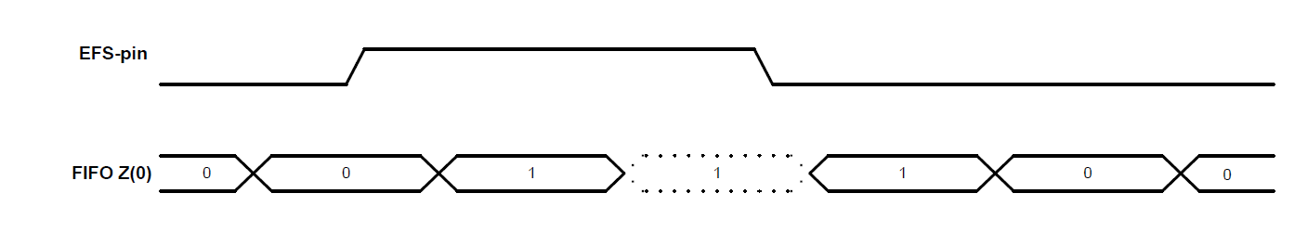


22 |
62
Bosch Sensortec | BMI088 Data sheet
4.9.3.4 FIFO Reset
The user can trigger a FIFO reset by writing 0xB0 to ACC_SOFTRESET (register 0x7E).

Gyroscope sensor FIFO buffer
4.9.4
The gyroscope part of BMI088 features an integrated FIFO memory capable of storing up to 100
frames of data in FIFO mode. Each frame consists of three 16-bit rate_x,y,z data words, and 16 bits of
interrupt data sampled at the same point in time.

4.9.4.1
Enabling FIFO and selecting the mode
The FIFO for gyroscope sensor data is enabled by setting the appropriate FIFO mode in Register 0x3E:
FIFO_CONFIG_1.

4.9.4.1.1
FIFO data sampling rate
The input data rate to the FIFO is the same as the configured ODR of the sensor.

4.9.4.1.2
FIFO sync with external interrupts (tag application) for the gyroscope
The FIFO of the gyroscope features a mode that allows the precise synchronization of external events
with the gyroscope angular rate saved in the FIFO. This synchronization can be used for example for
image and video stabilization applications.

Any of the gyroscope interrupt pins (INT3 or INT4) can be reconfigured to act as input pin, but not
both. In addition, the tag mode has to be enabled. The so configured interrupt pin will then behave as
an input pin and not as an interrupt pin. The working principle is shown in below figure:

Timing diagram for external FIFO synchronization. EFS-pin is the Interrupt pin configured to capture
external events. FIFO z(0) is the least significant bit of the z-axis gyro data stored in the FIFO.

In order to enable the tag mode, bit 5 must be set in register 0x34 (see 5.5.13). The pin can be chosen
in the same register, bit 4.

In this mode, the least significant bit of the z-axis is used as tag-bit, therefore losing its meaning as
gyroscope data bit. The remaining 15 bits of the z-axis gyroscope data keep the same meaning as in
standard mode.

Once the pin, which is configured for the tag mode, is set to high level, the next FIFO word will be
marked with a tag (z-axis LSB = 1). While pin is kept at a high level, the corresponding FIFO words will
continuously be tagged. After the pin is reset to low level, the immediate next FIFO word could still be
tagged, and only after this word, the next tag will be reset (z-axis LSB=0). This is shown in the above
diagram.

Modifications reserved | Data subject to change without notice
Document number: BST-BMI088-DS000-18
Revision_1.8_012022



23 |
62
Bosch Sensortec | BMI088 Data sheet
The tag synchronizes external events with the same time precision as the FIFO update rate. Therefore
update rate of the tag is determined by the output data rate.

4.9.4.2
FIFO Data Readout
The FIFO stores the data that are also available at the read-out registers 0x02-0x07. Thus, all
configuration settings apply to the FIFO data as well as the data readout registers. The FIFO read out
is possible through register 0x3F (FIFO_DATA). The readout can be performed using burst mode. A
single burst can read out one or more frames at a time. If a frame is not read completely due to an
incomplete read operation, the remaining part of the frame is lost. In this case the FIFO aligns to the
next frame during the next read operation.

The data format is described in 5.5.17.

4.9.4.2.1
Interface speed requirements for Gyroscope FIFO use
In order to use the FIFO effectively, larger blocks of data need to be read out quickly. Depending on
the output data rate of the sensor, this can impose requirements on the interface.

The output data rate of the gyroscope is determined by the filter configuration (see the data sheet of
the sensor). What interface speed is required depends on the selected rate.

•
2

For an I
C speed of 400 kHz, every filter mode can be used.
•
2
C speed of 200 kHz, only modes with an output data rate of 1 KHz and below are

For an I
recommended.
•
2
C speed of 100 kHz, only modes with an output data rate of 400 Hz and below are

For an I
recommended.

4.9.4.3
FIFO Frame Counter and Overrun Flag
The frame counter (address 0x0E bits<6:0>, see 5.5.4) indicates the current fill level of the buffer. If
additional frames are written to the buffer although the FIFO is full, the overrun flag (register 0x0E bit 7)
is set. If the FIFO is reset, the FIFO fill level indicated in the frame_counter<6:0> is set to ‘0’ and the
overrun flag is reset each time a write operation happens to the FIFO configuration registers.
Note: the overrun bit is not reset when the FIFO fill level frame_counter<6:0> has decremented to ‘0’
due to reading from the FIFO_DATA register, but only when a write operation is performed on FIFO
configuration registers.

4.9.4.4
FIFO Interrupts
The FIFO supports two interrupts, a FIFO full interrupt and a watermark interrupt:

•

The FIFO full interrupt is issued when the buffer has been fully filled with samples. In FIFO
mode this occurs after 100 samples, and in STREAM mode after 99 samples, have been
stored in a previously empty FIFO.
The status of the FIFO-full interrupt may be read back through the status bit in
INT_STATUS_1 register 0x0A.
•

The watermark interrupt is issued when the fill level in the buffer has reached the frame
number defined by the water mark level trigger in 0x3D. The status of the watermark may be
read back through the address 0x0A bit 4 (fifo_int) status bit. Writing to water mark level
trigger in register 0x3D clears the FIFO buffer.

Modifications reserved | Data subject to change without notice
Document number: BST-BMI088-DS000-18
Revision_1.8_012022



24 |
62
Bosch Sensortec | BMI088 Data sheet
5.
Register Maps
5.1
Communication with the sensor
The entire communication with the device is performed by reading from and writing to registers.
Registers have a width of 8 bits; they are mapped to an 8-bit address space. Accelerometer and
gyroscope have individual register maps. The selection of the appropriate register map is done on digital
2
2
interface level by either selecting the corresponding chip select pin (SPI mode) or I
C address (I
C
mode). For details regarding the digital interface, see chapter 0.

The functional registers and the register addresses containing functional bits are marked in the following
register maps. All non-functional registers are marked as reserved and should be completely ignored by
the user.

It is recommended to mask out (logical and with zero) non-functional bits (marked with ‘-‘) of registers
which partially contain functional bits (i.e. read the register content first, changing bit by means of bit-
wise operations, and write the modified byte back to the register).

Modifications reserved | Data subject to change without notice
Document number: BST-BMI088-DS000-18
Revision_1.8_012022



25 |
62
Bosch Sensortec | BMI088 Data sheet
5.2
Register Map: Accelerometer
Legend
Read-only
Read/Write
Write-only
Reserved
Reset
Addr
Name
bit7
bit6
bit5
bit4
bit3
bit2
bit1
bit0
value
0x7E
ACC_SOFTRESET
0x00
softreset_cmd (0xb6)
0x7D
ACC_PWR_CTRL
0x00
acc_enable
0x7C
ACC_PWR_CONF
0x03
pwr_save_mode
0x7B - 0x6E: reserved
-
0x6D
ACC_SELF_TEST
0x00
acc_self_test
0x6B - 0x59: reserved
-
0x58
INT_MAP_DATA
0x00
-
int2_drdy
int2_fwm
int2_ffull
-
int1_drdy
Int1_fwm
Int1_ffull
0x57 - 0x55: reserved
-
0x54
INT2_IO_CTRL
0x00
-
int2_in
int2_out
int2_od
int2_lvl
-
0x53
INT1_IO_CTRL
0x00
-
int1_in
int1_out
int1_od
int1_lvl
-
0x52 - 0x4A: reserved
-
FIFO_CONFIG_1
0x10
-
acc_en
-
1
int1_en
int2_en
0x49
-
0x48
FIFO_CONFIG_0
0x02
1
mode
-
fifo_water_mark[12:8]
0x47
FIFO_WTM_1
0x02
fifo_water_mark[7:0]
0x46
FIFO_WTM_0
0x00
fifo_downs
-
0x45
FIFO_DOWNS
0x80
1
0x44 - 0x42: reserved
-
0x41
ACC_RANGE
0x01
-
acc_range
acc_odr
0x40
ACC_CONF
0xA8
acc_bwp
0x3F - 0x27: reserved
-
fifo_ data
0x00
0x26
FIFO_DATA
fifo_byte_counter[13:8]
0x25
FIFO_LENGTH_1
0x00
-
fifo_byte_counter[7:0]
0x24
FIFO_LENGTH_0
0x00
temperature[2:0]
-
0x23
TEMP_LSB
0x00
temperature[10:3]
0x22
TEMP_MSB
0x00
0x21 - 0x1E: reserved
-
0x1D
ACC_INT_STAT_1
0x00
-
acc_drdy
0x1C - 0x1B: reserved
-
sensor_time[23:16]
0x1A
SENSORTIME_2
0x00
sensor_time[15:8]
0x19
SENSORTIME_1
0x00
sensor_time[7:0]
0x18
SENSORTIME_0
0x00
acc_z[15:8]
0x17
ACC_Z_MSB
0x00
acc_z[7:0]
0x16
ACC_Z_LSB
0x00
acc_y[15:8]
0x15
ACC_Y_MSB
0x00
acc_y[7:0]
0x14
ACC_Y_LSB
0x00
acc_x[15:8]
0x13
ACC_X_MSB
0x00
acc_x[7:0]
0x12
ACC_X_LSB
0x00
0x11 - 0x04: reserved
-
0x03
ACC_STATUS
0x10
-
drdy_acc
error_code
0x02
ACC_ERR_REG
0x00
-
-
fatal_ err
0x01
-
-
-
acc_chip_id
0x00
ACC_CHIP_ID
0x1E

Modifications reserved | Data subject to change without notice
Document number: BST-BMI088-DS000-18
Revision_1.8_012022



26 |
62
Bosch Sensortec | BMI088 Data sheet
5.3
Register Description: Accelerometer
Register 0x00: ACC_CHIP_ID
5.3.1

Bit
Access
Reset
Description
value
[7:0]
Contains identifier code of acceleration sensor
RO
0x1E

Register 0x02: ACC_ERR_REG
5.3.2
Reports sensor error conditions.

Bit
Name
Access
Reset
Description
value
[7:5]
reserved
[4:2]
error_code
RO
0x00
Error codes for persistent errors:
0x00: no error
0x01: error occurred in accelerometer configuration
(unvalid data in register ACC_CONF)
[1]
reserved
[0]
fatal_err
RO
0x0
Fatal Error, chip is not in operational state (Boot-,
power-system). This flag will be reset only by
power-on-reset or soft-reset.

Register 0x03: ACC_STATUS
5.3.3
Sensor status flag.

Bit
Name
Access
Reset
Description
value
[7]
acc_drdy
RO
0x0
Data ready for Accelerometer. Reset when one
acceleration data register is read out.
[6:0]
reserved

Modifications reserved | Data subject to change without notice
Document number: BST-BMI088-DS000-18
Revision_1.8_012022



27 |
62
Bosch Sensortec | BMI088 Data sheet
Register 0x12 – 0x17: ACC data
5.3.4
Registers containing the acceleration sensor output. The sensor output is stored as signed 16 bit number
in 2’s complement format in each 2 registers. From the registers, the acceleration values can be
calculated as follows:
Accel_X_int16 = ACC_X_MSB * 256 + ACC_X_LSB
Accel_Y_int16 = ACC_Y_MSB * 256 + ACC_Y_LSB
Accel_Z_int16 = ACC_Z_MSB * 256 + ACC_Z_LSB

When a register is read containing the LSB value of an acceleration value, the corresponding MSB
register is locked internally, until it is read. By this mechanism, it is ensured that both LSB and MSB
values belong to the same acceleration value and are not updated between the readouts of the individual
registers.

The unit is in LSB. The conversion from LSB to acceleration (mg) is based on the range settings and
can be calculated as follows (<0x41>: content of the ACC_RANGE register):
Accel_X_in_mg = Accel_X_int16 / 32768 * 1000 * 2^(<0x41> + 1) * 1.5
Accel_Y_in_mg = Accel_Y_int16 / 32768 * 1000 * 2^(<0x41> + 1) * 1.5
Accel_Z_in_mg = Accel_Z_int16 / 32768 * 1000 * 2^(<0x41> + 1) * 1.5

5.3.5
Register 0x18 – 0x1A: Sensortime data
Registers containing the value of the internal 24-bit counter.
•

Register 0x18 (SENSORTIME_0) contains the lower 8 bits of the counter. This register is
incremented every 39.0625 µs.
•

Register 0x19 (SENSORTIME_1) contains the middle 8 bits of the counter. This register is
incremented on SENSORTIME_0 overflow, which is every 10 ms.
•

Register 0x1A (SENSORTIME_2) contains the higher 8 bits of the counter. This register is
incremented on SENSORTIME_1 overflow, which is every 2.56 s.

The complete 24-bit counter overflows after 655.36 s or almost 11 minutes.

Register 0x1D: ACC_INT_STAT_1
5.3.6
Interrupt status register.

Bit
Name
Access
Reset
Description
value
[7]
acc_drdy
RO
0x00
Acceleration data ready interrupt. Cleared on read
of this register
[6:0]
reserved

Modifications reserved | Data subject to change without notice
Document number: BST-BMI088-DS000-18
Revision_1.8_012022



28 |
62
Bosch Sensortec | BMI088 Data sheet
Register 0x22 – 0x23: Temperature sensor data
5.3.7
Registers containing the temperature sensor data output. The data is stored in an 11-bit value in 2’s
complement format. The resolution is 0.125°C/LSB, thus the temperature can be obtained as follows:

Temp_uint11 = (TEMP_MSB * 8) + (TEMP_LSB / 32)
if Temp_uint11 > 1023:

Temp_int11 = Temp_uint11 – 2048
else:

Temp_int11 = Temp_uint11
Temperature = Temp_int11 * 0,125°C/LSB + 23°C

TEMP_MSB
TEMP_LSB
Temp_int11
Temperature
0x3E
0x00
496
85 °C
…
…
…
…
0x00
0x60
3
23.375 °C
0x00
0x40
2
23.250 °C
0x00
0x20
1
23.125 °C
0x00
0x00
0
23.0°C
…
…
…
…
0xC1
0x00
-504
-40 °C
0x80

Invalid

The temperature sensor data is updated every 1.28 s.

Register 0x24-0x25: FIFO_LENGTH
5.3.8
The FIFO length registers FIFO_LENGTH_1 and FIFO_LENGTH_0 contain the 14 bit FIFO byte
counter. The counter represents the current fill level of the FIFO buffer.
An empty FIFO corresponds to 0x8000. A FIFO content reset can be triggered by reading out all
frames from the FIFO buffer or by writing 0xB0 into register 0x7E. The byte counter is updated when a
complete frame is read or written.

Register 0x26: FIFO_DATA
5.3.9
When reading out data from FIFO, burst read access must be used. The address will not increase
when burst read at the address of FIFO_DATA. The FIFO data is organized in frames as described in
section 4.9.3.2.
When a frame is partially read through FIFO Data Register 0x26, it will be repeated completely with the
next access. However, in case of a FIFO overflow between the first partial read and the second read
attempt, the frame may be deleted.

Modifications reserved | Data subject to change without notice
Document number: BST-BMI088-DS000-18
Revision_1.8_012022



29 |
62
Bosch Sensortec | BMI088 Data sheet
Register 0x40: ACC_CONF
5.3.10
Accelerometer configuration register.

Bit
Name
Access
Reset
Description
value
[7:4]
acc_bwp
RW
0x0A
This parameter influences the bandwidth of the
accelerometer low pass filter. For details, see
section 4.4.1. Possible values:

acc_bwp
Filter setting
0x08
OSR4 (4-fold oversampling)
0x09
OSR2 (2-fold oversampling)
0x0A
Normal
others
reserved

[3:0]
acc_odr
RW
0x08
This parameter sets the output data rate ODR.
Possible values:

acc_odr
ODR in Hz
0x00 – 0x04
reserved
0x05
12.5
0x06
25
0x07
50
0x08
100
0x09
200
0x0A
400
0x0B
800
0x0C
1600
0x0D – 0X0F
reserved

Modifications reserved | Data subject to change without notice
Document number: BST-BMI088-DS000-18
Revision_1.8_012022



30 |
62
Bosch Sensortec | BMI088 Data sheet
Register 0x41: ACC_RANGE
5.3.11
Accelerometer range setting register.

Bit
Name
Access
Reset
Description
value
[7:2]
reserved
[1:0]
acc_range
RW
0x01
This parameter sets the measurement range.
Possible values:

acc_range
Range setting
0x00
±3g
0x01
±6g
0x02
±12g
0x03
±24g

Register 0x45: FIFO_DOWNS
5.3.12
Reduction of sample rate.
Bit
Name
Access
Reset
Description
value
[7]
Reserved
RW
0x01
This bit must always be ‘1’.
[6:4]
fifo_downs
RO
0x00
Reduction of sample rate by a factor
2**fifo_downs.
Example: fifo_downs=5 will reduce the FIFO
sampling rate by a factor of 2**5 = 32 in relation to
the chosen ODR of the sensor signal.
[3:0]
reserved

Register 0x46 – 0x47: FIFO_WTM
5.3.13
Registers containing the 13 bit FIFO watermark level value. A FIFO water mark interrupt signal is
active if the FIFO fill level is equal or greater than fifo_water_mark [12:0] (unit of the fifo water mark is
one byte).

Modifications reserved | Data subject to change without notice
Document number: BST-BMI088-DS000-18
Revision_1.8_012022



31 |
62
Bosch Sensortec | BMI088 Data sheet

Register 0x48: FIFO_CONFIG_0
5.3.14
Sets the FIFO mode.

Bit
Name
Access
Reset
Description
value
[7:2]
reserved
[1]
Reserved
RW
0x01
This bit must always be ‘1’.
[0]
mode
RW
0x00
This parameter sets the FIFO mode.
Possible values:

value
mode
0x00
STREAM mode
0x01
FIFO mode

Register 0x49: FIFO_CONFIG_1
5.3.15
Selects sources for the FIFO buffer.

Bit
Name
Access
Reset
Description
value
[7]
reserved
[6]
Acc_en
RW
0x00
Enables storing of accelerometer sensor data
[5]
Reserved
RW
0x00

[4]
Reserved
RW
0x01
This bit must always be ‘1’.
[3]
Enables storing of captured interrupt events at pin
Int1_en
RW
0x00
INT1 (pin needs to be configured as input pin
accordingly)
[2]
Enables storing of captured interrupt events at pin
Int2_en
RW
0x00
INT2 (pin needs to be configured as input pin
accordingly)
[1:0]
reserved

Modifications reserved | Data subject to change without notice
Document number: BST-BMI088-DS000-18
Revision_1.8_012022



32 |
62
Bosch Sensortec | BMI088 Data sheet
Register 0x53: INT1_IO_CONF
5.3.16
Configures the input/output pin INT1.

Bit
Name
Access
Reset
Description
value
[7:5]
reserved
[4]
int1_in
RW
0x00
Enable INT1 as input pin.
[3]
int1_out
RW
0x00
Enable INT1 as output pin.
[2]
int1_od
RW
0x00

int1_od
Pin behavior
0x00
Push-pull
0x01
Open-drain

[1]
int1_lvl
RW
0x00

int1_lvl
Active state
0x00
Active low
0x01
Active high

[0]
reserved

Modifications reserved | Data subject to change without notice
Document number: BST-BMI088-DS000-18
Revision_1.8_012022



33 |
62
Bosch Sensortec | BMI088 Data sheet
Register 0x54: INT2_IO_CONF
5.3.17
Configures the input/output pin INT2.

Bit
Name
Access
Reset
Description
value
[7:5]
reserved
[4]
int2_io
RW
0x00
Enable INT2 as input pin.
[3]
int2_out
RW
0x00
Enable INT2 as output pin.
[2]
int2_od
RW
0x00

int2_od
Pin behavior
0x00
Push-pull
0x01
Open-drain

[1]
int2_lvl
RW
0x00

int2_lvl
Active state
0x00
Active low
0x01
Active high

[0]
reserved

Register 0x58: INT1_INT2_MAP_DATA
5.3.18
Map data ready interrupt to output pin INT1 and/or INT2.

Bit
Name
Access
Reset
Description
value
[7]
reserved
[6]
Int2_drdy
RW
0x00
Map data ready interrupt to pin INT2
[5]
int2_fwm
RW
0x00
Map FIFO watermark interrupt to pin INT2
[4]
Map FIFO full interrupt to pin INT2
int2_ffull
RW
0x00
[5:3]
reserved
[2]
Int1_drdy
RW
0x00
Map data ready interrupt to pin INT1
[1]
int1_fwm
RW
0x00
Map FIFO watermark interrupt to pin INT1
[0]
int1_ffull
RW
0x00
Map FIFO full interrupt to pin INT1

Modifications reserved | Data subject to change without notice
Document number: BST-BMI088-DS000-18
Revision_1.8_012022



34 |
62
Bosch Sensortec | BMI088 Data sheet

Register 0x6D: ACC_SELF_TEST
5.3.19
Enables the sensor self-test signal, occurring as a steady offset to the sensor output. Note that the
self-test needs to be switched off actively by the user (details see 4.6.1).

Bit
Access
Reset
Description
value

[7:0]
RW
0x00
self_test
Behaviour
0x00
Self-test is switched off.
0x0D
Enable positive self-test signal.
0x09
Enable negative self-test signal.

Register 0x7C: ACC_PWR_CONF
5.3.20
Switches accelerometer into suspend mode for saving power. In this mode the data acquisition is
stopped.

Bit
Name
Access
Reset
Description
value
[7:0]
acc_pwr_save
RW
0x03

acc_pwr_save
Filter setting
0x03
Suspend mode
0x00
Active mode

Register 0x7D: ACC_PWR_CTRL
5.3.21
Switches accelerometer ON or OFF. Required to do after every reset in order to obtain acceleration
values.

Bit
Name
Access
Reset
Description
value
[7:0]
acc_enable
RW
0x00

acc_enable
Filter setting
0x00
Accelerometer off
0x04
Accelerometer on

Modifications reserved | Data subject to change without notice
Document number: BST-BMI088-DS000-18
Revision_1.8_012022



35 |
62
Bosch Sensortec | BMI088 Data sheet
Register 0x7E: ACC_SOFTRESET
5.3.22

Bit
Access
Reset
Description
value
Writing a value of 0xB6 to this register resets the sensor. (Do not write
[7:0]
W
N/A
any other content to this register.)
Following a delay of 1 ms, all configuration settings are overwritten with
their reset value.
The soft-reset can be triggered from any operation mode.

Modifications reserved | Data subject to change without notice
Document number: BST-BMI088-DS000-18
Revision_1.8_012022



36 |
62
Bosch Sensortec | BMI088 Data sheet
5.4
Register Map: Gyroscope

Reserved
Legend
Read-only
Read/Write
Write-only
Reset
bit4
bit3
bit2
bit1
bit0
bit5
Addr
Name
bit7
bit6
value
FIFO_DATA
N/A
0x3F
fifo_data_output_register
0x3E
FIFO_CONFIG_1
0x00
fifo_mode
-
FIFO_CONFIG_0
0x00
0x3D
fifo_water_mark_level_trigger_retain
0x3C
GYRO_SELF_TEST
N/A
bist_rdy
trig_ bist
-
bist_ fail
-
rate_ok
0x3B - 0x35: reserved
-
-
0x00
0x34
FIFO_EXT_INT_S
ext_fifo_s_en ext_fifo_s_sel
0x33 - 0x1F: reserved
-
0x00
0x1E
FIFO_WM_EN
fifo_watermark_enable
0x1D - 0x19: reserved
-
INT3_INT4_IO_MAP
0x00
0x18
Int3_ fifo
-
Int3_data
-
Int4_ fifo
Int4_data
-
0x17: reserved
-
INT3_INT4_IO_CONF
0x0F
0x16
Int3_ lvl
Int3_od
Int4_ lvl
-
Int4_od
0x00
0x15
GYRO_INT_CTRL
data_en
fifo_ en
-
0x14
GYRO_SOFTRESET
N/A
softreset
0x13 - 0x12: reserved
-
0x11
GYRO_LPM1
0x00
gyro_pm
0x10
GYRO_BANDWIDTH
0x80
gyro_bw
0x0F
GYRO_RANGE
0x00
gyro_range
0x0E
FIFO_STATUS
N/A
fifo_overrun
fifo_frame_counter
0x0D - 0x0B: reserved
-
N/A
0x0A
GYRO_INT_STAT_1
fifo_ int
gyro_drdy
-
-
0x09 - 0x08: reserved
-
N/A
0x07
RATE_Z_MSB
rate_z[15:8]
0x06
RATE_Z_LSB
N/A
rate_ z[7:0]
0x05
RATE_Y_MSB
N/A
rate_y[15:8]
0x04
RATE_Y_LSB
N/A
rate_ y[7:0]
0x03
RATE_X_MSB
N/A
rate_x[15:8]
0x02
RATE_X_LSB
N/A
rate_ x[7:0]
0x01
Reserved
N/A
-
0x00
GYRO_CHIP_ID
0x0F
gyro_chip_id

Modifications reserved | Data subject to change without notice
Document number: BST-BMI088-DS000-18
Revision_1.8_012022



37 |
62
Bosch Sensortec | BMI088 Data sheet
5.5
Register Description: Gyroscope
Register 0x00: GYRO_CHIP_ID
5.5.1

Bit
Access
Reset
Description
value
[7:0]
RO
Contains identifier code of gyroscope.
0x0F

Register 0x02 – 0x07: Rate data
5.5.2
Registers containing the angular velocity sensor output. The sensor output is stored as signed 16-bit
number in 2’s complement format in each 2 registers. From the registers, the gyro values can be
calculated as follows:

Rate_X: RATE_X_MSB * 256 + RATE_X_LSB
Rate_Y: RATE_Y_MSB * 256 + RATE_Y_LSB
Rate_Z: RATE_Z_MSB * 256 + RATE_Z_LSB

When a register is read containing the LSB value of a rate value, the corresponding MSB register is
locked internally, until it is read. By this mechanism, it is ensured that both LSB and MSB values belong
to the same rate range value and are not updated between the readouts of the individual registers.

The unit is in LSB. The conversion from LSB to angular velocity (degree per second) is based on the
range settings (see 5.5.5). For example, for the default range setting of 0x00 in register 0x0F, the
following conversion table applies:

Sensor output [LSB]
Angular rate (in 2000°/s range mode)
+32767
+ 2000°/s
…
…
0
0°/s
…
…
-32767
- 2000°/s

Modifications reserved | Data subject to change without notice
Document number: BST-BMI088-DS000-18
Revision_1.8_012022



38 |
62
Bosch Sensortec | BMI088 Data sheet
Register 0x0A: GYRO_INT_STAT_1
5.5.3

Bit
Name
Access
Reset
Description
value
[7]
gyro_drdy
RO
N/A
Data ready interrupt status. The interrupt is cleared
automatically after 280-400 µs.
reserved
[6:5]

[4]
FIFO interrupt status
fifo_int
RO
N/A
reserved
[3:0]

Register 0x0E: FIFO_STATUS
5.5.4
The register contains FIFO status information.

Bit
Name
Access
Reset
Description
value
[7]
Fifo_overrun
RO
If set, FIFO overrun condition has occurred.
N/A
Note: flag can only be cleared by writing to
the FIFO configuration register
FIFO_CONFIG_1
[6:0]
Fifo_frame_counter
RO
N/A
Current fill level of FIFO buffer. An empty
FIFO corresponds to 0x00. The frame counter
can be cleared by reading out all frames from
the FIFO buffer or writing to the FIFO
configuration register FIFO_CONFIG_1.

Modifications reserved | Data subject to change without notice
Document number: BST-BMI088-DS000-18
Revision_1.8_012022



39 |
62
Bosch Sensortec | BMI088 Data sheet
Register 0x0F: GYRO_RANGE
5.5.5

Bit
Access
Reset
Description
value
[7:0]
RW
0x00
Angular rate range and resolution. Possible values:

gyro_range
Full scale
Resolution
[°/s]
0x00
±2000
16.384 LSB/°/s

⬄
61.0 m°/s / LSB
0x01
±1000
32.768 LSB/°/s

⬄
30.5 m°/s / LSB
0x02
±500
65.536 LSB/°/s

⬄
15.3 m°/s / LSB
0x03
±250
131.072 LSB/°/s

⬄
7.6 m°/s / LSB
0x04
±125
262.144 LSB/°/s

⬄
3.8m°/s / LSB

Register 0x10: GYRO_BANDWIDTH
5.5.6

Bit
Access
Reset
Description
value
[7:0]
1
RW
0x80

The register allows the selection of the rate data filter bandwidth and
output data rate (ODR). Possible values:

gyro_bw
ODR [Hz]
Filter bandwidth [Hz]
0x00
2000
532
0x01
2000
230
0x02
1000
116
0x03
400
47
0x04
200
23
0x05
100
12
0x06
200
64
0x07
100
32

1
Note: bit #7 is read-only and always ‚1‘, but has no function and can safely be ignored.
Modifications reserved | Data subject to change without notice
Document number: BST-BMI088-DS000-18
Revision_1.8_012022



40 |
62
Bosch Sensortec | BMI088 Data sheet
Register 0x11: GYRO_LPM1
5.5.7
Selection of the main power modes. Please note that only switching between normal mode and the
suspend modes is allowed, it is not possible to switch between suspend and deep suspend and vice
versa.
Bit
Access
Reset
Description
value
[7:0]
RW
0x00
Switch to the main power modes.

gyro_pm
Power mode
0x00
normal
0x80
suspend
0x20
deep suspend

Register 0x14: GYRO_SOFTRESET
5.5.8

Bit
Access
Reset
Description
value
Writing a value of 0xB6 to this register resets the sensor. (Other
[7:0]
W
N/A
values are ignored.)
Following a delay of 30 ms, all configuration settings are overwritten
with their reset value.
The soft reset can be triggered from any operation mode.

Register 0x15: GYRO_INT_CTRL
5.5.9

Bit
Access
Reset
Description
value
[7]
RW
0x0
Enables the new data interrupt to be triggered on new data.
[6]
RW
0x0
Enables the FIFO interrupt.
[5:0]
reserved

Modifications reserved | Data subject to change without notice
Document number: BST-BMI088-DS000-18
Revision_1.8_012022



41 |
62
Bosch Sensortec | BMI088 Data sheet
Register 0x16: INT3_INT4_IO_CONF
5.5.10
Sets electrical and logical properties of the interrupt pins.

Bit
Name
Access
Reset
Description
value

[3]
Int4_od
RW
‘1’
Int4_od
Pin INT4 output configuration
‘0’
Push-pull
‘1’
Open-drain

[2]
Int4_lvl
RW
‘1’
Int4_lvl
Pin INT4 active state
‘0’
Active low
‘1’
Active high

[1]
Int3_od
RW

‘1’
Int3_od
Pin INT3 output configuration
‘0’
Push-pull
‘1’
Open-drain

[0]
Int3_lvl
RW
‘1’
Int3_lvl
Pin INT3 active state
‘0’
Active low
‘1’
Active high

Register 0x18: INT3_INT4_IO_MAP
5.5.11
Map the data ready interrupt pin to one of the interrupt pins INT3 and/or INT4.

Bit
Access
Reset
Description
value
Data ready interrupt is mapped to INT4 pin.
[7]
RW
0x0
reserved
[6]
[5]
RW
0x0
FIFO interrupt is mapped to INT4.
[4:3]
reserved
[2]
RW
FIFO interrupt is mapped to INT3.
0x0
reserved
[1]
[0]
RW
0x0
Data ready interrupt is mapped to INT3 pin.

Modifications reserved | Data subject to change without notice
Document number: BST-BMI088-DS000-18
Revision_1.8_012022



42 |
62
Bosch Sensortec | BMI088 Data sheet
Register 0x1E: FIFO_WM_ENABLE
5.5.12
Enables FIFO watermark level interrupt.

Bit
Access
Reset
Description
value

[7:0]
RW
0x08
Value
description
0x08
FIFO watermark level interrupt disabled
0x88
FIFO watermark level interrupt enabled

Register 0x34: FIFO_EXT_INT_S
5.5.13

Bit
Access
Reset
Description
value
reserved

[7:6]
[5]
RW
0x00
It set, enables external FIFO synchronization mode
Selects source for external FIFO synchronization
[4]
RW
0x00

ext_fifo
Behavior
_s_sel
0x0
Source is pin INT3
0x1
Source is pin INT4

reserved

[3:0]

Register 0x3C: GYRO_SELF_TEST
5.5.14
Built-in self-test of gyroscope.

Bit
Access
Name
Reset
Description
value
[4]
R
rate_ok
‘0’
A value of ‘1’ indicates proper sensor function.

If ‘0’ and bist_rdy = ‘1’: built-in self-test is ok, sensor is
[2]
R
bist_fail
‘0’
ok
If ‘1’ and bist_rdy = ‘1’: built-in self-test is not ok,
sensor values may not be in expected range
If bit is ‘1’, built-in self-test has been performed and
[1]
R
bist_rdy
‘0’
finished
[0]
W
trig_bist
Setting this bit to ‘1’ (i.e. writing 0x01 to this register)
N/A
starts the built-in self-test.

Modifications reserved | Data subject to change without notice
Document number: BST-BMI088-DS000-18
Revision_1.8_012022

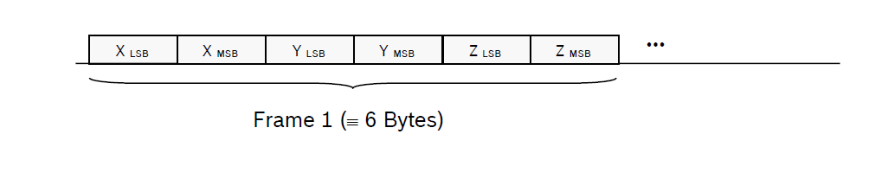


43 |
62
Bosch Sensortec | BMI088 Data sheet
Register 0x3D: FIFO_CONFIG_0
5.5.15

Bit
Access
Reset
Description
value
[7]
Reserved
[6:0]
RW
0x00
fifo_water_mark_level_trigger_retain<6:0> defines the FIFO
watermark level. An interrupt will be generated, when the number of
entries in the FIFO exceeds
fifo_water_mark_level_trigger_retain<6:0>.
Writing to this register clears the FIFO buffer.

Register 0x3E: FIFO_CONFIG_1
5.5.16
Contains FIFO configuration settings. The FIFO buffer memory is cleared and the fifo-full flag is
cleared when writing to FIFO_CONFIG_1 register. In addition, the FIFO overrun flag (see 5.5.4) is
cleared (it overrun occurred before).

Bit
Access
Reset
Description
value

[7:0]
RW
0x08
fifo_
mode
description
mode
0x40
data collection stops once buffer is full (i.e.
FIFO
filled with 100 frames)
sampling continues when buffer is full (i.e.
0x80
STREAM
filled with 99 frames); old is discarded
else
reserved

Register 0x3F: FIFO_DATA
5.5.17
FIFO data readout register. The format of the LSB and MSB components corresponds to that of the
angular rate data readout registers. Read burst access may be used since the address counter will not
increment when the read burst is started at the address of FIFO_DATA. The entire frame is discarded
when a fame is only partially read out.
The format of the data read-out from register 0x3F is as follows:

Modifications reserved | Data subject to change without notice
Document number: BST-BMI088-DS000-18
Revision_1.8_012022



44 |
62
Bosch Sensortec | BMI088 Data sheet

6.
Digital Interface
The BMI088 supports two serial digital interface protocols for communication as a slave with a host
device: SPI and I²C. The active interface is selected by the state of the Pin#07 (PS) ‘protocol select’ pin:
•

PS = ´VDDIO´ selects I²C
•

PS = ´GND´ selects SPI

Important:
•

Please note that in case of SPI protocol the initialization process for the accelerometer part of
BMI088 requires some additional steps (see chapter 3).
•

Please also note that as the pins of the package are shared between accelerometer and
gyroscope part, it is not advisable to configure different interfaces for the two parts.

Both digital interfaces share partly the same pins. Additionally each inertial sensor (accelerometer and
gyroscope) provides specific interface pins, which allow the user to operate the inertial sensors
independently of each other. The mapping for each interface and each inertial sensor is given in the
following table:

Table 10: Mapping of the interface pins
Pin#
Name
use w/
Description
use w/
SPI
I²C
15
SDO1
SDO1
address
SPI: Accel Data Output
I²C: Used to set LSB of Accel I²C address
10
SDO2
SDO2
address
SPI: Gyro Data Output
I²C: Used to set LSB of Gyro I²C address
9
SDA /
SDA
SDI
SDI
SPI: Accel and Gyro Data In
I²C: Serial Data
14
CSB1
CSB1
unused
SPI: Accel Chip Select (enable)
5
CSB2
CSB2
unused
SPI: Gyro Chip Select (enable)
8
SCL /
SCL
SCK
SPI: Serial Clock SCK
SCK
I²C: Serial Clock SCL

Modifications reserved | Data subject to change without notice
Document number: BST-BMI088-DS000-18
Revision_1.8_012022



45 |
62
Bosch Sensortec | BMI088 Data sheet
The following table shows the electrical specifications of the interface pins:

Table 11: Electrical specification of the interface pins
Parameter
Symbol
Condition
Min
Typ
Max
Units
Pull-up Resistance,

75
kΩ
R
up
CSB pin
Internal Pull-up
Resistance to
VDDIO
100
125
Input Capacitance
C

5
in

10
pF
I²C Bus Load

pF
I2C_Load
C
Capacitance (max.
drive capability)

400

In order to allow for the correct internal synchronisation of data written to the BMI088, a wait time of at
least 2 µs (normal mode) or 1000 µs (suspend mode) must be followed.

6.1
Serial Peripheral Interface (SPI)
The behavior of the SPI interface is slightly different between gyroscope part and accelerometer part:
•

Initialization phase: as described in chapter 3, the interface of the gyroscope part is selected by
2
the level of the PS pin. In contrast to this, the accelerometer part starts always in I
C mode
(regardless of the level of the PS pin) and needs to be changed to SPI mode actively by sending
a rising edge on the CSB1 pin (chip select of the accelerometer), on which the accelerometer
part
switches
to
SPI
mode
and
stays
in
this
mode
until
the
next
power-up-reset.
To change the sensor to SPI mode in the initialization phase, the user could perfom a dummy
SPI read operation, e.g. of register ACC_CHIP_ID (the obtained value will be invalid).
•

In case of read operations, the SPI interface of the accelerometer part does not send the
requested information directly after the master has send the corresponding register address,
but sends a dummy byte first, whose content is not predictable. Only after this dummy byte the
desired content is sent. (This dummy byte procedure does not apply to the gyroscope part.)
Please find more details below in section 6.1.2.

Modifications reserved | Data subject to change without notice
Document number: BST-BMI088-DS000-18
Revision_1.8_012022



46 |
62
Bosch Sensortec | BMI088 Data sheet

The timing specification for SPI of the BMI088 is given in the following table:

Table 12: SPI timing
Parameter
Symbol
Condition
Min
Max
Units
Clock Frequency
f

10
MHz
SPI
Max. Load on SDI or
SDO = 25pF
SCK Low Pulse
t

45
ns
SCKL

SCK High Pulse
t

ns
SCKH
45

SDI Setup Time
t

20

ns
SDI_setup
SDI Hold Time
t

20
ns
SDI_hold

SDO Output Delay
t

Load = 25pF
ns
SDO_OD

30
Load = 250pF,

ns
40
VDDIO > 2.4V
CSB Setup Time
t

40
ns
CSB_setup

CSB Hold Time
t

ns
CSB_hold
40

Idle time between write

normal mode
2
µs
IDLE_wacc
t
accesses

Modifications reserved | Data subject to change without notice
Document number: BST-BMI088-DS000-18
Revision_1.8_012022



47 |
62
Bosch Sensortec | BMI088 Data sheet

The following figure shows the definition of the SPI timings:

t
t
CSB_hold
CSB_setup
CSB
SCK
t
t
SCKH
SCKL
SDI
t
t
SDI_hold
SDI_setup
SDO
t
SDO_OD

Figure 2: SPI timing diagram

The SPI interface of the BMI088 is compatible with two modes, ´00´ and ´11´. The automatic selection
between [CPOL = ´0´ and CPHA = ´0´] and [CPOL = ´1´ and CPHA = ´1´] is controlled based on the
value of SCK after a falling edge of CSB (1 or 2).
SPI interface of gyroscope part
6.1.1
For single byte read as well as write operations, 16-bit protocols are used. The SPI interface also
supports multiple-byte read operations (burst-read).

The communication starts when the CSB (1 or 2) is pulled low by the SPI master and stops when CSB
(1 or 2) is pulled high. SCK is also controlled by SPI master. SDI and SDO (1 or 2) are driven at the
falling edge of SCK and should be captured at the rising edge of SCK.

The data bits are used as follows:
•

Bit #0: Read/Write bit. When 0, the data SDI is written into the chip. When 1, the data SDO from
the chip is read.
•

Bit #1-7: Address AD(6:0).
•

Bit #8-15: when in write mode, these are the data SDI, which will be written into the address.
When in read mode, these are the data SDO, which are read from the address.

Multiple read operations (burst-read) are possible by keeping CSB low and continuing the data transfer
(i.e. continuing to toggle SCK). Only the first register address has to be written. Addresses are
automatically incremented after each read access as long as CSB stays active low.

Modifications reserved | Data subject to change without notice
Document number: BST-BMI088-DS000-18
Revision_1.8_012022



48 |
62
Bosch Sensortec | BMI088 Data sheet
SPI interface of accelerometer part
6.1.2
In case of read operations of the accelerometer part, the requested data is not sent immediately, but
instead first a dummy byte is sent, and after this dummy byte the actual reqested register content is
transmitted.
This means that – in contrast to the description in section 6.1.1 – a single byte read operation requires
to read 2 bytes in burst mode, of which the first received byte can be discarded, while the second byte
contains the desired data.
The same applies to burst-read operations. For example, to read the accelerometer values in SPI mode,
the user has to read 7 bytes, starting from address 0x12 (ACC data). From these bytes the user must
discard the first byte and finds the acceleration information in byte #2 – #7 (corresponding to the content
of the addresses 0x12 – 0x17).

The data bits are used as follows:
•

Bit #0: Read/Write bit. When 0, the data SDI is written into the chip. When 1, the data SDO from
the chip is read.
•

Bit #1-7: Address AD(6:0).
•

Bit #8-15:

When in write mode, these are the data SDI, which will be written into the address.
o

When in read mode, these bits contain unpredictable values, and the user has to read
o
Bit #16-23 to get the actual data from the reading address.

6.2
Inter-Integrated Circuit (I²C)
The I²C bus uses SCL (= SCx pin, serial clock) and SDA (= SDx pin, serial data input and output) signal
lines. Both lines are connected to VDDIO externally via pull-up resistors so that they are pulled high
when the bus is free.

The I²C interface of the BMI088 is compatible with the I²C Specification UM10204 Rev. 03 (19 June
2007), available at http://www.nxp.com. The BMI088 supports I²C standard mode and fast mode, only
7-bit address mode is supported.

The default I²C addresses are:


Accelerometer:


SDO1 pin pulled to ‘GND’: 0011000b (0x18)


SDO1 pin pulled to ‘VDDIO’: 0011001b (0x19)


Gyroscope:


SDO2 pin pulled to ‘GND’: 1101000b (0x68)


SDO2 pin pulled to ‘VDDIO’: 1101001b (0x69)

The timing specification for I²C of the BMI088 is given in table 13:

Modifications reserved | Data subject to change without notice
Document number: BST-BMI088-DS000-18
Revision_1.8_012022



49 |
62
Bosch Sensortec | BMI088 Data sheet
Table 13: I²C timings
Parameter
Symbol
Min
Max
Units
Clock Frequency
f

400
kHz
SCL
SCL Low Period
t

s
LOW
1.3
SCL High Period
t

∝

0.6
HIGH
SDA Setup Time
t

0.1

SUDAT
SDA Hold Time
t

HDDAT
0.0
Setup Time for a repeated Start

0.6
t
SUSTA
Condition

Hold Time for a Start Condition
t

0.6

HDSTA
Setup Time for a Stop Condition
t

SUSTO
0.6
Time before a new Transmission can

t
BUF
1.3
start
Idle time between write accesses,

µs
t

IDLE_wacc_nm
2
normal mode
Idle time between write accesses,
t

450

µs
IDLE_wacc_sum
suspend mode

Figure 3 shows the definition of the I²C timings given in table 13:

SDA
t

BUF

t

LOW
t

f

SCL

t

t
HIGH
t
HDDAT
HDSTA
t

r
t

SUDAT

SDA

t
SUSTA
t

SUSTO

Figure 3: I²C timing diagram

Modifications reserved | Data subject to change without notice
Document number: BST-BMI088-DS000-18
Revision_1.8_012022



50 |
62
Bosch Sensortec | BMI088 Data sheet
The I²C protocol works as follows:

START: Data transmission on the bus begins with a high to low transition on the SDA line while SCL is
held high (start condition (S) indicated by I²C bus master). Once the START signal is transferred by the
master, the bus is considered busy.

STOP: Each data transfer should be terminated by a Stop signal (P) generated by master. The STOP
condition is a low to HIGH transition on SDA line while SCL is held high.

ACK: Each byte of data transferred must be acknowledged. It is indicated by an acknowledge bit sent
by the receiver. The transmitter must release the SDA line (no pull down) during the acknowledge pulse
while the receiver must then pull the SDA line low so that it remains stable low during the high period of
the acknowledge clock cycle.

In the following diagrams, these abbreviations are used:

S

Start

P

Stop

ACKS

Acknowledge by slave

ACKM

Acknowledge by master

NACKM
Not acknowledge by master

RW

Read / Write

A START immediately followed by a STOP (without SCL toggling from ´VDDIO´ to ´GND´) is not
supported. If such a combination occurs, the STOP is not recognized by the device.

I²C write access:
I²C write access can be used to write a data byte in one sequence.

The sequence begins with start condition generated by the master, followed by 7 bits slave address and
a write bit (RW = 0). The slave sends an acknowledge bit (ACK = 0) and releases the bus. Then the
master sends the one byte register address. The slave again acknowledges the transmission and waits
for the 8 bits of data, which shall be written to the specified register address. After the slave
acknowledges the data byte, the master generates a stop signal and terminates the writing protocol.

Example of an I²C write access to the accelerometer, writing 0xA8 to address ox40 (i.e. setting
continuous filter function, averaging to 4 samples, ODR to 100Hz):

Slave address (0x18)
RW
Register address (0x40)
Data (0xA8)
Start
Stop
ACKS
ACKS
ACKS
dummy
S
0
0
1
0
0
0
A
0
0
0
0
0
0
A
1
0
1
0
1
0
0
0
A
P
1
0
0
1

Figure 4: I²C write
I²C read access:
I²C read access also can be used to read one or multiple data bytes in one sequence.

A read sequence consists of a one-byte I²C write phase followed by the I²C read phase. The two parts
of the transmission must be separated by a repeated start condition (Sr). The I²C write phase addresses
the slave and sends the register address to be read. After slave acknowledges the transmission, the
master generates again a start condition and sends the slave address together with a read bit (RW =
1). Then the master releases the bus and waits for the data bytes to be read out from slave. After each
data byte the master has to generate an acknowledge bit (ACK = 0) to enable further data transfer. A
Modifications reserved | Data subject to change without notice
Document number: BST-BMI088-DS000-18
Revision_1.8_012022



51 |
62
Bosch Sensortec | BMI088 Data sheet
NACKM (ACK = 1) from the master stops the data being transferred from the slave. The slave releases
the bus so that the master can generate a STOP condition and terminate the transmission.
The register address is automatically incremented and, therefore, more than one byte can be
sequentially read out. Once a new data read transmission starts, the start address will be set to the
register address specified in the latest I²C write command. By default, the start address is set at 0x00.
In this way, repetitive multi-bytes reads from the same starting address are possible.

Example of an I²C read access to the accelerometer, reading all 6 bytes containing acceleration data
(0x12-0x17):

Slave address (0x18)
Register address (0x12)
RW
Start
ACKS
ACKS
dummy
S
0
0
1
1
0
0
0
0
A
x
0
0
1
0
0
1
0
A
Slave address (0x18)
Read data (0x13)
Read data (0x12)
RW
Start
ACKS
ACKM
ACKM
Sr
0
0
1
1
0
0
0
1
A
x
x
x
x
x
x
x
x
A
x
x
x
x
x
x
x
x
A
…
Read data (0x14)
Read data (0x15)
ACKS
ACKM
ACKM
… A
x
x
x
x
x
x
x
x
A
x
x
x
x
x
x
x
x
A
…
Read data (0x16)
Read data (0x17)
Stop
ACKS
ACKM
NACKM
… A
x
x
x
x
x
x
x
x
A
x
x
x
x
x
x
x
x
NA
P

Figure 5: I²C multiple read

Modifications reserved | Data subject to change without notice
Document number: BST-BMI088-DS000-18
Revision_1.8_012022

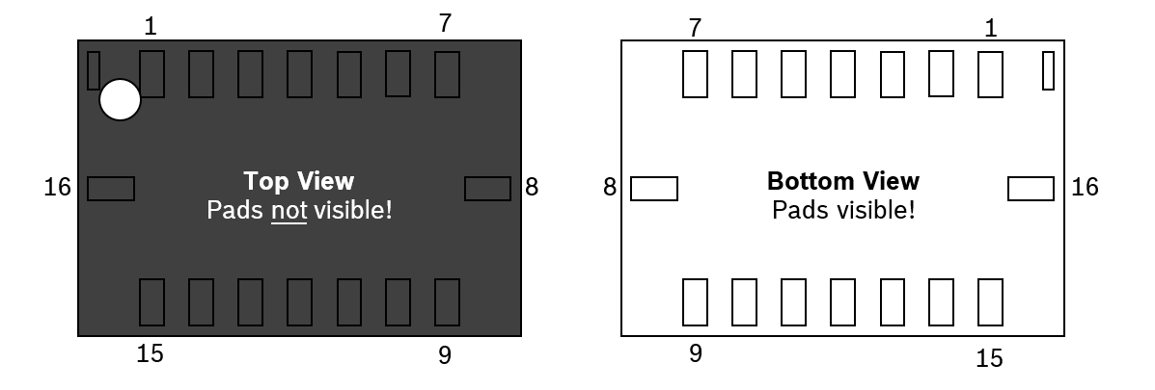


52 |
62
Bosch Sensortec | BMI088 Data sheet
7.
Pin-out and Connection Diagram

Figure 6: Pin-out top view Figure 7: Pin-out bottom view

7.1
Pin-out
Table 14: Pin description
1
2
Pin#
Name
I/O Type
Description
SPI mode
I
C mode
1*
INT2
Digital I/O
Interrupt pin 2 (accel int #2)
INT2
INT2
2
NC
--
--
GND
GND
3
VDD
Supply
Power supply analog & digital
VDD
VDD
domain (2.4 – 3.6V)
4
GNDA
Ground
Ground for analog domain
GND
GND
5
CSB2
Digital in
SPI Chip select Gyro
CSB2
DNC (float)
6
GNDIO
Ground
Ground for I/O
GND
GND
7
PS
Digital in
Protocol select gyroscope
GND
VDDIO
(GND = SPI, VDDIO = I²C)
8
SCL /
SCL
Digital in
SPI: serial clock SCK
SCK
SCK
I²C: serial clock SCL
9
SDA /
Digital I/O
SDA
I²C: SDA serial data I/O
SDI
SDI
SPI 4W: SDI serial data I
SPI 3W: SDA serial data I/O
10
SDO2
Digital out
SPI Serial data out Gyro
SDO2
GND
Address select in I²C mode
for default addr.
see chapter 9.2
11
VDDIO
Supply
Digital I/O supply voltage
VDDIO
VDDIO
(1.2V … 3.6V)
12*
INT3
Digital I/O
Interrupt pin 3 (gyro int #1)
INT3
INT3
13*
INT4
Digital I/O
Interrupt pin 4 (gyro int #2)
INT4
INT4
14
CSB1
Digital in
SPI Chip select Accel
CSB1
VDDIO or DNC
(float)
15
SDO1
Digital out
SPI Serial data out Accel
SDO1
GND
Address select in I²C mode
for default addr.
see chapter 9.2
16*
INT1
Digital I/O
Interrupt pin 1 (accel int #1)
INT1
INT1

* If INT are not used, do not connect them (DNC)!
Modifications reserved | Data subject to change without notice
Document number: BST-BMI088-DS000-18
Revision_1.8_012022

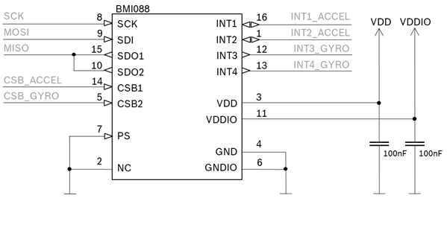
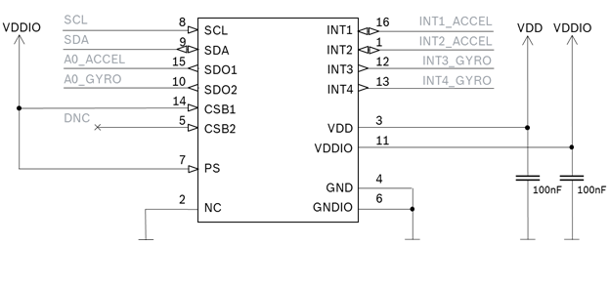


53 |
62
Bosch Sensortec | BMI088 Data sheet

7.2
Connection diagram SPI

Figure 8: SPI connection

2
7.3
Connection diagram I
C

BMI088

2
Figure 9: I
C connection

Modifications reserved | Data subject to change without notice
Document number: BST-BMI088-DS000-18

Revision_1.8_012022

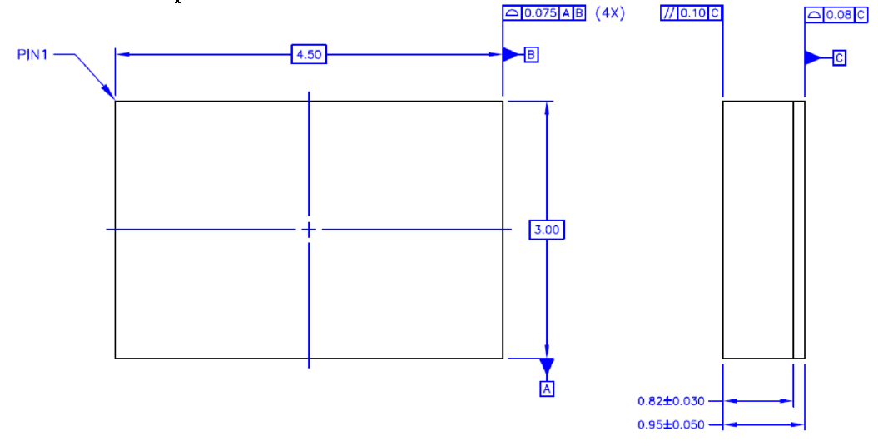
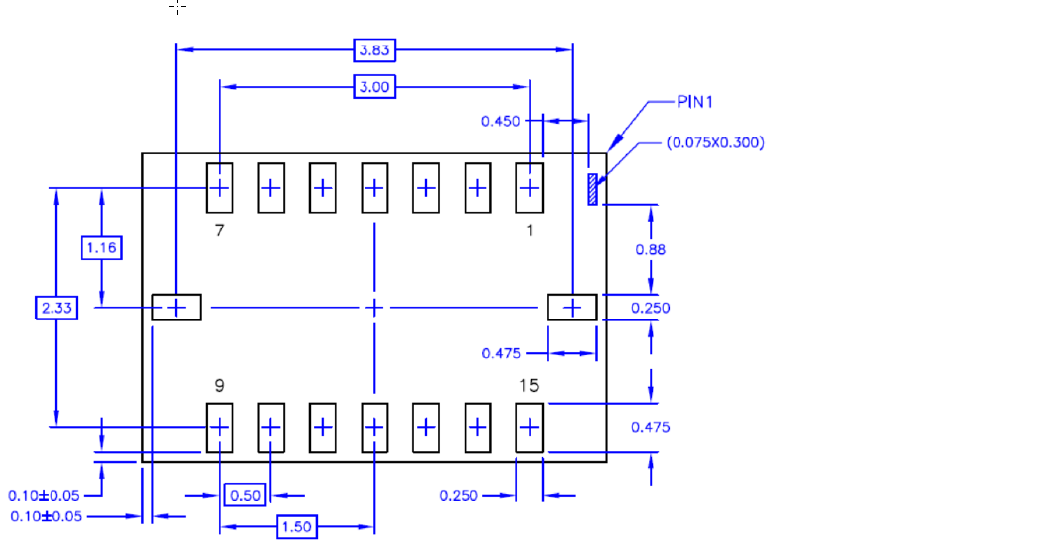


54 |
62
Bosch Sensortec | BMI088 Data sheet
8.
Package
8.1
Outline Dimensions
The sensor housing is a standard LGA package. Its dimensions are the following.
Unit is mm. Note: Unless otherwise specified tolerance = decimal ± 0.05

Top view

Figure 10: Package outline dimensions

Bottom view

Figure 10: Package dimensions

Modifications reserved | Data subject to change without notice
Document number: BST-BMI088-DS000-18
Revision_1.8_012022

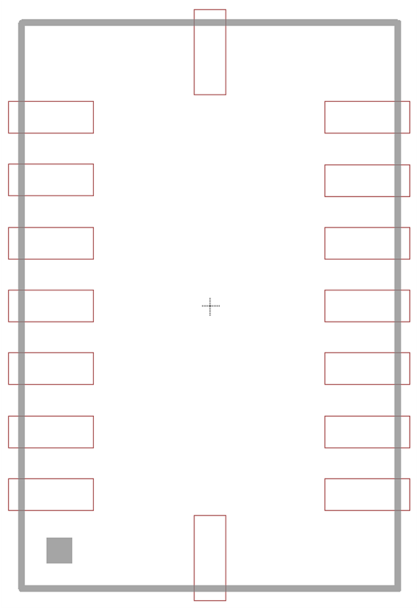


55 |
62
Bosch Sensortec | BMI088 Data sheet

8.2
Landing pattern

For the design of the landing patterns, we recommend the following dimensioning:

0.675

16

15
1
0.25

14
2

0.5

13
3

12
4
4.5

11
5

1.675

10
6

7
9

8

0.925

3.0

Figure 11: Landing pattern recommendation

Same tolerances as given for the outline dimensions in 8.1 should be assumed. A wiring no-go area in
the top layer of the PCB below the sensor is strongly recommended (e.g. no vias, wires or other metal
structures).

Modifications reserved | Data subject to change without notice
Document number: BST-BMI088-DS000-18
Revision_1.8_012022

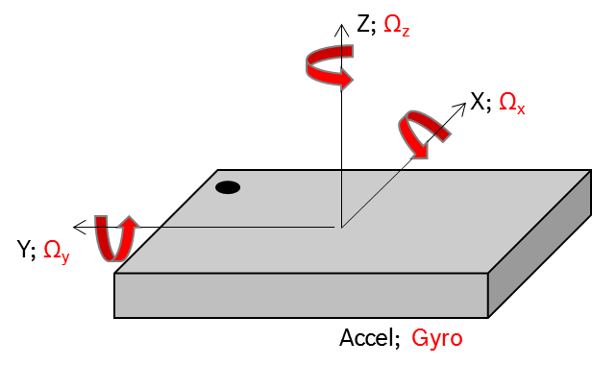



56 |
62
Bosch Sensortec | BMI088 Data sheet

8.3
Sensing axes orientation
If the sensor is accelerated and/or rotated in the indicated directions, the corresponding channels of the
device will deliver a positive acceleration and/or yaw rate signal (dynamic acceleration). If the sensor is
at rest without any rotation and the force of gravity is acting contrary to the indicated directions, the
output of the corresponding acceleration channel will be positive and the corresponding gyroscope
channel will be “zero” (static acceleration).

Example: If the sensor is at rest or at uniform motion in a gravity field according to the figure given below,
the output signals are:

GYR channel
•

0g for the X ACC channel

and
0°/sec for the Ω
X
GYR channel
•

0g for the Y ACC channel

and
0°/sec for the Ω
Y
GYR channel
•

+ 1g for the Z ACC channel

and
0°/sec for the Ω
Z

force
of gravity

Figure 12: Orientation of sensing axis

The following table lists all corresponding output signals on X, Y, Z while the sensor is at rest or at
uniform motion in a gravity field under assumption of a top down gravity vector as shown above.
, Ω
, Ω
show 0dps output under these static conditions.
The gyroscope signals Ω
X
Y
Z

Table 15: Output signals depending on device orientation

Sensor orientation

(gravity vector )

o

o

upright
upright

o

o

Output Signal X
0g
+1g
0g
-1g
0g
0g
Output Signal Y
-1g
0g
+1g
0g
0g
0g
Output Signal Z
0g
0g
0g
0g
+1g
-1g

Modifications reserved | Data subject to change without notice
Document number: BST-BMI088-DS000-18
Revision_1.8_012022



57 |
62
Bosch Sensortec | BMI088 Data sheet
8.4
Marking
Mass production samples
8.4.1
Table 16: Marking of mass production parts
Labeling
Name
Symbol
Remark

Product number
365
3 numeric digits, fixed to identify
product type
365
LYYWW
Sub-con ID
L
1 alphanumeric digit,
variable to identify sub-con
CCC
Date-Code
YYWW
4 numeric digits, fixed to identify YY = “year”
WW = “working week
Lot counter
CCC
3 alphanumeric digits, variable
to generate mass production trace-code
•
Pin 1 identifier

--

Engineering samples
8.4.2
Table 17: Marking of engineering samples
Labeling
Name
Symbol
Remark

Eng. sample ID
N
1 alphanumeric digit, fixed to identify
engineering sample, N = “+” or “e” or “E”
088N
PYYWW
Sample ID
PYYWW
P: assembly house
YYWW: Year (last 2 digits)/Work week
Counter ID
CC
C-samples; lot number
th
(e.g.C5: C-samples, 5
lot)
CC
•
Pin 1 identifier

--

8.5
PCB layout and soldering guidelines
The following general layout rules are recommended
•

PCB land width = LGA solder pin width
•

PCB land length = LGA solder pin length + 0.1 mm on each side
•

Solder mask opening width = PCB land width + 0.05 mm on each side
•

Solder mask opening length = PCB land length + 0.05 mm on each side

Recommendation about stencil design and solder paste application
•

It is recommended to keep the openings of the stencil mask for the signal pads between 70%
and 90% of the PCB pad area.
•

An accurate alignment of the stencil and the printed circuit board (within 0.025mm) is
recommended.
•

A stencil thickness of 80 – 150 μm is recommended for screen printing

Modifications reserved | Data subject to change without notice
Document number: BST-BMI088-DS000-18
Revision_1.8_012022

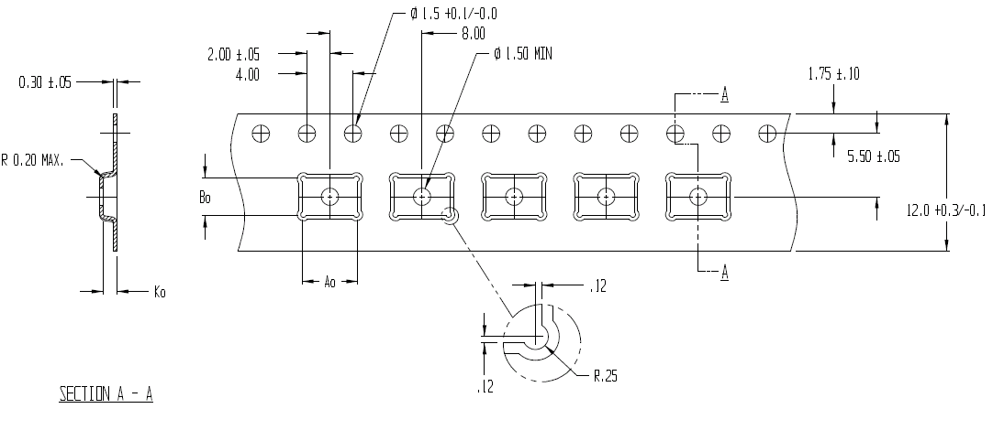


58 |
62
Bosch Sensortec | BMI088 Data sheet
The moisture sensitivity level (MSL) of the BMI088 sensors corresponds to JEDEC Level 1. See also:
•

IPC/JEDEC J-STD-020E “Joint Industry Standard: Moisture/Reflow Sensitivity Classification
for non-hermetic Solid State Surface Mount Devices”
•

IPC/JEDEC J-STD-033D “Joint Industry Standard: Handling, Packing, Shipping and Use of
Moisture/Reflow Sensitive Surface Mount Devices”

The sensor fulfils the lead-free soldering requirements of the above-mentioned IPC/JEDEC standard,
i.e. reflow soldering with a peak temperature up to 260°C.

For more details, refer the Handling, Soldering and Mounting Instructions document available at
https://www.bosch-sensortec.com/bst/support_tools/downloads/overview_downloads

8.6
Handling instructions
Micromechanical sensors are designed to sense acceleration with high accuracy even at low amplitudes
and contain highly sensitive structures inside the sensor element. The MEMS sensor can tolerate
mechanical shocks up to several thousand g’s. However, these limits might be exceeded in conditions
with extreme shock loads such as e.g. hammer blow on or next to the sensor, dropping of the sensor
onto hard surfaces etc.

We recommend to avoid g-forces beyond the specified limits during transport, handling and mounting
of the sensors in a defined and qualified installation process.

This device has built-in protections against high electrostatic discharges or electric fields (e.g. 2kV
HBM); however, anti-static precautions should be taken as for any other CMOS component. Unless
otherwise specified, proper operation can only occur when all terminal voltages are kept within the
supply voltage range. Unused inputs must always be tied to a defined logic voltage level.

8.7
Tape and Reel specification
BMI088 is shipped in a standard cardboard box. The box dimension for each reel is L x W x H = 35cm
x 35cm x 5cm. Each reel contains 5,000pcs of BMI088.
A
= 4.85; B
= 3.35; K
= 1.20
0
0
0

Tape and reel dimensions in mm
Modifications reserved | Data subject to change without notice
Document number: BST-BMI088-DS000-18
Revision_1.8_012022

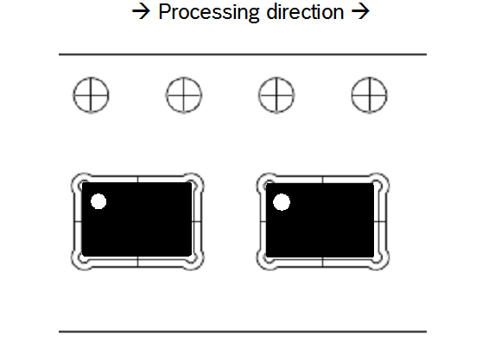


59 |
62
Bosch Sensortec | BMI088 Data sheet
Orientation within the reel
8.7.1

Orientation of the BMI088 devices relative to the tape

8.8
Environmental safety
The BMI088 sensor meets the requirements of the EC restriction of hazardous substances (RoHS)
directive, see also:

RoHS–Directive 2011/65/EU and its amendments, including the amendment 2015/863/EU on the
restriction of the use of certain hazardous substances in electrical and electronic equipment.

Halogen content
8.8.1
The BMI088 is halogen-free. For more details on the analysis results please contact your Bosch
Sensortec representative.

Modifications reserved | Data subject to change without notice
Document number: BST-BMI088-DS000-18
Revision_1.8_012022



60 |
62
Bosch Sensortec | BMI088 Data sheet
9.
Legal Disclaimer
9.1
Engineering samples
Engineering Samples are marked with an asterisk (*), (E) or (e). Samples may vary from the valid
technical specifications of the product series contained in this data sheet. They are therefore not
intended or fit for resale to third parties or for use in end products. Their sole purpose is internal client
testing. The testing of an engineering sample may in no way replace the testing of a product series.
Bosch Sensortec assumes no liability for the use of engineering samples. The Purchaser shall indemnify
Bosch Sensortec from all claims arising from the use of engineering samples.
9.2
Product use
Bosch Sensortec products are developed for the consumer goods industry. They may only be used
within the parameters of this product data sheet. They are not fit for use in life-sustaining or safety-
critical systems. Safety-critical systems are those for which a malfunction is expected to lead to bodily
harm, death or severe property damage. In addition, they shall not be used directly or indirectly for
military purposes (including but not limited to nuclear, chemical or biological proliferation of weapons or
development of missile technology), nuclear power, deep sea or space applications (including but not
limited to satellite technology).

Bosch Sensortec products are released on the basis of the legal and normative requirements relevant
to the Bosch Sensortec product for use in the following geographical target market: BE, BG, DK, DE,
EE, FI, FR, GR, IE, IT, HR, LV, LT, LU, MT, NL, AT, PL, PT, RO, SE, SK, SI, ES, CZ, HU, CY, US, CN,
JP, KR, TW. If you need further information or have further requirements, please contact your local sales
contact.

The resale and/or use of Bosch Sensortec products are at the purchaser’s own risk and his own
responsibility. The examination of fitness for the intended use is the sole responsibility of the purchaser.

The purchaser shall indemnify Bosch Sensortec from all third party claims arising from any product use
not covered by the parameters of this product data sheet or not approved by Bosch Sensortec and
reimburse Bosch Sensortec for all costs in connection with such claims.

The purchaser accepts the responsibility to monitor the market for the purchased products, particularly
with regard to product safety, and to inform Bosch Sensortec without delay of all safety-critical incidents.
9.3
Application examples and hints
With respect to any examples or hints given herein, any typical values stated herein and/or any
information regarding the application of the device, Bosch Sensortec hereby disclaims any and all
warranties and liabilities of any kind, including without limitation warranties of non-infringement of
intellectual property rights or copyrights of any third party. The information given in this document shall
in no event be regarded as a guarantee of conditions or characteristics. They are provided for illustrative
purposes only and no evaluation regarding infringement of intellectual property rights or copyrights or
regarding functionality, performance or error has been made.

Modifications reserved | Data subject to change without notice
Document number: BST-BMI088-DS000-18
Revision_1.8_012022



61 |
62
Bosch Sensortec | BMI088 Data sheet
10. Document History and Modification

Rev. No
Chapter
Description of modification/changes
Date
1.0
-
Initial release
03-Dec-2017
1.1
All
Typos
30-Jan-2018
3 + 4.1.1
5.2
1.2
5.3.6
23-Mar-2018
5.2+5.3.10+5.3.11
Updated switching between power modes
Fixed typo in register range
Added clearing condition of data ready int bit
Corrected INT pin settings bits
5.4
Fixed typo in bit naming in register 0x16
1.3
7.1
Updated pin 14 assignment in I2C mode
27-Apr-2018
4.4.1 + 5.2 + 5.3.8
Clarified how to set Accel bandwidth setting
4.9
Included info on FIFO
5.3.4
1.4
Corrected conversion from LSB to mg
7.2 + 7.3
16-Sep-2018
Updated pin 4 and 6 assignment in SPI/I2C mode
7.2
Clarified connection to SPI host interface
8.3
Updated marking
8.6
Included tape & reel specifications
4.9.1 – 4.9.4
Updated FIFO details
5.2, 5.4
Updated Register Maps with FIFO content
5.5.10
1.5
Updated reset values of Gyro Reg 0x16
8.2
07-Feb-2020
Included landing pattern
8.4.1
Corrected lot counter typo
8.5, 8.8
Updated content
9
Updated product use disclaimer
1.6
9
Disclaimer update
18-Nov-2020
8.8
Environmental safety – RoHS directive update
1.7
3
Device Initialization chapter update
08-Nov-2021
6.2
Timing t
update
IDLE_wacc_sum
1.8
4.8
Soft Reset chapter updated
17-Jan-2022

Modifications reserved | Data subject to change without notice
Document number: BST-BMI088-DS000-18
Revision_1.8_012022




62 |
62
Bosch Sensortec | BMI088 Data sheet

Bosch Sensortec GmbH
Gerhard-Kindler-Straße 9
72770 Reutlingen / Germany

contact@bosch-sensortec.com
www.bosch-sensortec.com

Modifications reserved
Specifications subject to change without notice
Document number: BST-BMI088-DS000-18
Revision_1.8_012022
Modifications reserved | Data subject to change without notice
Document number: BST-BMI088-DS000-18
Revision_1.8_012022

