Data Collection (A Component)

A1: Google Search Index Counts (A1 in Figure 4 in the manuscript)
Google Search index counts were collected through a controlled manual querying protocol to ensure temporal consistency across competing brands. Queries followed a standardized template:
"<Brand Name>" after:YYYY-MM-DD before:YYYY-MM-DD
All brands were queried simultaneously using identical temporal windows to avoid normalization distortions caused by asynchronous Google indexing behavior. This procedure was preferred over automated scraping to comply with Google platform policies.
Representative examples of extracted results are provided in the archived datasets on Mendeley Data.
For example, the queries:
"Irancell" after:2014-01-01 before:2014-02-01
"Irancell" after:2014-02-01 before:2014-03-01

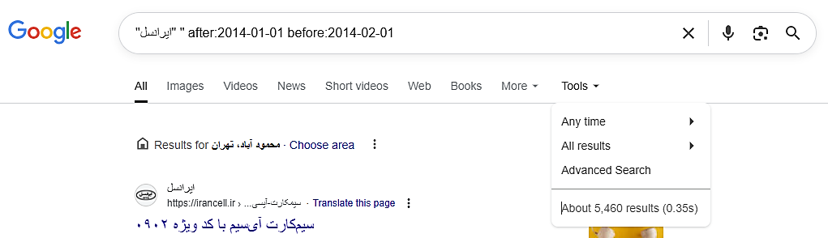
Figure 2 Download the monthly Values from the Google Search Engine

A2: Google Trends Timeline
Google Trends Timeline was obtained via the official Google Trends export interface. The final datasets relied on official exports to ensure stability and consistency. Download the CSV file from the Google Trends web GUI.
https://trends.google.com/trends/explore?date=2014-01-01%202024-12-31&q=همراه%20اول,ایرانسل&hl=en

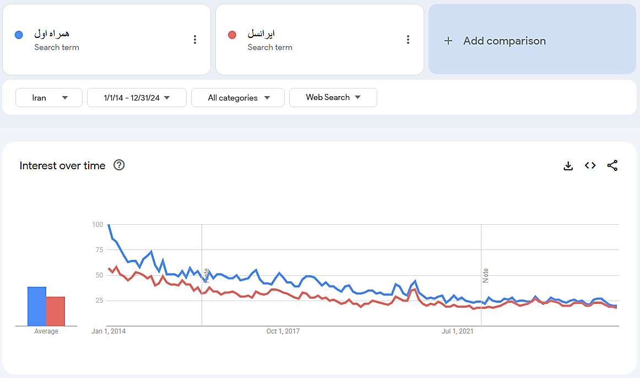
Figure 3 Download the ten-year timeline CSV File From the Google Trends Web GUI

A3: Google Trends Related Queries
The third dataset consists of monthly related search queries obtained from the “Related Queries” section of Google Trends for both target brands. These related queries offer insights into specific user intents and behaviors beyond the main brand search.
For each month between 2014 and 2024, related query data was downloaded as CSV files using Google Trends' built-in export functionality. To enrich this dataset, we manually added a sentiment column to each query. Specifically:
- A subset of 3,762 unique queries was labeled by three independent annotators as positive, negative, or neutral based on domain-specific criteria.
For example, the query:
https://trends.google.com/trends/explore?date=2024-01-01%202024-02-01&q=همراه%20اول,ایرانسل&hl=en

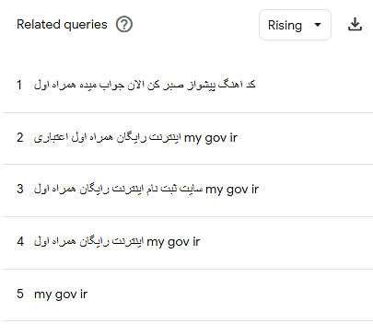
Figure 4 Download the monthly related query CSV File From the Google Trends Web GUI

All datasets used in the study are publicly archived with permanent DOIs on Mendeley Data, as reported in the Data Availability section of the manuscript.

