Optimization
The healthcare department attempting to use the resources more efficiently. It already has some queries that are being used for different purposes. The management suspects that these queries might not be efficient so they have requested to optimize the existing queries wherever necessary.
Given are some queries written in SQL server which may be optimized if necessary.

Query 1:
-- For each age(in years), how many patients have gone for treatment?
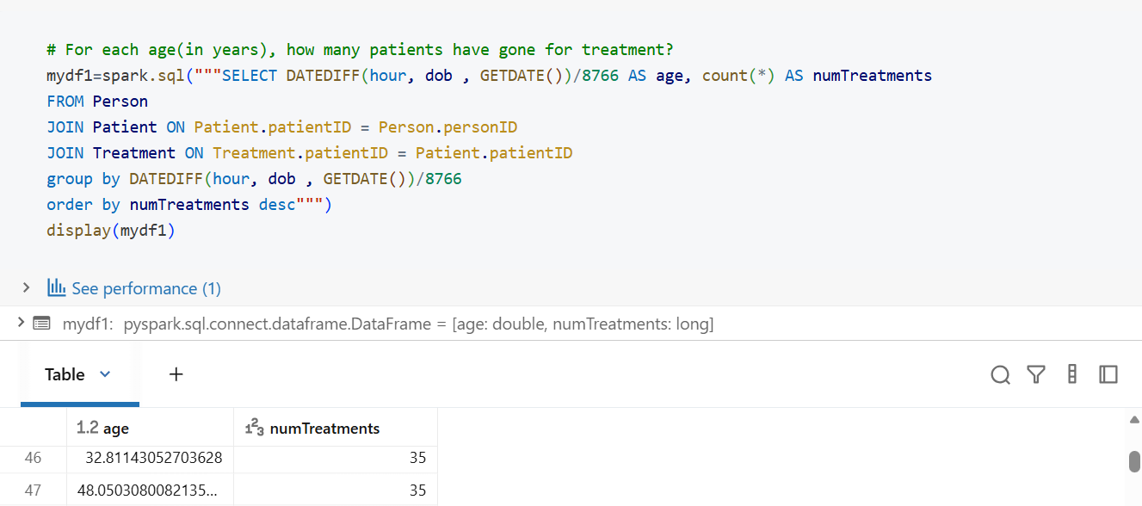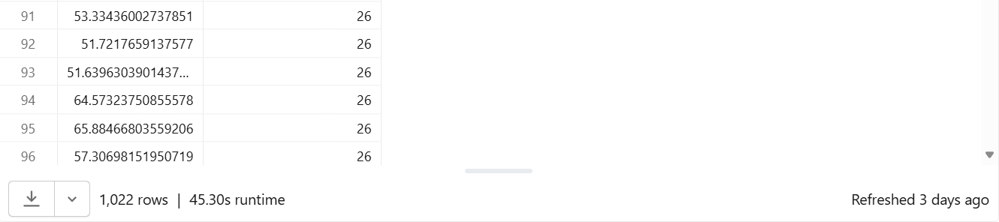

Output:
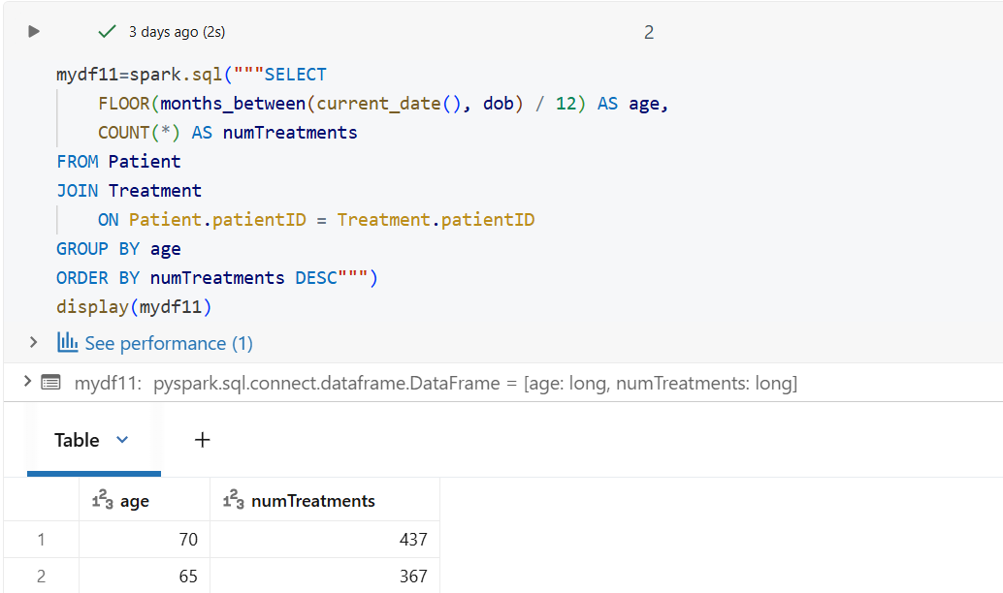
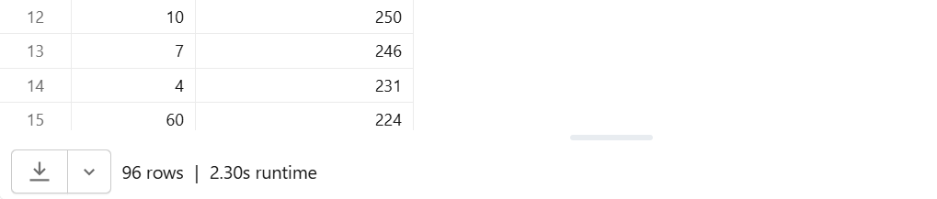
Query 2:
-- For each city, Find the number of registered people, number of pharmacies, and number of insurance companies.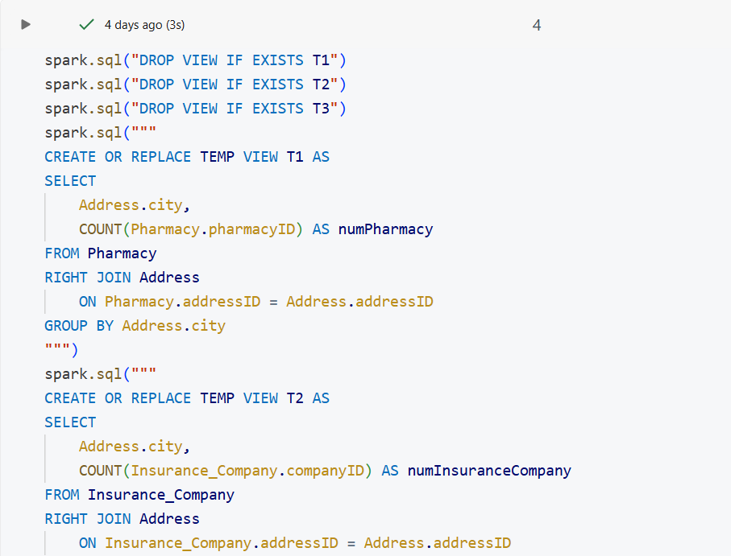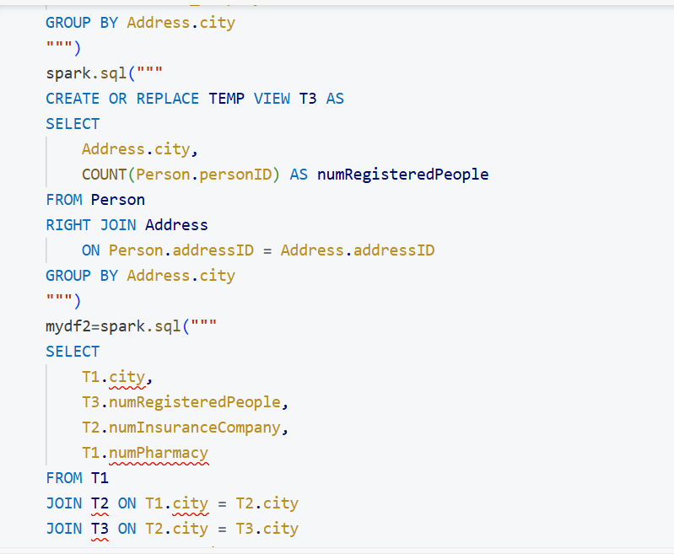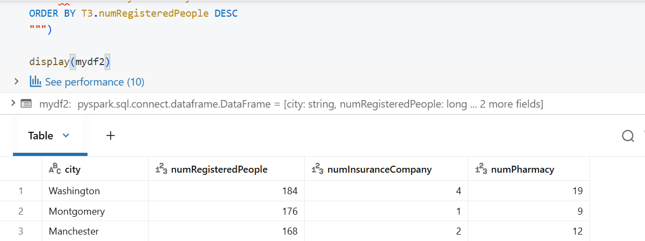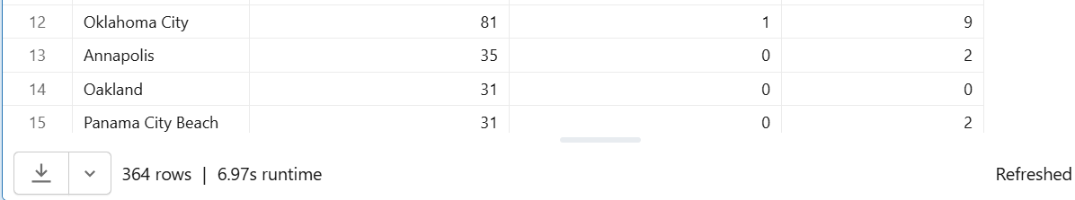

Output:
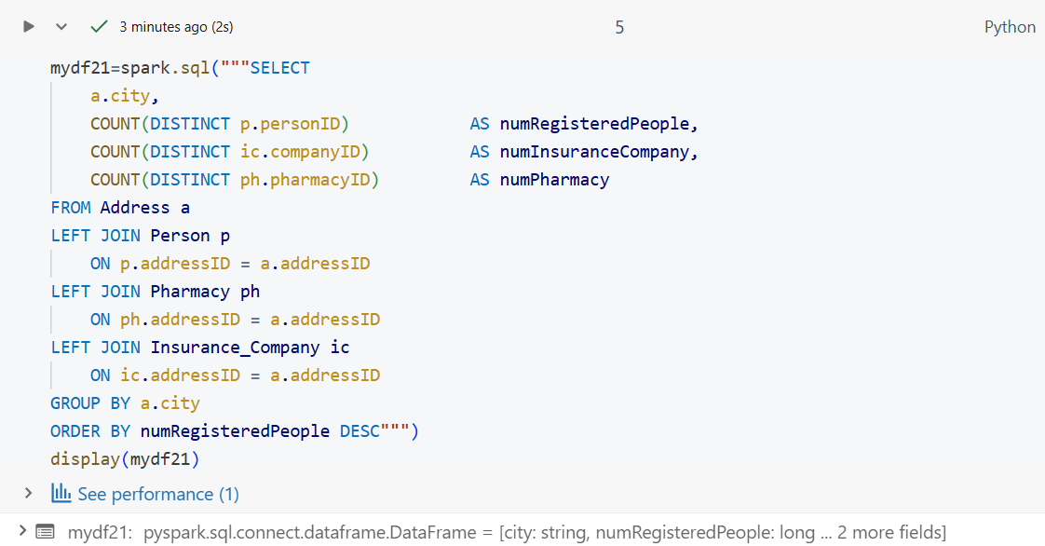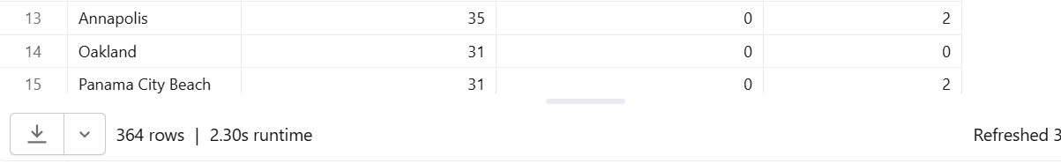
Query 3:
-- Total quantity of medicine for each prescription prescribed by Ally Scripts
-- If the total quantity of medicine is less than 20 tag it as "Low Quantity".
-- If the total quantity of medicine is from 20 to 49 (both numbers including) tag it as "Medium Quantity".
-- If the quantity is more than equal to 50 then tag it as "High quantity".
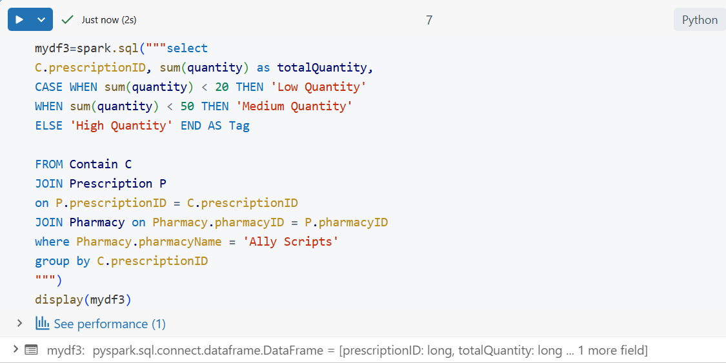Output:
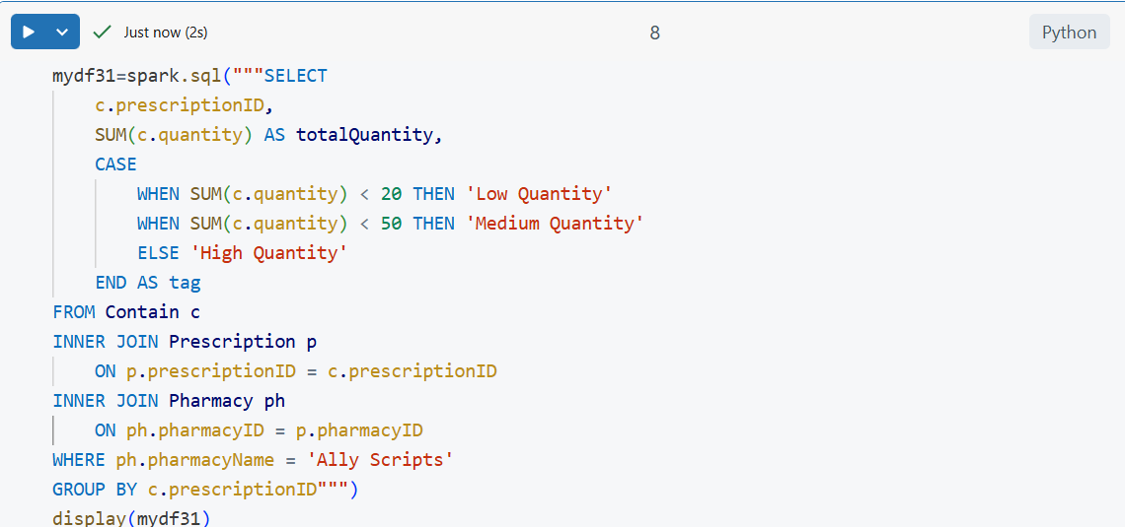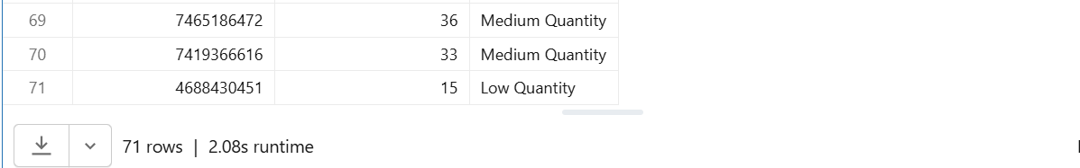Query 4:
-- The total quantity of medicine in a prescription is the sum of the quantity of all the medicines in the prescription.
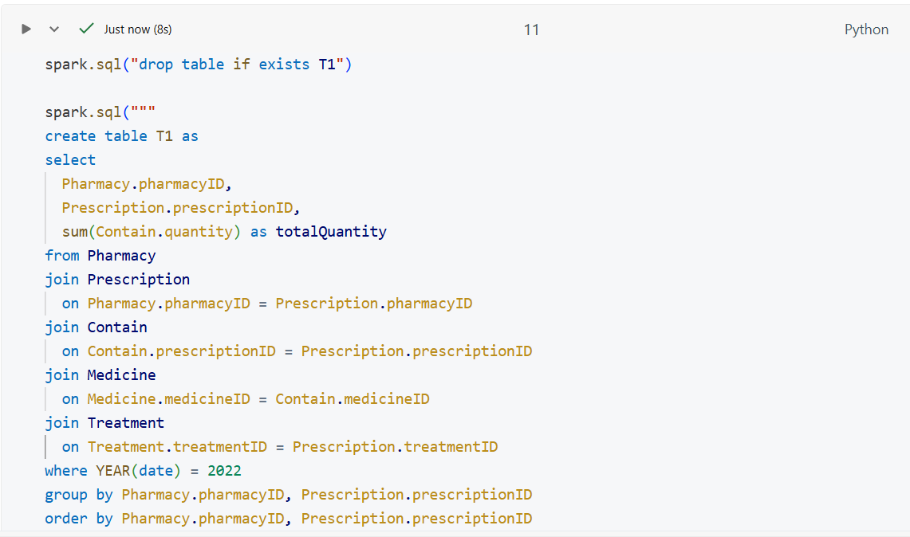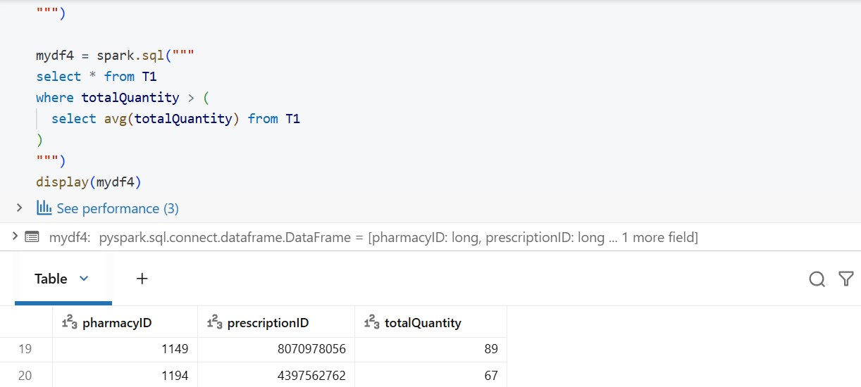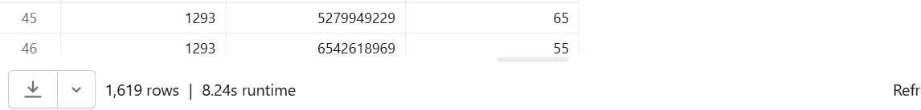

Output:
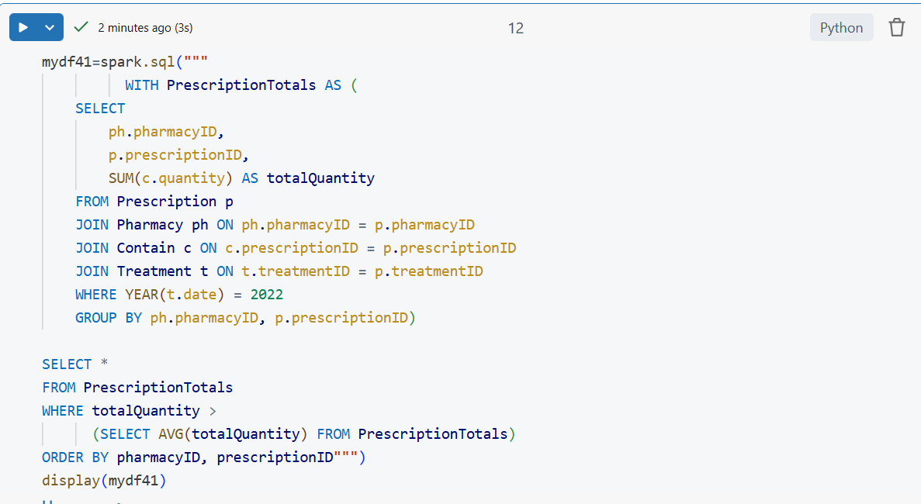Query 5:

-- Select every disease that has 'p' in its name, and
-- the number of times an insurance claim was made for each of them.

Output:
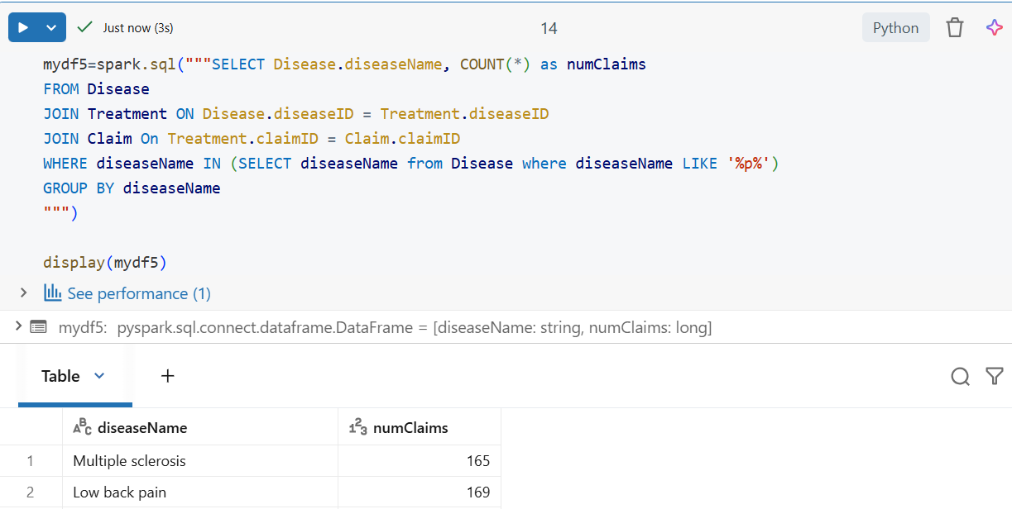
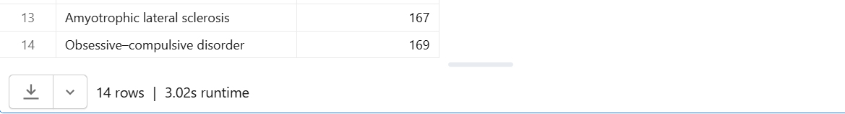Output:
