Name:I.karthik
Batch:08
R-no:2403A52200
Task Description#1 Basic Docstring Generation
- Write python function to return sum of even and odd numbers in the given list.
- Incorporate manual docstring in code with Google Style
- Use an AI-assisted tool (e.g., Copilot, Cursor AI) to generate a docstring describing the function.
- Compare the AI-generated docstring with your manually written one.

Expected Outcome#1: Students understand how AI can produce function-level documentation
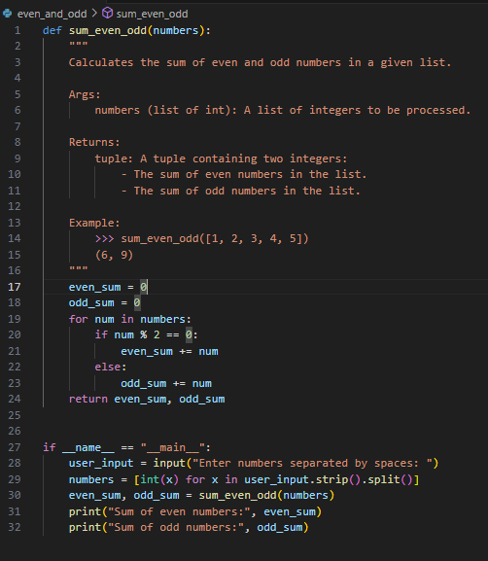
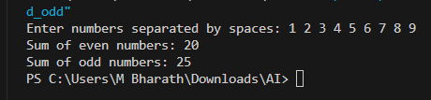
Manual Docstring:
"""
Calculates the sum of even and odd numbers in the provided input list.
input:
numbers (list of int): A list of integers.
Returns:
tuple: A tuple containing :
- The sum of even numbers.
- The sum of odd numbers.
"""
AI Generated Docstring:
"""
Calculates the sum of even and odd numbers in a given list.
Args:
numbers (list of int): A list of integers to be processed.
Returns:
tuple: A tuple containing two integers:
- The sum of even numbers in the list.
- The sum of odd numbers in the list.
Example:
>>> sum_even_odd([1, 2, 3, 4, 5])
(6, 9)
"""
Task Description#2 Automatic Inline Comments
- Write python program for sru_student class with attributes like name, roll no., hostel_status and fee_update method and display_details method.
- Write comments manually for each line/code block
- Ask an AI tool to add inline comments explaining each line/step.
- Compare the AI-generated comments with your manually written one.

Expected Output#2: Students critically analyze AI-generated code comments.

Manual Comments:
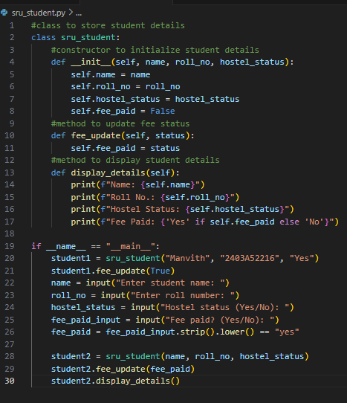
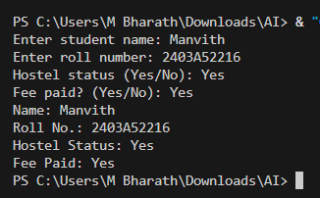
AI Generated Comments:
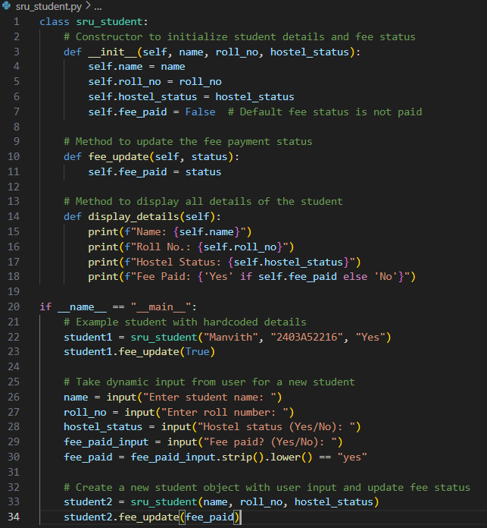

Task Description#3
- Write a Python script with 3–4 functions (e.g., calculator: add, subtract, multiply, divide).
- Incorporate manual docstring in code with NumPy Style
- Use AI assistance to generate a module-level docstring + individual function docstrings.
- Compare the AI-generated docstring with your manually written one.

Expected Output#3: Students learn structured documentation for multi-function scripts

Manual :
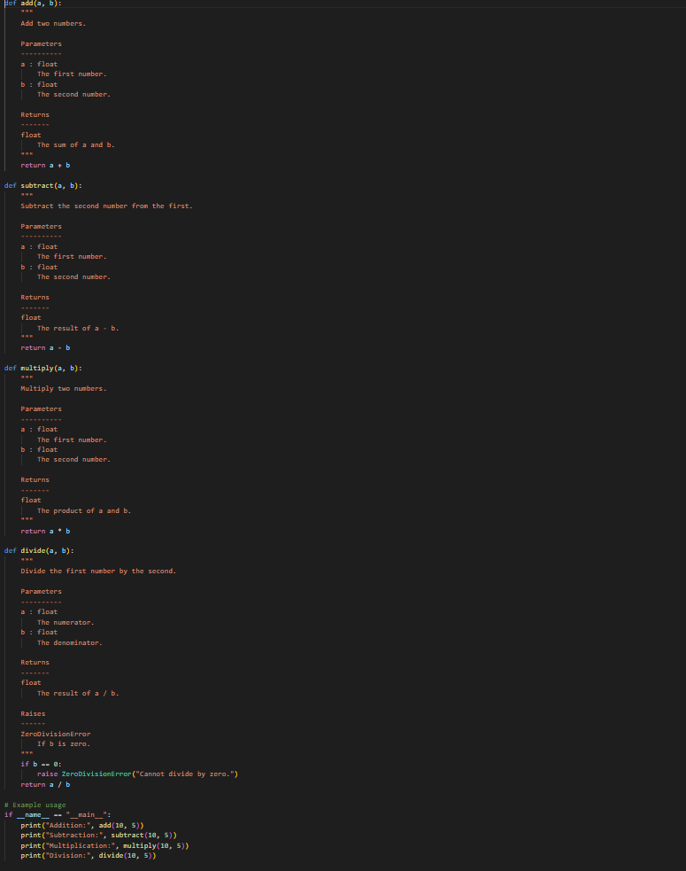
Prompt:
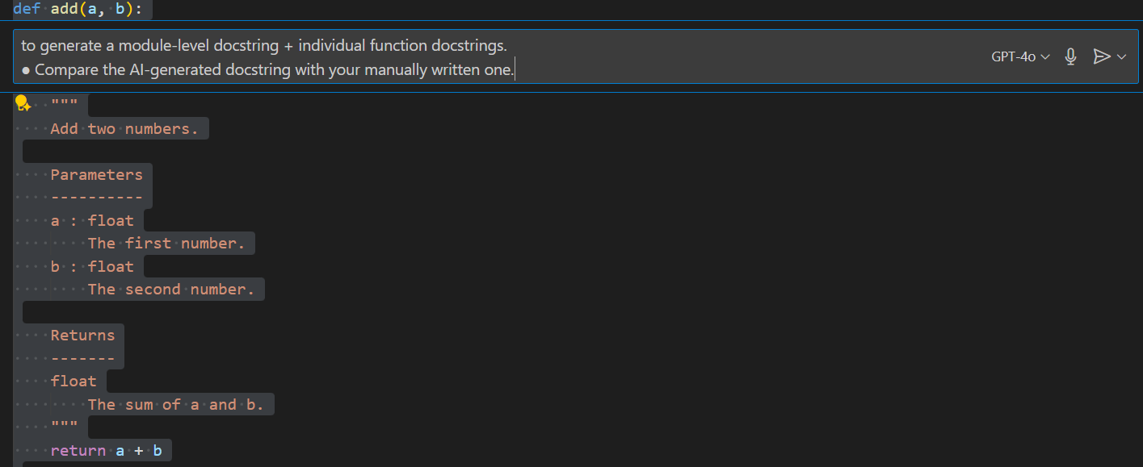
AI GENERATED COMMENTS:
