Name:I.karthik
Batch:08
R-no:2403A52200
Task 1 :

Prompt : - 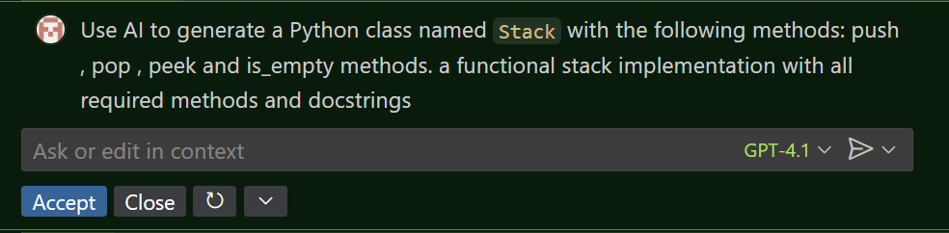
Code : - 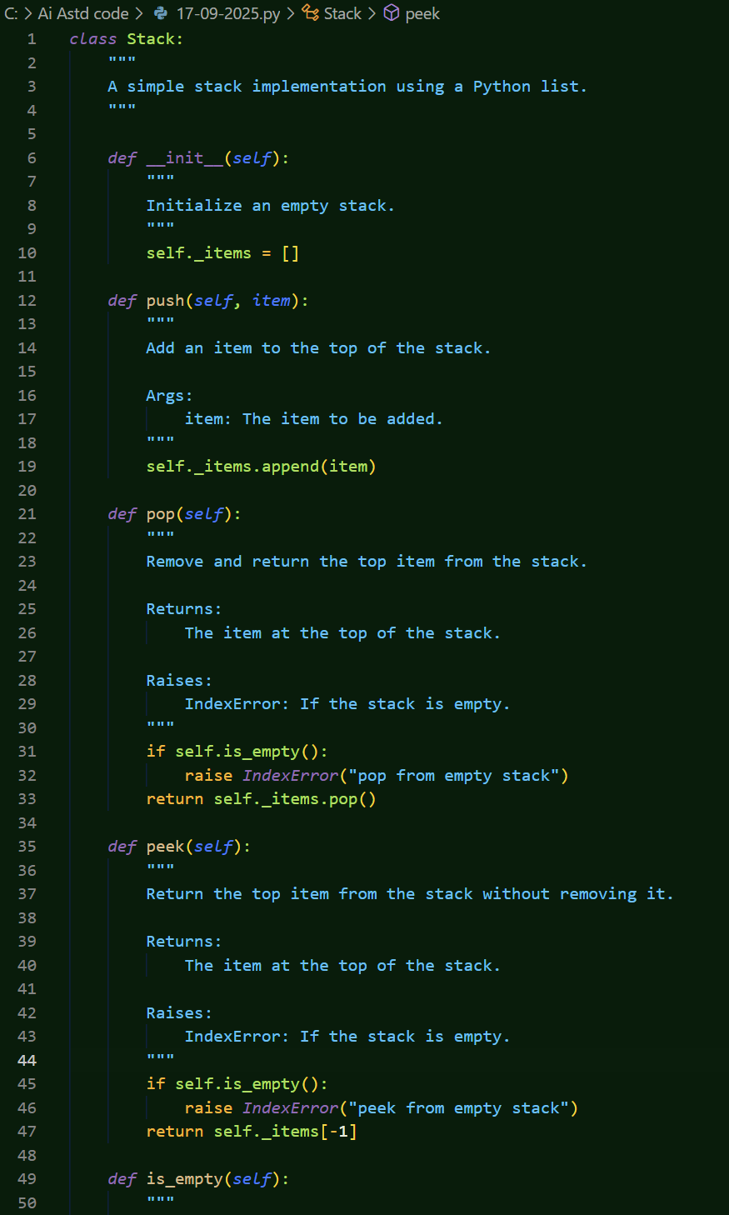
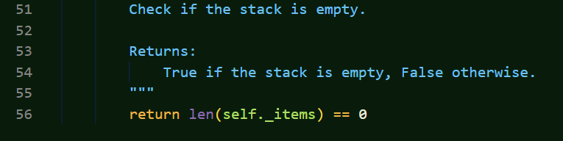

Task 2 _
Prompt :-

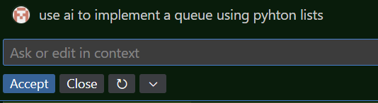

Code “_
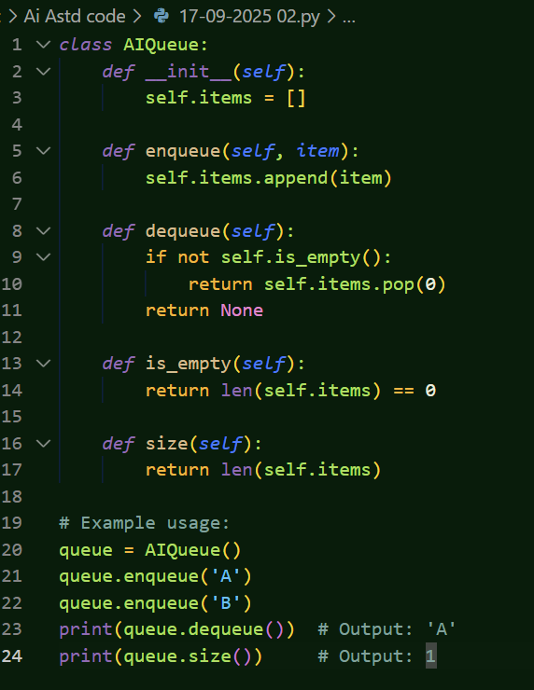
Task 3 –

Prompt :-
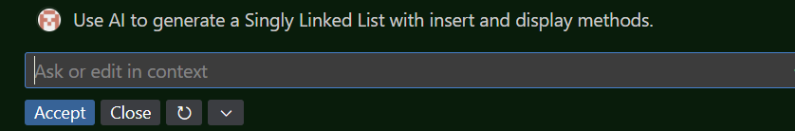

Code:-

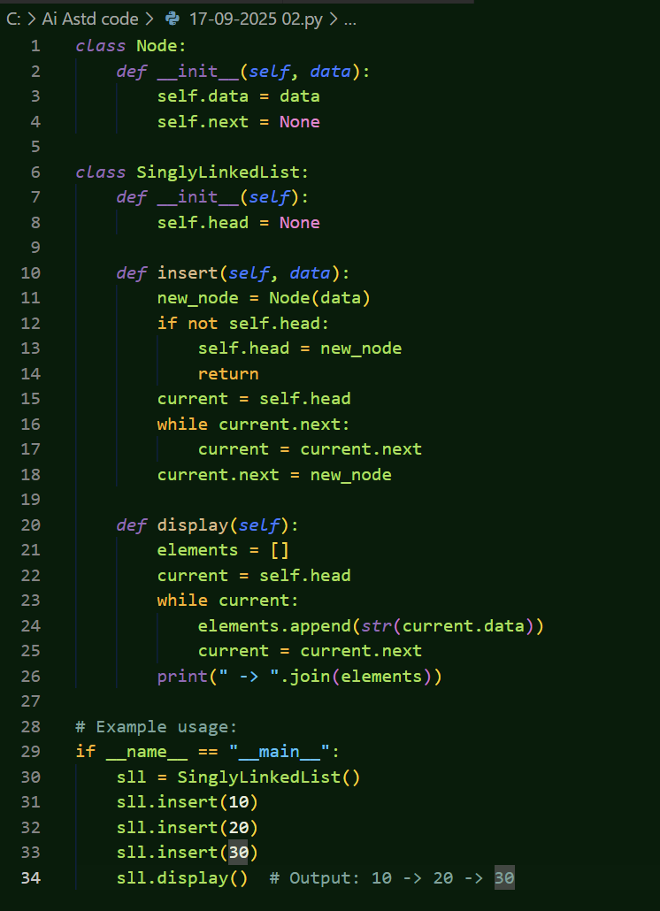

Task 4:-

Prompt :-

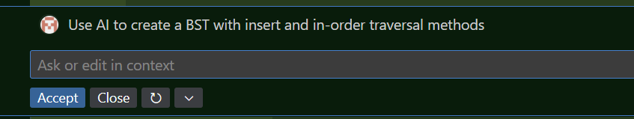

Code:-

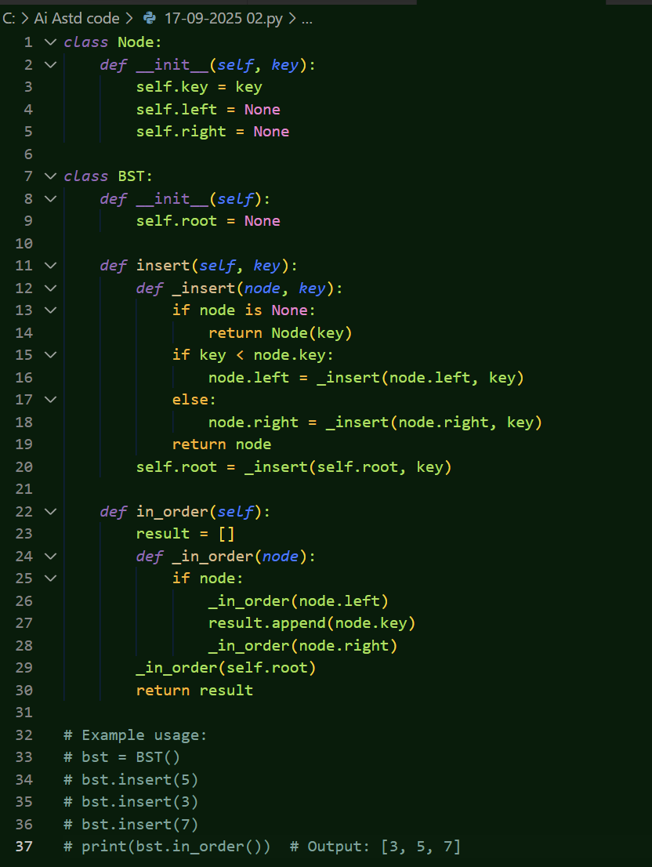

Task 5:-

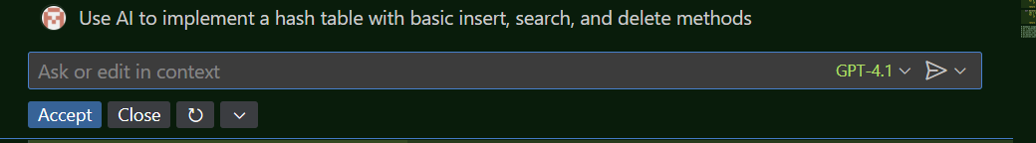

Code:-

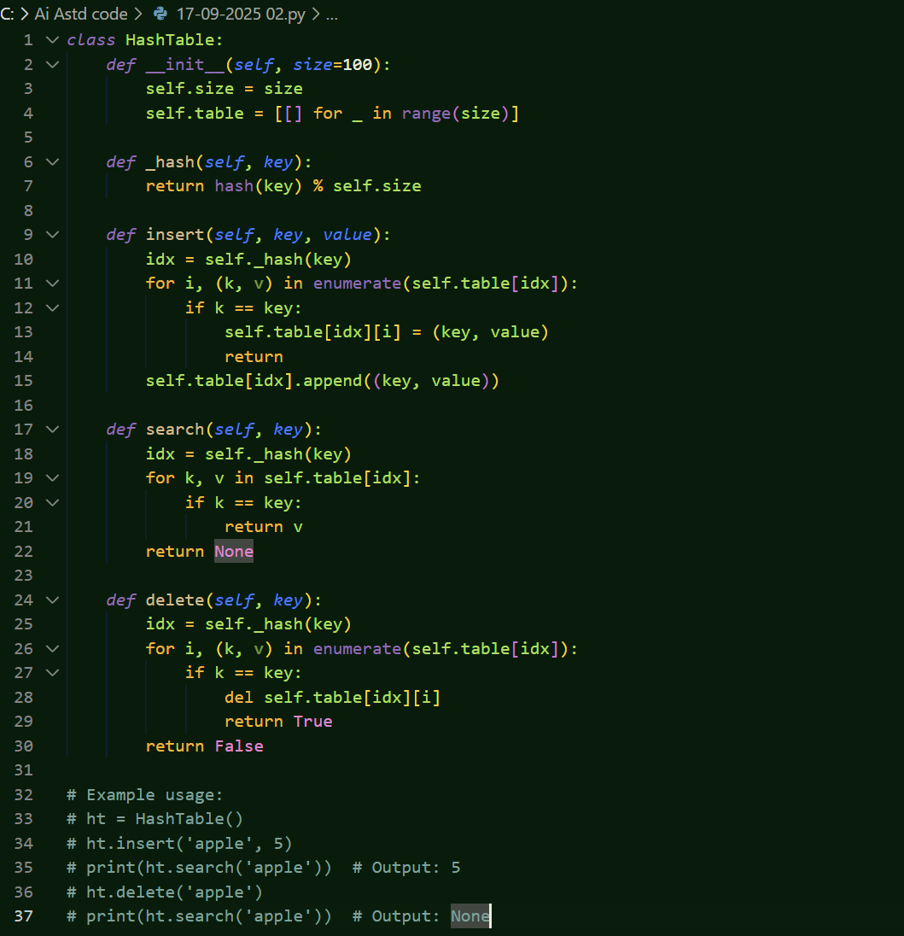

Task 6:- \
Prompt_

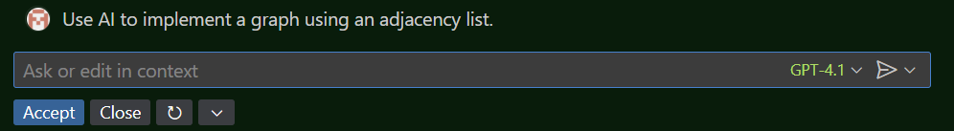

Code :-
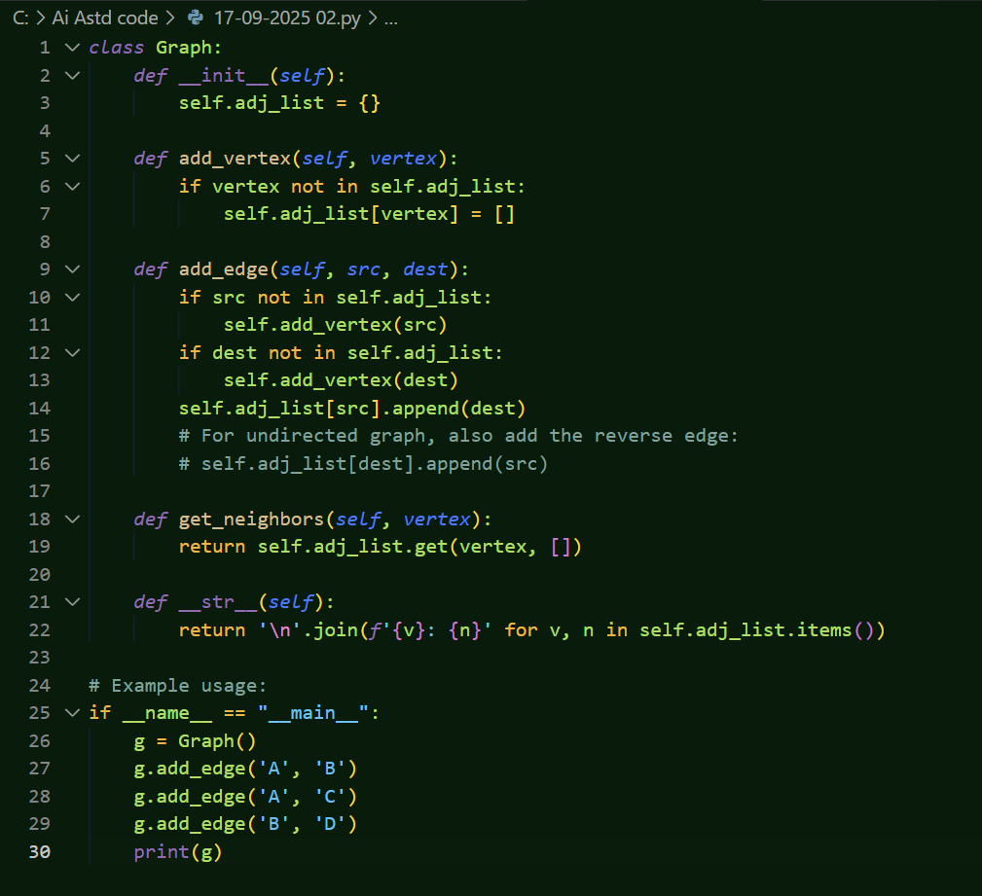

Task 7 :-

Prompt_
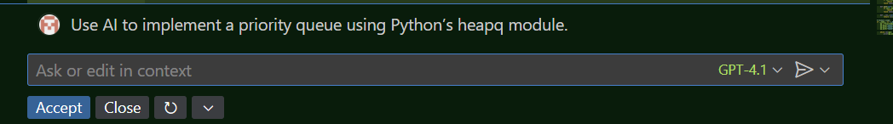

Code :-

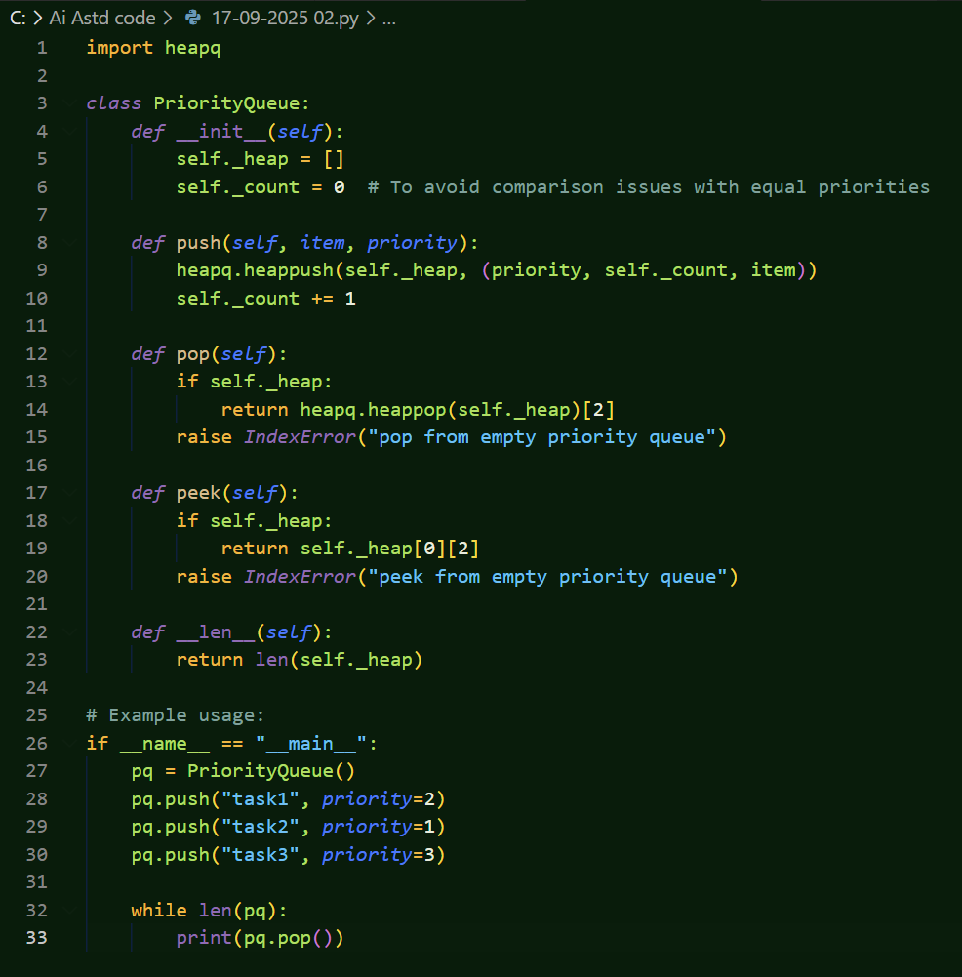

Task 8:--
Prompt :-

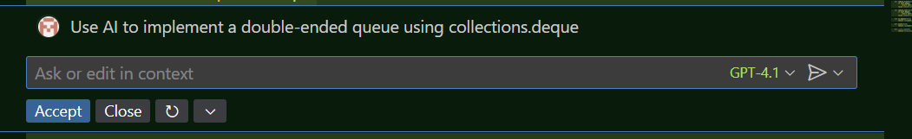

Code:-\

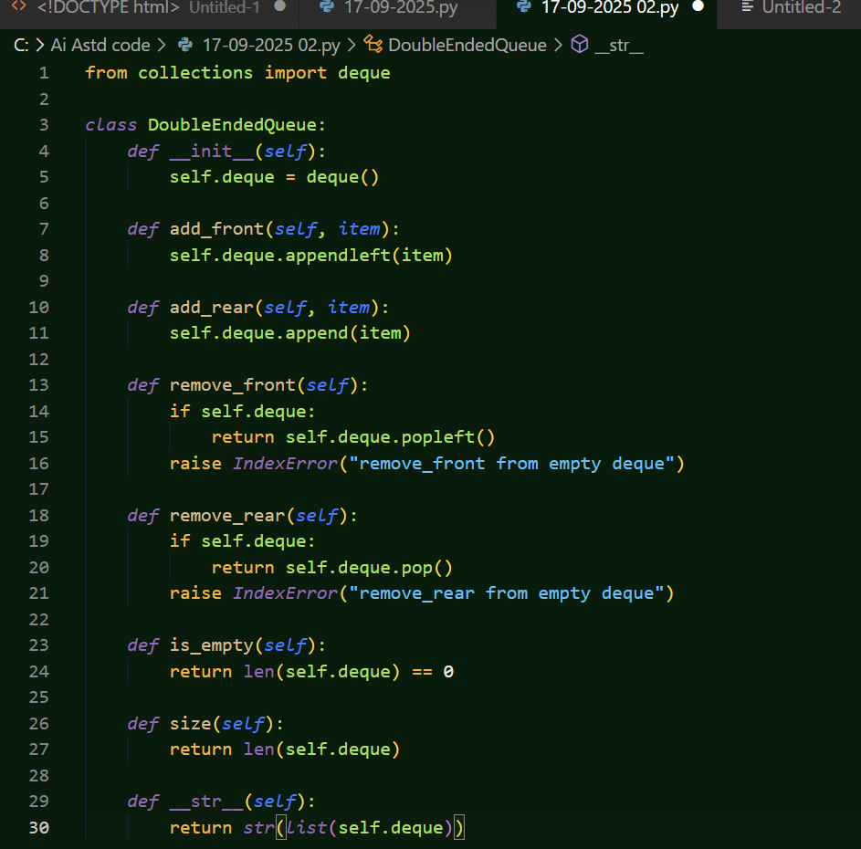
Task 9 :-
Prompt :-

Code:-
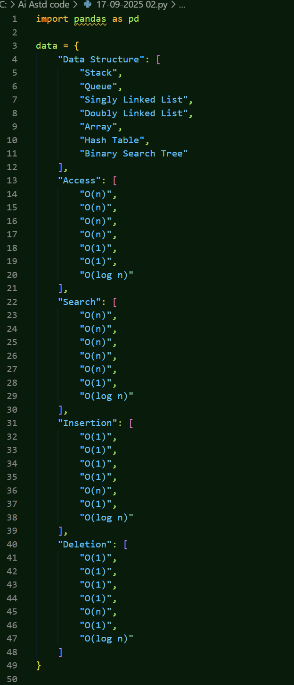

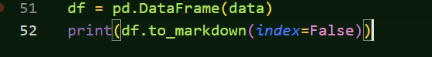

Task 10 :-

Prompt : -

