Name:I.karthik
Batch:08
R-no:2403A52200
Task #1
Prompt:
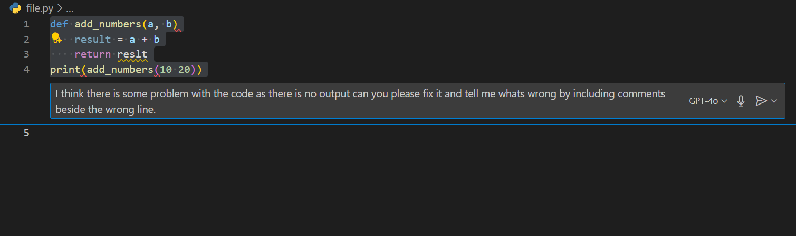
Code:
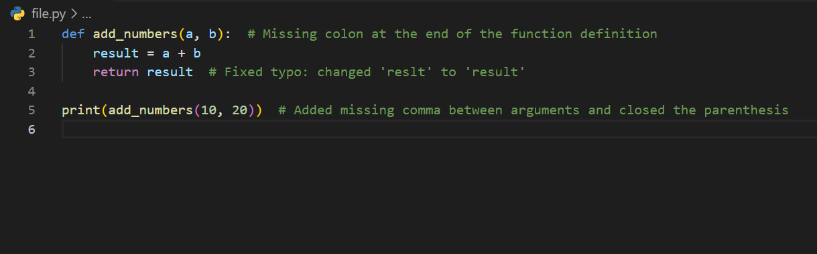
Output:
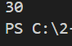
Task #2
Prompt:
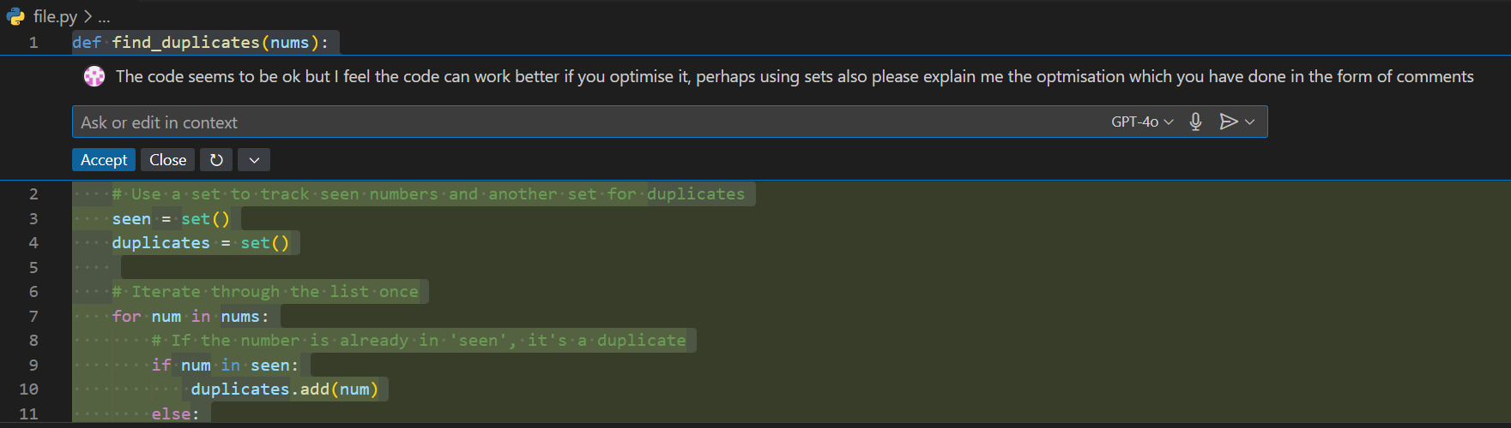
Code:
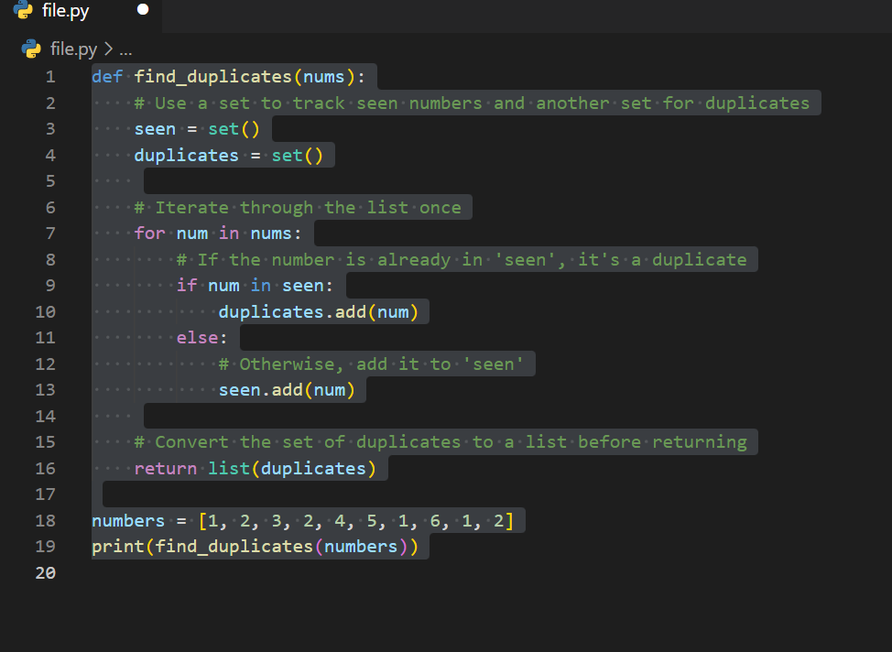
Output:

Task #3
Prompt:
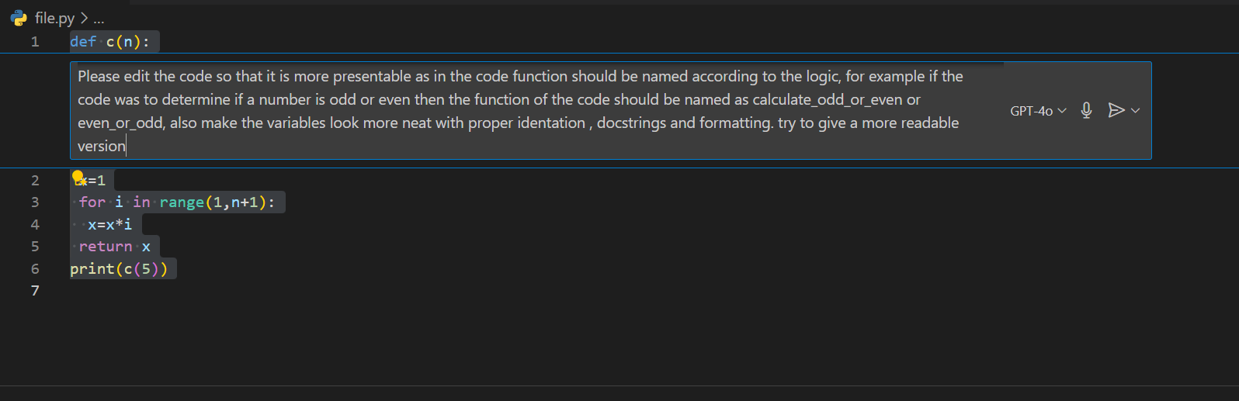

Output:
The code is optimized along with proper identation to even find factorials of big numbers as well.

Code:
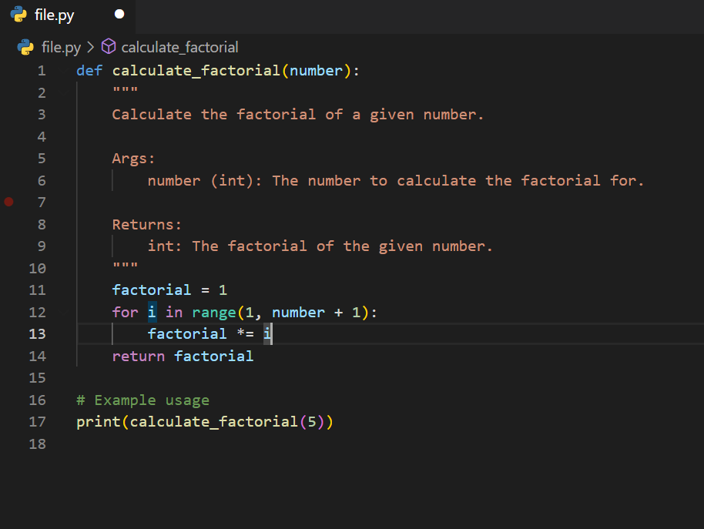

Task #4
Prompt:
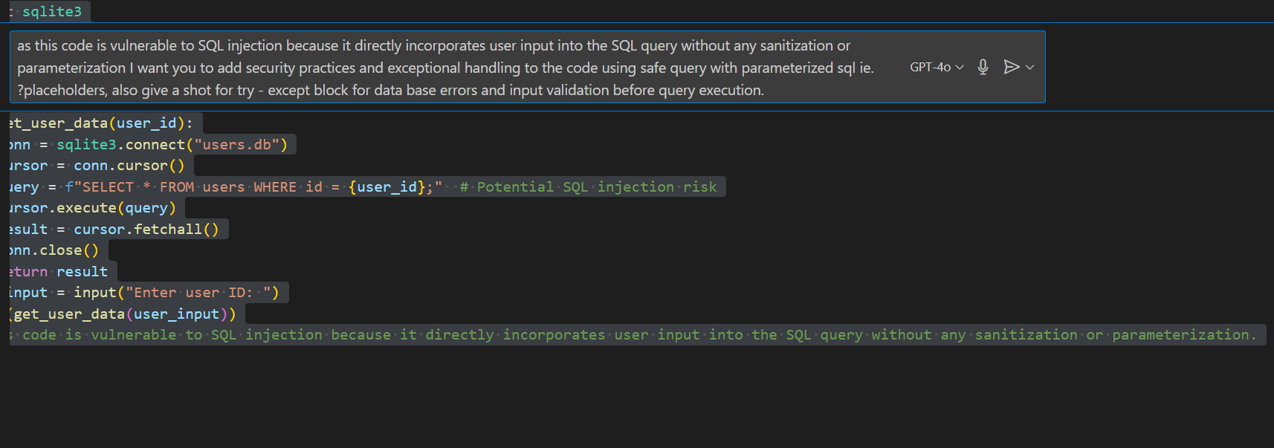

Output:

Code:
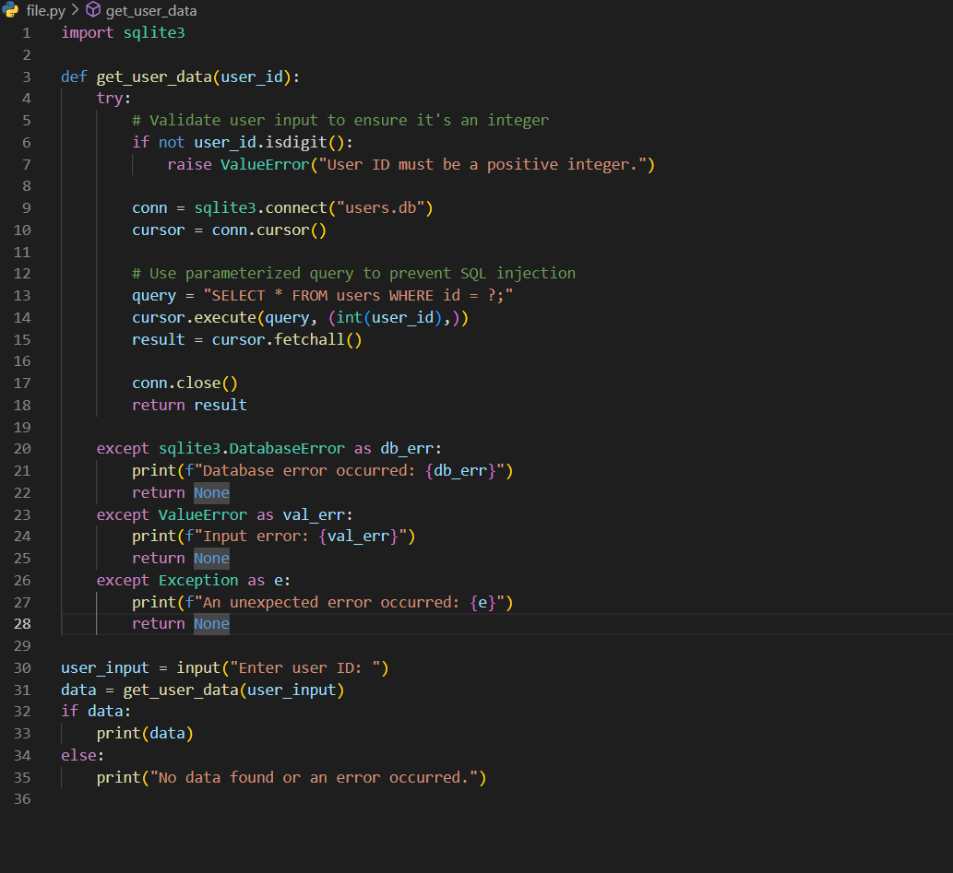
Task #5
prompt:
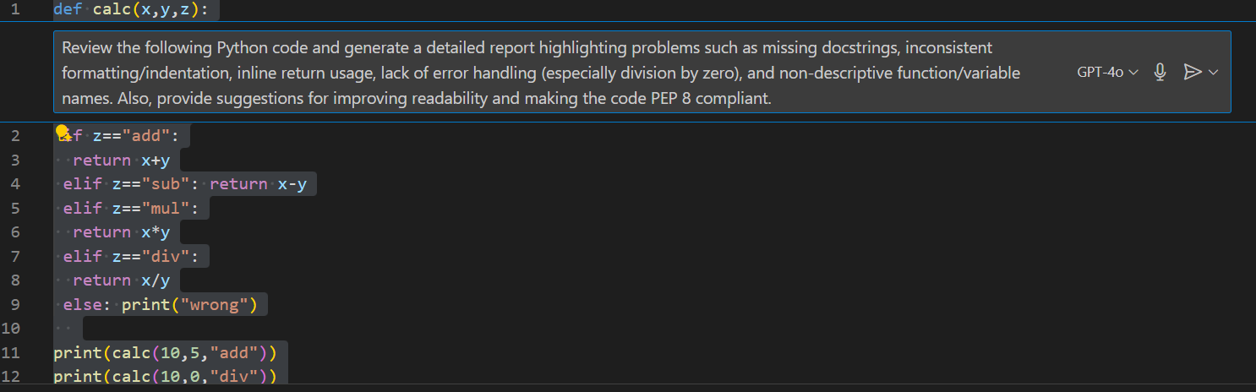
output:

code:
