Name:I.karthik
Batch:08
R-no:2403A52200
Task #1
Prompt:

Code:
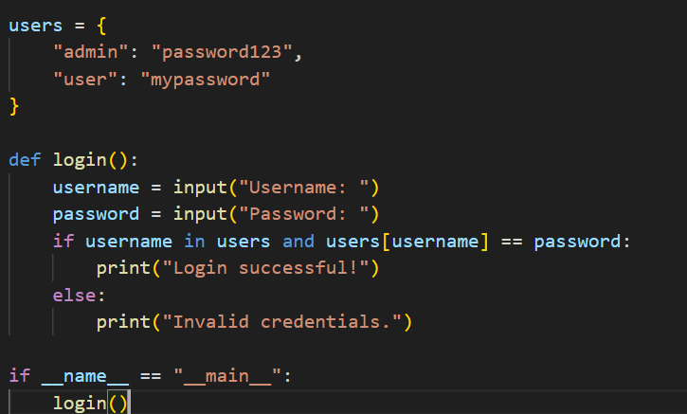
Secure Version Prompt:
Code:
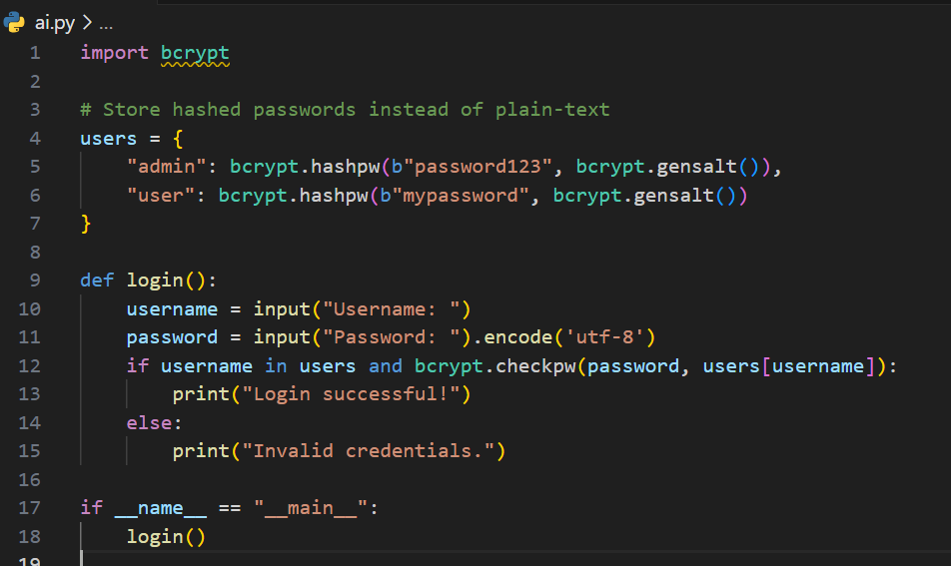
Task # 2
Prompt:
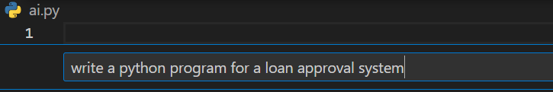
Code:
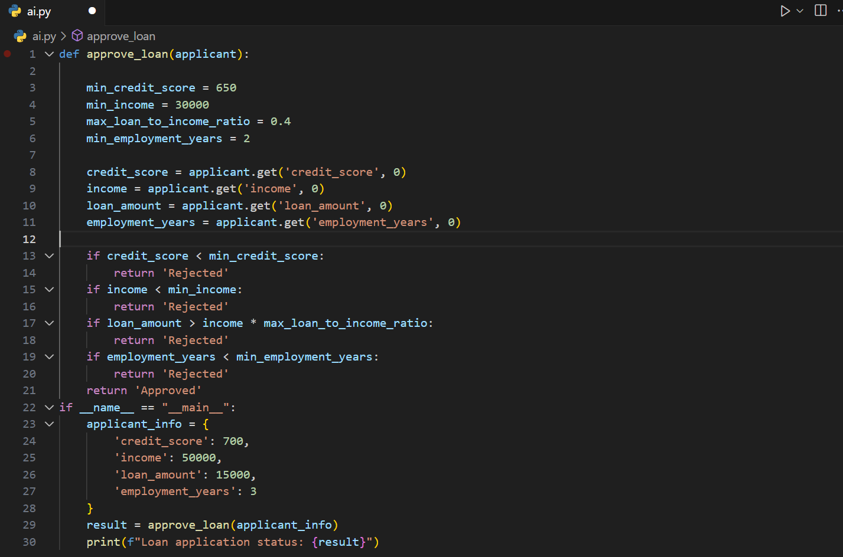
The code provided gives us an unbiased code as a result of mitigation is not required but minor improvements can be done in order to improve user experience.
Task #3
Prompt:
Code:
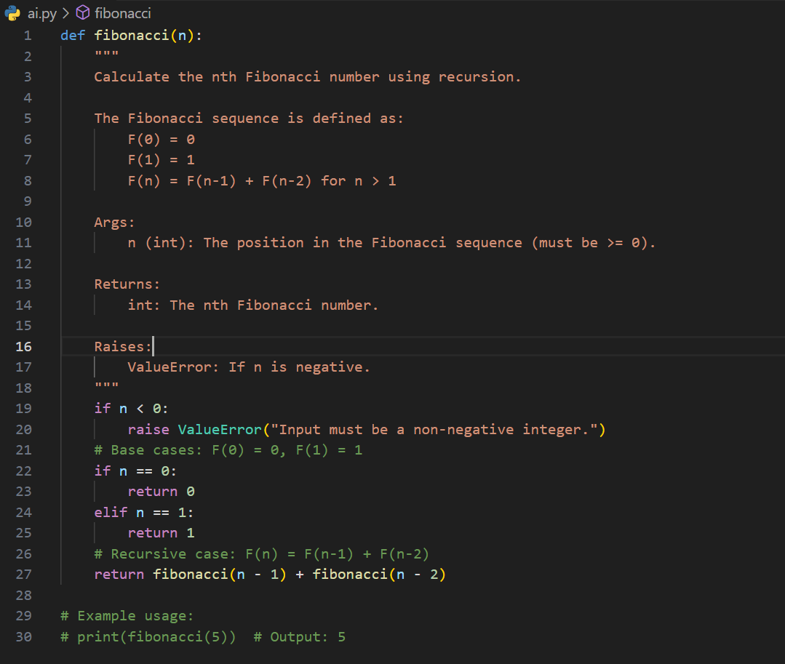
Task #4
Prompt:

