Name:I:karthik
Batch:08
R-no:2403A52200
Task Description #2

Use copilot to generate a is_prime() python function.
Prompt given:
Code:
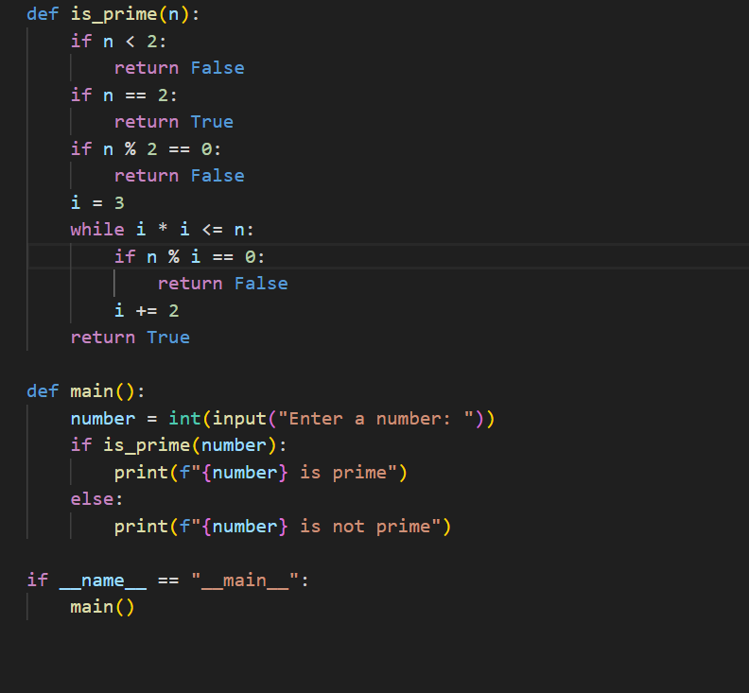
Output:
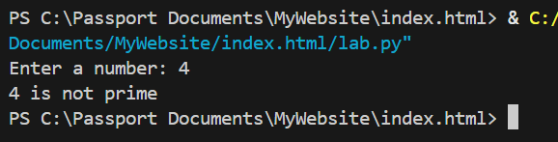
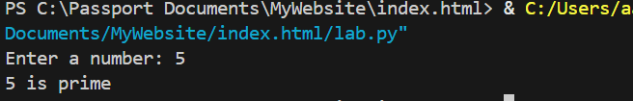
Task Description #3
Write a comment like # function to reverse a string and use copilot to generate the function.
Prompt given to github co pilot:
Code:
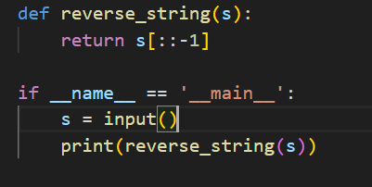
Code Output:
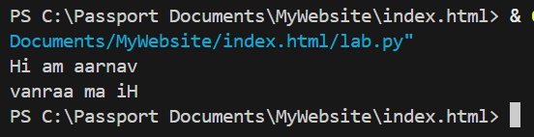

Task Description#4
Generate both recursive and iterative versions of a factorial function using comments.
Prompt given to github co pilot:
Code:
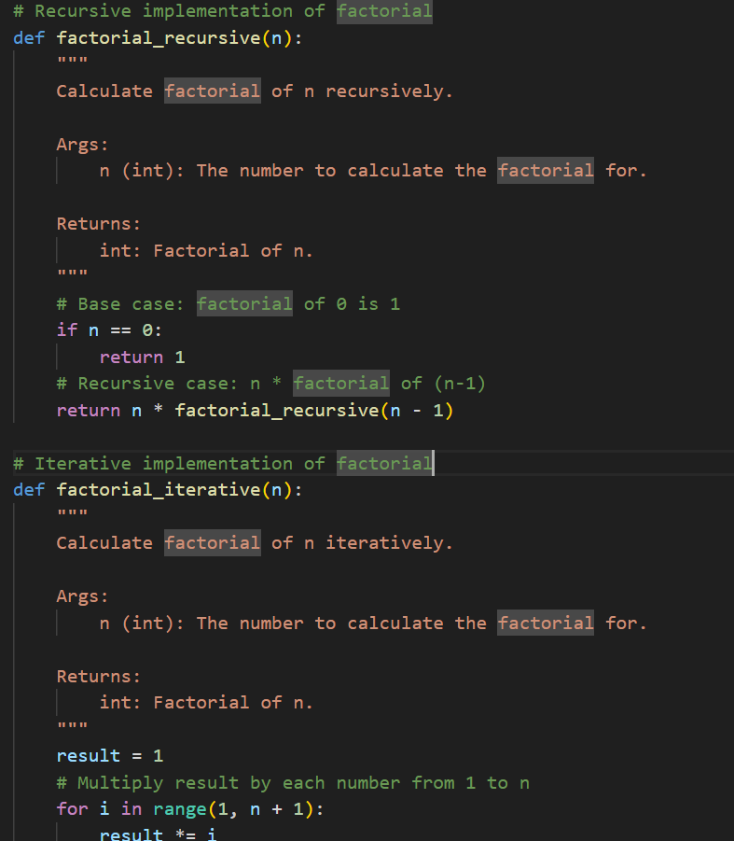 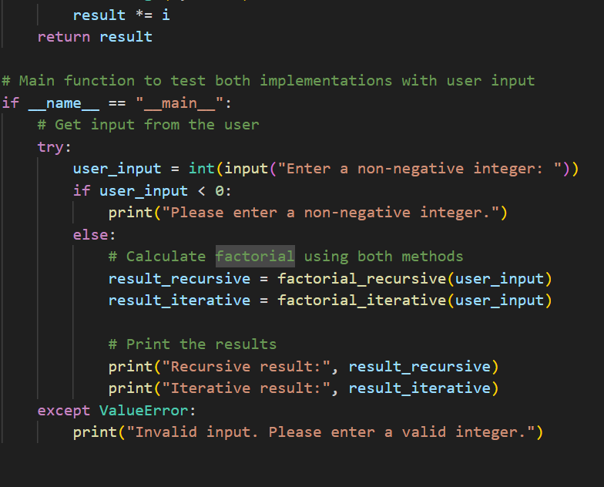
output:
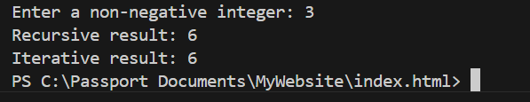
Task Description #5
Use co pilot to find the largest number in a ost assess code quality and efficiency
Prompt given:
Code:
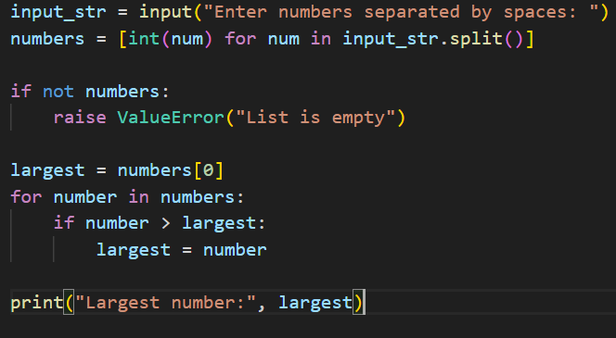
Output:
