

**DESIGN AND IMPLEMENTATION OF GIFT-THRIFT WEBSITE**

**PRESENTED BY**

|  |  |  |
| --- | --- | --- |
| **NO.** | **NAME** | **ADM NO** |
| **1.**  **2.** | **BOSCO ITHAU MUSAU**  **CALEB VINCENT KIPTOO** | **COM/056/19**  **COM/023/19** |
| **3.**  **4.**  **5.** | **ANTHONY MAIYO**  **EVANS WANYAMA**  **MICHAEL AHAYA** | **COM/1005/18**  **COM/036/19**  **COM/001/19** |
|  |  |  |

**FOR THE PARTIAL FULFILMENT OF THE BACHELOR’S DEGREE IN BACHELOR OF SCIENCE IN COMPUTER SCIENCE**

**SUPERVISOR: DR. FRANCIS MUSEMBI**

**DATE: January , 23,2023**

# DECLARATION

This research project is our original work and has never been submitted to any higher learning institution for the award of any degree**.**

*Signature……………………… Date……………………………*

***Name: BOSCO ITHAU MUSAU***

***Adm No: COM/056/19***

*Signature……………………… Date……………………………*

***Name: EVANS WANYAMA***

***Adm No: COM/036/19***

*Signature……………………… Date……………………………*

***Name: MICHAEL AHAYA***

***Adm No: COM/001/19***

*Signature……………………… Date……………………………*

***Name:* *ANTHONY MAIYO***

***Adm No: COM/1005/18***

*Signature……………………… Date……………………………*

***Name: CALEB VINCENT KIPTOO***

***Adm No: COM/023/19***

This research proposal has been submitted with our approval as the university supervisors:

*Signature……………………… Date……………………………*

**Dr. Francis Musembi**

**Research Project Supervisor.**

**University of Eldoret.**

# DEDICATION

We dedicate this project first and foremost to Almighty God who has been there right from the beginning to this point. Special dedication also to our ever supportive parents for their inexorable provision and compassion towards us during our University education. Furthermore, we want to dedicate this project to our lecturers for their continual impact of knowledge.

May God help us through.

# ACKNOWLEDGEMENT

With great pleasure, we would like to thank God for making this work a success. We also extend our special gratitude and appreciation to Dr. Francis Musembi, our supervisor who relentlessly ensured that we have gathered all the necessities for this project as well as his total commitment for this work, we also thank all the lecturers in the University of Eldoret in the department of Mathematics and Computer Science and other department who were our course instructors, who gave the necessary knowledge to carry on with the project, and finally to our fellow course mates whom we shared academic ideas. All the support you gave us is immensely great. Thank you all.

# ABSTRACT

The Online Gift-Thrift Shopping is a web based application intended for selling and buying of second hand items among retailers and customers. The website ressembles simpler version of websites such as “jumia online shopping ” and ‘ kilimall online shopping “ which are used for buying and selling of variety of new /refurbished items . The main objective of this application is to make it interactive and its ease of use. It would make searching, viewing and selection of a product easier.

This website can be used in any device which can access internet.

The core features includes the following ; customer viewing items ,buying an item

The website development follows an iterative waterfall model where stages of development are designed one at a time in order. It is being developed using Python progamming language and Django Framework for backend ,Javascript,Html,Css for frontend .

Contents

DECLARATION I

DEDICATION II

ACKNOWLEDGEMENT III

ABSTRACT IV

LIST OF FIGURES X

CHAPTER 1: INTRODUCTION 1

1.0 Introduction: 1

1.1 Background information 1

1.3 Problem statement 2

1.2 Motivation 2

1.4 Objectives 3

1.4.1 General Objectives 3

1.4.2 Specific objectives 3

1.5 Justification 3

1.6 Significance: 4

Scope 4

1.7 Limitation 4

1.8 Summary 5

CHAPTER 2:LITERATURE REVIEW 6

CHAPTER 3: ANALYSIS AND DESIGN 8

3.1 Introduction 8

3.2 Feasibility study 9

3.2.1Economic feasibility 9

3.2.2 Technical feasibility 10

3.2.3 Operational feasibility 10

i. Legal feasibility 10

ii. Schedule feasibility 10

3.3 Requirement analysis 11

3.4 Data flow diagrams (DFDs) 12

3.5 Use case diagrams 23

3.6 Entity Relationship Diagram(ER Diagram) 24

It show the detailed logical representation of data in the application 24

3.7 Software design 25

CHAPTER 4: METHODOLOGY 28

4.1 Introduction 28

4.2 Methodology used 28

CHAPTER 5: PROJECT MANAGEMENT 30

CHAPTER 6: DISCUSSION/RESULTS 32

6.1 Introduction 32

CHAPTER 7: CONCLUSIONS AND RECOMMENDATION 38

7.1 CONCLUSION 38

7.2 RECOMENDATION 38

REFERENCES 39

LIST OF TABLES

table1…………………………………………………………………………………………………………………………………………………………11

table2…………………………………………………………………………………………………………………………………………………………30

table3…………………………………………………………………………………………………………………………………………………………31

# LIST OF FIGURES

Fig1…………………………………………………………………………………………………………………………………………………………34

Fig2…………………………………………………………………………………………………………………………………………………………35

Fig3…………………………………………………………………………………………………………………………………………………………36

Fig4…………………………………………………………………………………………………………………………………………………………36

Fig5…………………………………………………………………………………………………………………………………………………………37

# CHAPTER 1: INTRODUCTION

## Introduction:

University students usually have second hand items which can be sold once again at cheaper price as compared to when buying it new. After the students move outside the school environment ,they sell there belongings to second hand shops .

In our daily life in university , it is difficult to find those second hand items which are much cheaper as compared to the new items. For instance imagine needing a cheaper bed at “comrade price “ you have to move from one seller to another and compare the prices of the item,that is time wasting and you do’t have the clear picture of the item . how do you get an item ,or how can you access the item. It is difficult to buy items before you examine them. Let us also consider scenario where first year students have reported and need to have outside residence ,how will you get cheaper items ? You may also have a problem with the budget you have ,how do you work with the budget plan you have.

To answer this questions we decided to come up with a website that can provide these services to the users. Currently there is no website that fully offers online services such as selling and buying of second hand items in university. Most websites that are in the market today are; online shops such as Jumia,Kilimall etc. Therefore we as young developers saw that there is a niche and it needs to be bridged. The above services are crucial in our daily lives, thus we ought to develop an application that can provide such services.

## 1.1 Background information

Gift-Thrift shop is an online shopping website that resembles a simpler version of modern large scale commercial websites such as “Jumia”,”Jiji” and “Kilimall “ which are used to order new and refurbished products from independed vendors enlisted to sell their products in the respective websites. This website is a cross platform website which can run in smartphone,Laptop,Palmtop,Desktop. Core features include the following; viewing and adding the desired ones to cart , reviewing and giving comments,checking out a product added in cart

## 1.3 Problem statement

The existing system has the following problems that will be solved with our website system;

* There was no existing online website for second hand items. The existing websites found were not catering for the second hand products.
* In the manual/traditional system it was hectic to second items on sale in an area.in this scenario the client has to travel to the place where the products are sold.
* It was not easy to determine whether the seller is genuine or not. A seller might con someone after payment .

## 1.2 Motivation

* Help the society in bridging the unemployment gap.unemployed people can be employed by starting transportation of the items,selling of the items with ease

**Price comparisons.** Comparing and researching products and their prices is so much easier online. Also, we have the ability to share information and reviews with other shoppers who have firsthand experience with a product or retailer.

* Help in providing qualified service to the clients. The clients are able to compare different items at the comfort of their residences and making the right order .
* Help reduce time taken to locate a service provider. People don't usually like to move a lot to get what they want.as in the normal scenario a person needs to travel from one seller to another which is time consuming .
* It saves on money. The amount of money needed in moving from one area to another will be saved .
* The website is open on 365×24×7. Additionally, Time does not act as a barrier, wherever the buyers are.
* The prices of the items are lower
* The is providence of all detailed information about the product
* Clients can compare various brands of items
* A wide variety/range of products is available.

## Objectives

### 1.4.1 General Objectives

* The project aims to design a cross platform website that will offer basic order services to the users

### 1.4.2 Specific objectives

* To investigate the problems of the existing online shop websites.
* To investigate the problems faced by individuals to look for a products service .
* To analyze the problems of current systems and problems faced by clients and second hand shop owners, thus come up with possible solutions
* To design and implement a cross platform website that will the give best solution after analysis

## 1.5 Justification

The major reasons that led to the development of a second hand products website is;

1. It’s a requirement in our studies in order to complete our degrees in the university.
2. As young scientist, we are trying to solve problems using scientific skills, come up with a platform clients and entreprenuers can buy and sell products respectively .

## 1.6 Significance:

* The study is important to our clients since the clients will be able to get quality services on second hand products at the comfort of their homes .
* The study will provide a platform where service entreprenuers can market themselves on a larger market i.e. online market which can be used country wide or even globally.
* The feature of bidding will help the user/client choose the best product that is, the client will choose a desired product from the many from the Shop Admin.

## Scope

* The current system can be extended to allow the users to create accounts and save products in to wish list.
* The current system is confined only to the shopping cart process. It can be extended to have a easy to use check out process.
* Users can have multiple addition of products to the cart. During checkout they can use the drag and drop feature to select shipping and billing information.

## 1.7 Limitation

The study has some limitations;

in that both the entrepreneur and client must own a smart phone in order to access Gift-Thrift online.

Lack of shopping experience .

Lack of interactivity in online shopping.

Online shoppers do not have the ability to physically inspect or try on the item being considered for purchase.

Online shoppers often do not have a person to talk to directly when dealing with a problem.

## 1.8 Summary

In summary, Gift-Thrift online website that will try to solve unemployment issues in the society and also help individuals to access products easily. It can also provide a platform for entrepreneurs to market their jobs and get a steady source of income.The clients are able to access products ,view them and add to cart their desired products.

# CHAPTER 2:LITERATURE REVIEW

1. **INTRODUCTION**

The practice of purchasing used items has been around for a while. It is not at all a novel idea. However, with the introduction of businesses like Thrift+ and others, who have given the industry a new spark, the prospects and potential it produces have drastically transformed in recent years.

Historically, purchasing worn clothing has been viewed as a very time-consuming, unreliable, and tiresome process. Fortunately, we now approach the used market very differently. We don't have to solely trawl through thrift stores and flea markets in the hopes of discovering anything that might be in good shape, attractive, and comfortable to wear. In fact, the growth of internet resale, notably through platforms like Vinted, has made secondhand shopping so popular that, in ten years, the fast fashion industry may lose market share to used apparel (Stein, 2019). Platforms like The Real Real and Depop have significantly changed how people view and can obtain used goods.

The importance of used goods purchases for the future of the world is rising. Given that it prolongs the lifespan of things, conserves natural resources, and lessens the desire for quick fashion (Dunphy, 2023), it is perhaps one of the most environmentally friendly shopping practices one can undertake.

1. **REVIEW OF RELATED LITERATURE**

Baden & Barber (2005) posit that Less than 0.5 percent of the value of all clothing commerce worldwide is made up of the SHC (Second hand clothes) trade, but for several nations in sub-Saharan Africa, it dominates the clothing market (more than 30 per cent of the total value of imports, and much more than 50 per cent in volume terms). Due to the rise in new imports from Asia, SHC is losing ground as a percentage of overall apparel imports in the majority of these countries, although it still holds a significant share of the market. The trade clearly benefits consumers. Because in many Sub-Saharan African countries it appears that practically all socio-economic categories are choosing to buy SHC, this is particularly true in nations with limited purchasing power and for consumers who are impoverished. For instance, more than 90% of Ghanaians buy SHC. The main driver behind why consumers purchase these items is affordability. Additionally, it appears that consumer and fashion trends are moving away from traditional "African" clothes and toward more "Western"-inspired attire. In underdeveloped nations, the trade provides hundreds of thousands of people with a living. These include positions in retail, distribution, apparel repair and style, and laundry. According to data conducted in Senegal by Oxfam, 24,000 people work in the industry there. Although precise comparisons with employment resulting from domestic manufacturing are not available, however it is known that 62,000 people are employed in informal textile and clothing production in Senegal, while 1,355 individuals work in official textile and clothing industries there.

According to Geegamage et al. (2021)Consumer awareness and concern about the fashion industry's environmental and social responsibilities are rising, as seen by the rise in sustainability-related mentions on social media. Researchers have found that innovation, inventiveness, and beauty are the main drivers of customer motivation to influence the purchase of sustainable clothing. Although they found other requirements for adopting sustainable habits, the three characteristics described above were the most important ones for sustainable fashion consumption. Self-expression, hedonic, economic, environmental, and social contribution values were shown to be the top five value points among customers who purchase used apparel. Which makes it easier to categorize consumers into four distinct groups: those who are price-conscious, quality- and style-conscious, brand-conscious, and environmentally and socially conscious.

According to a study done by the Institute of Economic Affairs and the Mitumba Consortium Association of Kenya, 91.5% of Kenyan families purchased used clothing, or mitumba, in the year 2019. The number of used clothing imported into Kenya increased in 2019 as a result of the rise in the demand for them among Kenyans. 185,000 tonnes of Mitumba, or 8,000 containers, were imported into the nation.

# CHAPTER 3: ANALYSIS AND DESIGN

## 3.1 Introduction

Analysis and design includes all activities, which help the transformation of requirement specification into implementation. Requirement specifications specify all functional and non-functional expectations from the software.Analysis and design is the intermediate stage, which helps human-readable requirements to be transformed into actual code.

Requirements analysis, also called requirements engineering, is the process of determining user expectations for a new or modified product. These features, called requirements, must be quantifiable, relevant and detailed. In software engineering, such requirements are often called functional requirements.

Requirements analysis involves frequent communication with system users to determine specific feature expectations, resolution of conflict or ambiguity in requirements as demanded by the various users or groups of users, avoidance of feature creep and documentation of all aspects of the project development process from start to finish. Energy should be directed towards ensuring that the final system or product conforms to client needs rather than attempting to mold user expectations to fit the requirements.

Analysis is defined as the process of carefully studying an object or something that can be studied either carefully or with the use of statistical methods with an aim of understanding it and maybe explaining it in a better way. This is a major step before commencing development and helps in ensuring everything is in order. The analysis process takes three steps which we followed through to ensure all aspects are ready before commencing the project;

* Fact-finding
* Feasibility study and report
* Requirements specification

Software design is the process of envisioning and defining software solutions to one or more sets of problems.

The design phase of software development deals with transforming the customer requirements as described in the SRS documents into a form implementable using a programming language.  
The software design process can be divided into the following three levels of phases of design:

* Interface Design
* Architectural Design
* Detailed Design

## 3.2 Feasibility study

Defined as the feasibility analysis or it is a measure of the software product in terms of how much beneficial product development will be for the organization in a practical point of view.

It has two main aims

* Determine the resources and technologies needed
* Determine whether the website project offers reasonable return vs risk given that it is an investment.

### 3.2.1Economic feasibility

Economic feasibility focuses on the financial aspects of the application whereby it focuses on what the organization is going to earn from application and its distribution. Feasibility study also focuses on the costs that the organization will have to incur with the development of this website. An software that is economically feasible should have higher returns than the initial investment and thus termed as making profits rather than resulting in losses to the company. The Gift-Thrift web application is considered as economically feasible because;

* Uses VS code which is free for development
* The project can be run in any of devices connected to internet connection , hence no new hardware will be bought different from existing ones,hence the existing devices can be used.
* These factors combined make it easy to develop the python website which is therefore considered economically feasible.

### 3.2.2 Technical feasibility

The technical feasibility studies software in terms of the available resources in form of hardware and software. These resources are seen as necessary for the accomplishment of the user requirements as defined in the onset of the design process of the software. The group reviewed these resources to ensure that there are available resources to necessitate the implementation of the application. Some the other tasks in the technical feasibility include analysis of the technical skills which the group found itself well equipped, availability of technology to facilitate production and assurance that the technology has a large user base. In this case,windows, android and iOS platforms have a wider number of users with the same being seen in python which is the programming language used in the development of the website. With this, the project was deemed technically feasible as all requirements under the study were met.

### 3.2.3 Operational feasibility

The operational feasibility revolves around studying the degree of providing service to requirements . the website is analyzed along with how much easy product will be to operate and maintenance after deployment.. For this reason, it is mostly a form of foresight aiming at envisioning the software’s operation after it has been developed and made ready for the market. Through operational feasibility, we also study the problems and solutions identified at the requirements gathering phase are in cohesion i.e. the suggested solutions solve the risks anticipated. The operational feasibility also analysis the different use cases and this determine how the users will adapt to the application.

### Legal feasibility

For any country that we operate in, any project revolving around software development has to conform to the laws of the state and this will using include copyright laws that are meant to ensure the application is not a duplication of another person’s intellectual property

### Schedule feasibility

In Schedule Feasibility Study mainly timelines/deadlines is analyzed for project which includes how much time the team will take to complete final project which has a great impact on the organization as purpose of project may fail if it can’t be completed on time.

In our project we had outlined :

|  |  |
| --- | --- |
| **ACTIVITY** | **TIME LINE (in weeks)** |
| Feasibility study | 1 |
| Requirement gathering and analysis | 2 |
| System design | 5 |
| coding | 6 |
| Testing and system implementation | 1 |
| User Training | 2 |
| **Total** | **17** |

Table1

## Requirement analysis

In requirement analysis we analyzed, refined, and scrutinized the gathered requirements to make consistent and unambiguous requirements. This activity usually reviews all requirements and may provide a graphical view of the entire system. After the completion of the analysis, it is expected that the understandability of the project may improve significantly. Here, we may also use the interaction with the customer to clarify points of confusion and to understand which requirements are more important than others.

The system takes both functional and non-functional requirements

#### Functional requirements **(FRs)**

Refers to Any Requirement Which Specifies What The System Should Do.

These are the things that the system must meet in order to fulfill the requirements as per the user’s specifications these include:

* User’s details including username, email, and password
* Seller can add products and delete them.
* Store this information
* Accept orders as input and enable clients to track their orders
* Authentication to ensure safe usage of the application

#### Non-functional requirements

* Easy to use interface
* Portability to enable the system to be used in various devices
* Continuous access to the services
* The system should be able to handle 20 million users without performance deterioration

## 3.4 Data flow diagrams (DFDs)

Data Flow Diagrams otherwise DFDs help in explaining the flow of information across the system from the time when the application is launched to its termination. With the DFD

it will be easier to follow through how the system operates

**Context level diagram(**o – Level DFD**)**

Shop Admin

USER

REQUEST FOR   
REGISTRATION/LOGIN

REQUEST FOR   
LOGIN

RESPONSE

RESPONSE

GIFT-THRIFT  
ONLINE  
SHOPPING

0.0

Fig1. o – Level DFD for Online shopping website project

Check for login

Request for login

Response

reply

AdminMst

1.0

login

SHOP ADMIN

Insert data

Add/Edit Category

Response

reply

CategoryMst

2.0

Manage  
Category

Insert data

Add/Edit brand

Response

reply

BrandMst

3.0

Manage  
brand

Insert data

Add/Edit Product

Response

reply

ProductMst

4.0

Manage  
product

View order

Manage Order

Response

reply

OrderMst

Manage  
order

5.0

View Report

View Report

Display Data

reply

UserMst/OrderMst

Manage  
report

6.0

1-level DFD( admin side)

Fig2

Check for login

Request for login

Response

reply

AdminMst

2.0

login

SHOP ADMIN

Insert data

reply

CategoryMst

2.1

Add   
category

Update information

reply

CategoryMst

2.2

Change name

Remove data

reply

CategoryMst

2.3

Delete   
Category

2-level DFD (Shop Admin side-2.0)

Fig 3

Check for login

Request for login

Response

reply

AdminMst

3.0

login

SHOP ADMIN

Insert data

reply

BrandMst

3.1

Add   
brand

Update information

reply

BrandMst

3.2

Change name/

Remove data

reply

BrandMst

3.3

Delete   
Brand

2-level DFD Shop Admin side-3.0

Check for login

Request for login

Response

reply

AdminMst

4.0

login

SHOP ADMIN

Insert data

reply

ProductMst

4.1

Add   
product

Update information

reply

ProductMst

4.2

Change name/price/size

Remove data

reply

ProductMst

4.3

Delete   
Product

2-level DFD admin side-4.0

Check for login

Request for login

Response

reply

AdminMst

5.0

login

SHOP ADMIN

Request for view

reply

OrderMst

5.1

View   
order

Request to Confirm

reply

OrderMst

5.2

Confirm/cancel   
order

Dispatch order

reply

OrderMst

5.3

Dispatch order

2-level DFD Shop Admin side-5.0

Check for login

Request for login

Response

reply

AdminMst

6.0

login

SHOP ADMIN

Request for view

reply

UserMst

6.1

User   
report

Request for view

reply

ProductMst

6.2

Product  
report

Request for view

reply

OrderMst

6.3

Order   
report

2-level DFD Shop Admin side-6.0

Check for login

Request for login

Response

reply

AdminMst

6.0

login

SHOP ADMIN

Request for view

reply

UserMst

6.1

User   
report

Request for view

reply

ProductMst

6.2

Product  
report

Request for view

reply

OrderMst

6.3

Order   
report

2-level DFD Shop Admin side-

Check for login

Request for login

Response

reply

UserMst

1.0

login

Customer

Add/Edit Category

Response

reply

UserMst

2.0

Registration

Display account  
information

Add/Edit brand

Response

reply

UserMst

3.0

account

Request to confirm

Add/Edit Product

Response

reply

ProductMst

4.0

buy  
product

Request to confirm

Manage Order

Response

reply

OrderMst

make  
order

5.0

Request to confirm

View Report

Display Data

reply

PaymentMst

Make  
payment

6.0

1-level DFD customer side

Request to confirm

Check details

Request for login

Response

reply

UserMst

3.0

login

Customer

Request for view

reply

UserMst

3.1

View   
Account

Update password

reply

UserMst

3.2

Change   
Password

Edit Profile

reply

UserMst

3.3

Edit   
Account

2-level DFD customer side –3.0

Check details

Request for login

Response

reply

UserMst

4.0

login

Customer

Request for view

reply

OrderMst

4.1

View   
Product

Update information

reply

OrderMst

4.2

Add to   
Cart

Request confirmation

reply

OrderMst

4.3

Confirm  
order

2-level DFD customer side –4.0

## 3.5 Use case diagrams

Use case diagrams are graphical; representations of the possible user interactions with the application and thus considered the primary software requirement whenever designing a new application.

ADMIN

USER

## 3.6 Entity Relationship Diagram(ER Diagram)

## It show the detailed logical representation of data in the application

It contains 3 main constructs:

* Entities
* Relationship
* Attribute

logins

Gift-Thrift Website

customer

Shop Admin

views

manages

products

adds

cart

User proceeds

buy

category

Product  
attributes

## 3.7 Software design

System design comes as the third stage of the software development life cycle whereby we transform the user requirements to some suitable form which helps programmer in coding and implementation.It involves moving concentration from problem domain to solution domain . It tries to specify how to fulfill requirement as mentioned in the SRS document.

It is comprised of different design levels: architectural design,high level design,detailed design

**3.7.1 Activity diagram**

homepage

Browse Category

View Cart

Browse Category

Select Item

Continue shopping

[Cart empty]

[product ==0]

[product >=0]

Checkout

View information

View Cart

login

Place order

[Authentication success]

[Invalid Username]

[Invalid password]

**3.7.2 Sequence Diagram**

customer

Gift-Thrift  
website

Product  
Page

Shopping  
 cart Page

signUp/  
Login  
Page

Payment  
Page

Order   
Review

Order   
Confirmation

Select Product

Browse website

Get Product  
Information

Display Product details

Shopping  
 Cart Redirect

Click “Buy”

Display shopping cart Page

Continue to Register/Login

Display Login and create profile page

Login as existing customer or Register as a New Customer

Enter Login Credentials

Display Payment  
 Page

Display Order Review Page

Review the order and continue to Purchase

Display the order Confirmation Page with Order Number

#### **3.7.3 Flowchart**

The flowchart depicts a logical operation of the existing system as shown in the diagram

customer

Shop Admin

login

register

No

Yes

Search Product

View Product

Buy Product and add to cart

Payment

Order Placed

Logout

Yes

No

login

No

Add /Update Category

Add /Update Product

Yes

Manage Product Attributes

Manage Order

Manage Payment

Check Feedback

# CHAPTER 4: METHODOLOGY

## 4.1 Introduction

The software development lifecycle gives developers a procedure which can be otherwise considered a set of rules that help govern the programmers on a procedure to be followed by the developers thus producing systems that meet certain criteria as per software development rules.

## 4.2 Methodology used

For the Gift-Thrift system, we made use of the iterative waterfall model that comes with a range of advantages of with a major one being the fact that waterfall ensures that one activity is done before moving to the next making it easy to track and manage progress thus error detection is made easier . With an iterative, it is an improvement to traditional waterfall in that unlike with tradition, the iterative waterfall allows the developer to go back to another process thus ensuring that requirements are addressed fully. With the waterfall model, we went through a series of steps as defined by the model including;

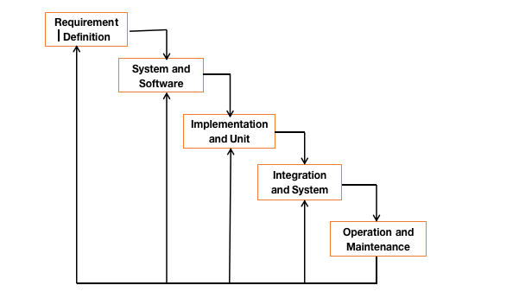

* Requirement definition
* System and software design
* Implementation and unit testing
* Integration and system testing
* Operation and maintenance

Advantages of the iterative waterfall model

* It is easy to understand and use the model
* Every phase of the model contains a feedback path that allows going back to the previous phase
* With the iteration, it is simple to make changes and modifications
* It makes finishing the project easier
* It does not require customer involvement. This was especially helpful to Twendekazi which with customer involvement might make the system harder to understand.

# CHAPTER 5: PROJECT MANAGEMENT

**PROJECT MANAGEMENT**

|  |  |  |
| --- | --- | --- |
|  | **ACTIVITY** | PRICE |
| 1 | computer | 70000/= |
| 2 | Storage | 10000/= |
| 3 | Traveling, meals and drinks | 30000/= |
| 4 | Printing of papers | 3000/= |
| 5 | Binding of project | 1500/= |
|  | Total | 114500/= |

Table2

PROJECT SCHEDULE

|  |  |  |  |  |  |  |  |  |  |  |  |  |  |  |  |  |
| --- | --- | --- | --- | --- | --- | --- | --- | --- | --- | --- | --- | --- | --- | --- | --- | --- |
| **YEAR & MONTH** | **SEPT 2022** | | | | **OCT 2022** | | | | **NOV 2022** | | | | **DEC 2022** | | | |
| **WEEKS** | **1** | **2** | **3** | **4** | **1** | **2** | **3** | **4** | **1** | **2** | **3** | **4** | **1** | **2** | **3** | **4** |
| Feasibility study |  |  |  |  |  |  |  |  |  |  |  |  |  |  |  |  |
| Requirement gathering and analysis |  |  |  |  |  |  |  |  |  |  |  |  |  |  |  |  |
| System design |  |  |  |  |  |  |  |  |  |  |  |  |  |  |  |  |
| Database Design |  |  |  |  |  |  |  |  |  |  |  |  |  |  |  |  |
| GUI Design |  |  |  |  |  |  |  |  |  |  |  |  |  |  |  |  |
| System Coding And Implementation |  |  |  |  |  |  |  |  |  |  |  |  |  |  |  |  |
| Testing and system implementation |  |  |  |  |  |  |  |  |  |  |  |  |  |  |  |  |

Table3

# CHAPTER 6: DISCUSSION/RESULTS

## 6.1 Introduction

This document serves as an illustration tool that guides the system development team so as to assist them in the design review process.

Implementation

**6.1.1 System requirement**

* Operating system
* Windows 11/10/8/7/XP (with X64 or X86 based Processors)
* MacOS
* Android
* iOs

**Database (RDBMS)**

* Sqlite
* Sqlite enables programmers to create, read, update, and delete information in a database

**Client Web Browsers**

* Chrome
* Mozilla Firefox
* Microsoft Edge
* Opera
* Brave
* Vivaldi
* DUckDuckgo

**6.1.2 Hardware requirement**

* Laptop/desktop
* Processor: Intel(R) Celeron(R) CPU N2840 @2.16 2.16GHz or greater
* RAM: 4GB
* Hard Disk Drive: 250 GB (or larger)

**Log in**

This page will enable registered users to log in and for new users will have to create account first i.e. Signup . When developing applications, the log in page serves as the basic form of security and as it helps in authenticating users who are trying to access the application. The log in page displayed below will take the user’s Username and password such that if the user is registered, they will be authenticated and thus allowed to access the home screen and purchase products for the case of customers and if the user is authenticated as Shop Administrator ,is allowed to access the Admin panel.

Sample code

{% extends 'base.html' %}

{% load static %}

{% block content %}

<main class="container my-4">

    <!-- Featured Products -->

    <h3 class="my-4 border-bottom pb-1">Login</h3>

    <table class="table table-bordered">

        <form method="post">

            {% csrf_token %}

            {{form.as_table}}

            <tr>

                <td colspan="2">

                    <input type="submit" value="Login" class="btn btn-primary" />

                </td>

            </tr>

        </form>

    </table>

    <p><a href="#" class="text-danger">Reset Password?</a></p>

    <p>If you are not registered, Please <a href="{% url 'signup' %}">Signup here</a>.</p>

</main>

{% endblock %}

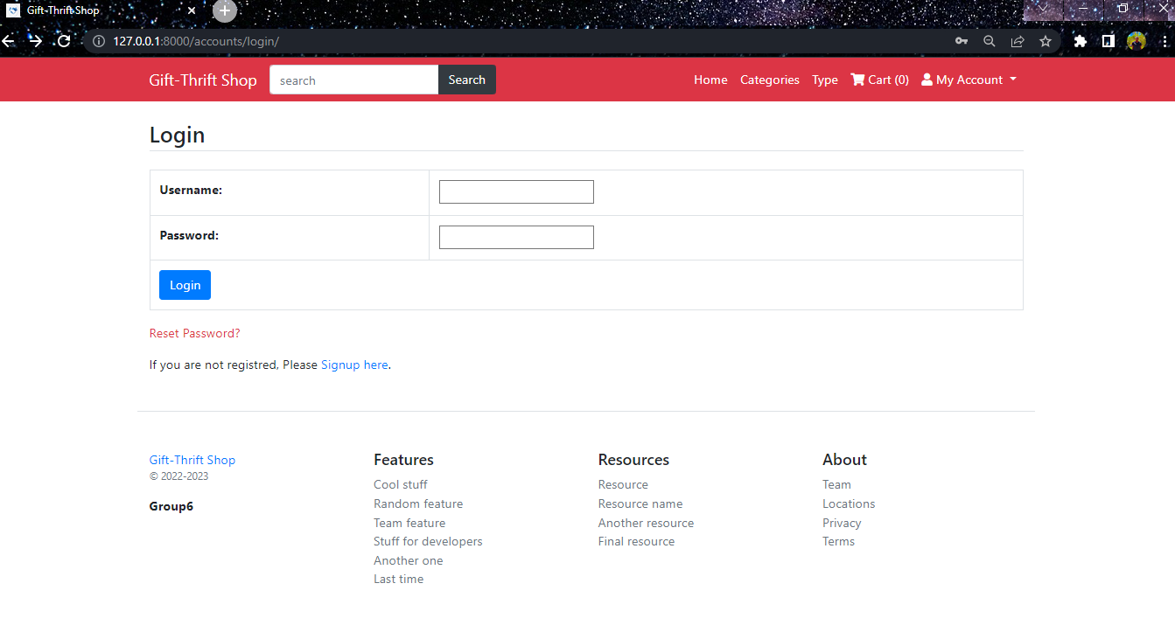

Figure 1: login screen

**Sign Up Page**

New users will register here by entering their personal details. When a user tries to log in and they do not have an account registered with the specific applications, they will be requested to register through the sign up button in the log in page. A user signing up will add their details to the database meaning that using these credentials, the user will be able to log in and thus access the application. The sign up screens takes input including the user’s name, email and password for security reasons. With these details, only the authenticated user will be able to access the specific account.

**Sample code**

{% extends 'base.html' %}

{% load static %}

{% block content %}

<main class="container my-4">

    <!-- Featured Products -->

    <h3 class="my-4 border-bottom pb-1">SignUp</h3>

    <table class="table table-bordered">

        <form method="post">

            {% csrf_token %}

            {{form.as_table}}

            <tr>

                <td colspan="2">

                    <input type="submit" value="Register" class="btn btn-primary" />

                </td>

            </tr>

        </form>

    </table>

</main>

{% endblock %}

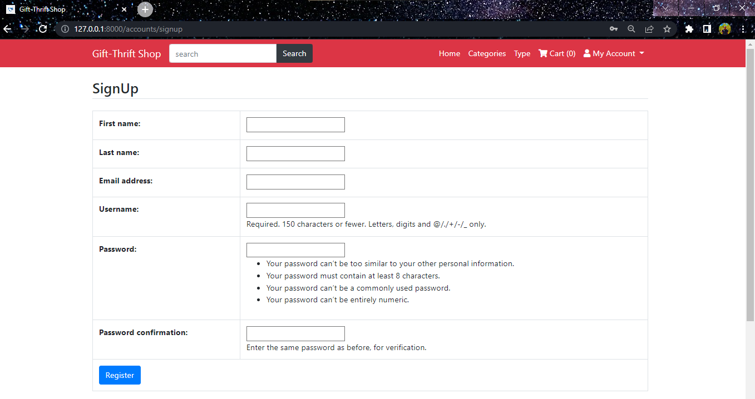

Figure 2: Sign Up Screen

**The home Page**

This page will welcome and introduce the user to the website application. This screen does not provide a wide range of functionalities as it is meant to serve as an introduction to what the user will be able to do using the application. With the buttons at the top of page and featured products, the user will be able to navigate different products and thus utilise the various functionalities as provided by the application from viewing products ,adding wishlist ,adding to cart to making payment for the ordered product .

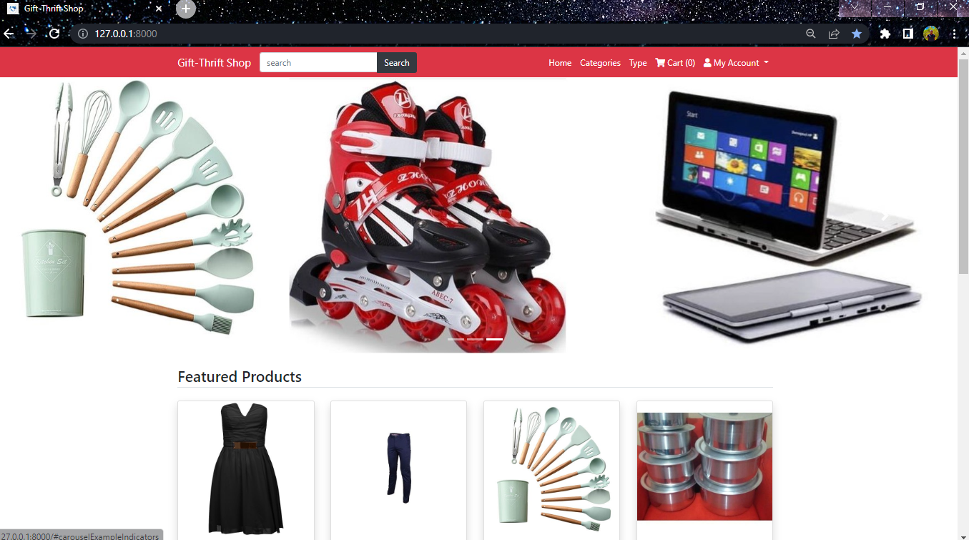

Figure 3:Home Screen

**The cart page**

This page will enable the customer to place order. Gift-Thrift Online App allows Customers to make orders and in turn get provided with the item from the shop Administrator. The orders page helps the user to define the total amount of items to buy or delete the ones the customer does not need .

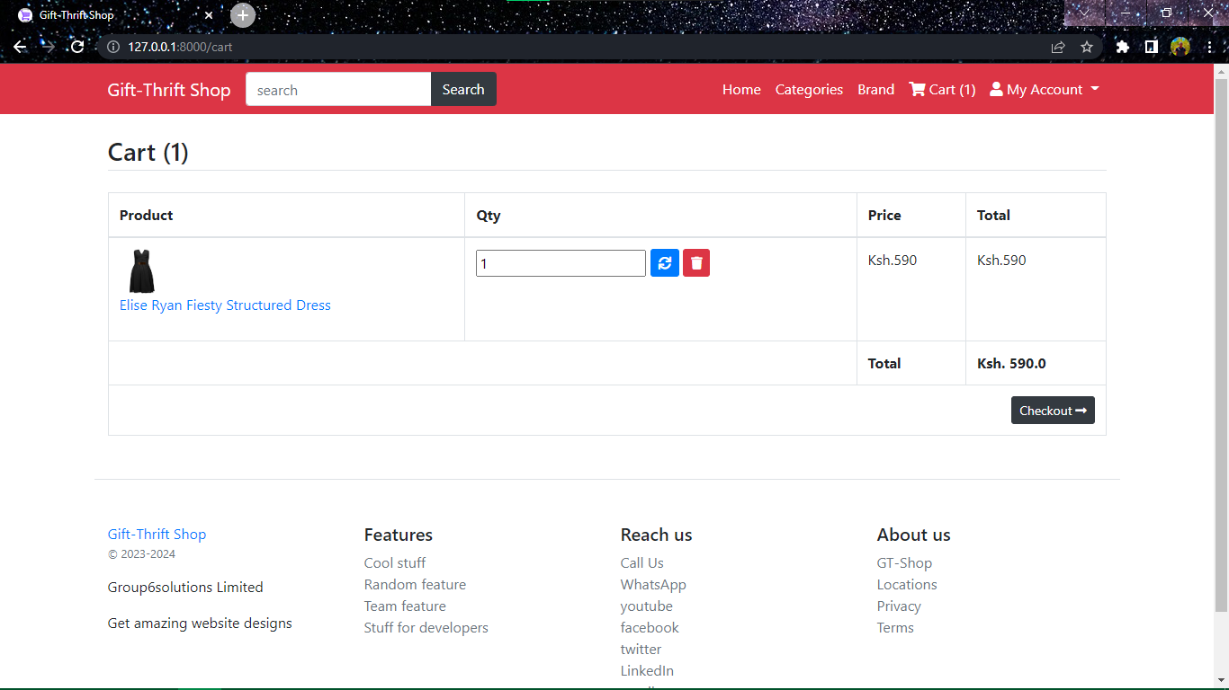

Figure 4: cart Screen

**My orders screen**

Placed orders and completed orders will be viewed here. If the user posts an order, the order will be displayed in the screen as part of the ‘All’ section. With an order that is yet to be bid on, the client will be able to view all the bids available on the order they initially posted and therefore accept the bid of their choice.

Figure 5: My orders Screen

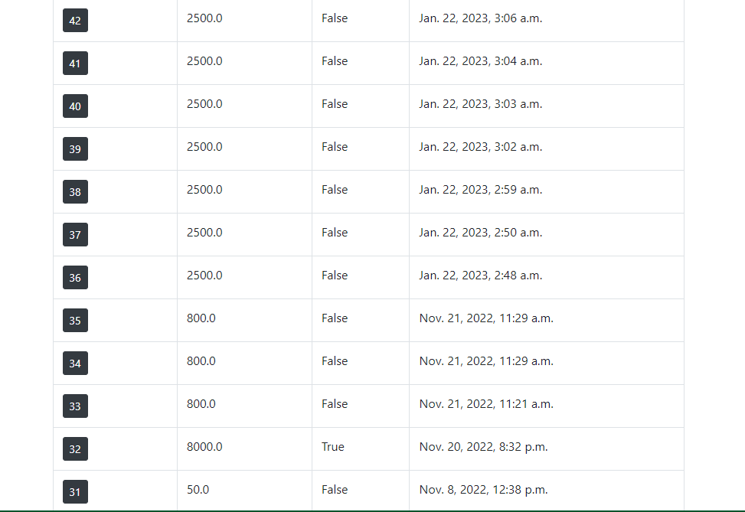

# CHAPTER 7: CONCLUSIONS AND RECOMMENDATION

## 7.1 CONCLUSION

In carrying out this project, we were able to develop a second hand market system that is easy to use and monitor selling of your items. We were able to finish these project with knowledge gotten from class work.the project was successful and can even be improved further to cater for users changing needs. We have also been able to acquire necessary skills such as researching skills, project management and programming in different languages example python, HTML, CSS and MYSQL.

**ACHIEVEMENTS**

1. The project will allow persons to acquire products at a cheaper price and easily available to their location
2. The users will be able to keep track of their purchases

## 7.2 RECOMENDATION

As technology grows, the need to keep track of user requirements grow daily and thus improving the system is a requirement. Project can be improved by adding levels of administrators, adopting payment technology such as MPESA, VISA, PAYPAL. We can encourage students and people at large to adopt to e-commerce as a way to do business.

# REFERENCES

Baden, S., & Barber, C. (2005). The impact of the second-hand clothing trade on developing countries. https://doi.org/10.21201/2005.112464

Dunphy, S. (2023, January 14). *Shopping Sustainable Brands vs second hand – which is better for the planet?* Laid Bare. Retrieved January 24, 2023, from https://www.bonandberg.com/post/shopping-second-hand-vs-sustainable-brands

Geegamage, T., Ranaweera, H. R. A., & Halwatura, R. U. (2021). Second-hand fashion consumption: A literature review. *ERU Symposium 2021 Proceedings*. https://doi.org/10.31705/eru.2021.6

Stein, S. (2019, March 29). *Secondhand could supplant fast fashion in a decade, Thredup & The Realreal are leading the way*. Forbes. Retrieved January 24, 2023, from https://www.forbes.com/sites/sanfordstein/2019/03/26/resale-revamp-thanks-to-thredup-and-the-realreal/?sh=7c011cf71f3e