**ASSESSMENTS OF MARGINAL WORKERS IN TAMILNADU**

**Phase 4: Development Part 2**

**Perform the demographic analysis and create visualizations.**

**Step 1: Import Libraries**

**Step 2: Load the CSV File**

**Step 3: Data Exploration**

**Before creating visualizations, it's essential to explore your data to understand its structure and the demographic variables it contains.**

**You can use functions like head(), info(), and describe() to get a sense of the data.**

**Step 4: Demographic Analysis**

**Depending on your dataset and the demographic variables you want to analyze,**

**you can perform various operations.**

**For example, to analyze the age distribution, you can create a histogram**

**Step 5: Additional Visualizations**

**Depending on your dataset and analysis goals, you can create various types of visualizations, including bar charts, pie charts, scatter plots, and more.**

**Step 6: Export or Display Visualizations**

**You can display the visualizations in your Jupyter Notebook or export them to files using plt.savefig() if needed.**

**Program:**

import pandas as pd

import matplotlib.pyplot as plt import seaborn as sns

data = pd.read_csv('data.csv') plt.scatter(data['Age group'], data['Area Name']) plt.xlabel('Age group')

plt.ylabel('Area Name') plt.title('Scatter Plot') plt.show()

plt.hist(data['Age group'], bins=20, edgecolor='k') plt.xlabel('Age group')

plt.ylabel('Frequency')

plt.title('Age group Distribution (Histogram)')

plt.show()

category_counts = data['Age group'].value_counts() plt.figure(figsize=(8, 8))

plt.pie(category_counts, labels=category_counts.index, autopct='%1.1f%

%', startangle=140) plt.axis('equal')

plt.title('Pie Chart') plt.show()

data = pd.read_csv('data.csv') plt.scatter(data['Age group'], data['Area Name']) plt.xlabel('Age group')

plt.ylabel('Area Name') plt.title('Scatter Plot') plt.show()

plt.hist(data['Age group'], bins=20, edgecolor='k') plt.xlabel('Age group')

plt.ylabel('Frequency')

plt.title('Age group Distribution (Histogram)') plt.show()

category_counts = data['Age group'].value_counts() plt.figure(figsize=(8, 8))

plt.pie(category_counts, labels=category_counts.index, autopct='%1.1f%

%', startangle=140) plt.axis('equal') plt.title('Pie Chart') plt.show()

**OUTPUT:**

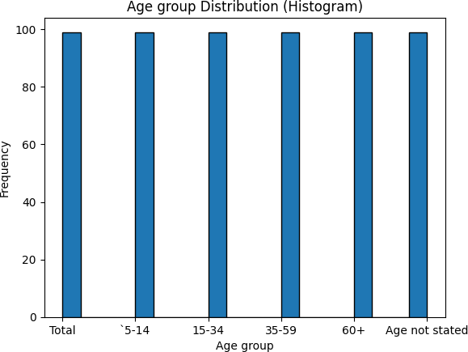

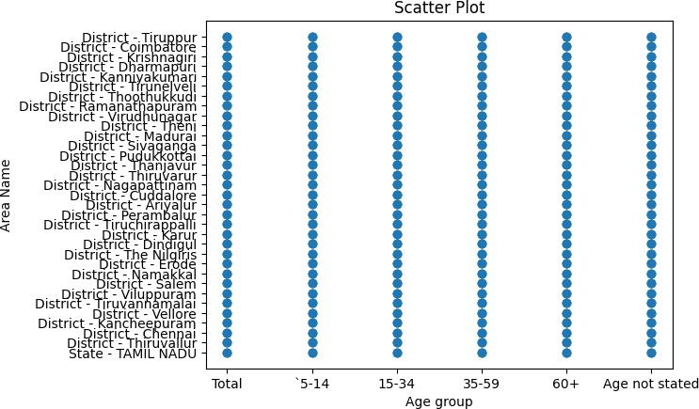

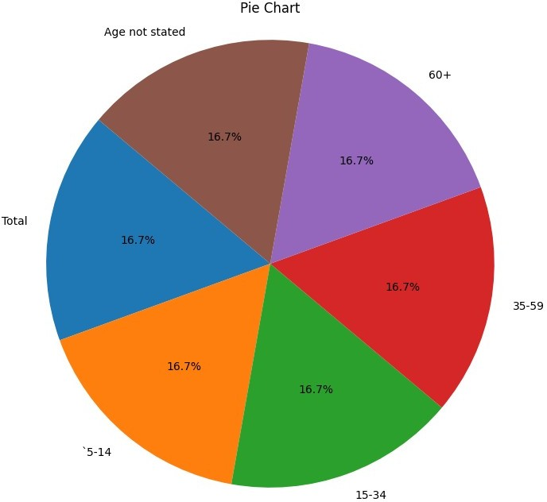

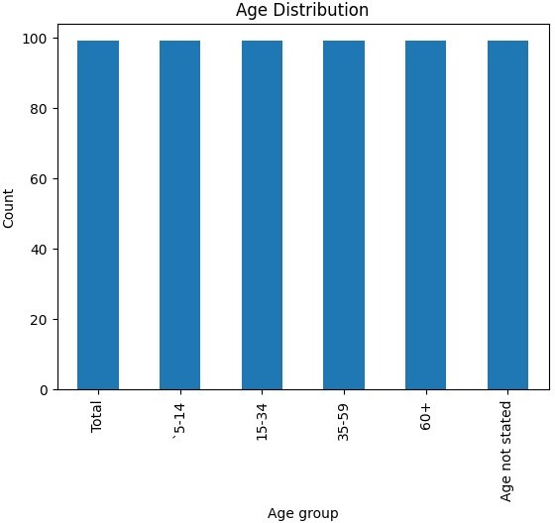

Table Code State Code District Code Area Name Total/

Rural/ Urban \

|  |  |  |  |  |  |  |
| --- | --- | --- | --- | --- | --- | --- |
| 0 | B0806SC | `33 | `000 | State | - TAMIL | NADU |
| Total |  |  |  |  |  |  |
| 1 | B0806SC | `33 | `000 | State | - TAMIL | NADU |
| Total |  |  |  |  |  |  |
| 2 | B0806SC | `33 | `000 | State | - TAMIL | NADU |
| Total |  |  |  |  |  |  |
| 3 | B0806SC | `33 | `000 | State | - TAMIL | NADU |
| Total |  |  |  |  |  |  |
| 4 | B0806SC | `33 | `000 | State | - TAMIL | NADU |
| Total |  |  |  |  |  |  |

Age group Worked for 3 months or more but less than 6 months - Persons \

|  |  |  |
| --- | --- | --- |
| 0 | Total | 1200828 |
|  |  |  |
| 1 | `5-14 | 27791 |
|  |  |  |
| 2 | 15-34 | 514340 |
|  |  |  |
| 3 | 35-59 | 542581 |
|  |  |  |
| 4 | 60+ | 115103 |

Worked for 3 months or more but less than 6 months - Males \

|  |  |  |
| --- | --- | --- |
|  |  |  |
| \0 | 589003 |
| 1 | 14125 |
| 2 | 259560 |
| 3 | 251957 |
|  | 4 | 62833 |

Worked for 3 months or more but less than 6 months - Females \

|  |  |  |  |  |  |
| --- | --- | --- | --- | --- | --- |
| 0 | 611825 | | | | |
| 1 | 13666 | | | | |
| 2 | 254780 | | | | |
| 3 | 290624 | | | | |
| 4 | 52270 | | | | |
| Worked for less than 3 months - Persons ... \ | | | | | |
| 0 | 221386 ... | | | | |
| 1 | 2447 ... | | | | |
| 2 | 92423 ... | | | | |
| 3 | 99202 ... | | | | |
| 4 | 27165 ... | | | | |
| Industrial Category - N to O - Females \ | | | | | |
| 0 | 3565 | | | | |
| 1 | 11 | | | | |
| 2 | 1754 | | | | |
| 3 | 1619 | | | | |
| 4 | 175 | | | | |
| Industrial Category - P to Q - Persons \ | | | | | |
| 0 | 11080 | |  | | |
| 1 | 122 | |  | | |
| 2 | 7536 | |  | | |
| 3 | 3205 | |  | | |
| 4 | 211 | |  | | |
| Industrial Category - P to Q - Males \ | | | | | |
| 0 | 4019 |  | | | |
| 1 | 71 |  | | | |
| 2 | 2718 |  | | | |
| 3 | 1131 |  | | | |
| 4 | 93 |  | | | |
| Industrial Category - P to Q - Females \ | | | | | |
| 0 | 7061 | | |  |  |
| 1 | 51 | | |  |  |
| 2 | 4818 | | |  |  |
| 3 | 2074 | | |  |  |
| 4 | 118 | | |  |  |
|  |  | | |  |  |
|  | Industrial Category - R to U - HHI - Persons | | | \ |  |
| 0 | 16833 | | |  |  |

0

1

2

3

4

12567

258

6219

5104

974

0

1

2

3

4

Industrial Category - R to U - Non HHI - Persons

122088

19305

68929

26498

7065

\

0

1

2

3

4

Industrial Category - R to U - Non HHI - Males

55801

9774

32803

9675

3394

\

\

|  |  |  |  |
| --- | --- | --- | --- |
|  |  |  | |
| 1 | 427 | |
| 2 | 8346 | |
| 3 | 6591 | |
| 4 | 1457 | |
| Industrial Category - R to U - HHI - Males | | | |
| 0 | | 4266 |  |
| 1 | | 169 |  |
| 2 | | 2127 |  |
| 3 | | 1487 |  |
| 4 | | 483 |  |

Industrial Category - R to U - HHI - Females \

Industrial Category - R to U - Non HHI - Females 0 66287

1 9531

2 36126

3 16823

4 3671

[5 rows x 69 columns]

<class 'pandas.core.frame.DataFrame'> RangeIndex: 594 entries, 0 to 593 Data columns (total 69 columns):

# Column

Non-Null Count Dtype

0 Table Code

594 non-null object

1 State Code

594 non-null object

2 District Code

594 non-null object

3 Area Name

594 non-null object

4 Total/ Rural/ Urban 594 non-null object

5 Age group

594 non-null object

6 Worked for 3 months or more but less than 6 months - Persons 594 non-null int64

7 Worked for 3 months or more but less than 6 months - Males 594 non-null int64

8 Worked for 3 months or more but less than 6 months - Females 594 non-null int64

9 Worked for less than 3 months - Persons 594 non-null int64

10 Worked for less than 3 months - Males 594 non-null int64

11 Worked for less than 3 months - Females 594 non-null int64

12 Industrial Category - A - Cultivators - Persons 594 non-null int64

13 Industrial Category - A - Cultivators - Males 594 non-null int64

14 Industrial Category - A - Cultivators - Females 594 non-null int64

15 Industrial Category - A - Agricultural labourers - Persons 594 non-null int64

16 Industrial Category - A - Agricultural labourers - Males 594 non-null int64

17 Industrial Category - A - Agricultural labourers - Females 594 non-null int64

18 Industrial Category - A - Plantation, Livestock, Forestry, Fishing, Hunting and allied activities - Persons 594 non-null int64

19 Industrial Category - A - Plantation, Livestock, Forestry, Fishing, Hunting and allied activities - Males 594 non-null int64

20 Industrial Category - A - Plantation, Livestock, Forestry, Fishing, Hunting and allied activities - Females 594 non-null int64

21 Industrial Category - B - Persons 594 non-null int64

22 Industrial Category - B - Males 594 non-null int64

23 Industrial Category - B - Females 594 non-null int64

24 Industrial Category - C - HHI - Persons 594 non-null int64

25 Industrial Category - C - HHI - Males 594 non-null int64

26 Industrial Category - C - HHI - Females 594 non-null int64

27 Industrial Category - C - Non HHI - Persons 594 non-null int64

28 Industrial Category - C - Non HHI - Males 594 non-null int64

29 Industrial Category - C - Non HHI - Females 594 non-null int64

30 Industrial Category - D & E - Persons 594 non-null int64

31 Industrial Category - D & E - Males 594 non-null int64

32 Industrial Category - D & E - Females 594 non-null int64

33 Industrial Category - F - Persons 594 non-null int64

34 Industrial Category - F - Males 594 non-null int64

35 Industrial Category - F - Females 594 non-null int64

36 Industrial Category - G - HHI - Persons 594 non-null int64

37 Industrial Category - G - HHI - Males 594 non-null int64

38 Industrial Category - G - HHI - Females 594 non-null int64

39 Industrial Category - G - Non HHI - Persons 594 non-null int64

40 Industrial Category - G - Non HHI - Males 594 non-null int64

41 Industrial Category - G - Non HHI - Females 594 non-null int64

42 Industrial Category - H - Persons 594 non-null int64

43 Industrial Category - H - Males 594 non-null int64

44 Industrial Category - H - Females 594 non-null int64

45 Industrial Category - I - Persons 594 non-null int64

46 Industrial Category - I - Males 594 non-null int64

47 Industrial Category - I - Females 594 non-null int64

48 Industrial Category - J - HHI - Persons

594 non-null int64

49 Industrial Category - J - HHI - Males 594 non-null int64

50 Industrial Category - J - HHI - Females 594 non-null int64

51 Industrial Category - J - Non HHI - Persons 594 non-null int64

52 Industrial Category - J - Non HHI - Males 594 non-null int64

53 Industrial Category - J - Non HHI - Females 594 non-null int64

54 Industrial Category - K to M - Persons 594 non-null int64

55 Industrial Category - K to M - Males 594 non-null int64

56 Industrial Category - K to M - Females 594 non-null int64

57 Industrial Category - N to O - Persons 594 non-null int64

58 Industrial Category - N to O - Males 594 non-null int64

59 Industrial Category - N to O - Females 594 non-null int64

60 Industrial Category - P to Q - Persons 594 non-null int64

61 Industrial Category - P to Q - Males 594 non-null int64

62 Industrial Category - P to Q - Females 594 non-null int64

63 Industrial Category - R to U - HHI - Persons 594 non-null int64

64 Industrial Category - R to U - HHI - Males 594 non-null int64

65 Industrial Category - R to U - HHI - Females 594 non-null int64

66 Industrial Category - R to U - Non HHI - Persons 594 non-null int64

67 Industrial Category - R to U - Non HHI - Males 594 non-null int64

68 Industrial Category - R to U - Non HHI - Females 594 non-null int64

dtypes: int64(63), object(6) memory usage: 320.3+ KB None

Worked for 3 months or more but less than 6 months - Persons \

count 5.940000e+02

mean 1.617277e+04

|  |  |
| --- | --- |
| std | 7.607172e+04 |
|  |  |
| min | 0.000000e+00 |
|  |  |
| 25% | 2.872500e+02 |
|  |  |
| 50% | 2.225500e+03 |
|  |  |
| 75% | 9.628500e+03 |
|  |  |
| max | 1.200828e+06 |

Worked for 3 months or more but less than 6 months - Males \

|  |  |
| --- | --- |
| count | 594.000000 |
| mean | 7932.700337 |
| std | 36864.822704 |
| min | 0.000000 |
| 25% | 147.250000 |
| 50% | 1147.000000 |
| 75% | 4770.500000 |
| max | 589003.000000 |

Worked for 3 months or more but less than 6 months - Females \

|  |  |  |
| --- | --- | --- |
| count | 594.000000 | |
| mean | 8240.067340 | |
| std | 39259.545337 | |
| min | 0.000000 | |
| 25% | 144.000000 | |
| 50% | 1076.000000 | |
| 75% | 4887.500000 | |
| max | 611825.000000 | |
| Worked for less than 3 months - Persons \ | | |
| count | 594.000000 | |
| mean | 2981.629630 | |
| std | 13909.621137 | |
| min | 0.000000 | |
| 25% | 27.000000 | |
| 50% | 430.000000 | |
| 75% | 1775.250000 | |
| max | 221386.000000 | |
| Worked for less than 3 months - Males \ | | |
| count | 594.000000 |  |
| mean | 1338.289562 |  |
| std | 6127.047670 |  |
| min | 0.000000 |  |
| 25% | 14.250000 |  |

50% 198.500000

count mean std min 25%

50%

75%

max

Industrial Category - A - Cultivators - Females

594.000000

398.693603

1978.682322

0.000000

4.000000

32.000000

204.750000

29603.000000

\

75% 774.250000

max 99368.000000

Worked for less than 3 months - Females \

|  |  |
| --- | --- |
| count | 594.000000 |
| mean | 1643.340067 |
| std | 7808.832522 |
| min | 0.000000 |
| 25% | 13.000000 |
| 50% | 213.000000 |
| 75% | 946.500000 |
| max | 122018.000000 |

|  |  |  |  |  |  |
| --- | --- | --- | --- | --- | --- |
|  | Industrial | Category | - A | - Cultivators - Persons | \ |
| count |  |  |  | 594.000000 |  |
| mean |  |  |  | 865.117845 |  |
| std |  |  |  | 4274.458077 |  |
| min |  |  |  | 0.000000 |  |
| 25% |  |  |  | 9.000000 |  |
| 50% |  |  |  | 69.500000 |  |
| 75% |  |  |  | 466.000000 |  |
| max |  |  |  | 64235.000000 |  |

|  |  |  |  |  |  |  |
| --- | --- | --- | --- | --- | --- | --- |
|  | Industrial | Category | - A | - Cultivators - Males | \ |  |
| count |  |  |  | 594.000000 |  |  |
| mean |  |  |  | 466.424242 |  |  |
| std |  |  |  | 2298.072295 |  |  |
| min |  |  |  | 0.000000 |  |  |
| 25% |  |  |  | 5.000000 |  |  |
| 50% |  |  |  | 35.500000 |  |  |
| 75% |  |  |  | 244.250000 |  |  |
| max |  |  |  | 34632.000000 |  |  |

Industrial Category - A - Agricultural labourers - Persons ...

\

count 594.000000 ...

mean 12225.616162 ...

|  |  |  |  |
| --- | --- | --- | --- |
|  |  |  |  |
| std | 60458.382586 | ... |
|  |  |  |
| min | 0.000000 | ... |
|  |  |  |
| 25% | 79.250000 | ... |
|  |  |  |
| 50% | 1094.000000 | ... |
|  |  |  |
| 75% | 6279.750000 | ... |
|  |  |  |  |
|  | max | 907752.000000 | ... |

Industrial Category - N to O - Females \

|  |  |
| --- | --- |
| count | 594.000000 |
| mean | 48.013468 |
| std | 222.553500 |
| min | 0.000000 |
| 25% | 0.000000 |
| 50% | 2.000000 |
| 75% | 18.000000 |
| max | 3565.000000 |

Industrial Category - P to Q - Persons \

|  |  |  |
| --- | --- | --- |
| count | 594.000000 | |
| mean | 149.225589 | |
| std | 696.553730 | |
| min | 0.000000 | |
| 25% | 0.000000 | |
| 50% | 14.500000 | |
| 75% | 99.750000 | |
| max | 11080.000000 | |
| Industrial Category - P to Q - Males \ | | |
| count | 594.000000 |  |
| mean | 54.127946 |  |
| std | 253.067862 |  |
| min | 0.000000 |  |
| 25% | 0.000000 |  |
| 50% | 6.000000 |  |
| 75% | 35.750000 |  |
| max | 4019.000000 |  |
| Industrial Category - P to Q - Females | | |
| count | 594.000000 | |
| mean | 95.097643 | |
| std | 444.011425 | |
| min | 0.000000 | |
| 25% | 0.000000 | |
| 50% | 6.500000 | |

\

75%

max

64.000000

7061.000000

count mean std min 25%

50%

75%

max

Industrial Category - R to U - Non HHI - Persons

594.000000

1644.282828

7325.241597

0.000000

64.500000

263.500000

994.000000

122088.000000

\

count mean std min 25%

50%

Industrial Category - R to U - Non HHI - Males

594.000000

751.528620

3352.811737

0.000000

34.000000

123.000000

\

\

|  |  |  |
| --- | --- | --- |
| Industrial Category - R to U - HHI - Persons | | |
| count | 594.000000 | |
| mean | 226.707071 | |
| std | 1039.953069 | |
| min | 0.000000 | |
| 25% | 0.000000 | |
| 50% | 27.000000 | |
| 75% | 126.750000 | |
| max | 16833.000000 | |
| Industrial Category - R to U - HHI - Males \ | | |
| count | 594.000000 | |
| mean | 57.454545 | |
| std | 265.230865 | |
| min | 0.000000 | |
| 25% | 0.000000 | |
| 50% | 7.500000 | |
| 75% | 32.000000 | |
| max | 4266.000000 | |
| Industrial Category - R to U - HHI - Females | | |
| count | 594.000000 |  |
| mean | 169.252525 |  |
| std | 776.206806 |  |
| min | 0.000000 |  |
| 25% | 0.000000 |  |
| 50% | 20.000000 |  |
| 75% | 97.500000 |  |
| max | 12567.000000 |  |

\

75%

max

447.750000

55801.000000

[8 rows x 63 columns]

Industrial Category - R to U - Non HHI - Females count 594.000000

mean 892.754209

std 3988.125301

min 0.000000

25% 30.500000

50% 135.000000

75% 500.000000

max 66287.000000