**Invoice #INV-12345**

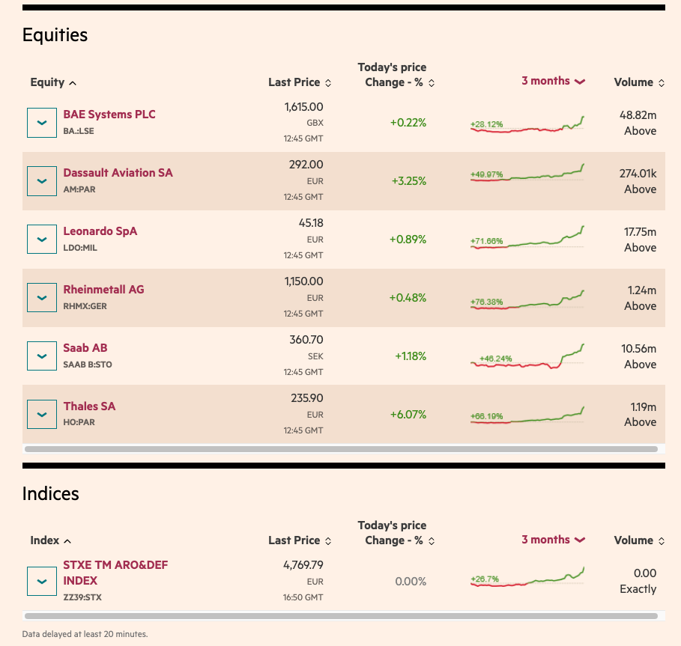

**Document Information**

Generated on: 2025-03-06

Document ID: INV-12345

**Client Details**

**Name:** John Smith  
**Email:** john.smith@example.com  
**Phone:** +1 (555) 123-4567

**Items**

|  |  |  |  |  |
| --- | --- | --- | --- | --- |
| **ID** | **Name** | **Quantity** | **Price** | **Total** |
| PROD-001 | Product A | 2 | $29.99 | $59.98 |
| PROD-002 | Product B | 1 | $49.99 | $49.99 |

**Summary**

**Total Amount:** $109.97

**Payment Status:** Paid

**Notes**

Thank you for your business!