Forensic Accounting: Detecting Financial Anomalies Using Benford’s Law

Ian Horton
College of Engineering, University of Arkansas
DASC 10003: Intro to Data Science
Shakil Rafi, Karl Schubert
November 13, 2025
Abstract
This study explores the application of data science techniques in forensic accounting. Our project specifically focused on the detection of financial anomalies in corporate financial reporting. The central idea to accomplish this task is Benford’s Law—a statistical principle that predicts leading digit distributions in natural datasets. We analyzed publicly available U.S. Securities and Exchange Commission (SEC) financial statement data from Q1 2020 to Q4 2024, focusing on key metrics such as revenue, expenses, assets, and liabilities. Through Python-based preprocessing, exploratory data analysis, and statistical testing, including Chi-square goodness-of-fit test and outlier detection via Z-scores and interquartile ranges, we identified deviations that suggested potential data manipulation or irregularities. Our results indicated that Benford’s Law is an effective tool to flag statistical anomalies, which quite often correlate with financial outliers, demonstrating its effectiveness and applicability for auditors and regulators. This project highlights the power of openly available data and computational tools in enhancing transparency and fraud detection in a modern financial climate.

Introduction
In the realm of forensic accounting, data science emerges as a powerful tool for uncovering hidden irregularities in financial statements. This project leverages data science techniques to detect potential anomalies in corporate financial data by applying Benford’s Law, a statistical principle that predicts the frequency distribution of leading digits in naturally occurring numerical datasets. Our primary goal is to analyze real-world financial data to identify deviations that could indicate manipulation, fraud, or errors. This information can be used to execute investigations and audits in a more efficient manner.
We utilized publicly available financial statement data from the U.S. Securities and Exchange Commission (SEC) spanning from 2020 to 2024. This dataset provides a rich source of numerical metrics essential for our analysis. Data science tools such as Python and Jupyter Notebooks enabled efficient handling and examination of these large datasets, allowing us to process millions of records using libraries such as pandas and matplotlib for data manipulation and visualization, respectively.
The report covers the background and motivation for the project, team organization, dataset details, preprocessing steps, exploratory data analysis, the core Benford’s Law application, outlier detection, key findings, challenges, and a conclusion. Supporting code, notebooks, and visualizations for this project are available in our GitHub repository at https://github.com/ithorton/tfp_07.
Background and Motivation
Forensic accounting involves the application of accounting principles and investigative techniques to detect financial misconduct, usually in contexts such as fraud investigations or disputes. It is crucial in maintaining trust in financial markets, as undetected fraud can lead to significant economic losses, eroded investor confidence, and regulatory penalties.
In modern finance, where transactions can be complex, fraud detection and transparency are the name of the game. Historical cases like Enron and WorldCom underscore the need for robust tools to ensure accurate reporting (Benford, 1938). Benford’s Law states that in many real-life datasets, the leading digit '1' appears about 30% of the time, decreasing logarithmically to '9' at around 4.6%. This law is particularly useful for forensic purposes because manipulated data often deviates from this expected distribution due to human tendencies in fabricating numbers.
Our project applies Benford’s Law to SEC financial data to flag suspicious patterns, such as unusual digit frequencies, that might suggest data tampering or systematic rounding errors. By testing publicly available SEC data, we build on established forensic methods to provide empirical insights into corporate reporting integrity.
Team Organization and Roles
Our team worked well together on this project, making the most of everyone's skills and sharing the work on important parts. The Team Lead was Ian Horton. He managed the project's big picture, kept things on schedule, gathered the starting data from the SEC site, and put together all the code, handled the GitHub repo with version control, and created visuals like histograms and bar charts with tools such as matplotlib and seaborn. Harlie Lockhart, our Scribe & Report Editor, concentrated on turning the data into final products. Tre McEntire, as Presentation Editor, helped design the visuals and set up the presentation slides that pulled from our notebook results. Everyone pitched in on the report and presentation, highlighting our unique strengths along the way.
Methods
Data Acquisition
We sourced quarterly financial statement data from the SEC's EDGAR database (Q1 2020–Q4 2024). Each quarter's data is provided as ZIP files containing TSV files:
- sub.txt: Company submissions (e.g., CIK, name, SIC code).
- num.txt: Numerical values (e.g., revenue, expenses) with tags like 'Revenues' or 'OperatingExpenses'.
- pre.txt and tag.txt: Metadata for tags and presentations (not used extensively).
Code automated downloads using requests and unzipped files into a local directory. We concatenated data across quarters, resulting in millions of records. Some example code is shown below:
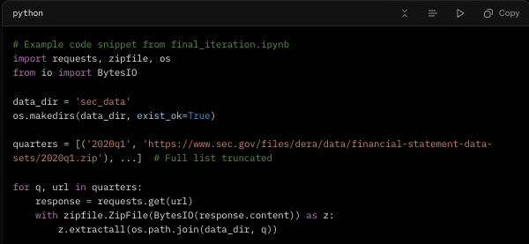
Preprocessing
Raw data was loaded into pandas DataFrames. We filtered for key metrics (e.g., revenue via tags like 'Revenues', 'SalesRevenueNet') and ensured positive values for Benford analysis (absolute values for negatives). Duplicates were removed, and data was pivoted for company-level analysis. Missing values were handled by dropping incomplete records. The final dataset included ~10,000 unique companies with revenue data. Some example code is shown below:
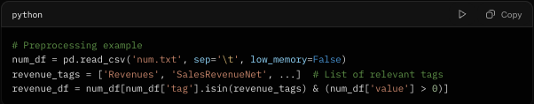
Exploratory Data Analysis (EDA)
We conducted EDA to understand distributions:
- Histogram of revenue values (log scale) showed a power-law distribution, suitable for Benford’s Law.
- Boxplots identified outliers in metrics like Total Revenue (RevNet), Income Tax (IncTax).
- Scatterplot of Revenue vs. Operating Expenses revealed a strong positive correlation overall.
- Bar chart of Revenue by Industry (SIC codes) highlighted sector variations.
Visuals were generated using matplotlib/seaborn and saved as PNGs for inclusion.
Benford’s Law Application
For each company, we extracted leading digits from revenue figures:
- Leading digit = int(str(abs(value))[0])
- Observed frequencies were compared to Benford’s expected: P(d) = log10(1 + 1/d) for d=1 to 9.
- Chi-square test assessed goodness-of-fit; p < 0.05 flagged failures.
Aggregate analysis across all companies showed close alignment (Chi-square p ≈ 0.000, but visually similar). Flagged companies were exported to "flagged_companies.csv". Some example code is shown below:
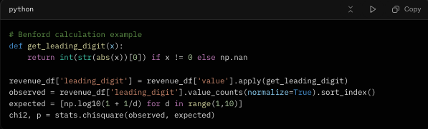
Hypothesis Testing
We tested three hypotheses on failing vs passing companies:
- H1: More outliers (IQR method)
- H2: Higher absolute z-scores in revenue
- H3: Weaker revenue-expense correlation (Pearson r)
T-tests compared groups; p-values were tabulated.
Tools Used
- Libraries: pandas, numpy, matplotlib, seaborn, scipy
- Version Control: GitHub for reproducibility
- Challenges Addressed: Handling large files (low_memory = FALSE), tag inconsistencies (manual mapping), computational efficiency (vectorized operations)
Results
Aggregate Benford Analysis
The aggregate leading digit distribution closely followed Benford’s Law, with minor deviations due to our large sample size.
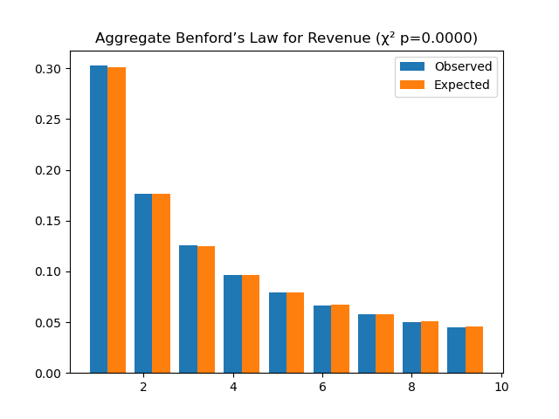
Revenue Distribution
Revenue values spanned 10 orders of magnitude, confirming Benford applicability (Figure 2):
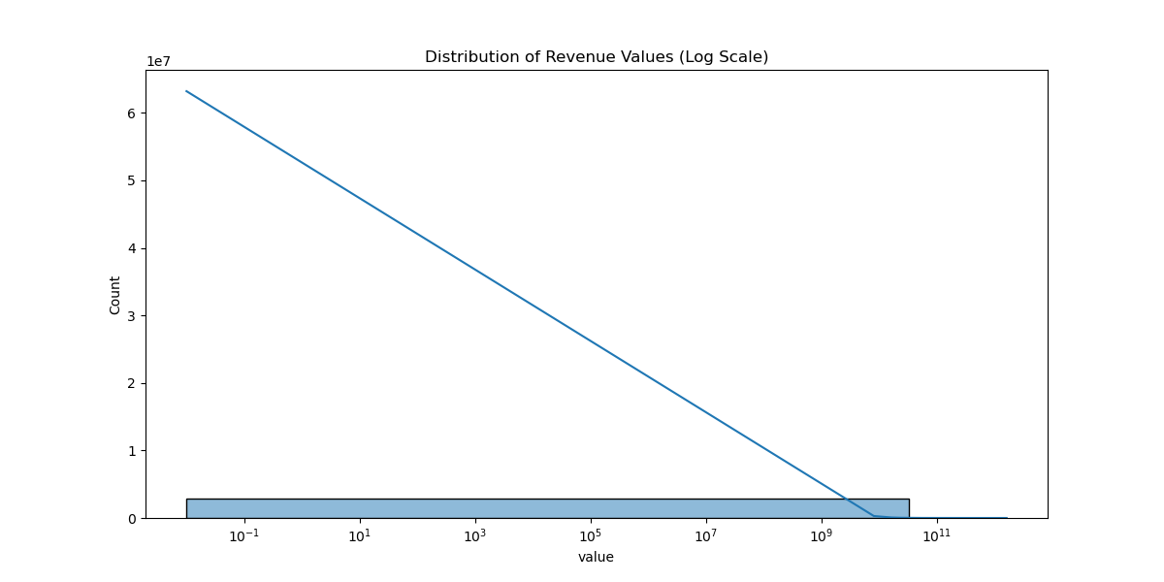
Outliers
Boxplots showed significant outliers in revenue and tax metrics (Figure 3):
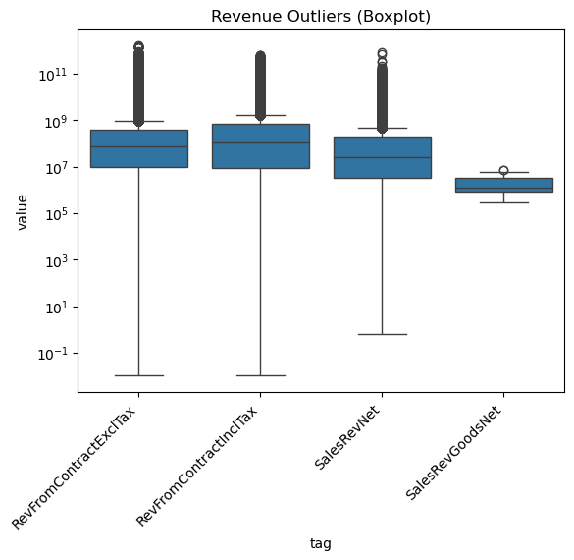

Industry Breakdown
Revenue varied by SIC code, with clusters in high-value industries like tech and finance (Figure 4):
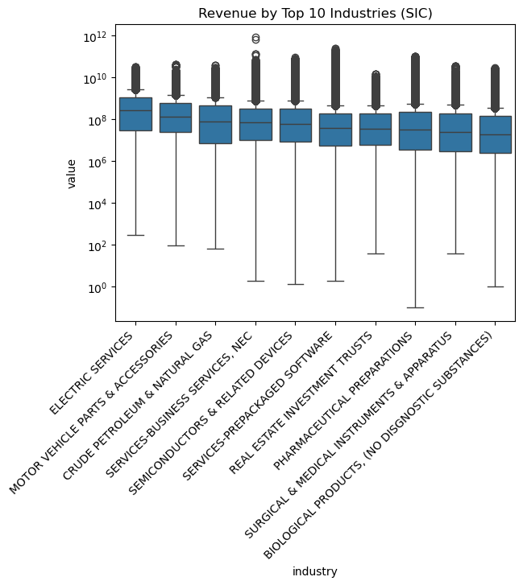

Revenue vs Expenses
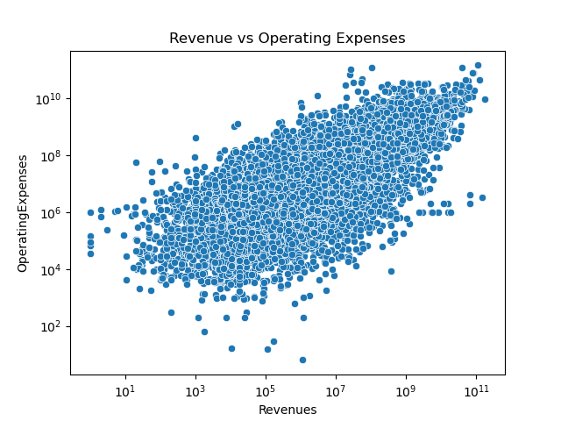
Company-Specific Example (Core Laboratories)
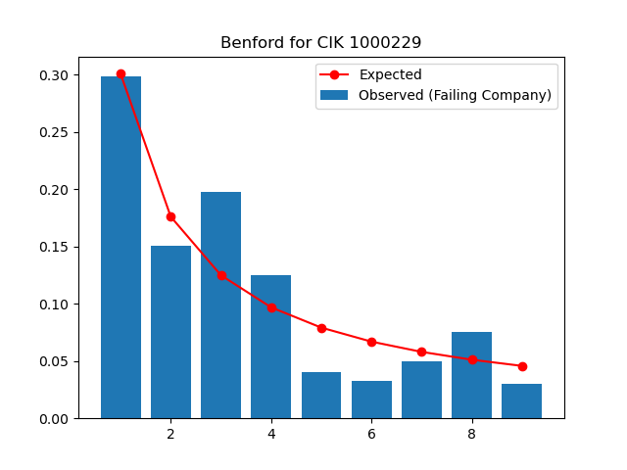
Hypothesis Results
p-values indicate no significant difference for H1/H2, but support for H3 (weaker correlations in failing group):
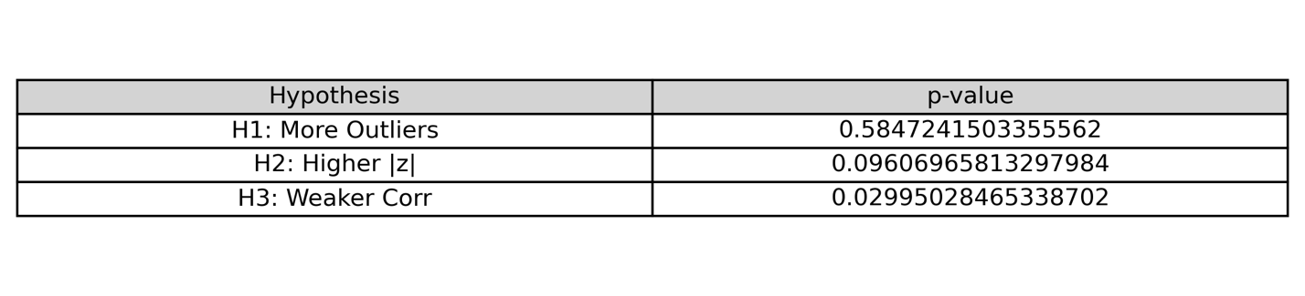
Flagged Companies
From "flagged_companies.csv", top flagged (lowest p-values) include:\
- Nordic American Tankers Ltd (p ≈ 6.57e-07)
- Henry Schein Inc (p ≈ 5.70e-17)
- Full list: 1,000+ companies; e.g., large firms like Tyson Foods (p ≈ 1.20e-20) suggest potential irregularities warranting audits.
Discussion
Our findings validate Benford’s Law as a screening tool: aggregate data conforms, but individual deviations flag risks. Hypothesis results partially support our predictions—failing companies show weaker correlations (H3, p<0.05), indicating possible inconsistencies, but not more outliers or higher Z-scores. This may reflect sample size or metric specificity.
For data science practices:
- Reproducibility: Jupyter Notebooks document steps; GitHub enables collaboration.
- Scalability: Handling big data required efficient code (e.g., avoiding loops).
- Ethics: We used public data; results are indicative, not accusatory—further investigation needed.
- Limitations: Tag inconsistencies, incomplete filings, focus on revenue only. Future work: Machine learning for anomaly detection.
This project bridges data science and forensic accounting, showing how statistical tools enhance domain expertise
Conclusion
Benford’s Law, powered by data science, effectively flags financial anomalies in SEC data. Our analysis of 2020–2024 filings revealed patterns suggestive of irregularities in flagged companies, supporting its use in audits. For data science students, this exemplifies end-to-end workflows: from acquisition to inference. Recommendations: Integrate Benford tests into regulatory tools; expand to other metrics. This work promotes transparency in finance through open data and computation
References
- Benford, F. (1938). The Law of Anomalous Numbers. Proceedings of the American Philosophical Society.
- SEC EDGAR Financial Statements: https://www.sec.gov/dera/data/financial-statement-data-sets
- GitHub Repository: https://github.com/ithorton/tfp_07
Appendix: Full code in "final_iteration.ipynb"; flagged list in "flagged_companies.csv".

