For Admin.

User: toanvv@evolableasia.vn
Password: Aa123456@

Supplier.
In the left menu. Click Catalog -> Suppliers.

The suppliers list
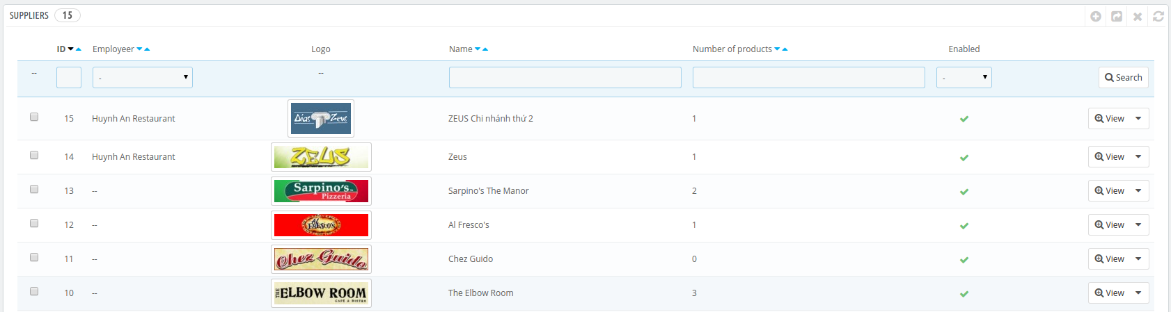

Add a supplier
Click add new in the toolbar gird.
We need 2 steps.
Example. I want to create The House Coffee Supplier and this account will allow create a new products, get order list, and delivery.

Step 1. Create The House Coffee employee
In the left menu. Click Administration > Employees -> Add new.
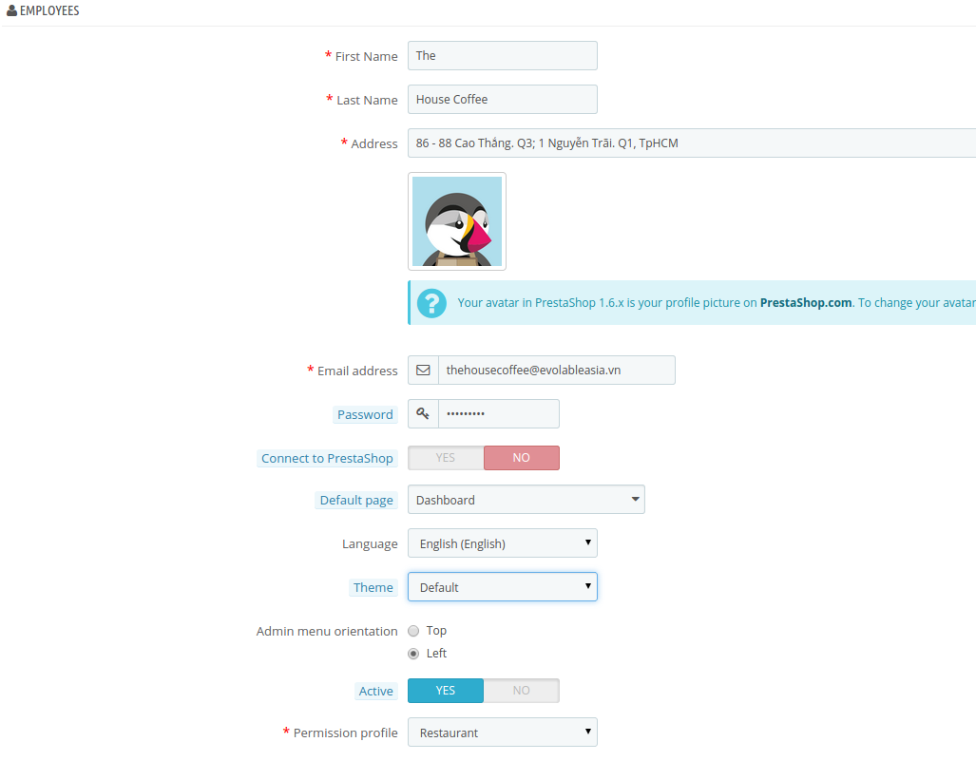

Note: The permission profile is Restaurant.
After that click Save button. The House Coffee account will create.

Step2. Connect The House Coffee with supplier.
Create The house coffee supplier.
In the left menu. Click Catalog -> Suppliers -> Add new.
Note. The employee is The House Coffee account.

