Curriculum Vitae
Date:16/3/2015

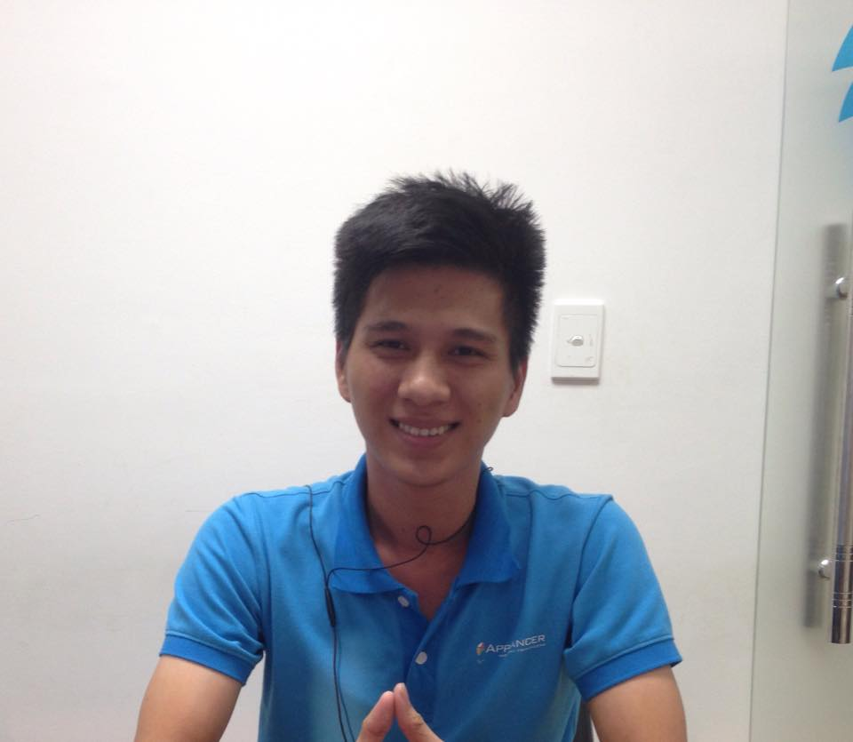
Picture
name | Huynh Thai An
phone | 0916.624.099
email | Ithtan558@gmail.com
address | 8b Tan Vien Street, District Tan Binh, HCM City, Vietnam
address(parental) | Hau Giang
birthday | 17/6/1990

Year | Month | Education and Training（High school, University...）
2009 - 2013 |  | - CTU (CanTho University, Can Tho, Vietnam)  + Subjects studied :  ▪ Operating Systems : Windows 2000, XP  ▪ Programming languages : C, C++, C#, Java, PHP, MySQL, HTML, XML.  ▪ Databases : MS SQL Server 2000, Mysql  ▪ And subjects : System Analysis and Design, Software Project Management, Object - Oriented Programming(using C# language ), Database Management System, Design and develop website  ▪ I have 4 years programming experience  ▪ After once subjects I must make a project for close.  2012 – 2013 : Certifiles : Algie Project Managent with Scrum
Year | Month | Working experience/Part time
2013– 2014 | 13 | I’m woking for nsp.com.vn (that is company network)  - The follow demo about my projects :  Link : http://fredton.com
2014 - 2015 | 9 | I’m woking for Applancer.net (That is company “Hire great freelancers, easily create mobile apps”)  - The follow demo about my projects :  + Trading platform Applancer  Applancer - Hire great freelancers, easily create mobile apps (With many support tools for mobile app developers, Applancer is the world’s mobile app outsourcing platform.)  Responsibilities: Program and test interface, function.  Link : https://applancer.net  + Market app (Build Native Mobile Apps for your WordPress Site)  Sapp is the market for everybody sell and buy on website an easy convenient and security first.  Link : http://sapp.co

Year | Month | Certificates
- -2013 |  | CTU (CanTho University, Can Tho, Vietnam)
2012 – 2013 |  | Certifiles : Algie Project Managent with Scrum
■ PR (your skill/reason for application)

- Over 2 years of Programming industry experience
  - 2 years of experience in PHP, MySQL, Jquery, CSS3, HTML5, Javascript
  - 1 year of experience in Codeigniter
  - 6 month of experience in Yii, laravel
  - 1 year of experience in Bootstap
  - 6 month of experience in marketing online (SEO)
  - 6 month of experience in C#, Webservice, API
- Reason for application : i want to work in the challenging and progressive environment, i have researched a number organization carefully and you have excellent reputation as an employer

■ Hobby・Special skill・Favorite book:

■Smoking not at all / sometimes / everyday
■Marriage Married / not yet

