

LoanHub Vodacom M-Pesa OpenAPI
Sandbox Testing, Verification and Go-Live Manual
Web release: LoanHub v1.2 M-Pesa Integration
Market: Vodacom Lesotho (vodacomLES / LES / LSL)
Prepared for: Matsepo and LoanHub participating lending companies
Prepared by: Ithute Solutions
Release statement
This manual validates the implemented LoanHub integration and guides sandbox testing. It does not prove production approval, settlement, or certification. Live operation requires valid Vodacom credentials, product enablement, organisation linking, end-to-end testing, review and go-live approval.

1. Document control and release scope
Item | Value
Document owner | Ithute Solutions / LoanHub platform owner
Version | 1.0 testing manual for LoanHub M-Pesa web integration
Date | 2026-07-17
Database migration head | b8d5e21f9a30
Backend | FastAPI, SQLAlchemy, Alembic, PostgreSQL, Redis
Frontend | Next.js 16, React 19, TypeScript, Tailwind CSS
M-Pesa market | vodacomLES
Country and currency | LES / LSL
Supported actors | Borrower, company finance/management, platform owner

Purpose
This manual provides repeatable test procedures for LoanHub's M-Pesa payment, disbursement, direct-debit, reversal, monitoring, receipt and support-query features. It is designed for developers, finance testers, company owners, support teams and the platform owner.

What is implemented
Per-company encrypted M-Pesa configuration and SessionKey testing.
C2B single-stage and multi-stage borrower repayments.
Query Beneficiary Name before B2C loan disbursement.
B2C disbursement, B2B business payment, transaction query and status update.
Direct Debit Create, Payment, Query and Cancel.
Reversal request, management approval and compensating accounting/loan effects.
Idempotent callbacks, automatic status reconciliation and PDF transaction documents.
Platform-owner monitoring, company/borrower query centre and one non-overlapping floating tool dock.

Verification boundary
Important
The exact field names and response fields for each product must be compared with the current Vodacom Lesotho portal page attached to the actual application. The Query Transaction Status contract is confirmed from supplied documentation. Other payloads follow the portal conventions but must be validated during sandbox certification.

2. Manual contents
Section | Topic
3 | Architecture and role controls
4 | Environment preparation and installation
5 | Company M-Pesa configuration
6 | SessionKey and connection tests
7 | Borrower C2B single-stage repayment
8 | Borrower C2B multi-stage repayment
9 | Callbacks, status query and reconciliation
10 | B2C loan disbursement and beneficiary verification
11 | B2B company payment
12 | Direct-debit mandate and collection
13 | Reversal workflow
14 | Receipts, loan balance and accounting
15 | Platform-owner oversight
16 | User query centre and floating tools
17 | Error-code and resilience tests
18 | Security and privacy tests
19 | Responsive UI and accessibility tests
20 | Regression and go-live sign-off
21 | Troubleshooting reference

Test result convention
Result | Meaning
PASS | Observed result matches the expected result.
FAIL | Observed result differs; record evidence and stop go-live for affected feature.
BLOCKED | External credentials, product scope, test number or provider availability prevents execution.
NOT APPLICABLE | The company contract does not enable the product.

3. Architecture and role controls
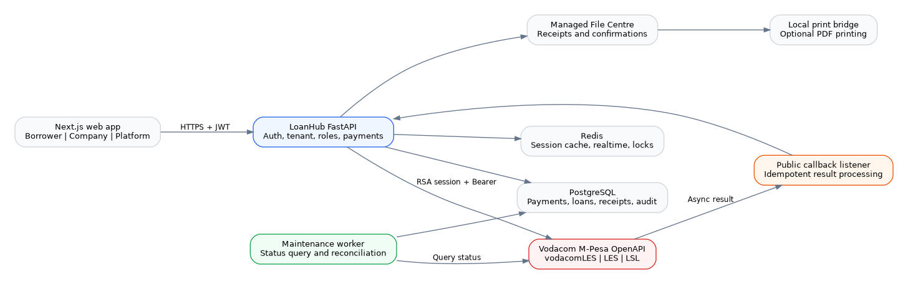
Figure 1 - LoanHub M-Pesa runtime architecture
M-Pesa secrets remain in the backend. Next.js sends normal LoanHub requests authenticated with the user access token and company header. The backend resolves tenant and branch access before calling M-Pesa.

Role matrix
Action | Borrower | Finance role | Company management | Platform owner
View own M-Pesa transactions | Yes | Company/branch scope | Company scope | All companies
Initiate own C2B repayment | Yes | Assisted only when permitted | View/oversight | View/oversight
Configure M-Pesa credentials | No | View/test where allowed | Create/update/enable | Configuration metadata only
Query beneficiary and B2C disburse | No | Yes | Yes | Oversight
B2B payment | No | Company-wide finance only | Yes | Oversight
Create/cancel own direct debit | Yes | Yes for company clients | Yes | Oversight
Collect direct debit | No | Yes | Yes | Oversight
Request reversal | No | Yes | Yes | Oversight
Approve reversal | No | No | Yes | Oversight
Respond to platform queries | Submit | Submit | Submit | Review/respond/status

Branch protection
Branch-scoped staff see only M-Pesa records linked to loans in their assigned branch. Company-level B2B payments require company-wide finance access.

4. Environment preparation and installation

4.1 Prerequisites
PostgreSQL backup and tested restore procedure.
Redis available for session cache, realtime communication and locks.
HTTPS-capable public callback URL for end-to-end sandbox tests.
Vodacom developer application linked to the organisation and required products enabled.
Sandbox API key, public key, service-provider code and trusted origin.
Sandbox MSISDNs/scenarios supplied by Vodacom.

4.2 Back up the database
pg_dump --format=custom --no-owner --no-privileges \
"$DATABASE_URL" > loanhub-before-mpesa.dump

4.3 Apply the migration
cd apps/loan_backend
source .venv/bin/activate
alembic current
alembic heads
alembic upgrade head
alembic current
Expected head
b8d5e21f9a30

4.4 Runtime settings
ENVIRONMENT=development
PAYMENT_MOCK_MODE=false
MPESA_HOST=https://openapi.m-pesa.com
MPESA_HTTP_TIMEOUT_SECONDS=45
MPESA_CALLBACK_TOKEN=<random-private-value>
REDIS_URL=redis://localhost:6379/0
Company API keys, public keys and shortcodes are entered through the Company M-Pesa page and are stored encrypted. They are not placed in browser environment variables.

4.5 Start services
uvicorn main:app --host 0.0.0.0 --port 8000 --reload
python -m docker.maintenance
cd apps/frontend
pnpm install
pnpm typecheck
pnpm lint
pnpm build
pnpm dev

5. Company M-Pesa configuration
Open Company > M-Pesa. Only authorised company-management users may save production-sensitive configuration.
1. Select Sandbox for all initial testing.
2. Confirm the market is vodacomLES, country LES and currency LSL.
3. Enter the service-provider code/shortcode assigned to the organisation.
4. Enter the M-Pesa API key and current RSA public key.
5. Enter the exact trusted Origin registered in the developer application.
6. Enter an HTTPS callback base URL for end-to-end callback tests.
7. Enable only the M-Pesa products approved for this application.
8. Keep Production enabled off until Vodacom and the organisation approve go-live.
9. Save the configuration, then run Test connection.
Field | Validation
Environment | sandbox initially; openapi only after explicit production enablement
Market/Country/Currency | vodacomLES / LES / LSL; fixed by LoanHub
Service provider code | 4-12 characters according to provider contract
Origin | Must match trusted source; no wildcard in production
Callback base URL | HTTPS for production; points to reachable LoanHub API
API key/Public key | Required on first save; never returned after save
Enabled products | Must match products enabled in the M-Pesa application

6. Generate SessionKey and connection tests
LoanHub encrypts the API key with the configured M-Pesa RSA public key, calls Generate SessionKey and caches the returned session per company and environment.
Test ID | Procedure | Expected result
SES-01 | Save valid sandbox credentials and select Test connection. | Success message; last test status and time updated.
SES-02 | Use an invalid API key. | Safe failure message; no key appears in response or logs.
SES-03 | Use malformed public key data. | Configuration test fails with invalid-public-key guidance.
SES-04 | Repeat connection test. | A new forced SessionKey is requested; existing operational session cache is safely replaceable.
SES-05 | Stop Redis and test in development. | In-process cache fallback works; operator receives error only when provider call fails.

Session activation
Some portal configurations may take time before a newly issued session is accepted. LoanHub retries authentication once and preserves uncertain payment attempts for reconciliation instead of generating duplicate customer payments.

7. Borrower C2B single-stage repayment
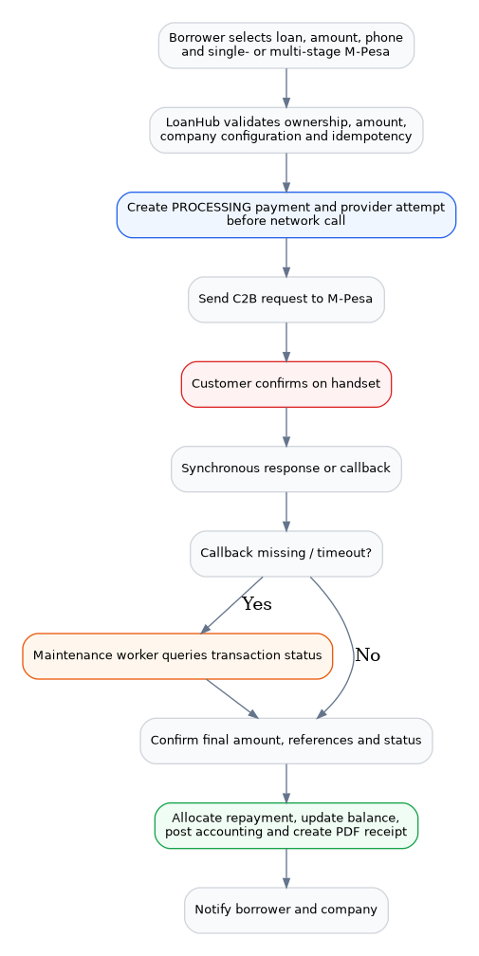
Figure 2 - Borrower repayment, callback and reconciliation flow

7.1 Happy-path test
1. Sign in as a borrower with an active loan.
2. Open Borrower > M-Pesa or the loan repayment action.
3. Select the loan and enter an amount that does not exceed the allowed repayment rules.
4. Enter a valid Lesotho M-Pesa number.
5. Select Single Stage and submit once.
6. Complete the M-Pesa handset prompt using the sandbox scenario.
7. Wait for the callback or select Refresh status.
8. Open the transaction and download the PDF receipt.
Expected checkpoint | Expected value
Local payment | Exactly one PaymentTransaction with provider=mpesa and status processing/succeeded
Provider attempt | Created before the network call with a ThirdPartyConversationID
Final status | succeeded only after conclusive provider result
Loan | Payment allocated and outstanding balance reduced
Accounting | Journal created once
Receipt | One PDF; borrower and authorised company users can download
Notification | Borrower and company receive relevant update

7.2 Idempotency test
Submit the same frontend idempotency key twice. The second request must return the original transaction and must not create another provider attempt or charge request.

7.3 Timeout test
Trigger the provider timeout scenario. The payment and provider attempt must remain processing. Query Transaction Status must run later. Do not submit a second payment to compensate for the timeout.

8. Borrower C2B multi-stage repayment
Multi-stage is available only for loan repayment in this release. It is used when the M-Pesa product requires an additional customer or merchant status step.
Test ID | Procedure | Expected result
C2M-01 | Create a repayment and choose Multi Stage. | Operation is c2b_multi; payment is processing after initial acceptance.
C2M-02 | Complete customer confirmation. | Callback/status query moves transaction to succeeded when final result is complete.
C2M-03 | As authorised finance user, use Update Transaction Status where the provider flow requires it. | Update is recorded against the provider transaction; no direct database-only success is allowed.
C2M-04 | Attempt status update on a normal single-stage transaction. | UI does not offer the action or backend rejects inappropriate workflow.
C2M-05 | Reject or let the handset prompt expire. | Payment becomes failed/rejected only after provider confirmation.

Field verification
Compare the current Vodacom Lesotho C2B Multi Stage request fields and required update status values with the actual portal application documentation before certification.

9. Callbacks, transaction status and reconciliation

9.1 Callback test
POST /api/v1/mpesa/callbacks/transaction-result
Content-Type: application/json
{
"input_OriginalConversationID": "<provider-conversation>",
"input_TransactionID": "<mpesa-transaction>",
"input_ResultCode": "INS-0",
"input_ResultDesc": "Request processed successfully",
"input_ThirdPartyConversationID": "<loanhub-reference>",
"input_OriginalTransactionID": "<original-transaction>",
"input_Reversed": "False"
}
Assertion | Expected result
Acknowledgement | Response code 0 and original/third-party references returned quickly.
Duplicate callback | Same payload hash is acknowledged without duplicate allocation/accounting/receipt.
Unmatched callback | Stored with processing_status=unmatched for platform investigation.
Sensitive data | Callback payload stored through sanitisation; phone/key-like fields are redacted/masked.

9.2 Query Transaction Status
LoanHub queries by M-Pesa TransactionID, ConversationID or its ThirdPartyConversationID. The request uses LES and the company service-provider code. This is the recovery path for timeout, missing callback, closed browser or network interruption.

9.3 Maintenance worker
Checks created/pending/processing provider attempts after a minimum age.
Respects a minimum interval between status queries.
Queries only active company configurations with Query Transaction Status enabled.
Caps status-query attempts and isolates each transaction error.
Applies final payment, loan, accounting and receipt changes exactly once.

10. B2C loan disbursement and beneficiary verification
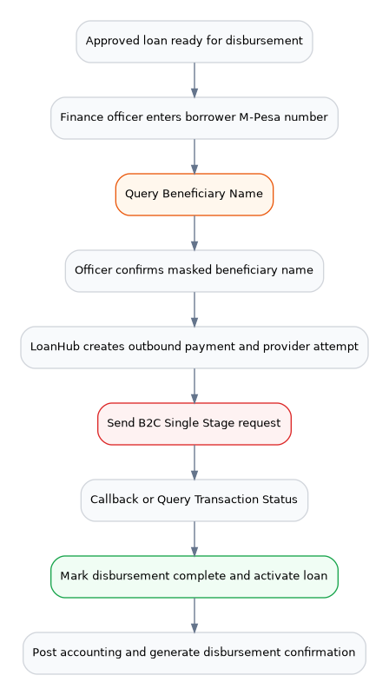
Figure 3 - Beneficiary verification and B2C loan disbursement
1. Approve a walk-in or marketplace loan through normal company controls.
2. Open the company loan record and choose M-Pesa disbursement.
3. Enter the borrower M-Pesa number.
4. Run Query Beneficiary Name.
5. Compare the masked/returned name with the approved borrower identity.
6. Confirm and submit the B2C disbursement.
7. Wait for final provider status or run Refresh status.
8. Confirm the loan is activated only after successful disbursement.
9. Download the disbursement confirmation document.
Negative test | Expected result
Beneficiary name not returned | Disbursement cannot be confirmed as verified.
Wrong company/branch | 403 access denial.
Duplicate idempotency key | Original transaction returned.
Timeout | Disbursement remains processing and is reconciled; loan is not activated prematurely.
Provider failure | Loan remains undistributed; safe failure shown.

11. B2B company payment
B2B is intended for approved company payments to a registered business. It is not exposed to ordinary borrowers and requires company-wide finance access.
1. Sign in with a company-wide finance role.
2. Open Company > M-Pesa > Business payments.
3. Enter amount, receiver party code, transaction reference and business-purpose description.
4. Use a unique idempotency key and submit.
5. Confirm provider status by callback or query.
6. Check the outbound accounting journal and transaction confirmation.
Test | Expected result
Branch-only finance user | Blocked from company-level B2B.
Missing receiver party code | Validation error before provider call.
Provider timeout | Payment and provider attempt remain processing and reconcilable.
Completed B2B | Outbound transaction recorded; no loan principal allocation is fabricated.

12. Direct-debit mandate and collection
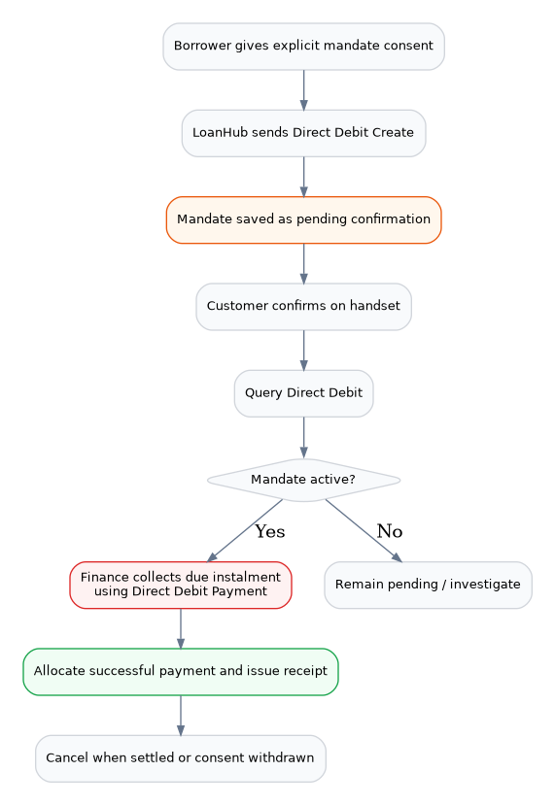
Figure 4 - Direct-debit mandate lifecycle

12.1 Create mandate
1. Open an active borrower loan and choose automatic repayment/direct debit.
2. Enter mobile number, amount or maximum amount, frequency, start/end dates and consent text.
3. Confirm explicit borrower consent.
4. Submit Direct Debit Create.
5. Complete the customer handset confirmation.
6. Run Query Direct Debit until the mandate is active.
Safety rule
A newly created mandate remains pending_confirmation even when the initial request is accepted. LoanHub allows collection only after Query Direct Debit confirms an active state.

12.2 Collect instalment
1. Sign in as authorised finance staff.
2. Open an active mandate and choose Collect.
3. Enter the due amount, transaction reference and unique idempotency key.
4. Submit Direct Debit Payment.
5. Confirm final status, allocation, balance, accounting and receipt.

12.3 Cancel mandate
Borrowers may cancel their own mandate; authorised finance/compliance staff may cancel within company scope. Cancellation is idempotent. Test cancellation when the loan is settled, consent is withdrawn, or the mandate is replaced.

13. Reversal workflow
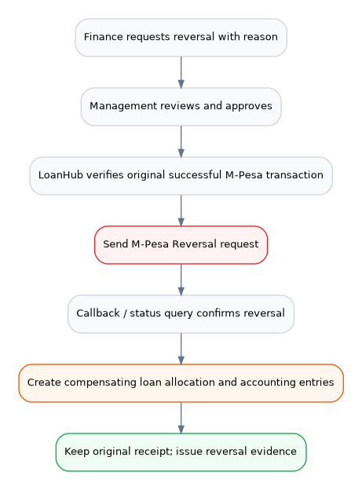
Figure 5 - Controlled M-Pesa reversal workflow
1. Choose a successful M-Pesa transaction.
2. Finance submits a reversal request with a clear reason and amount not greater than the original transaction.
3. Company management reviews and approves.
4. LoanHub verifies that an M-Pesa transaction ID is available.
5. LoanHub sends the provider reversal request.
6. Wait for provider confirmation or query the result.
7. Confirm compensating loan allocation/accounting entries.
8. Confirm the original receipt remains available and reversal evidence is retained.
Negative test | Expected result
Pending/failed original payment | Reversal request rejected.
Amount exceeds original | 422 validation error.
Duplicate active request | Existing request returned; no second provider reversal.
No M-Pesa transaction ID | Operator instructed to refresh status first.
Unapproved request | No provider call.

14. Receipts, loan balance and accounting
LoanHub generates a purpose-specific PDF document after confirmed success. The document is stored in the encrypted/managed File Centre and linked to the payment.
Purpose | Document wording | Financial effect
Loan repayment | Repayment receipt | Allocate instalments, reduce balance, post inbound journal.
Loan disbursement | Disbursement confirmation | Activate/disburse loan, post outbound journal.
Refund | Refund confirmation | Outbound transaction and appropriate accounting.
B2B | Business payment confirmation | Outbound business transaction; no loan allocation unless explicitly linked.

Receipt assertions
Document number, M-Pesa reference, date, customer, loan reference, transaction type and method.
Repayment receipt includes balance before, amount, principal, interest, fee, penalty and balance after.
Non-repayment documents use correct labels such as Amount disbursed or Amount transferred.
One verification code and one PDF per payment.
Receipt is unavailable until the payment is conclusively succeeded.
Reversal never deletes the original document.

15. Platform-owner oversight
Open Platform > M-Pesa. The platform owner receives operational visibility without receiving decrypted company credentials.
Metric/list | Test
Configurations | Counts all and active configurations; sandbox and production separated.
Transactions | Totals processing, completed, failed and reversed provider attempts.
Direct-debit mandates | Count matches records across companies.
Callback events | Shows received/unmatched/failed events for support investigation.
Configuration list | Shows metadata and has_api_key/has_public_key flags, never secret values.

Tenant responsibility
The platform owner monitors system health. Each lending company remains responsible for its organisation agreement, provider credentials, settlement, limits, accounting and authorised operational users.

16. User query centre and floating tools
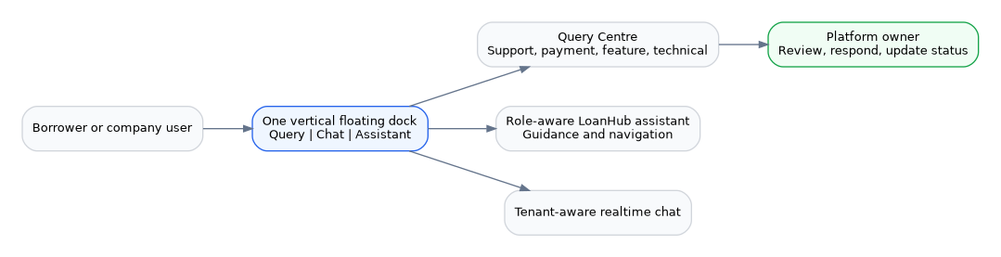
Figure 6 - Query, Chat and Assistant tools

16.1 Submit a query
1. As a borrower or company user, select the Query button in the floating dock.
2. Choose support, payment, feature, technical or training category.
3. Enter title, priority and detailed description.
4. Submit and note the generated query reference.
5. Confirm the query appears in the user history.

16.2 Platform response
1. As platform owner, open Platform > Queries.
2. Filter and open the submitted query.
3. Add the official response and update status.
4. Confirm the submitting user can read the response.

16.3 Floating-tool collision test
Viewport | Expected layout
Phone portrait | Vertical Query, Chat, Assistant dock remains visible; assistant panel opens above entire dock.
Tablet | Dock remains at lower right; panel has responsive height and no action is covered.
Desktop | Assistant panel opens beside the dock; query/chat buttons remain clickable.

17. Error-code and resilience tests
Provider code | Meaning | LoanHub expected action
INS-0 | Request processed successfully | Use returned/final status; do not assume settlement from code alone.
INS-1 | Internal error | Controlled retry/status enquiry; safe operator message.
INS-6 | Transaction failed | Mark failed when conclusive.
INS-9 | Request timeout | Keep processing and query original transaction; never duplicate payment.
INS-13 | Invalid shortcode | Fail configuration/transaction and alert company administrator.
INS-20 | Missing parameters | Developer/configuration defect; no secret leakage.
INS-21 | Parameter validation failed | Show safe validation guidance; compare current product docs.
INS-23 | Transaction not found | Keep unknown/reconciliation state according to retry policy.
INS-28 | Invalid third-party reference | Investigate reference generation and limits.
INS-996 | Outside usage time | Retry only during configured usage period.
INS-997 | API not enabled | Enable product in M-Pesa application/organisation.
INS-998 | Invalid market | Verify vodacomLES and LES.

Resilience scenarios
Kill the browser after submission; callback/worker still completes transaction.
Restart API after creating processing transaction; PostgreSQL provider attempt supports recovery.
Stop callback route temporarily; Query Transaction Status later finalises.
Send the same callback twice; financial side effects happen once.
Simulate Redis outage; no credentials appear and in-process session fallback is bounded.
Simulate database error during callback; event records failed processing for support retry.

18. Security and privacy tests
Test | Expected result
Inspect browser network | No M-Pesa API key, public key, session ID or shortcode secret returned.
Read configuration API response | Only has_api_key/has_public_key booleans; secrets absent.
Inspect logs | MSISDN masked; authorization/key/secret-like fields redacted.
Cross-company access | 403 or 404; no foreign transaction data.
Borrower access | Only own borrower transactions/mandates/receipts.
Branch access | Only branch-linked loan transactions.
Callback duplicate | Payload-hash uniqueness prevents duplicate processing.
Production callback URL | HTTPS required.
Production toggle | Cannot select production without explicit production_enabled confirmation.

Credential exposure
Any API key or Bearer session pasted into chat, tickets, screenshots or code should be rotated before further testing.

19. Responsive UI and accessibility tests
Area | Phone | Tablet/Desktop
Borrower repayment dialog | Single-column, scrollable, submit/cancel reachable. | Comfortable width, no excessive stretch.
Company M-Pesa tabs | Scrollable/wrapped navigation; permissions hide forbidden actions. | All applicable tabs readable.
Transaction list | Cards or horizontal-safe table; status visible. | Table/cards use available width.
Floating tools | No overlap with assistant; touch targets at least approximately 44px. | Panel beside dock.
Keyboard | Tab order reaches controls; Escape closes safe dialogs. | Focus visible throughout.
Dark mode | Logo, fields, status chips and text remain readable. | Same.

Minimum viewport checks
320 x 568 phone
390 x 844 modern phone
768 x 1024 tablet
1366 x 768 laptop
1920 x 1080 desktop

20. Regression and go-live sign-off

20.1 Engineering validation
Check | Result / evidence
Python compileall
M-Pesa unit tests
Alembic single head
OpenAPI route generation
Frontend typecheck
Frontend lint
Frontend production build
Callback public reachability
Maintenance worker running
Database backup restore tested

20.2 Financial user acceptance
Scenario | Tester | Result | Evidence/reference
C2B single repayment
C2B multi-stage repayment
B2C disbursement
B2B payment
Direct-debit lifecycle
Reversal
Receipt and accounting
Platform monitoring

20.3 Go-live gate
Developer account linked to the organisation.
Application sent for organisation review and accepted.
Vodacom end-to-end testing/certification completed.
Production products and transaction/customer limits enabled.
Trusted sources and callback URL registered.
Production credentials entered through LoanHub and connection tested.
First transactions monitored and independently reconciled.
Incident, reversal and support escalation contacts documented.

21. Troubleshooting reference
Symptom | Likely cause | Action
Connection test fails | API key/public key/origin invalid or session not active | Verify portal configuration, rotate exposed keys, retry after provider activation delay.
INS-997 | Product not enabled | Enable product in developer application and organisation account.
INS-998 | Wrong market | Use vodacomLES and LES.
Payment stuck processing | Callback missing or provider uncertain | Use Refresh status; confirm maintenance worker and Query Status product.
Receipt unavailable | Payment not conclusively succeeded | Refresh/query status; do not create manual success.
Direct debit cannot collect | Mandate pending/not active | Complete handset confirmation and Query Direct Debit.
B2C blocked | Beneficiary not verified or role/branch mismatch | Run QBN and use authorised finance/company scope.
Callback unmatched | References differ from stored attempt | Inspect platform callback events and portal field mapping.
Query/chat/robot overlap | Old frontend bundle or cached CSS | Deploy current frontend, clear .next/browser cache and reload.

Support evidence to collect
LoanHub payment ID and ThirdPartyConversationID.
M-Pesa ConversationID and TransactionID when available.
Company, branch, user role and test timestamp.
Safe response code/description without API keys or SessionKey.
Browser/API logs with personal data masked.
Screenshot of the visible user error and provider sandbox scenario used.
Final reminder
Never mark a transaction succeeded solely to make testing pass. Resolve status through the final provider result or authorised reconciliation process.

