

LoanHub v1.0
Product Description, UI Guide and Role-by-Role Operations

Release | LoanHub v1.0
Audience | Platform owner, company teams, branch teams and borrowers
Prepared | 16 July 2026
Developer | Ithute Solutions


Developed and maintained by Ithute Solutions

Document control
Item | Value
Product | LoanHub multi-tenant loan marketplace and management platform
Release | v1.0
Purpose | Explain what the finished system does and how every role uses it.
Audience | All operational users and trainers
Developer | Ithute Solutions
Source baseline | Final engineered monorepo plus WebSocket, file-upload and accounting race fixes
Database head | f1a9c4e7b620
Business timezone | Africa/Maseru

Version note
The product handover is named LoanHub v1.0. The FastAPI metadata string in the current source is an independent API schema version and should be governed consistently in future releases.

Contents
1. Product purpose and scope
2. Branding and interface principles
3. System roles
4. UI tour
5. Accounts and tenant navigation
6. Company and borrower onboarding
7. Marketplace and offers
8. Loan servicing and payments
9. Notifications, chat and files
10. Employees and performance
11. Accounting and reports
12. Audit and system errors
13. Role workflows
14. Operational checklists
15. Troubleshooting and boundaries

1. Product purpose and scope
LoanHub is a multi-tenant loan marketplace and loan-management platform designed for Lesotho. Many independent lending companies use one platform while their operational data remains separated by company and, where configured, by branch. Borrowers submit funding requests, eligible lenders compete through offers, and the accepted lender services the resulting loan.
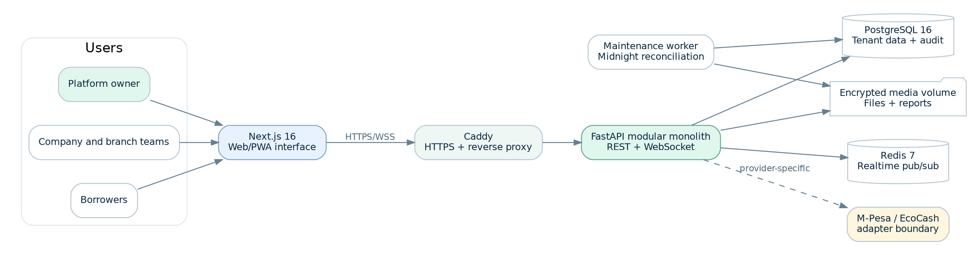
Figure 1. LoanHub users, applications, services and persistent stores.

Completed v1.0 modules
Module | What v1.0 provides
Accounts, authentication and sessions | Email/phone login, access tokens, refresh cookie, logout, account status and safe session recovery.
Multi-tenant company administration | Company registration/approval, branches, staff memberships, roles and active company selection.
Borrower profiles | Identity, contact, address, employment, affordability, consent and personal document context.
Loan-request marketplace | Broadcast requests, lender discovery, subscription/pay-per-request unlocks and competing offers.
Loan servicing | Accepted loans, disbursement, repayment schedules, allocations, overdue processing and completion.
Billing and payments | Plans, subscriptions, unlock charges, platform fees and provider-neutral payment records.
Notifications, audit and incidents | Persistent actionable alerts, audit transparency and grouped technical error monitoring.
Chat and presence | Direct/group chat, one shared socket per tab, online/offline state, typing, read state and voice notes.
Managed files | Permissioned uploads/downloads, checksums, encryption, visibility and report/voice-note storage.
Employees and performance | Employee profiles, managers, departments, goals, reviews and analytics.
Accounting | Chart of accounts, balanced journal entries, posting, trial balance, profit/loss and balance sheet.
Reports and midnight automation | Manual/scheduled PDF and CSV reports plus 00:00 Africa/Maseru reconciliation.

Production boundary
Live M-Pesa and EcoCash provider certification is not represented as complete. Provider credentials, signed callbacks, status enquiry, reversals and settlement reconciliation are required before real-money production use.

2. Branding and interface principles
LoanHub is the product/system identity. The square app icon is used for compact navigation and application identity; the horizontal LoanHub logo is used on entry, reports and primary product areas. The Ithute Solutions logo identifies the developer and maintenance provider and is displayed as a smaller credit.
- Readable names and business references are shown before raw UUIDs.
- Navigation changes by role, company status, branch scope and subscription.
- Responsive layouts support desktop, tablet and mobile use.
- Light, Dark and System themes are supported.
- The floating chat button remains available outside chat pages.
- Technical stack traces are never shown to ordinary users.
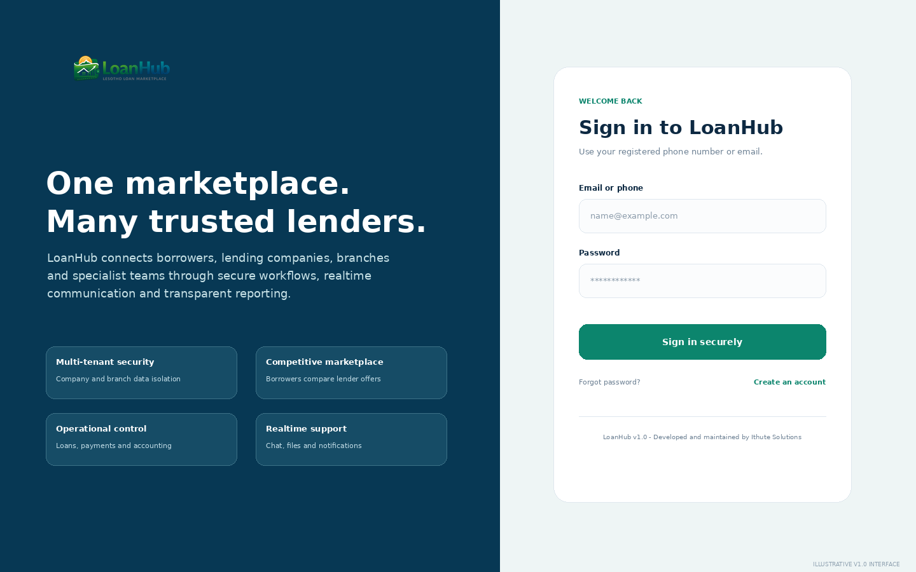
Figure 2. Illustrative sign-in experience and product branding.

3. System roles

Platform owner / SuperAdmin
Governs the multi-tenant platform, approves companies, configures plans, reviews platform accounting/reports, manages incidents and performs audited role switching.
- Review pending companies and incidents
- Monitor plans, payments and platform performance
- Use role switching only with a recorded support/testing reason
- Protect secrets, backups and migration discipline

Company owner
Highest authority inside a lending company.
- Maintain company details, branches, staff and products
- Oversee marketplace, loans, payments, accounting and reports
- Separate duties between finance, lending, collections and audit where possible

Company administrator
Coordinates day-to-day company operations.
- Maintain master data and staff scope
- Route work to specialist roles
- Review notifications, activity and incomplete workflows

Branch manager
Runs an assigned branch.
- Assign branch work
- Review active and overdue loans
- Monitor branch employees, goals and reports

Loan officer
Evaluates marketplace requests and prepares responsible offers.
- Review matching requests
- Unlock details only when authorised
- Check affordability and create compliant offers

Finance officer
Controls disbursement, repayment, reconciliation and accounting evidence.
- Verify payment references and status
- Reconcile provider result with LoanHub records
- Review journals and statements

Collections officer
Manages due and overdue repayment follow-up.
- Verify payment history before contact
- Record promises, disputes and escalation
- Follow respectful consumer-protection procedures

Compliance officer
Reviews access, consent, controls and regulatory exceptions.
- Review audit events and high-risk changes
- Collect evidence using reports and files
- Document remediation and escalation

Auditor
Performs independent, read-oriented review.
- Define scope and period
- Compare source events, approvals, payments and journals
- Use friendly references in findings

Customer support
Assists users without exceeding permissions.
- Verify the user safely
- Use request, loan, report or payment references
- Escalate finance, IT, compliance or lending issues

HR manager
Maintains workforce records and protected HR information.
- Maintain employee status and reporting lines
- Restrict salary/HR notes
- Coordinate performance-review periods

Performance manager
Creates goals and evidence-based reviews.
- Define measurable goals
- Track progress and quality
- Compare branches with context

Risk manager
Reviews credit, payment and operational risk.
- Monitor overdue/failure trends
- Investigate unusual activity
- Assign mitigations and monitor outcomes

IT support
Investigates availability and technical incidents.
- Use request IDs and fingerprints
- Reproduce safely in staging
- Patch root causes without editing financial history

Borrower
Creates funding requests and manages personal loans.
- Maintain profile and consent
- Compare total repayment, fees and term
- Track schedules, balances and approved payments

4. User interface tour
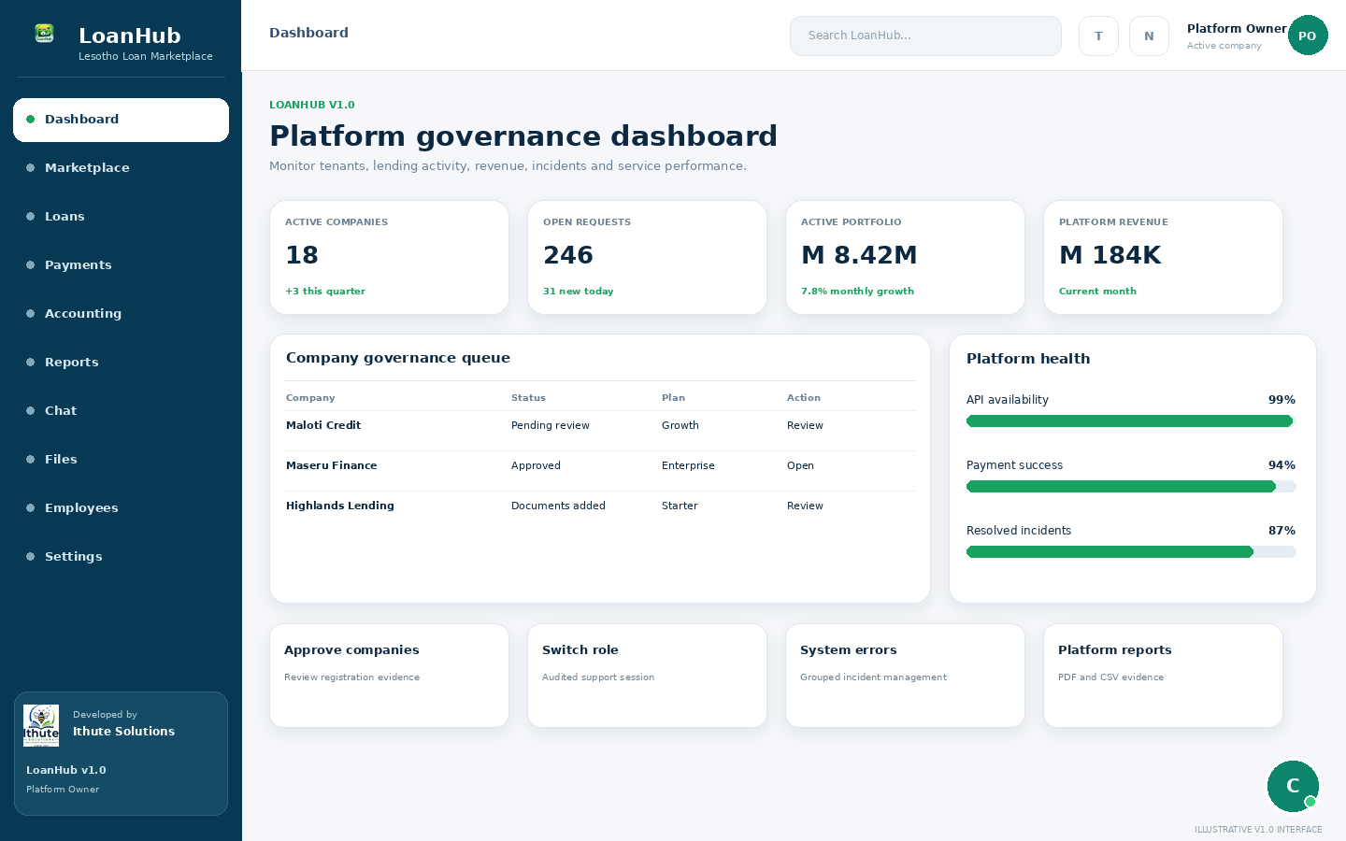
Platform governance dashboard: company queue, platform metrics, incidents and reports.
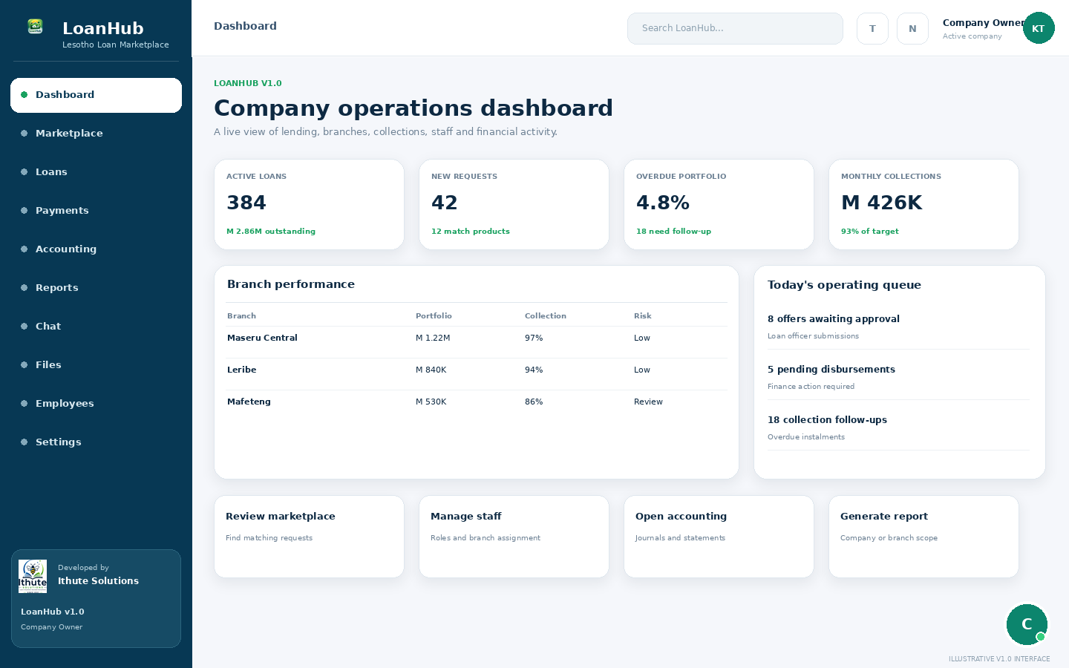
Company operations dashboard: lending, branches, collections and quick actions.
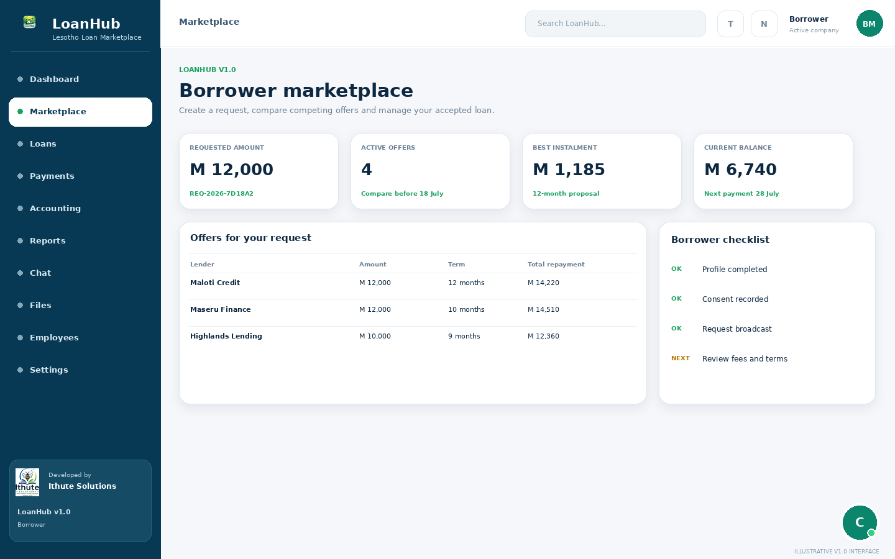
Borrower marketplace: requests, offer comparison, loans and next actions.
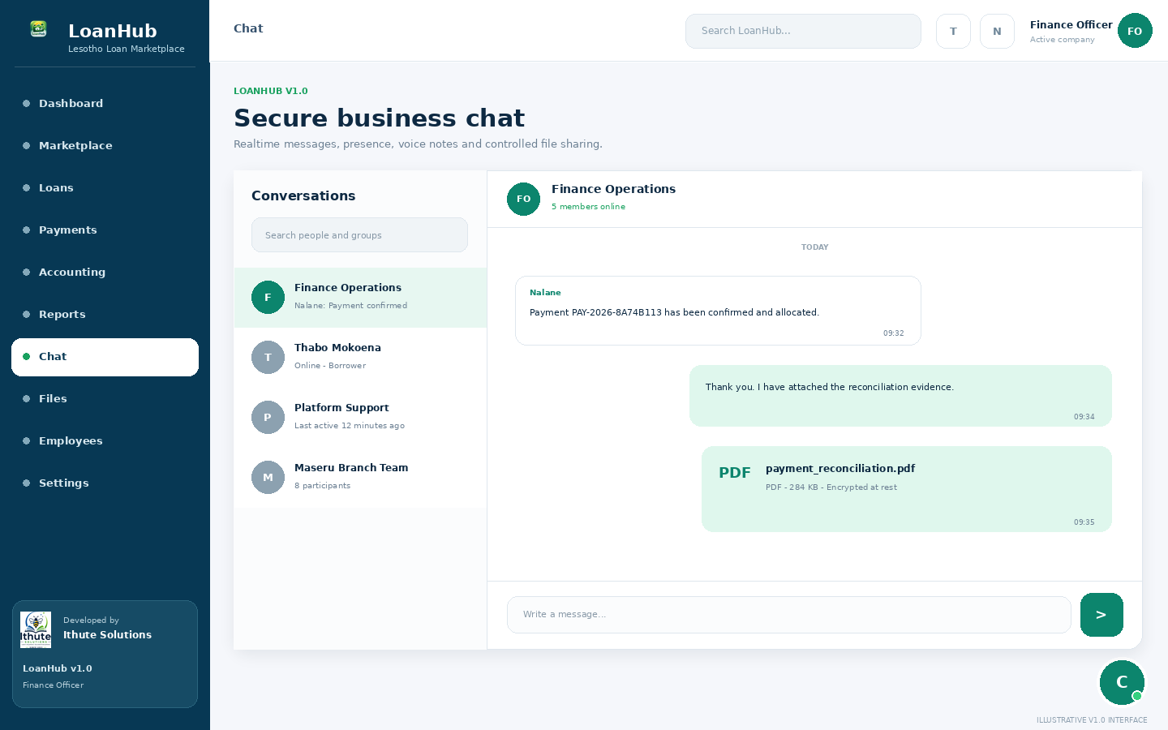
Secure business chat: presence, messages, files and voice-note entry.
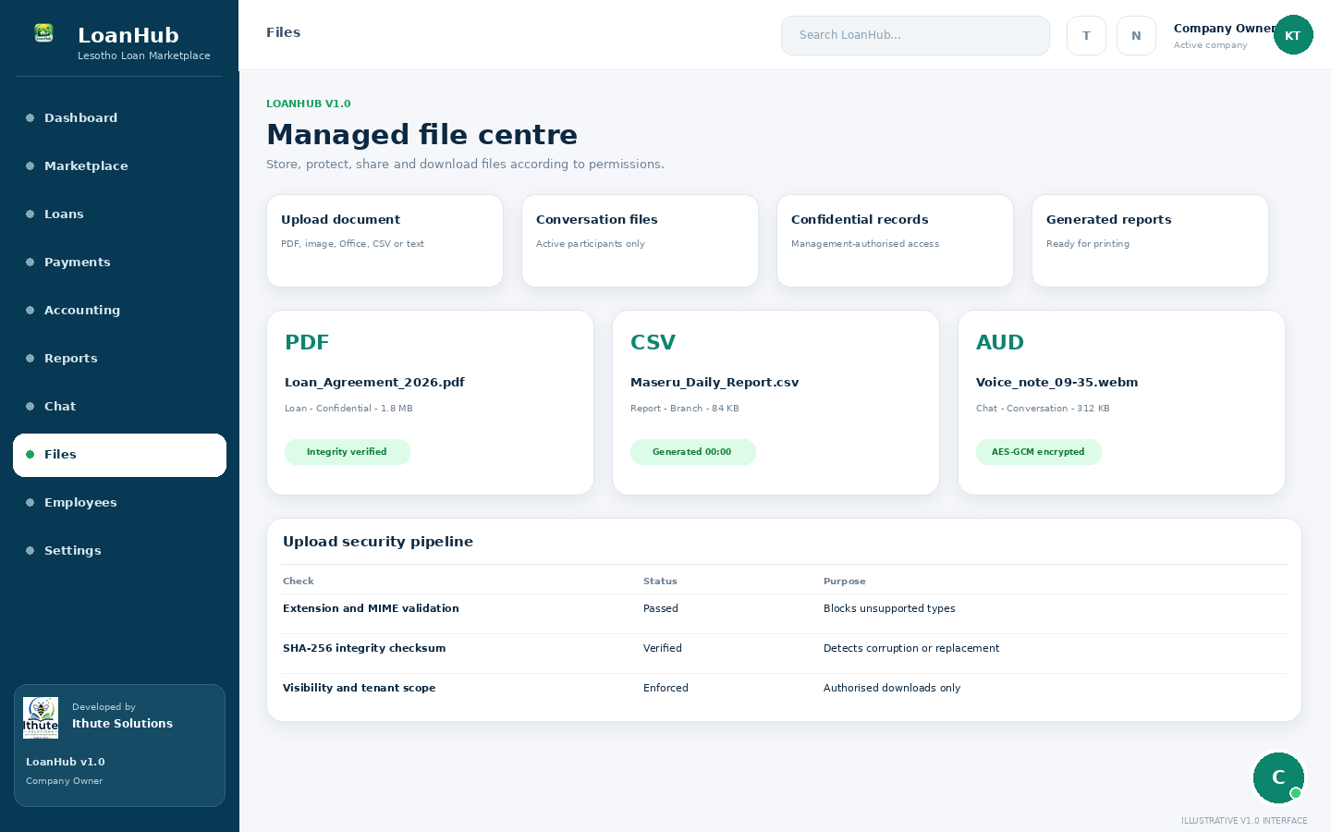
Managed file centre: visibility, integrity and encrypted storage status.
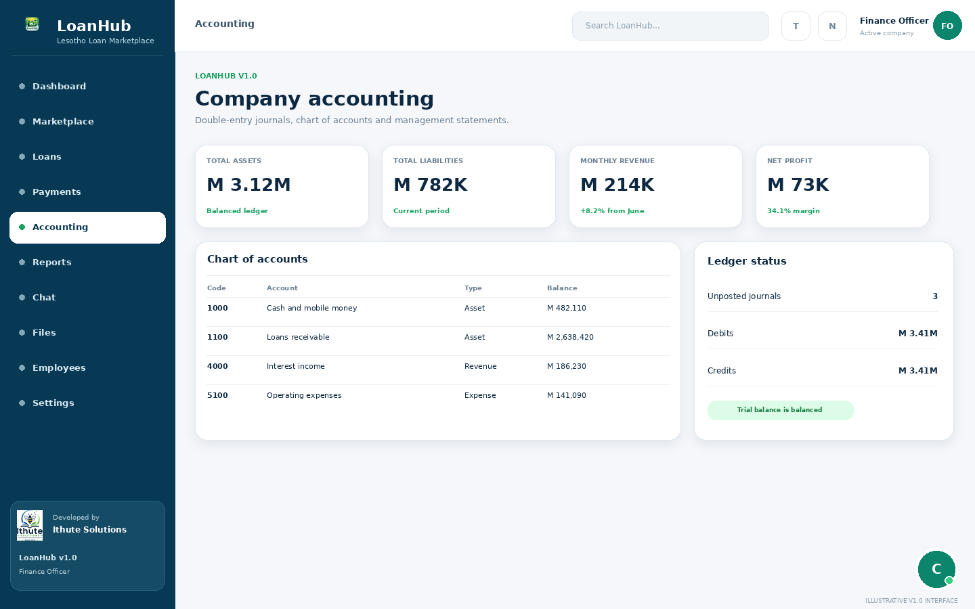
Accounting workspace: chart of accounts, balances and journals.
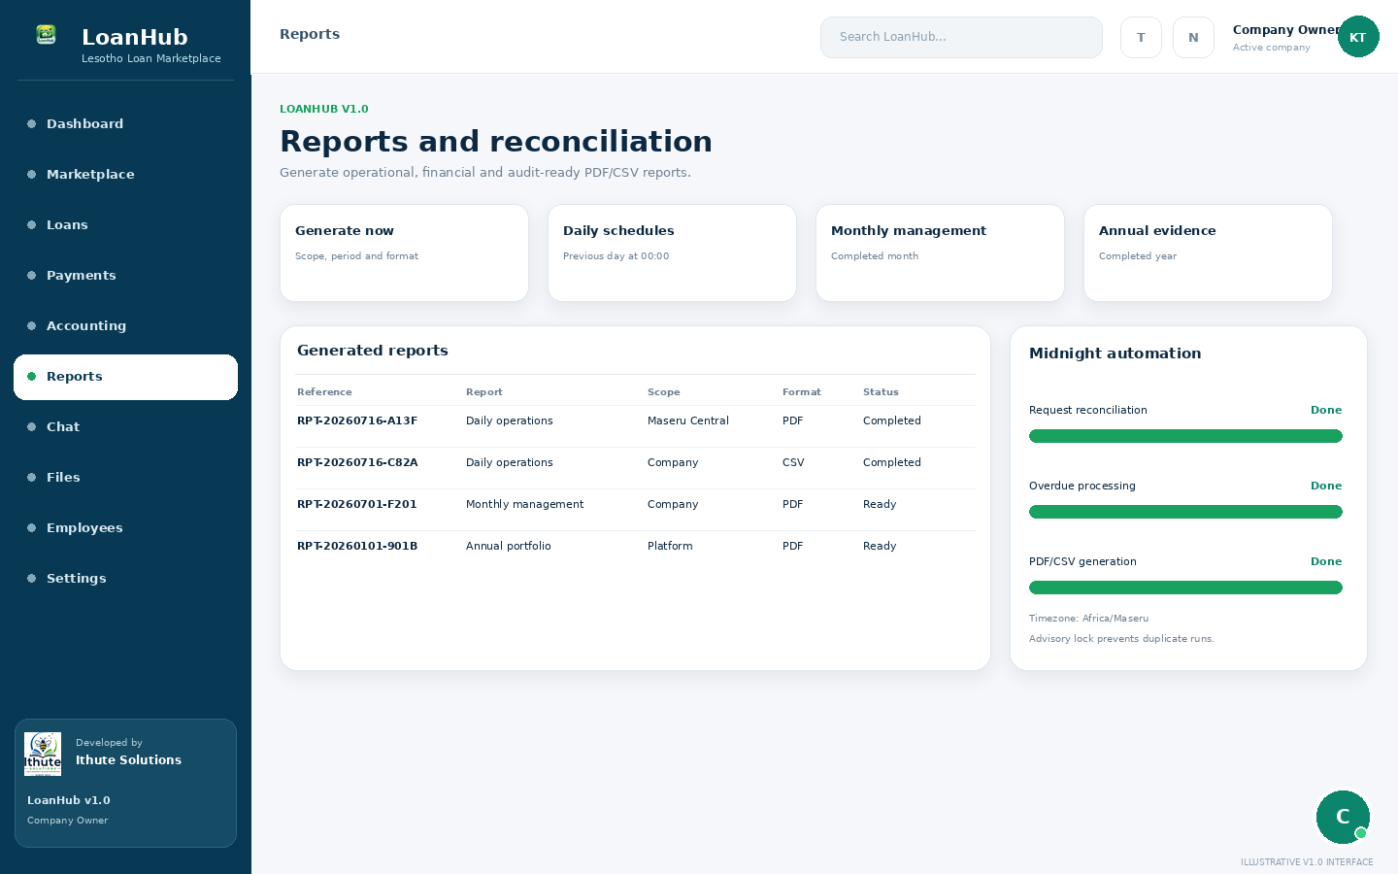
Report workspace: generated files and midnight automation.
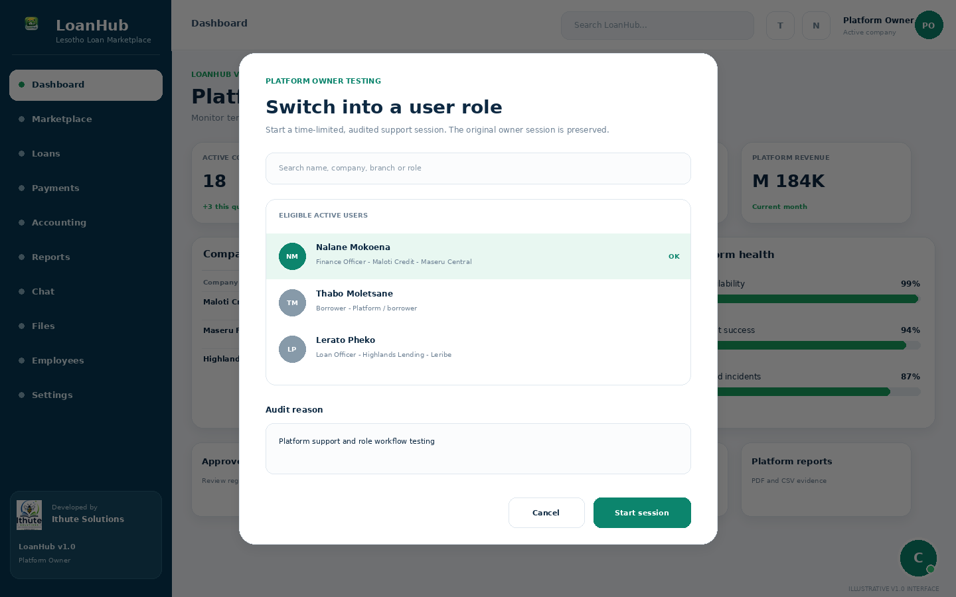
Platform-owner audited role-switching dialog.
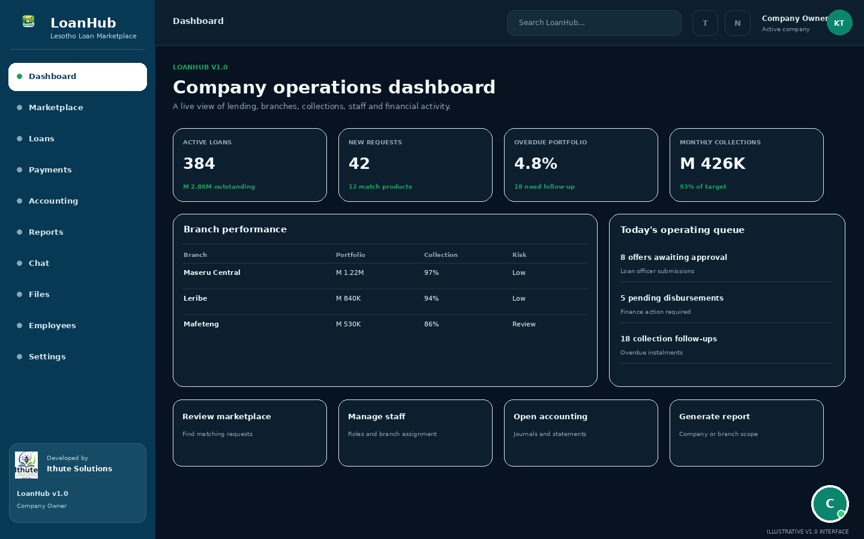
Company dashboard using the Dark theme.

5. Accounts, tenants and navigation
Figure 3. Authentication, role routing and selected-company resolution.
A user account stores authentication and global identity. Company users also require an active CompanyStaff membership. The active company is sent in the X-Company-ID header, and the backend verifies that the user belongs to that company. Company owners and administrators normally have company-wide scope; other roles become branch-scoped when their membership is assigned to a branch.
- Open the official LoanHub URL.
- Sign in with the registered email/phone and password.
- Confirm the portal and active company shown in the navigation header.
- Use the company selector when the account belongs to more than one tenant.
- Sign out when leaving a shared computer.

6. Company and borrower onboarding

Company registration
- Choose company registration.
- Enter legal identity, registration/licence evidence and operating contacts.
- Create the first company-owner account.
- Submit the application in Pending status.
- The platform owner reviews, approves, rejects or requests correction.
- After approval, configure branches, staff, products and billing.

Borrower registration
- Create an account and borrower profile.
- Complete identity, contact, address and employment fields.
- Record consent and supporting evidence.
- Create a draft request, review it and broadcast it.

7. Marketplace and offers
Figure 4. Borrower request, lender access, offer competition and selection.

Borrower workflow
- Create a request with amount, purpose, term and consent.
- Monitor active offers and their expiry times.
- Compare amount, interest method, fees, instalment, term and total repayment.
- Accept one offer only after reviewing the complete cost.

Lender workflow
- Review redacted requests that match company products and risk appetite.
- Unlock full details only through an authorised subscription or pay-per-request workflow.
- Perform affordability and document checks.
- Create one compliant offer and monitor acceptance/expiry.

8. Loan servicing and payments
Figure 5. Offer acceptance, disbursement, repayment, allocation and accounting.

Disbursement
- Confirm approval and agreement requirements.
- Verify borrower payee details.
- Create an outbound payment record.
- Wait for verified provider/manual success evidence.
- Generate or confirm the repayment schedule and activate the loan.

Repayment
- Borrower initiates payment through an approved route.
- LoanHub creates an inbound transaction with an idempotency key.
- Provider callback/status or approved manual evidence confirms success.
- The payment is allocated to instalments.
- Balance/status and accounting entries update.
Payment rule
A Pending payment record is not proof of settlement. Never mark a payment successful without verified evidence.

9. Notifications, chat and files

Notifications
Notifications are persistent actionable events. Realtime delivery makes them immediate, but PostgreSQL persistence keeps them available after reconnect. Presence-only activity does not create business notification spam.

Chat
Figure 6. Chat message, voice note and managed-file security flow.
- Direct and group conversations.
- One shared WebSocket per browser tab.
- Online/offline and last-seen indicators.
- Typing and read state.
- Voice notes and PDF/image/Office attachments.
- Polling and reconnect fallback.

Files
Visibility | Who can access
Private | Uploader/owner only
Conversation | Active conversation participants
Branch | Assigned branch and authorised company management
Company | Active members of the same tenant
Confidential | Authorised management/platform administration
Platform | Platform administration

10. Employees and performance
Employee profiles link workforce information to active company staff. HR and management can maintain employee number, title, department, manager, branch, employment status and protected notes. Performance goals record target, period and progress; reviews record evidence and scores at employee, branch, company or platform level.
- Do not place salary, disciplinary or sensitive HR information in ordinary group chat.
- Use confidential file visibility for protected workforce evidence.
- Investigate data quality before using automated activity counts as a performance judgement.

11. Accounting and reports

Accounting
The accounting foundation uses a chart of accounts and balanced journal entries. Entries are prepared as Draft, reviewed and then Posted. Statements include trial balance, profit and loss and balance sheet. Chart bootstrap is idempotent and protected against simultaneous initialization.

Reports
Figure 7. Midnight reconciliation and automatic report generation.
Frequency | Period generated
Daily | Previous day
Weekly | Previous completed week, generated Monday
Monthly | Previous completed month, generated on day 1
Annual | Previous calendar year, generated on 1 January

Reports are generated in PDF and CSV for platform, company and branch scope, saved in managed media and made available for authorised download and printing.

12. Audit and system errors
Figure 8. Business notifications and restricted technical incident handling.
Audit history records actor, company, branch, entity, action, changed fields, request ID and timestamps. Technical failures are grouped by fingerprint. Ordinary users see a safe message and request reference; active platform owners receive the technical incident notification. Repeated incidents are rate-limited to prevent inbox spam.

13. Role workflows

Platform owner / SuperAdmin
Governs the multi-tenant platform, approves companies, configures plans, reviews platform accounting/reports, manages incidents and performs audited role switching.

Recommended routine
- Review pending companies and incidents
- Monitor plans, payments and platform performance
- Use role switching only with a recorded support/testing reason
- Protect secrets, backups and migration discipline

Control reminder
Use only the records and actions granted to this role. Escalate work that belongs to another specialist role rather than requesting excessive permissions.

Company owner
Highest authority inside a lending company.

Recommended routine
- Maintain company details, branches, staff and products
- Oversee marketplace, loans, payments, accounting and reports
- Separate duties between finance, lending, collections and audit where possible

Control reminder
Use only the records and actions granted to this role. Escalate work that belongs to another specialist role rather than requesting excessive permissions.

Company administrator
Coordinates day-to-day company operations.

Recommended routine
- Maintain master data and staff scope
- Route work to specialist roles
- Review notifications, activity and incomplete workflows

Control reminder
Use only the records and actions granted to this role. Escalate work that belongs to another specialist role rather than requesting excessive permissions.

Branch manager
Runs an assigned branch.

Recommended routine
- Assign branch work
- Review active and overdue loans
- Monitor branch employees, goals and reports

Control reminder
Use only the records and actions granted to this role. Escalate work that belongs to another specialist role rather than requesting excessive permissions.

Loan officer
Evaluates marketplace requests and prepares responsible offers.

Recommended routine
- Review matching requests
- Unlock details only when authorised
- Check affordability and create compliant offers

Control reminder
Use only the records and actions granted to this role. Escalate work that belongs to another specialist role rather than requesting excessive permissions.

Finance officer
Controls disbursement, repayment, reconciliation and accounting evidence.

Recommended routine
- Verify payment references and status
- Reconcile provider result with LoanHub records
- Review journals and statements

Control reminder
Use only the records and actions granted to this role. Escalate work that belongs to another specialist role rather than requesting excessive permissions.

Collections officer
Manages due and overdue repayment follow-up.

Recommended routine
- Verify payment history before contact
- Record promises, disputes and escalation
- Follow respectful consumer-protection procedures

Control reminder
Use only the records and actions granted to this role. Escalate work that belongs to another specialist role rather than requesting excessive permissions.

Compliance officer
Reviews access, consent, controls and regulatory exceptions.

Recommended routine
- Review audit events and high-risk changes
- Collect evidence using reports and files
- Document remediation and escalation

Control reminder
Use only the records and actions granted to this role. Escalate work that belongs to another specialist role rather than requesting excessive permissions.

Auditor
Performs independent, read-oriented review.

Recommended routine
- Define scope and period
- Compare source events, approvals, payments and journals
- Use friendly references in findings

Control reminder
Use only the records and actions granted to this role. Escalate work that belongs to another specialist role rather than requesting excessive permissions.

Customer support
Assists users without exceeding permissions.

Recommended routine
- Verify the user safely
- Use request, loan, report or payment references
- Escalate finance, IT, compliance or lending issues

Control reminder
Use only the records and actions granted to this role. Escalate work that belongs to another specialist role rather than requesting excessive permissions.

HR manager
Maintains workforce records and protected HR information.

Recommended routine
- Maintain employee status and reporting lines
- Restrict salary/HR notes
- Coordinate performance-review periods

Control reminder
Use only the records and actions granted to this role. Escalate work that belongs to another specialist role rather than requesting excessive permissions.

Performance manager
Creates goals and evidence-based reviews.

Recommended routine
- Define measurable goals
- Track progress and quality
- Compare branches with context

Control reminder
Use only the records and actions granted to this role. Escalate work that belongs to another specialist role rather than requesting excessive permissions.

Risk manager
Reviews credit, payment and operational risk.

Recommended routine
- Monitor overdue/failure trends
- Investigate unusual activity
- Assign mitigations and monitor outcomes

Control reminder
Use only the records and actions granted to this role. Escalate work that belongs to another specialist role rather than requesting excessive permissions.

IT support
Investigates availability and technical incidents.

Recommended routine
- Use request IDs and fingerprints
- Reproduce safely in staging
- Patch root causes without editing financial history

Control reminder
Use only the records and actions granted to this role. Escalate work that belongs to another specialist role rather than requesting excessive permissions.

Borrower
Creates funding requests and manages personal loans.

Recommended routine
- Maintain profile and consent
- Compare total repayment, fees and term
- Track schedules, balances and approved payments

Control reminder
Use only the records and actions granted to this role. Escalate work that belongs to another specialist role rather than requesting excessive permissions.

14. Operational checklists

Daily
- Unread actionable notifications
- New requests and expiring offers
- Pending disbursements and failed repayments
- Overdue instalments and collection follow-up
- Open chat/support cases
- System incidents and unposted journals

Weekly
- Branch performance and workload
- Collections and payment reconciliation
- Audit exceptions and role changes
- File/storage housekeeping
- Subscription limits and upcoming renewals

Monthly
- Profit/loss and balance sheet review
- Portfolio and overdue trend
- Company/branch reports
- Access and role review
- Backup restore test
- Recurring incident review

Annual
- Commercial plan review
- Licence and regulatory evidence
- Retention and privacy review
- Security and business-continuity test
- Provider reconciliation and contract review

15. Troubleshooting and boundaries
Problem | Likely cause | Safe action
Repeated WebSocket connections | More than one provider opened a socket or old frontend cache | Use the shared RealtimeProvider, close old tabs and clear .next
WebSocket 403 | WebSocket session cookie/hostname mismatch | Use the same hostname and prepare the short-lived session before connecting
File upload fields missing | FormData sent with forced application/json | Do not set Content-Type manually; let the browser create the multipart boundary
Accounting bootstrap temporary 500 | Concurrent chart initialization | Use the idempotent locked backend service and load accounts once
Payment remains pending | No verified provider confirmation | Do not mark success manually; perform authorised enquiry
Page unavailable | Role, tenant, branch or company status restriction | Confirm active context and ask authorised management
Report missing | Worker stopped, invalid scope or storage problem | Generate manually and inspect worker/storage logs

External integrations
Official mobile-money settlement, report email delivery, S3/MinIO multi-server storage and enterprise malware scanning remain deployment/provider work, not completed v1.0 provider services.

