4. Solving Linear Programming Problems: The Simplex Method
We now are ready to begin studying the simplex method, a general procedure for solving linear programming problems. Developed by George Dantzig in 1947, it has proved to be a remarkably efficient method that is used routinely to solve huge problems on today’s computers. Except for its use on tiny problems, this method is always executed on a computer, and sophisticated software packages are widely available. Extensions and variations of the simplex method also are used to perform post-optimality analysis (including sensitivity analysis) on the model.

This chapter describes and illustrates the main features of the simplex method. The first section introduces its general nature, including its geometric interpretation. The following three sections then develop the procedure for solving any linear programming model that is in our standard form (maximization, all functional constraints in ≤ form, and non-negativity constraints on all variables) and has only non-negative right-hand sides in the functional constraints. Certain details on resolving ties are deferred to Sec. 4.5, and Sec. 4.6 describes how to adapt the simplex method to other model forms. Next we discuss post post-optimality analysis (Sec. 4.7), and describe the computer implementation of the simplex method (Sec. 4.8). Sec 4.9 the introduces an alternative to the simplex method (the interior-point approach) for solving large linear programming problems.

4.1 THE ESSENCE OF THE SIMPLEX METHOD

The simplex method is an algebraic procedure. However, its underlying concepts are geometric. Understanding these geometric concepts provides a string intuitive feeling for how the simplex method operates and what makes it so efficient. Therefore, before delving into algebraic details, we focus in this section on the big picture from a geometric viewpoint.

To illustrate the general geometric concepts, we shall use the Wyndor Glass Co. example presented in Sec. 3.1. (Sections 4.2 and 4.3 use the algebra of the simplex method to solve this same example.) Section 5.1 will elaborate further on these geometric concepts for larger problems.

To refresh your memory, the model and graph for this example are repeated in Fig. 4.1. The five constraint boundaries and their points of intersection are highlighted in this figure because they are the keys to analysis. Here, each constraint boundary is a line that forms the boundary of what is permitted by the corresponding constraint. The points of intersection are the corner-point-solutions of the problem. The five that lie on the corners of the feasible region (0, 0), (0, 6), (2, 6), (4, 3), and (4, 0) – are the corner point feasible solutions (CPF solutions). [The other three – (0, 9), (4, 6), and (6, 0) – are called corner point infeasible solution.]

In this example, each corner point solution lies at the intersection of two constraint boundaries. (For a linear programming problem with n decision variables, each of its corner point solutions lies at the intersection of n constraint boundaries. Certain pairs of the CPF solutions in Fig. 4. 1 share a constraint boundary, and other pairs do not. It will be important to distinguish between these cases by using the following general definitions.
Although a corner point solution is defined in terms of n constraint boundaries whose intersection gives this solution, it also is possible that one or more additional constraint boundaries pass through this same point.
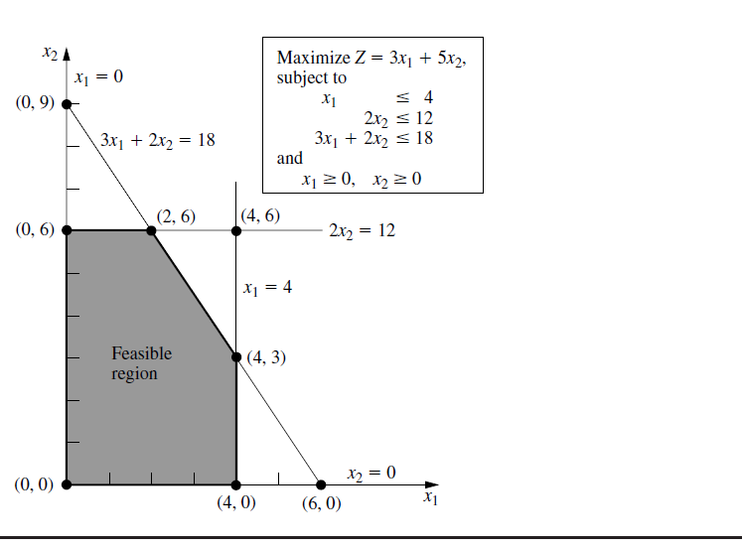
FIGURE 4. 1 Constraint boundaries and corner-point solutions for the Wyndor Glass Co. problem.
Since n = 2 in the example, two of its CPF solutions are adjacent if they share one constraint boundary; for example, (0, 0) and (0, 6) are adjacent because they share the constraint boundary. The feasible region in Fig. 4. 1 has five edges, consisting of the five line segments forming the boundary of this region. Note that two edges emanate from each CPF solution. Thus, each CPF solution has two adjacent CPF solutions (each lying at the other end of one of the two edges), as enumerated in Table 4. 1. (In each row of this table, the CPF solution in the first column is adjacent to each of the two CPF solutions in the second column, but the two CPF solutions in the second column are not adjacent to each other.)

TABLE 4.1 Adjacent CPF solutions for each CPF solution of the Wyndor Glass Co. problem
CPF Solution | Its Adjacent CPF Solutions
(0, 0) | (0, 6) and (4, 0)
(0, 6) | (2, 6) and (0, 0)
(2, 6) | (4, 3) and (0, 6)
(4, 3) | (4, 0) and (2, 6)
(4, 0) | (0, 0) and (4, 3)

