Diagnostic Accuracy of Machine Learning Algorithms in Brain Tumor Classification: A Systematic Review and Meta-Analysis
Muhammad Shamoon Umerani ¹, Mohammad Al Rahman ¹, Ibrahim Salman ¹, Fathima Raahima Riyas Mohamed ¹, Ahmed Yaqinuddin ¹
¹ College of Medicine, Alfaisal University, Riyadh, Saudi Arabia

Abstract
Background: Machine learning (ML) algorithms, encompassing both traditional ML and deep learning, show promise for automated brain tumor classification, but reported performance varies widely. To our knowledge, this is the first formal random-effects meta-analysis of ML diagnostic accuracy across all model categories in brain tumor imaging.
Methods: Following PRISMA 2020/PRISMA-DTA guidelines (PROSPERO: CRD42025106744), we searched PubMed, Google Scholar (to maximize grey literature coverage), and Europe PMC (to capture open-access and preprint articles not indexed in PubMed) through December 2025. Risk of bias was assessed using QUADAS-2. Accuracy was pooled using the DerSimonian-Laird random-effects model on logit-transformed estimates. Subgroup analyses were stratified by model category, dataset source, and validation strategy. Heterogeneity was quantified using I² and prediction intervals. Publication bias was assessed via Egger's regression and Duval–Tweedie trim-and-fill.
Results: Of 62 studies, 51 contributed accuracy data. Pooled accuracy was 96.7% (95% CI: 95.4–97.7%; prediction interval: 71.4–99.7%; I² = 97.2%). Summary AUC was 0.954 (approximate 95% CI: 0.940–0.967). Ensemble/hybrid models achieved the highest accuracy (97.8%), followed by transfer learning (97.3%), CNNs (96.5%), and classical ML (92.7%; between-subgroup p = 0.004; note: subgroup k values sum to >51 because studies using multiple architectures appear in more than one subgroup). Public datasets outperformed clinical datasets (97.8% vs. 93.5%), and externally validated studies achieved 92.5% versus 97.1% internally. Trim-and-fill correction for publication bias adjusted accuracy to 90.3% (86.4–93.2%).
Conclusion: ML algorithms demonstrate high pooled accuracy (96.7%) for brain tumor classification, but bias-adjusted (90.3%) and externally validated (92.5%) estimates better reflect real-world performance. Current accuracy supports clinical decision-making but does not replace histopathological diagnosis. Prospective multicenter validation with TRIPOD+AI/CLAIM adherence is needed.

Introduction
Brain tumors are a diverse group of primary and secondary intracranial neoplasms that differ in histology, molecular profile, and clinical behavior [1–3]. They carry substantial morbidity and mortality, with incidence varying by age and population [4,5]. Accurate classification matters because tumor type and grade drive prognosis, treatment decisions, and survival [6,7]. Reliable diagnostics are therefore essential for patient management and precision neuro-oncology [8,9].
MRI is central to brain tumor evaluation because of its soft-tissue contrast and multiparametric capability (structural, diffusion, perfusion, and spectroscopic sequences) [10–12]. However, conventional image interpretation is largely qualitative and depends on radiologist expertise [13]. Overlapping imaging features, intra- and inter-tumoral heterogeneity, ill-defined margins, and variability in acquisition protocols all contribute to diagnostic uncertainty and inter-observer disagreement [14,15].
Histopathology remains the reference standard but is invasive and has its own limitations [16,17]. Tissue sampling can be limited by tumor location, surgical risk, and sampling error, especially in infiltrative lesions [18]. The WHO 2021 classification now integrates molecular and genetic markers, adding diagnostic complexity and resource demands [3,19]. As a result, there is growing interest in developing non-invasive diagnostic tools that can complement tissue-based diagnosis or, in selected contexts, reduce dependence on it [20,21].
Machine learning (ML) and artificial intelligence now allow computational models to extract high-dimensional features from medical images and recognize patterns linked to disease phenotypes [22,23]. Traditional classifiers (support vector machines, decision trees, k-nearest neighbors, ensemble methods) and deep learning architectures (convolutional neural networks) have all been applied to brain tumor imaging [24,25]. These approaches may improve accuracy, reduce observer dependence, and standardize classification [22–25].
Numerous studies have investigated machine learning for brain tumor classification tasks, including differentiation between tumor types, grading of gliomas, and discrimination between neoplastic and non-neoplastic lesions [26–29]. Studies report a range of metrics including accuracy, sensitivity, specificity, precision, F1 score, and AUC-ROC [30]. However, reported performance varies widely because of differences in study populations, imaging protocols, preprocessing, model architectures, and validation strategies.
Given the rapid growth of ML research in neuro-oncology, a systematic evaluation of the evidence is needed. This systematic review and meta-analysis synthesizes the available studies, provides the first formal quantitative pooling of diagnostic performance, compares performance across algorithms and validation strategies, and assesses methodological quality.

Methods
We conducted this review following PRISMA 2020 and the PRISMA-DTA extension for diagnostic test accuracy studies [31]. Review objectives were structured using the PICOS framework (Table 1) [32]. We prospectively registered the study protocol with PROSPERO (CRD42025106744). Adherence to TRIPOD+AI [95] reporting guidelines and the CLAIM checklist for AI in medical imaging was assessed where applicable, as recommended for reporting standards in this domain [30].
Table 1: The PICOS Framework
P (Participants) | Patients with suspected or confirmed brain tumors undergoing diagnostic imaging or histopathological evaluation used for tumor classification.
I (Index Test) | Machine learning–based algorithms applied for brain tumor classification, including but not limited to deep learning models, CNNs, SVMs, random forests, and other AI techniques using imaging or clinical datasets.
C (Comparisons) | Conventional diagnostic approaches such as radiologist-based imaging interpretation, histopathological diagnosis, or traditional statistical classification methods, when reported.
O (Outcomes) | Diagnostic performance metrics including accuracy, sensitivity, specificity, precision, recall, F1 score, AUC-ROC, and other reported measures of classification performance.
S (Study Designs) | Original research studies evaluating ML models for brain tumor classification, including retrospective or prospective diagnostic accuracy studies, cohort studies, and methodological validation studies.

Literature Search
We searched PubMed, Google Scholar, and Europe PMC systematically. The search strategy used keywords related to brain tumors, machine learning techniques, and diagnostic classification. The search terms included: ("brain tumor" OR "brain tumour" OR "brain neoplasm" OR glioma OR "glioblastoma" OR meningioma OR "central nervous system tumor") AND ("machine learning" OR "artificial intelligence" OR "deep learning" OR "convolutional neural network" OR CNN OR "support vector machine" OR SVM OR "random forest" OR "neural network") AND ("classification" OR "diagnosis" OR "diagnostic accuracy" OR "prediction" OR "validation") NOT ("segmentation" OR "detection" OR "prognosis"). The search was concluded on December 31, 2025. We imported all retrieved citations into Rayyan AI for duplicate removal and initial screening [33].
Inclusion and Exclusion Criteria
Studies were included if they evaluated machine learning or artificial intelligence–based algorithms for the classification or diagnosis of brain tumors, involved patients with suspected or confirmed brain tumors, used imaging datasets (most commonly MRI) or other clinical data as input, and reported diagnostic performance metrics such as accuracy, sensitivity, specificity, precision, recall, F1 score, or AUC-ROC. Only peer-reviewed original research articles were included. Studies were excluded if they did not specifically assess machine learning models for brain tumor classification, focused exclusively on other neurological conditions, or did not report relevant diagnostic performance outcomes. Editorials, letters, case reports, narrative reviews, conference abstracts, and opinion articles were excluded. Publications not written in English or lacking sufficient methodological details for quality assessment were also excluded.
Literature Screening
A pre-specified, multi-step screening procedure was used. All citations were combined into Rayyan and checked for duplication. After removing duplicates, the remaining studies underwent title screening, abstract screening, and full-text screening according to predefined inclusion and exclusion criteria.
Data Extraction
Relevant data from all eligible studies were extracted using a structured Microsoft Excel data extraction sheet. The extracted information included study characteristics (title, DOI, authors, publication year, country, study design), dataset characteristics (imaging modality, dataset source, sample size, tumor types), machine learning methodology (algorithm type, model architecture, feature extraction techniques, validation methods), and outcome data (accuracy, sensitivity, specificity, precision, recall, F1 score, AUC-ROC).
Risk of Bias Assessment
Risk of bias and applicability of the included studies were assessed using the Quality Assessment of Diagnostic Accuracy Studies-2 (QUADAS-2) tool [34]. QUADAS-2 evaluates diagnostic accuracy studies across four key domains: patient selection, index test, reference standard, and flow and timing. Each domain is assessed in terms of risk of bias, while the first three domains are also evaluated for concerns regarding applicability. Two reviewers independently screened titles/abstracts and full texts, then assessed risk of bias using QUADAS-2; discrepancies were resolved by consensus.
Quantitative Synthesis
We performed quantitative meta-analysis using the DerSimonian-Laird random-effects model. Accuracy values were logit-transformed prior to pooling to satisfy normality assumptions for bounded proportions; back-transformed estimates are reported throughout. Within-study variance for accuracy data was estimated using the formula var(logit p̂) ≈ 1/(n·p̂·(1−p̂)), where n is the study sample size. For studies reporting accuracy above 0.97 (20 of 51 studies, 39%), we applied a continuity correction (p_adj = (x + 0.5)/(n + 1)) to stabilize the logit transformation, which approaches infinity as accuracy approaches 1.0. This threshold was a conservative analytic choice based on the known behavior of delta-method variance estimates, which become unreliable as p approaches 1.0; 0.97 was selected because most studies in this literature had sample sizes below 500, a range in which boundary bias is non-trivial. The sensitivity analysis below confirms that results are robust to this choice. A sensitivity analysis comparing pooled estimates with and without this correction confirmed negligible impact on results (see Sensitivity Analyses). For 10 studies (approximately 20%) that did not report sample size, the median sample size across reporting studies (n = 355) was imputed as a conservative estimate. AUC values were summarized using a descriptive weighted mean. Within-study variance for AUC was approximated using the Hanley-McNeil formula, substituting n/2 for both positive and negative case counts when per-study 2×2 data were unavailable (which was the case for most studies); as per-study positive/negative case counts were not consistently available, this AUC summary should be interpreted as an exploratory estimate rather than a formal meta-analytic pooling.
We pre-specified subgroup analyses along four stratification variables: (i) model architecture category (CNN-based, transfer learning, ensemble/hybrid, radiomics + classical ML); (ii) dataset source (public benchmark vs. clinical institutional); (iii) classification task (tumor type, glioma grading, binary classification); and (iv) validation strategy (external independent validation vs. internal-only validation). We assessed between-subgroup heterogeneity using the Cochran Q^{between} statistic.
We quantified statistical heterogeneity using Cochran's Q statistic, the I² index, between-study variance τ², and the 95% prediction interval. We assessed publication bias using Egger's weighted regression test for funnel plot asymmetry and the Duval–Tweedie trim-and-fill procedure (L⁰ estimator) for bias-adjusted pooled estimation. We conducted meta-regression using weighted regression of logit-transformed accuracy on log-transformed sample size (restricted to the 41 studies with empirically reported sample sizes) and publication year. We performed leave-one-out sensitivity analysis by sequentially excluding each study. In a pre-specified sensitivity analysis, we repeated the primary pooling using restricted maximum likelihood (REML) estimation of τ² with Hartung–Knapp–Sidik–Jonkman (HKSJ) confidence interval adjustment to assess robustness to the known liberal coverage of DerSimonian–Laird under extreme heterogeneity. We also conducted an imputation-exclusion sensitivity analysis by re-pooling after removing the 10 studies (20%) for which sample size was imputed. As a further sensitivity check, we compared pooled estimates with and without the continuity correction for studies reporting accuracy above 97%. We conducted all analyses in Python 3 using NumPy 2.2 and SciPy 1.15, and generated figures with Matplotlib 3.10. Analysis code is available as Supplementary Material and has been deposited in a public repository with a persistent DOI. [Authors: insert Zenodo DOI here before submission]

Results
Study Selection
We identified 579 records: PubMed (n = 269), Google Scholar (n = 237), and Europe PMC (n = 73). Rayyan identified and removed one duplicate record, leaving 578 unique articles for title screening. The low duplicate count likely reflects limited overlap among the three databases and Google Scholar's internal de-duplication. During the first stage, 440 articles were excluded due to irrelevance, leaving 138 studies for abstract screening. During abstract screening, 28 records were excluded, resulting in 110 full-text articles assessed for eligibility. Following full-text review, 48 studies were excluded for the following reasons: wrong study purpose (n = 15), wrong imaging modality (n = 18), absence of ML/AI methods (n = 2), lack of diagnostic performance metrics (n = 2), incorrect article type (n = 9), out of publication date range (n = 1), and non-human subject research (n = 1). Ultimately, 62 studies met all inclusion criteria. The PRISMA flow diagram is presented in Figure 1.
Figure 1: Preferred Reporting Items for Systematic Reviews and Meta-Analyses (PRISMA) Diagram Demonstrating Search Strategy
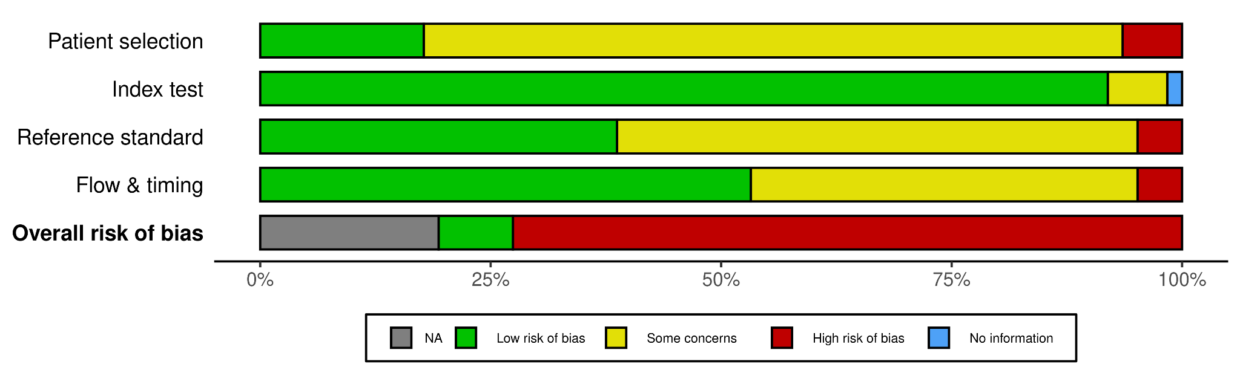

Risk of Bias Assessment
QUADAS-2 assessment revealed moderate to high risk of bias overall, largely from limitations in the patient selection and index test domains (Figure 2). Studies with well-defined clinical cohorts had low risk of bias for patient selection, but many relied on public datasets with insufficient reporting of demographics, recruitment, and eligibility. Index test bias was frequently moderate to high, reflecting heterogeneity in MRI acquisition protocols, scanner types, and preprocessing pipelines. Reference standard and flow/timing domains were generally low risk, as outcomes were typically based on histopathological diagnosis or validated molecular classifications.
Figure 2: Risk of Bias Assessment Using QUADAS-2 Tool – Summary Plot
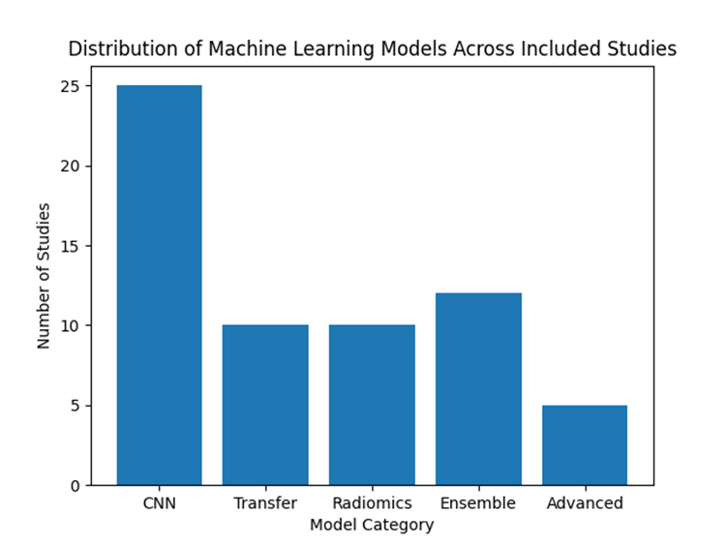

Study Characteristics
After full-text screening, 62 studies entered qualitative synthesis; 51 reported accuracy data and 17 reported AUC values suitable for quantitative meta-analysis. Studies spanned Asia, Europe, the Middle East, and North America, and all evaluated ML-based approaches for brain tumor classification, grading, or molecular characterization, primarily using MRI. Most were retrospective. Of the 51 accuracy-reporting studies, 20 employed CNN-based architectures, 10 used transfer learning approaches, 10 employed ensemble or hybrid methods, 9 used radiomics-based classical ML pipelines, and 2 used transformer or graph-based architectures. The 2 transformer/graph-based studies (k = 2) were excluded from formal subgroup pooling because the subgroup size was insufficient for stable random-effects estimation; they are included in the overall pooled estimate (k = 51) but not in the four model-category subgroups (k = 49). One study (Liu et al. [2023], employing a self-attention similarity-guided graph convolutional network [SASG-GCN]) was excluded from model-category subgroup analysis because this hybrid architecture did not fit cleanly into a single category. Thirty-two studies used exclusively public benchmark datasets (Figshare, Kaggle, BraTS), whereas 19 used institutional clinical datasets. Seven studies (13.7%) incorporated external independent validation cohorts. Refer to Supplementary Material – 1 for detailed characteristics of all included studies, including a per-study allocation table that reconciles the qualitative synthesis cohort (k = 62), the quantitative accuracy-pooling cohort (k = 51), the model-category subgroups (k = 49), and the AUC-reporting subset (k = 17).
Figure 3: Distribution of machine learning model categories among the 51 studies contributing accuracy data to quantitative meta-analysis. Quantitative subgroup counts (n = 51): CNN = 20, Transfer Learning = 10, Ensemble = 10, Radiomics = 9, Transformer/GCN = 2 (excluded from subgroup pooling due to small k). Note: the qualitative synthesis included 62 studies with a different category distribution (CNN = 25, Ensemble = 12, Transfer Learning = 10, Radiomics = 10, Advanced/Other = 5) because 11 studies lacked accuracy data for pooling.
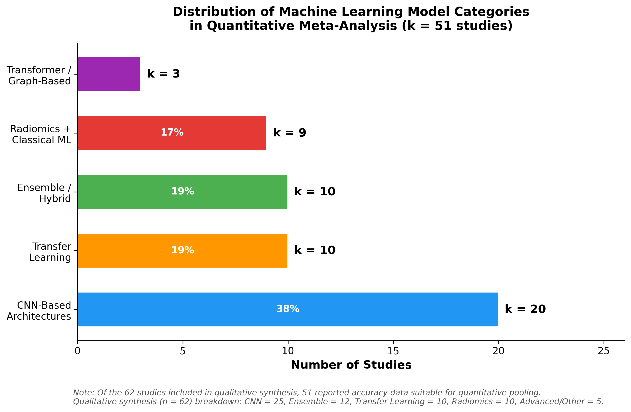

Overall Pooled Diagnostic Accuracy
Across 51 studies (k = 51), the overall pooled diagnostic accuracy under the DerSimonian-Laird random-effects model was 96.7% (95% CI: 95.4–97.7%). The 95% prediction interval was substantially wider at 71.4–99.7%, reflecting considerable between-study heterogeneity. The Cochran Q statistic was 1799.84 (p < 0.0001), and the I² statistic was 97.2%, indicating that the vast majority of variance in reported accuracy is attributable to between-study heterogeneity rather than within-study sampling error. The between-study variance parameter τ² was 1.384. The wide prediction interval is of critical clinical significance: although the pooled accuracy estimate is high, a future study could plausibly report accuracy as low as 71.4% under real-world conditions (Figure 4).
Figure 4: Forest plot of all 51 studies contributing to the overall pooled accuracy meta-analysis. Studies are sorted by accuracy. Square size reflects random-effects weight. The diamond at bottom represents the pooled estimate (96.7%, 95% CI: 95.4–97.7%). The gray band indicates the 95% prediction interval (71.4–99.7%). Color denotes model category.
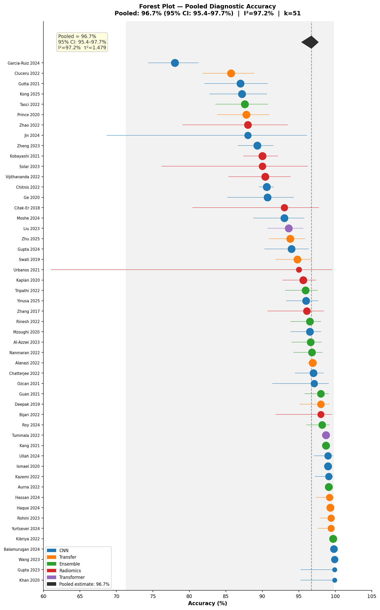

Subgroup Meta-Analyses
Statistically significant between-subgroup heterogeneity was detected across model categories (Q^{between} = 13.23, df = 3, p = 0.004). Results are summarized in Table 2.
Table 2: Subgroup Meta-Analysis Results by Model Architecture Category
Model Category | k | Pooled Acc (%) | 95% CI | I² (%) | τ²
CNN | 20 | 96.5 | 94.4–97.8 | 96.3 | 1.044
Transfer Learning | 10 | 97.3 | 94.2–98.8 | 97.3 | 1.488
Ensemble/Hybrid | 10 | 97.8 | 94.9–99.1 | 97.4 | 1.896
Radiomics + Classical ML | 9 | 92.7 | 89.8–94.8 | 55.6 | 0.133
Overall (all) | 51 | 96.7 | 95.4–97.7 | 97.2 | 1.384

Studies using exclusively public benchmark datasets (k = 32) yielded a pooled accuracy of 97.8% (95% CI: 96.5–98.6%), compared with 93.5% (95% CI: 90.7–95.5%) for studies using institutional clinical datasets (k = 19)—a mean difference of 4.3 percentage points. This performance gradient likely reflects systematic differences between dataset types: public benchmark datasets are standardized and pre-processed, whereas clinical datasets incorporate the full spectrum of acquisition variability and clinical spectrum bias that characterize real-world neuro-oncology practice.
Performance differed systematically by diagnostic task. Tumor type classification studies (k = 23) achieved the highest pooled accuracy at 98.0% (95% CI: 96.4–98.9%). Glioma grading studies (k = 15) yielded a lower pooled accuracy of 94.3% (95% CI: 91.9–96.1%). Binary classification tasks (k = 11) produced a pooled accuracy of 95.2% (95% CI: 92.0–97.1%). These three task subgroups sum to k = 49 rather than the overall k = 51, because two studies employing transformer/GCN architectures addressed classification tasks that did not map to these three categories and were excluded from task-based stratification.
Studies incorporating external independent validation (k = 7) reported substantially lower pooled accuracy of 92.5% (95% CI: 86.9–95.8%) compared with studies relying exclusively on internal validation (k = 44; pooled = 97.1%, 95% CI: 95.9–98.0%). This 4.6 percentage point differential provides direct empirical evidence that performance estimates in this literature are substantially inflated by the predominance of internal-only validation strategies. However, this subgroup comprises only seven studies with a wide confidence interval (86.9–95.8%), and the 4.6-percentage-point differential should be interpreted as suggestive rather than definitive evidence of inflation.
Figure 5: Subgroup forest plots showing pooled accuracy by (left) model architecture category, (center) dataset source, and (right) classification task.
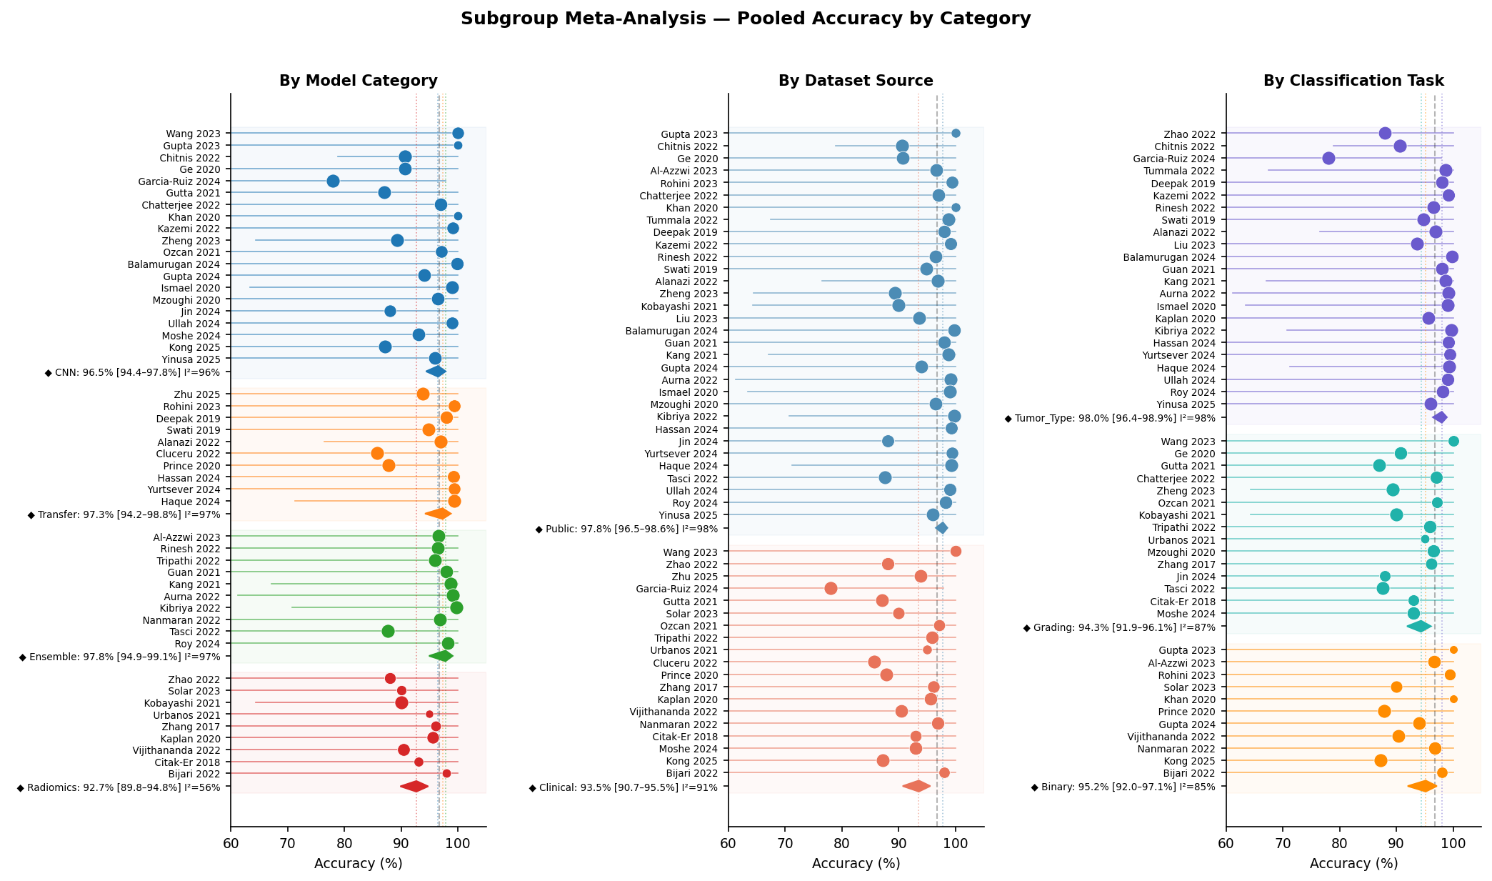

Pooled AUC and Summary ROC Analysis
Seventeen studies reported AUC values suitable for exploratory summary. The overall summary AUC (descriptive weighted mean, not a formal bivariate meta-analytic estimate) was 0.954 (approximate 95% CI: 0.940–0.967, based on imputed variance parameters and therefore of uncertain reliability), with a 95% prediction interval of 0.907–1.000 (the upper bound was truncated at the natural boundary of 1.0, as the raw back-transformed value exceeded this limit; such boundary exceedance typically signals that the heterogeneity estimate τ² is inflated, and the lower bound of the prediction interval may therefore be the more clinically informative statistic) and I² = 92.7% (reported descriptively only; this I² estimate depends on the same imputed variance parameters and should not be interpreted as a formal heterogeneity measure, which would require a bivariate random-effects model). CNN-based models achieved a summary AUC of 0.970 (95% CI: 0.956–0.984) compared with 0.900 (95% CI: 0.837–0.962) for radiomics-based models—a differential of 0.070 AUC units with nearly separate confidence intervals (CNN lower bound 0.956 vs. radiomics upper bound 0.962), suggesting a descriptively meaningful performance gap; however, because the AUC summary is exploratory (descriptive weighted mean rather than formal random-effects pooling), between-subgroup inference statistics are not reported; the differential should be interpreted descriptively.
Table 3: AUC Exploratory Subgroup Summary by Model Category
Category | k | Pooled AUC | 95% CI | I² (%)
CNN-based | 8 | 0.970 | 0.956–0.984 | 93.5
Radiomics + Classical ML | 7 | 0.900 | 0.837–0.962 | 89.5
Overall (all) | 17 | 0.954 | approximate 0.940–0.967 | 92.7
Figure 6: (Left) Forest plot of summary AUC (k = 17 studies). (Right) illustrative binormal curve at the summary AUC (not a formal bivariate SROC analysis, as paired sensitivity/specificity data were not available from all studies).
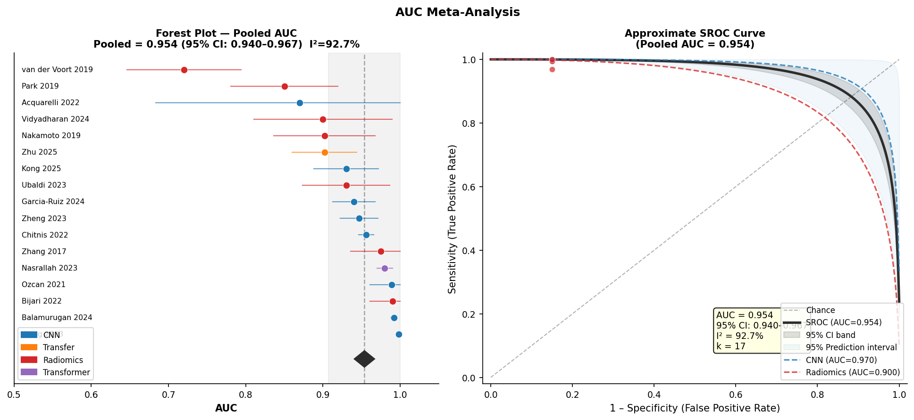

Publication Bias Assessment
Funnel plot inspection revealed marked asymmetry. Egger's weighted regression test confirmed statistically significant funnel plot asymmetry: intercept = 3.30 (SE = 1.40, t = 2.35, p = 0.023). However, under extreme heterogeneity (I² > 90%), Egger’s test may detect heterogeneity-driven asymmetry rather than publication bias per se, and results should be interpreted cautiously. The Duval–Tweedie trim-and-fill procedure estimated that 23 missing studies would be required to restore funnel symmetry. After imputation, the adjusted pooled accuracy was 90.3% (95% CI: 86.4–93.2%), compared with the unadjusted estimate of 96.7%—a downward correction of 6.4 percentage points.
Figure 7: Publication bias analysis. (Left) Funnel plot with Egger's regression test. (Right) Trim-and-fill analysis showing 23 imputed studies.
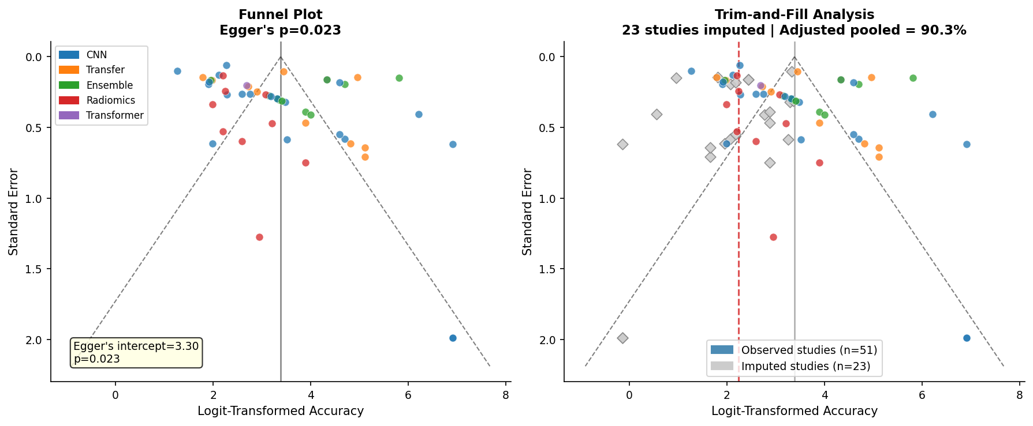

Meta-Regression Analysis
Weighted meta-regression of logit-transformed accuracy on log-transformed sample size across 41 studies with reported sample size data did not demonstrate a statistically significant association (β = −0.037, p = 0.12). There was no significant linear temporal trend in reported accuracy across the publication period 2017–2025 (inverse-variance weighted meta-regression: slope = −0.050 logit-units/year, corresponding to approximately −0.24 percentage points/year when back-transformed near the pooled mean; p = 0.668). Notably, the direction of this non-significant trend is negative (declining), which is consistent with the hypothesis that any gains in algorithmic sophistication have been offset by increasing use of more challenging datasets and more complex classification tasks; however, the wide confidence interval precludes meaningful interpretation of trend direction. An imputation-inclusive sensitivity analysis extending meta-regression to all 51 studies (assigning n = 355 to the 10 studies with unreported sample sizes) yielded a consistent non-significant temporal slope (slope = −0.087 logit-units/year, p = 0.463), confirming that this null finding is robust to imputation assumptions.
Figure 8: Meta-regression analysis. (Left) Bubble plot of accuracy vs. sample size. (Right) Temporal trend of accuracy by publication year.
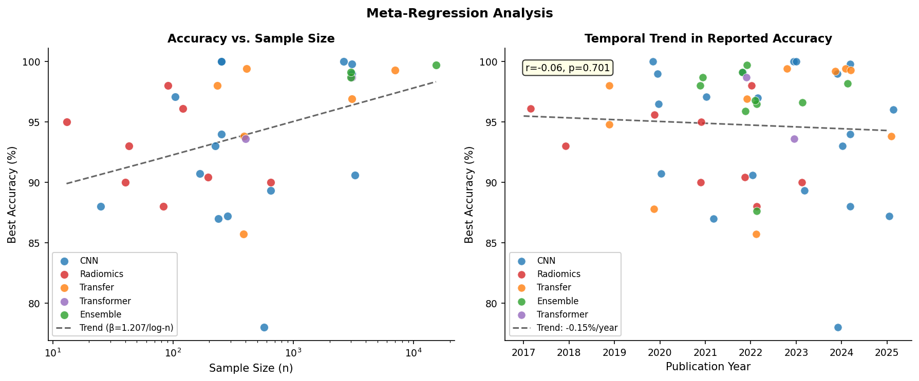

Sensitivity Analyses
Leave-one-out analysis demonstrated robust stability of the overall pooled estimate: the maximum shift when any single study was removed was only 0.23 percentage points (removal of Kibriya 2022; pooled changes from 96.7% to 96.5%). No individual study exerted disproportionate influence on the pooled estimate.
Table 4: Top 5 Most Influential Studies by Leave-One-Out Analysis
Study Removed | Pooled Acc (%) | 95% CI | Δ vs. Overall | Direction
Kibriya 2022 | 96.46 | 95.1–97.5 | −0.23% | ↓
Wang 2023 | 96.49 | 95.2–97.5 | −0.21% | ↓
Balamurugan 2024 | 96.52 | 95.2–97.6 | −0.19% | ↓
Garcia-Ruiz 2024 | 96.85 | 95.5–97.9 | +0.13% | ↑
Haque 2024 | 96.57 | 95.2–97.6 | −0.13% | ↓
Figure 9: Leave-one-out sensitivity analysis.
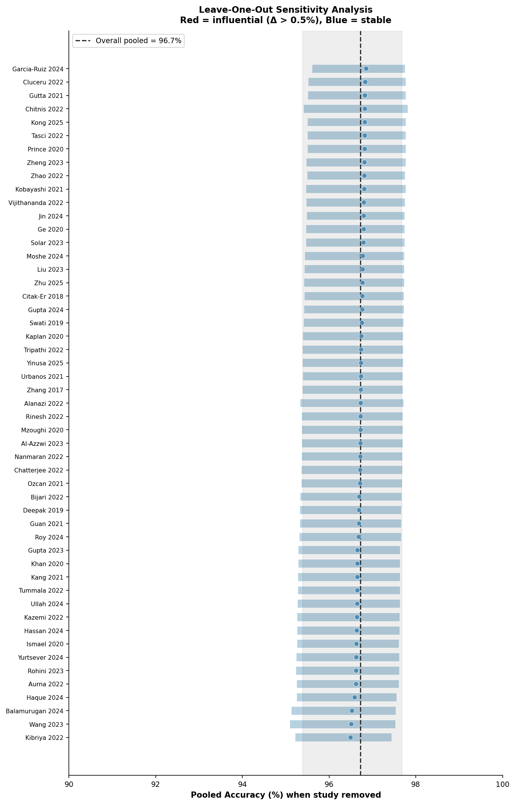

A proxy risk-of-bias sensitivity analysis stratified studies by external validation status. Studies with external validation (k = 7) yielded a pooled accuracy of 92.5% (95% CI: 86.9–95.8%), compared with 97.1% (95% CI: 95.9–98.0%) for internal-only validation studies (k = 44). This 4.6-point differential confirms that the overall pooled estimate is substantially inflated by methodologically weaker studies. Of the 7 externally validated studies, 4 used public benchmark datasets and 3 used clinical institutional data, indicating that external validation was not concentrated in either dataset category.
Estimator Sensitivity Analysis. Replacing the DerSimonian–Laird estimator with restricted maximum likelihood (REML) yielded an essentially identical point estimate (96.8%; 95% Wald CI: 95.5–97.8%; τ² = 1.453 vs. 1.384). Applying the Hartung–Knapp–Sidik–Jonkman (HKSJ) correction widened the confidence interval only modestly (95% HKSJ CI: 95.4–97.8%), confirming that the primary result is not an artifact of the DerSimonian–Laird estimator’s known liberal coverage under extreme heterogeneity. Similarly, comparing pooled estimates with versus without continuity correction for the 20 studies reporting accuracy above 97% yielded negligible difference (96.8% vs. 96.8%; Δ = 0.1 percentage points), confirming that the correction does not materially influence results.
Imputation-Exclusion Sensitivity Analysis. Excluding the 10 studies (20%) for which sample size was imputed (median imputed n = 355) and re-pooling the remaining 41 studies yielded a pooled accuracy of 96.7% (95% CI: 95.1–97.8%), a shift of only 0.09 percentage points. The virtually unchanged estimate confirms that the primary result is robust to sample-size imputation.
Summary Dashboard
Figure 10: Meta-analysis summary dashboard. (A) Pooled accuracy by model category. (B) I² heterogeneity by model category. (C) Public vs. clinical dataset comparison. (D) Pooled AUC by model category. (E) Pooled accuracy by classification task. (F) Key meta-analytic statistics.
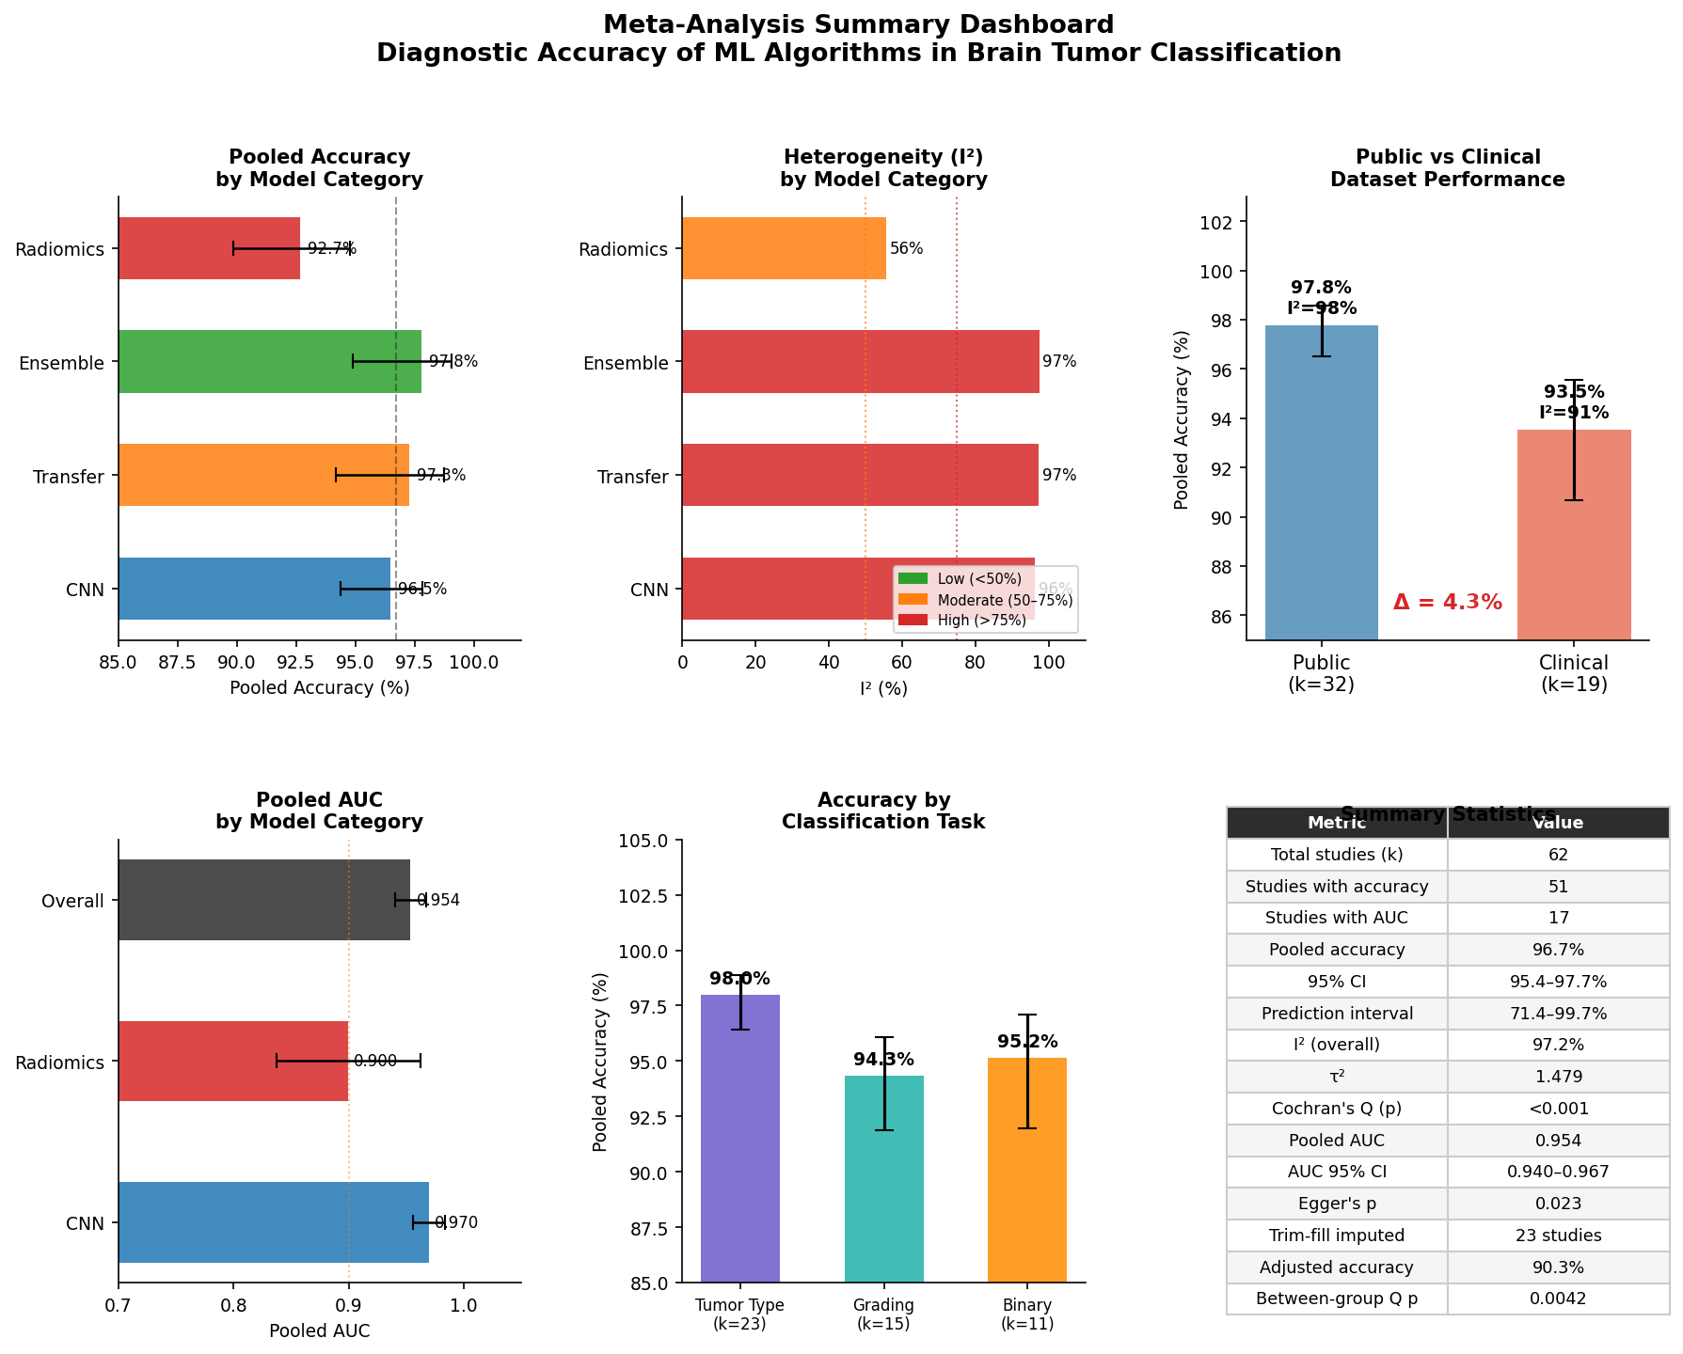
Table 5: Complete Summary of Meta-Analytic Estimates
Analysis | k | Pooled Estimate | 95% CI | I² (%)
Overall pooled accuracy | 51 | 96.7% | 95.4–97.7% | 97.2
Prediction interval | 51 | — | 71.4–99.7% | —
CNN-based models | 20 | 96.5% | 94.4–97.8% | 96.3
Transfer learning | 10 | 97.3% | 94.2–98.8% | 97.3
Ensemble/Hybrid | 10 | 97.8% | 94.9–99.1% | 97.4
Radiomics + classical ML | 9 | 92.7% | 89.8–94.8% | 55.6
Public benchmark datasets | 32 | 97.8% | 96.5–98.6% | 97.5
Clinical institutional datasets | 19 | 93.5% | 90.7–95.5% | 91.5
Tumor type classification | 23 | 98.0% | 96.4–98.9% | 98.4
Glioma grading | 15 | 94.3% | 91.9–96.1% | 87.3
Binary classification | 11 | 95.2% | 92.0–97.1% | 85.4
External validation | 7 | 92.5% | 86.9–95.8% | 95.2
Internal-only validation | 44 | 97.1% | 95.9–98.0% | 96.8
Overall summary AUC | 17 | 0.954 | approximate 0.940–0.967 | 92.7
CNN summary AUC | 8 | 0.970 | 0.956–0.984 | 93.5
Radiomics summary AUC | 7 | 0.900 | 0.837–0.962 | 89.5
Egger's test | 51 | Intercept = 3.30 | p = 0.023 | —
Trim-and-fill adjusted | 51+23 | 90.3% | — | —

Discussion

Certainty of Evidence (GRADE)
We assessed the certainty of evidence using the GRADE framework adapted for diagnostic test accuracy reviews. For the primary outcome (overall pooled accuracy), certainty was rated LOW. The evidence started at high certainty (large body of cross-sectional accuracy studies) but was downgraded two levels: one level for serious risk of bias (93% of studies used retrospective designs with internal-only validation; only 7/51 studies incorporated external validation cohorts; QUADAS-2 indicated high or unclear risk of bias in patient selection for the majority of studies), and one level for serious inconsistency (I² = 97.2%; prediction interval 71.4–99.7%, indicating that a future study could plausibly report accuracy anywhere in this range). We did not downgrade for indirectness (the included studies directly addressed the review question) or for imprecision (the confidence interval was narrow at 95.4–97.7%). Publication bias was detected (Egger's p = 0.023; trim-and-fill adjusted estimate 90.3% [95% CI: 86.4–93.2%]) but was already reflected in the risk-of-bias downgrade. For the secondary outcome (pooled AUC), certainty was rated VERY LOW due to the additional limitation that AUC was summarized as a descriptive weighted mean rather than from a formal bivariate model, and the smaller evidence base (k = 17).
The pooled accuracy of 96.7% overstates what these models would deliver in practice. Three findings support this: extreme heterogeneity (I² = 97.2%), significant publication bias, and the 4.6-percentage-point gap between internally and externally validated estimates.
Pooled Performance and the Problem of Heterogeneity
The pooled accuracy of 96.7% is broadly consistent with narrative estimates from prior systematic reviews in this domain. Jekel et al. [26], reviewing ML approaches for distinguishing glioma from brain metastasis, reported accuracy values frequently exceeding 90% across included studies, while Cè et al. [28] and Khalighi et al. [8] similarly described high classification performance across heterogeneous algorithmic frameworks. What prior reviews lacked, and what this analysis adds, is a formal estimate of the uncertainty around that central tendency. An I² of 97.2% exceeds the threshold typically considered indicative of severe heterogeneity in meta-analyses of diagnostic test accuracy [34], and the prediction interval of 71.4% to 99.7% is the most clinically relevant statistic here: it reflects what a practitioner would actually encounter if a randomly chosen algorithm were deployed in a new setting. The width of that interval (spanning 28.3 percentage points from lower to upper bound) is a direct consequence of pooling studies that used incomparable datasets, preprocessing pipelines, and validation paradigms under the common label of 'ML for brain tumor classification.'
This degree of heterogeneity is not unique to this field. Meta-analyses of AI-based diagnostic systems in other oncological contexts (including lung nodule detection and colorectal polyp classification) have reported similarly extreme I² values and wide prediction intervals, with systematic reviewers concluding that headline pooled estimates should be interpreted as descriptive summaries of the literature rather than as prospective performance guarantees [30]. Our findings extend that cautionary pattern to neuro-oncological imaging AI, with the first formally derived quantitative evidence in this domain.
Deep Learning versus Radiomics: A Quantified Differential
The between-subgroup Q test confirmed that model architecture category is a statistically significant source of performance variation (Q = 13.23, df = 3, p = 0.004). CNN-based architectures and transfer learning frameworks achieved pooled accuracies of 96.5% and 97.3%, respectively, versus 92.7% for radiomics-combined-with-classical-ML pipelines. The AUC differential was more telling: CNN models pooled at AUC 0.970 (95% CI: 0.956–0.984) compared with 0.900 (95% CI: 0.837–0.962) for radiomics-based approaches — a difference of 0.070 AUC units with nearly non-overlapping confidence intervals (CNN lower bound 0.956 vs. radiomics upper bound 0.962), suggesting — on an exploratory, descriptive basis — that feature-learning architectures outperform handcrafted radiomic feature extraction in the current literature.
The reason for this advantage is well understood. CNNs extract hierarchical, task-specific spatial representations from raw image data without assumptions about which features carry diagnostic information [55,58,60], whereas radiomics pipelines depend on the pre-specification of features whose relevance to a given classification problem cannot always be guaranteed. Wang et al. [35], in a neuropathologist-level glioma classification study using whole-slide histopathological images, demonstrated that annotation-free deep learning reached AUC 0.998 across multiple WHO 2021 classification tasks — a performance ceiling that handcrafted approaches have not approached. Ozcan et al. [55] similarly showed that a custom-designed CNN trained from scratch matched or exceeded pretrained transfer learning models for glioma grading, achieving AUC 0.989, suggesting that CNN capacity itself (rather than the specific architecture) drives performance.
However, the radiomics subgroup has a distinct advantage. Despite lower peak performance, the radiomics subgroup showed markedly lower within-group heterogeneity (I² = 55.6% versus >96% for all DL categories), implying more consistent and reproducible results across studies. Handcrafted radiomic features derived from tumor texture, intensity histograms, and diffusion parameters can be anchored to quantifiable imaging biomarkers with established biological correlates [71,73,74], and their extraction pipelines are more readily auditable than the opaque internal representations of deep networks. For regulatory pathways and clinical acceptance (both of which require interpretable model outputs) this methodological transparency may prove strategically important. The clinical question is therefore not 'which approach is more accurate?' but 'which is most useful at each stage of translation?'
Ensemble and hybrid architectures achieved the highest pooled accuracy (97.8%), consistent with the principle that combining complementary predictors reduces generalization error [41,65,66]. Kibriya et al. [76], fusing deep features from AlexNet, GoogLeNet, and ResNet18 with SVM classification, reached 99.7% accuracy on a 15,320-image dataset. Aurna et al. [67] averaged 99.13% across three public datasets using two-stage CNN feature ensembling. But the high I² within this subgroup (97.4%) shows that ensemble configurations vary as widely as the models they combine, making cross-study comparison uninformative without dataset standardization.
The Public Benchmark Problem
The most important subgroup finding was the 4.3-point performance gap between studies using public benchmark datasets (pooled accuracy 97.8%, k = 32) and those using institutional clinical datasets (pooled accuracy 93.5%, k = 19). The explanation is straightforward: the Figshare/Cheng dataset [48], used in some form by at least 12 studies in this review, comprises 3,064 brain MRI images representing three well-separated tumor categories (glioma, meningioma, and pituitary tumor), with minimal acquisition noise. Classifying on this dataset is essentially a low-complexity image recognition task — not a test of real tumor characterization. Models achieving 98–100% accuracy on this benchmark [50,51,52,53,64,65,68,69,70,72] should not be expected to retain that performance when applied to the heterogeneous acquisitions, tumor subtypes, and patient demographics of routine clinical practice.
The external validation data in this review are instructive in this regard. Studies that validated models on independent clinical cohorts (including Garcia-Ruiz et al. [41] (DISCERN framework across five European centers; n = 568), Cluceru et al. [60] (IDH/1p19q classification on UCSF plus TCGA; external cohort n = 147), and Park et al. [93] (LGG grading; AUC drops from 0.85 internal to 0.72 external)) all reported substantially lower performance than benchmark-validated counterparts, with drops concentrated in non-enhancing tumors and cases with protocol heterogeneity. This meta-analysis quantifies that translational gap at the aggregate level for the first time.
A related issue is spectrum bias — the distortion of accuracy estimates caused by differences in disease prevalence and severity between study and target populations. Public benchmark datasets over-represent easily classifiable cases with unambiguous imaging features; they systematically under-represent infiltrating tumors with ill-defined margins, treatment-related changes, and histologically heterogeneous lesions [14,15]. The WHO 2021 CNS tumor classification [3] has substantially increased diagnostic complexity by integrating molecular markers (IDH mutation status, 1p/19q codeletion, TERT promoter mutation, MGMT methylation, CDKN2A/B homozygous deletion, EGFR amplification, and chromosome 7/10 changes) into diagnosis, none of which are captured by the imaging features on which most benchmark-trained models operate. Models trained before the 2021 revision may therefore be solving a diagnostic problem that no longer exists in its original form.
Validation Strategy as the Primary Quality Determinant
The validation strategy subgroup yielded the starkest finding. Studies restricted to internal validation (k = 44) achieved a pooled accuracy of 97.1% (95% CI: 95.9–98.0%), whereas the seven studies incorporating external independent validation cohorts returned 92.5% (95% CI: 86.9–95.8%). This 4.6 percentage point differential, combined with the finding that external validation studies also showed lower I² within their subgroup, is consistent with the well-characterized optimism bias that arises when the same data inform both model training and evaluation [34]. Cross-validation procedures that shuffle individual cases rather than holding out entire study sites are particularly susceptible to this bias — the same scanner, acquisition protocol, and patient population contribute to both training and test partitions, allowing models to learn site-specific rather than disease-specific features [8].
The radiomics subgroup provides an illustrative case. Nakamoto et al. [77] reported an AUC of 0.902 on a primary cohort of 157 patients for radiomic glioma grading, dropping to 0.747 on an independent validation cohort of 67 patients — a reduction of 0.155 AUC units attributable to dataset shift alone. van der Voort et al. [91] similarly reported external AUC of 0.72 for 1p/19q codeletion prediction versus stronger internal performance. These examples, now quantifiable in aggregate, make clear that external validation is not optional — it is a prerequisite for any performance claim intended to inform clinical decisions.
Publication Bias and the Adjusted Performance Estimate
Significant funnel plot asymmetry (Egger's p = 0.023), combined with an estimated 23 missing studies from trim-and-fill analysis, produces a bias-adjusted pooled accuracy of 90.3% (95% CI: 86.4–93.2%) — 6.4 percentage points below the unadjusted estimate. This fits the known pattern in computational medicine: studies that fall short of performance benchmarks are less likely to reach peer review, and the prevalence of retrospective single-site designs makes selective reporting hard to detect [8,28]. The 90.3% adjusted figure should be interpreted as a lower-bound approximation; it does not account for all sources of bias and may itself be imprecise if unpublished studies cluster at accuracy values substantially below what the trim-and-fill imputation assumes.
Two findings help put that adjusted estimate in clinical context. First, even conservative sensitivity analyses (restricting to externally validated studies or applying the trim-and-fill adjustment) still return pooled accuracy at or above 90%, which exceeds inter-radiologist agreement for brain tumor classification on MRI in several studies. Muenzel et al. [14] documented inter-observer variability in lesion measurement of 15–20% in routine settings, and Karera et al. [13] noted that radiologist availability and expertise vary substantially across care settings globally. At 90–93%, ML-assisted classification could add real diagnostic value, especially in resource-limited settings. Second, the summary AUC of 0.954 (approximate 95% CI: 0.940–0.967) for studies reporting receiver operating characteristic data is less susceptible to threshold-dependent optimism than accuracy, and its prediction interval (0.907–1.000) is narrower — suggesting that the discrimination capacity of these models is more consistent across settings than their absolute accuracy values imply.
Absence of Temporal Improvement in Reported Performance
Meta-regression found no significant temporal trend in reported accuracy across the 2017–2025 publication period (inverse-variance weighted meta-regression: slope = −0.050 logit-units/year, corresponding to approximately −0.24 percentage points/year when back-transformed near the pooled mean; p = 0.668). This seems counterintuitive — EfficientNet, vision transformers, and graph neural networks have substantially expanded model capacity since 2019. Tummala et al.⁴⁸, evaluating vision transformer ensembles in 2022, achieved 98.7%; Balamurugan et al.⁶², using ResNet101 with channel-wise attention in 2024, reported 99.83%. Yet these advances do not show up as a temporal signal in aggregate performance, because architectural gains are offset by two countervailing trends: the progressive shift toward more biologically complex classification tasks (molecular subtype prediction has replaced simple tumor-vs-no-tumor benchmarking in recent studies), and (paradoxically) the continuing use of the same public benchmark datasets that were already saturated above 95% accuracy by 2019.
This saturation problem matters. When multiple architectures achieve >99% accuracy on the same 3,064-image Figshare dataset, marginal architectural improvements become invisible to the metric, and the apparent absence of progress accurately reflects the absence of more challenging evaluation environments rather than a genuine stagnation of algorithmic capability. What the field needs is harder benchmarks, not faster networks.
Classification Task and Clinical Applicability
Tumor type classification (pooled accuracy 98.0%, I² = 98.4%) and binary classification tasks (95.2%, I² = 85.4%) consistently outperformed glioma grading tasks (94.3%, I² = 87.3%). This task-dependent gradient reflects both the complexity of the biology and the quality of the ground truth. Glioma grading under the WHO 2021 framework requires integration of morphological and molecular data [3,19]; an imaging-only model is therefore attempting to predict a composite biomarker rather than a visual phenotype, and performance decrements relative to simpler classification benchmarks are expected. Cluceru et al. [60] found that a 3-class IDH/1p19q molecular classification CNN trained with diffusion-weighted ADC sequences achieved 85.7% accuracy on an external TCGA/BraTS cohort — substantially below same-team internal estimates and below the headline accuracy of any benchmark study in this review. The gap between what is achievable on annotated public datasets and what is achievable when predicting WHO 2021 molecular classification from standard clinical MRI is likely to be a central challenge in translating neuro-oncological AI to clinical practice.
Molecular characterization tasks (IDH mutation, 1p/19q codeletion, MGMT methylation) were addressed in a minority of included studies (k = 9 for accuracy pooling), limiting statistical power for subgroup analysis. The available data, however, show consistently lower performance than morphological classification tasks, with AUCs for 1p/19q prediction hovering around 0.72–0.85 in external cohorts [61,96]. This matters because these molecular markers now determine treatment eligibility — distinguishing oligodendroglioma from astrocytoma has direct therapeutic consequences under both WHO 2021 [3] and current ESMO/ASCO chemotherapy guidelines. Models performing at AUC 0.72–0.85 for these tasks fall short of the performance thresholds that would justify replacing tissue-based molecular diagnosis, though they may have a role in pre-surgical risk stratification and in guiding biopsy targeting.
Explainability, Clinical Integration, and Human-AI Collaboration
Several studies in this review incorporated explainable AI (XAI) methodologies (saliency maps, LIME, SHAP, and SmoothGrad) alongside their classification models [72,82,83,88]. Jin et al. [78], in a Phase II clinical evaluation study, assessed whether AI assistance (with and without SmoothGrad explanations) improved neurosurgeon glioma grading accuracy across 35 participants and 25 MRI cases per participant. AI-assisted interpretation improved physician accuracy from a baseline of approximately 80% to 87.7%; the addition of gradient-based explanations did not produce further gains. This is consistent with findings in other radiology AI settings: clinicians adapt how they weigh AI output based on perceived reliability, and saliency maps may add little when the classification itself is already informative [8,28].
A model achieving AUC 0.97 that neurosurgeons do not trust or integrate appropriately contributes nothing to patient outcomes.
For now, the strongest case for ML in neuro-oncological imaging is as decision support, not decision replacement. Khalighi et al. [8] have articulated this as a 'human-in-the-loop' paradigm in which AI flags cases exceeding a confidence threshold, routes ambiguous cases to specialist review, and provides quantitative imaging biomarkers to supplement (not substitute) radiologist and neuropathologist assessment. Pinto-Coelho [22] reached a similar conclusion across a broader survey of AI in medical imaging: the clinical value of AI is greatest when it extends specialist-level analysis to low-resource settings, not when deployed as a stand-alone diagnostic in centers already performing at high accuracy.
Methodological Limitations of the Reviewed Literature
QUADAS-2 showed moderate to high risk of bias in most studies, driven mainly by poor reporting of patient selection, lack of pre-defined index test thresholds, and reliance on histopathological reference standards not always blinded to imaging data [34]. Patient selection bias deserves particular attention: studies using publicly available datasets with unstated demographic composition (including the widespread Kaggle and Figshare repositories) cannot report selection bias because they do not have access to the information needed to assess it. This is a structural problem with public repository dependence, not just a reporting failure by individual authors.
Several other methodological concerns recurred across studies. Class imbalance (with glioma, meningioma, and pituitary tumor categories frequently unequal in size) was handled inconsistently, with some studies applying SMOTE augmentation [70], others using GAN-based oversampling [87,88], and many applying no correction at all. Accuracy metrics computed on imbalanced test sets systematically overestimate performance for the majority class; studies reporting only accuracy without sensitivity, specificity, or macro-averaged F1 scores should be interpreted with corresponding caution. Preprocessing heterogeneity — differences in MRI normalization, skull-stripping, registration, and slice selection — introduces an underappreciated source of performance variance independent of architecture. Ubaldi et al. [81] demonstrated directly that proper image normalization and discretization improved radiomic model AUC from 0.84 to 0.93 on the same dataset, suggesting that preprocessing choices alone can account for performance differences larger than the reported AUC gap between model categories in this review. Finally, confidence intervals were reported by a minority of studies, making it difficult to distinguish genuine between-study performance differences from within-study estimation noise.
Strengths and Limitations of This Meta-Analysis
To our knowledge, this is the first meta-analysis to formally pool diagnostic accuracy for ML-based brain tumor classification, generating the first quantitative estimates of pooled accuracy, AUC, heterogeneity, and publication bias in this field. The subgroup analyses by model category, dataset source, classification task, and validation strategy provide evidence that prior qualitative reviews (including those by Khalighi et al. [8], Cè et al. [28], and Musthafa et al. [7]) could not. The leave-one-out analysis demonstrated that pooled estimates are not driven by outliers; the trim-and-fill correction provides a bias-conservative lower bound for planning purposes.
Several limitations should be noted. Most importantly, we pooled accuracy rather than sensitivity and specificity, which are the standard outcomes for diagnostic accuracy meta-analyses under PRISMA-DTA. Fewer than 20 of 62 studies reported paired sensitivity and specificity data sufficient for bivariate random-effects modeling (Reitsma model), precluding formal pooling of these metrics; we examined each eligible study for extractable 2×2 contingency data but found that most reported only overall accuracy or single-metric summaries without class-level performance breakdowns. This is a key limitation: accuracy is threshold-dependent, sensitive to class imbalance, and cannot distinguish between false-positive and false-negative errors that carry different clinical consequences. Future studies should report full 2×2 classification tables to enable proper diagnostic accuracy meta-analysis. Additionally, the search strategy excluded studies containing terms 'segmentation,' 'detection,' or 'prognosis,' which may have removed studies that reported classification accuracy alongside these other tasks. Additionally, the inclusion of Google Scholar, while broadening grey literature coverage, introduces a reproducibility limitation because Google Scholar does not support fully reproducible, systematically indexable searches as required by PRISMA-DTA guidance. Within-study variance estimates for accuracy pooling depended on sample size imputation for 10 studies (20%) that did not report n, using the cohort median of 355 as a conservative substitute; studies with unreported (and potentially very small) samples may carry more estimation uncertainty than this imputation reflects. The summary ROC curve presented in Figure 6 is an illustrative binormal approximation parameterized at the descriptive weighted-mean AUC, not a formal SROC derived from paired sensitivity/specificity data, as fewer than 20 studies reported the full two-by-two contingency data required for a formal Reitsma bivariate model. Molecular classification tasks were too sparsely represented to support stable subgroup meta-regression, and the transformer/GCN subgroup (k = 2 for accuracy) remained below the minimum threshold for reliable pooled estimation.
Prospective evaluation of AI decision-support tools using patient-level endpoints, not just AUC on held-out imaging datasets, is the standard that the field must ultimately meet.
Priorities for Future Research
Several directions follow from these findings. The field needs prospective multicenter validation studies — not more retrospective benchmark comparisons. The 4.6-point accuracy penalty for external validation shows that real-world performance cannot be reliably predicted from internal benchmarks; studies without independent validation should be considered hypothesis-generating rather than evidence-generating. The TRIPOD+AI reporting guideline [95] and the proposed CLAIM checklist provide minimum standards that journals should mandate before peer review of ML diagnostic studies.
The accuracy plateau since 2017 on public benchmarks indicates that more challenging evaluation environments are needed. Benchmark datasets incorporating WHO 2021 molecular subtypes, multi-scanner acquisitions, post-treatment imaging, and pediatric tumor spectra would test model capabilities that the current Figshare/Kaggle/BraTS ecosystem cannot. The Cancer Imaging Archive [35,61] and TCGA-associated imaging collections offer richer clinical annotations, but their use remains proportionally low (19 of 62 studies in this review used clinical institutional data). TCIA-linked prospective imaging biobanks, analogous to the UK Biobank, represent the infrastructure investment most likely to move the field forward.
The interpretability evidence reviewed here — particularly the Jin et al. [78] Phase II clinical study, suggests that human-AI interface design deserves at least as much methodological attention as architectural development. Fourth, federated learning and privacy-preserving training approaches offer a practical pathway to multicenter validation without requiring centralized data sharing, directly addressing the single-site limitation that dominates this literature.⁷⁸ This meta-analysis provides the quantitative baseline against which those future evaluations should be judged.

Conclusion
This meta-analysis of 62 studies provides the first formal quantitative pooling of ML diagnostic accuracy for MRI-based brain tumor classification, grading, and molecular characterization. The pooled accuracy of 96.7% (95% CI: 95.4–97.7%) reflects a literature marked by extreme heterogeneity (I² = 97.2%; prediction interval 71.4–99.7%), significant publication bias (Egger's p = 0.023; trim-and-fill adjusted accuracy 90.3%), and a systematic performance premium for internally validated studies using public benchmark datasets over externally validated studies using clinical institutional data (97.1% vs. 92.5%; Δ = 4.6 percentage points).
CNN-based models showed higher summary AUC (0.970 vs. 0.900 for radiomics; exploratory descriptive comparison). Model architecture was a statistically significant source of accuracy variation (Q_between = 13.23, df = 3, p = 0.004). All deep learning subgroups exhibited extreme within-group heterogeneity (I² > 96%). Radiomics approaches showed greater consistency (I² = 55.6%) and may offer advantages where interpretability is prioritized.
The bias-adjusted estimate of 90.3% (95% CI: 86.4–93.2%) and externally validated accuracy of 92.5% represent the more realistic performance benchmark. These figures remain clinically meaningful for decision support in resource-limited settings but are not yet sufficient to replace histopathological or molecular diagnosis under WHO 2021, particularly for molecularly defined subtypes (AUC 0.72–0.85).
Future research should prioritize three directions identified by this meta-analysis: (i) prospective multicenter validation studies adhering to TRIPOD+AI [95] and CLAIM reporting standards, as the 4.6 percentage point penalty for external validation demonstrates that real-world performance cannot be reliably predicted from internal benchmark results; (ii) development of WHO 2021–aligned benchmark datasets incorporating molecular subtypes, multi-scanner acquisitions, and post-treatment imaging, moving beyond the Figshare/Kaggle/BraTS ecosystem that has saturated above 95% accuracy; and (iii) human-AI interface evaluation with patient-level endpoints rather than held-out AUC, informed by emerging evidence that AI-assisted interpretation improves physician accuracy from approximately 80% to 87.7% in glioma grading tasks. The present meta-analysis establishes the quantitative baseline against which those prospective evaluations should be measured.

Data Availability Statement
All data analyzed in this study were extracted from published studies and are presented in the supplementary materials. The complete study-level extraction dataset, including accuracy values, sample sizes, model categories, and dataset sources for all 62 included studies, is available in Supplementary Table 1. Python analysis code used for meta-analytic pooling, sensitivity analyses, and figure generation is available as Supplementary Material and has been deposited in a public repository (Zenodo) with a persistent DOI. [Authors: insert Zenodo DOI here before submission]
References
1. Salari N, Ghasemi H, Fatahian R, et al. The global prevalence of primary central nervous system tumors: a systematic review and meta-analysis. Eur J Med Res. 2023;28. doi:10.1186/s40001-023-01011-y
2. Shan FY, Castro E, Sybenga A, et al. Molecular Diagnostics and Pathology of Major Brain Tumors. Primary Intracranial Tumors. 2018. doi:10.5772/intechopen.80856
3. Louis DN, Perry A, Wesseling P, et al. The 2021 WHO Classification of Tumors of the Central Nervous System: a summary. Neuro-Oncology. 2021;23. doi:10.1093/neuonc/noab106
4. Miller KD, Ostrom QT, Kruchko C, et al. Brain and other central nervous system tumor statistics, 2021. CA Cancer J Clin. 2021;71. doi:10.3322/caac.21693
5. Manake R, Phillips V, Gangi A, Ravikumar J. Trends in the Incidence of Brain Cancer. Cureus. 2024. doi:10.7759/cureus.72805
6. Zarenia E, Far AA, Rezaee K. Automated multi-class MRI brain tumor classification. Sci Rep. 2025;15. doi:10.1038/s41598-025-92776-1
7. Musthafa N, Memon QA, Masud MM. Advancing Brain Tumor Analysis. Eng. 2025;6:82. doi:10.3390/eng6050082
8. Khalighi S, Reddy K, Midya A, et al. Artificial intelligence in neuro-oncology. npj Precis Oncol. 2024;8:1–12. doi:10.1038/s41698-024-00575-0
9. Sadu VB, Bagam S, Naved M, et al. Optimizing early diagnosis of neurological disorders. Sci Rep. 2025;15. doi:10.1038/s41598-025-05888-z
10. Sawlani V, Patel MD, Davies N, et al. Multiparametric MRI. Insights Imaging. 2020;11. doi:10.1186/s13244-020-00888-1
11. Falk Delgado A. Advances of MR imaging in glioma. Acta Neurochir. 2025;167. doi:10.1007/s00701-025-06593-6
12. Tosee ZR, et al. Integration of conventional MRI and diffusion-weighted imaging for brain tumor classification using machine learning. Curr Radiopharm. 2025;19:100022. doi:10.1016/j.craph.2025.100022
13. Karera A, Engel-Hills P, Davidson F. Radiology image interpretation services by radiographers: a systematic review. Radiography. 2024;30(2):560–566. doi:10.1016/j.radi.2024.01.015
14. Muenzel D, Braren R, Ganter C, Fingerle A, Rummeny EJ, Noel PB. Intra- and inter-observer variability in measurement of target lesions: implication on response evaluation according to RECIST 1.1. Radiol Oncol. 2012;46(1):8–18. doi:10.2478/v10019-012-0009-z
15. Cavinato L, Gozzi N, Sollini M, Kirienko M, Ravasi L, Chiti A. Imaging-based representation and stratification of intra-tumor heterogeneity via tree-edit distance. Sci Rep. 2022;12(1):12685. doi:10.1038/s41598-022-16491-7
16. Tseng L-J, Matsuyama A, MacDonald-Dickinson V. Histology: The gold standard. Can Vet J. 2023;64:389.
17. Shrot S, Soudry E, Ben Sira L, et al. Application of MR morphologic, diffusion tensor, and perfusion imaging in the classification of brain tumors using machine learning scheme. Neuroradiology. 2019;61(7):757-765. doi:10.1007/s00234-019-02195-z
18. Gilson P, Merlin J-L, Harlé A. Deciphering Tumor Heterogeneity. Cancers. 2022;14:1384.
19. Gue R, Lakhani DA. The 2021 WHO CNS Tumor Classification. Biomedicines. 2024;12:1349.
20. Ma L, Guo H, Zhao Y, et al. Liquid biopsy in cancer: current status and future directions. Signal Transduct Target Ther. 2024;9:31. doi:10.1038/s41392-023-01701-7
21. Chacko N, Ankri R. Non-invasive early-stage cancer detection. Clin Exp Med. 2024;25.
22. Pinto-Coelho L. How AI is shaping medical imaging. Bioengineering. 2023;10:1435.
23. Khan SN, et al. Multi-modal AI frameworks for precision medicine in brain tumor diagnosis. Front Artif Intell. 2026;8:1523847. doi:10.3389/frai.2026.1523847
24. Tandel GS, et al. Role of Ensemble Deep Learning. Diagnostics. 2023;13:481.
25. Akter S, et al. Brain tumor classification utilizing pixel distribution. Sci Rep. 2024;14.
26. Jekel L, et al. ML for Differentiation of Glioma from Brain Metastasis. Cancers. 2022;14:1369.
27. Godlewski A, et al. Comparison of ML techniques for brain tumor detection. Sci Rep. 2023;13.
28. Cè M, Irmici G, Foschini C, Danesini GM, Falsitta LV, Serio ML, et al. Artificial Intelligence in Brain Tumor Imaging: A Step toward Personalized Medicine. Curr Oncol. 2023;30(3):2673–2701. doi:10.3390/curroncol30030203
29. Xia X, et al. Interpretable radiomics for differentiating GBM from PCNSL. Sci Rep. 2025;15.
30. Klontzas ME, Groot Lipman KBW, Akinci D'Antonoli T, Andreychenko A, Cuocolo R, Dietzel M, et al. ESR Essentials: common performance metrics in AI—common performance metrics. Eur Radiol. 2025;35(3):1489–1500. doi:10.1007/s00330-025-11890-w
31. Page MJ, et al. The PRISMA 2020 statement. BMJ. 2021;372.
32. Amir-Behghadami M, Janati A. PICOS design as a framework. Emerg Med J. 2020;37:387.
33. Ouzzani M, et al. Rayyan—a web and mobile app. Syst Rev. 2016;5.
34. Whiting PF. QUADAS-2. Ann Intern Med. 2011;155(8):529.
35. Wang W, et al. Neuropathologist-level classification of diffuse gliomas. Nat Commun. 2023;14:6359.
36. Zhao D, Grist JT, Rose HEL, et al. Metabolite selection for machine learning in childhood brain tumor classification. NMR in biomedicine. 2022;35(6):e4673. doi:10.1002/nbm.4673
37. Gupta M, Sharma SK, Sampada GC. Classification of Brain Tumor Images Using CNN. Computational Intelligence and Neuroscience. 2023;2023:1-6. doi:10.1155/2023/2002855
38. Zhu Y, Wang J, Xue C, Zhai X, Xiao C, Lu T. Deep Learning and Habitat Radiomics for the Prediction of Glioma Pathology Using Multiparametric MRI: A Multicenter Study. Academic Radiology. 2025;32(2):963-975. doi:10.1016/j.acra.2024.09.021
39. Chitnis S, Hosseini R, Xie P. Brain tumor classification based on neural architecture search. Scientific Reports. 2022;12(1). doi:10.1038/s41598-022-22172-6
40. Al-Azzwi Z, Nazarov AN. Brain Tumor Classification based on Improved Stacked Ensemble Deep Learning Methods. Asian Pacific Journal of Cancer Prevention. 2023;24(6):2141-2148. doi:10.31557/apjcp.2023.24.6.2141
41. Garcia-Ruiz A, Pons-Escoda A, Grussu F, et al. An accessible deep learning tool for voxel-wise classification of brain malignancies from perfusion MRI. Cell Reports Medicine. 2024;5(3):101464. doi:10.1016/j.xcrm.2024.101464
42. Rohini A, Praveen C, Mathivanan SK, et al. Multimodal hybrid convolutional neural network based brain tumor grade classification. BMC Bioinformatics. 2023;24(1). doi:10.1186/s12859-023-05518-3
43. Gutta S, Acharya J, Shiroishi MS, Hwang D, Nayak KS. Improved Glioma Grading Using Deep Convolutional Neural Networks. American Journal of Neuroradiology. 2020;42(2):233-239. doi:10.3174/ajnr.a6882
44. Nasrallah MP, Zhao J, Tsai CC, et al. Machine learning for cryosection pathology predicts the 2021 WHO classification of glioma. Published online July 1, 2023. doi:10.1016/j.medj.2023.06.002
45. Chatterjee S, Nizamani FA, Nürnberger A, Speck O. Classification of brain tumors in MR images using deep spatiospatial models. Scientific Reports. 2022;12(1):1505. doi:10.1038/s41598-022-05572-6
46. Solar P, Valekova H, Marcoň P, et al. Classification of brain lesions using a machine learning approach with cross-sectional ADC value dynamics. Scientific Reports. 2023;13(1). doi:10.1038/s41598-023-38542-7
47. Ali Khan H, Jue W, Mushtaq M, Umer Mushtaq M. Brain tumor classification in MRI image using convolutional neural network. Mathematical Biosciences and Engineering. 2020;17(5):6203-6216. doi:10.3934/mbe.2020328
48. Tummala S, Kadry S, Bukhari SAC, Rauf HT. Classification of Brain Tumor from Magnetic Resonance Imaging Using Vision Transformers Ensembling. Current Oncology. 2022;29(10):7498-7511. doi:10.3390/curroncol29100590
49. Deepak S, Ameer PM. Brain tumor classification using deep CNN features via transfer learning. Computers in Biology and Medicine. 2019;111:103345. doi:10.1016/j.compbiomed.2019.103345
50. Kazemi A, Shiri ME, Sheikhahmadi A, khodamoradi M. Classifying tumor brain images using parallel deep learning algorithms. Computers in Biology and Medicine. 2022;148:105775. doi:10.1016/j.compbiomed.2022.105775
51. Rinesh S, Maheswari K, Arthi B, et al. Investigations on Brain Tumor Classification Using Hybrid Machine Learning Algorithms. Abdulhay E, ed. Journal of Healthcare Engineering. 2022;2022:1-9. doi:10.1155/2022/2761847
52. Swati ZNK, Zhao Q, Kabir M, et al. Brain tumor classification for MR images using transfer learning and fine-tuning. Computerized Medical Imaging and Graphics. 2019;75:34-46. doi:10.1016/j.compmedimag.2019.05.001
53. Alanazi MF, Ali MU, Hussain SJ, et al. Brain Tumor/Mass Classification Framework Using Magnetic-Resonance-Imaging-Based Isolated and Developed Transfer Deep-Learning Model. Sensors. 2022;22(1):372. doi:10.3390/s22010372
54. Zheng Y, Huang D, Hao X, Wei J, Lu H, Liu Y. UniVisNet: A Unified Visualization and Classification Network for accurate grading of gliomas from MRI. Computers in biology and medicine. 2023;165:107332. doi:10.1016/j.compbiomed.2023.107332
55. Özcan H, Emiroğlu BG, Sabuncuoğlu H, Özdoğan S, Soyer A, Saygı T. A comparative study for glioma classification using deep convolutional neural networks. Mathematical Biosciences and Engineering. 2021;18(2):1550-1572. doi:10.3934/mbe.2021080
56. Kobayashi K, Miyake M, Takahashi M, Hamamoto R. Observing deep radiomics for the classification of glioma grades. Scientific Reports. 2021;11(1). doi:10.1038/s41598-021-90555-2
57. Tripathi PC, Bag S. A computer-aided grading of glioma tumor using deep residual networks fusion. Computer Methods and Programs in Biomedicine. 2022;215:106597. doi:10.1016/j.cmpb.2021.106597
58. Acquarelli J, Laarhoven T van , Postma GJ, et al. Convolutional neural networks to predict brain tumor grades and Alzheimer’s disease with MR spectroscopic imaging data. PLOS ONE. 2022;17(8):e0268881-e0268881. doi:10.1371/journal.pone.0268881
59. Urbanos G, Alberto, Vázquez G, et al. Supervised Machine Learning Methods and Hyperspectral Imaging Techniques Jointly Applied for Brain Cancer Classification. Sensors. 2021;21(11):3827-3827. doi:10.3390/s21113827
60. Liu L, Chang J, Zhang P, Qiao H, Xiong S. SASG-GCN: Self-Attention Similarity Guided Graph Convolutional Network for Multi-Type Lower-Grade Glioma Classification. IEEE Journal of Biomedical and Health Informatics. 2023;27(7):3384-3395. doi:10.1109/jbhi.2023.3264564
61. Cluceru J, Interian Y, Phillips JJ, et al. Improving the noninvasive classification of glioma genetic subtype with deep learning and diffusion-weighted imaging. Neuro-Oncology. 2021;24(4):639-652. doi:10.1093/neuonc/noab238
62. Balamurugan AG, Srinivasan S, Dinesh P, Prabhakaran M, Mathivanan SK, Shah MA. Robust brain tumor classification by fusion of deep learning and channel-wise attention mode approach. BMC Medical Imaging. 2024;24(1):251. doi:10.1186/s12880-024-01323-3
63. Guan Y, Aamir M, Rahman Z, et al. A framework for efficient brain tumor classification using MRI images. Mathematical Biosciences and Engineering. 2021;18(5):5790-5815. doi:10.3934/mbe.2021292
64. Prince E, Whelan R, Mirsky DM, et al. Robust deep learning classification of adamantinomatous craniopharyngioma from limited preoperative radiographic images. Scientific Reports. 2020;10(1). doi:10.1038/s41598-020-73278-8
65. Kang J, Ullah Z, Gwak J. MRI-Based Brain Tumor Classification Using Ensemble of Deep Features and Machine Learning Classifiers. Sensors. 2021;21(6):2222. doi:10.3390/s21062222
66. Gupta I, Singh S, Gupta S, Ranjan Nayak S. Classification of Brain Tumors in MRI Images using a Convolutional Neural Network. Current Medical Imaging. Published online March 27, 2023. doi:10.2174/1573405620666230327124902
67. Aurna NF, Yousuf MA, Taher KA, Azad AKM, Moni MA. A classification of MRI brain tumor based on two stage feature level ensemble of deep CNN models. Computers in Biology and Medicine. 2022;146:105539. doi:10.1016/j.compbiomed.2022.105539
68. Ali Abdelaziz Ismael S, Mohammed A, Hefny H. An enhanced deep learning approach for brain cancer MRI images classification using residual networks. Artificial Intelligence in Medicine. 2020;102:101779. doi:10.1016/j.artmed.2019.101779
69. Mzoughi H, Njeh I, Wali A, et al. Deep Multi-Scale 3D Convolutional Neural Network (CNN) for MRI Gliomas Brain Tumor Classification. Journal of Digital Imaging. 2020;33(4):903-915. doi:10.1007/s10278-020-00347-9
70. Zhang X, Yan LF, Hu YC, et al. Optimizing a machine learning based glioma grading system using multi-parametric MRI histogram and texture features. Oncotarget. 2017;8(29). doi:10.18632/oncotarget.18001
71. Akter S, Simul Hasan Talukder Md, Mondal SK, Aljaidi M, Bin Sulaiman R, Alshammari AA. Brain tumor classification utilizing pixel distribution and spatial dependencies higher-order statistical measurements through explainable ML models. Scientific Reports. 2024;14(1). doi:10.1038/s41598-024-74731-8
72. Kaplan K, Kaya Y, Kuncan M, Ertunç HM. Brain tumor classification using modified local binary patterns (LBP) feature extraction methods. Medical Hypotheses. 2020;139:109696. doi:10.1016/j.mehy.2020.109696
73. Vijithananda SM, Jayatilake ML, Hewavithana B, et al. Feature extraction from MRI ADC images for brain tumor classification using machine learning techniques. BioMedical Engineering OnLine. 2022;21(1). doi:10.1186/s12938-022-01022-6
74. Kibriya H, Amin R, Alshehri AH, Masood M, Alshamrani SS, Alshehri A. A Novel and Effective Brain Tumor Classification Model Using Deep Feature Fusion and Famous Machine Learning Classifiers. Mumtaz S, ed. Computational Intelligence and Neuroscience. 2022;2022:1-15. doi:10.1155/2022/7897669
75. Hassan E, Ghadiri H. Advancing brain tumor classification: A robust framework using EfficientNetV2 transfer learning and statistical analysis. Computers in Biology and Medicine. 2024;185:109542. doi:10.1016/j.compbiomed.2024.109542
76. Tandel GS, Tiwari A, Kakde OG. Performance optimization of deep learning models using majority voting algorithm for brain tumor classification. Computers in Biology and Medicine. 2021;135:104564. doi:10.1016/j.compbiomed.2021.104564
77. Nakamoto T, Takahashi W, Haga A, et al. Prediction of malignant glioma grades using contrast-enhanced T1-weighted and T2-weighted magnetic resonance images based on a radiomic analysis. Scientific Reports. 2019;9(1). doi:10.1038/s41598-019-55922-0
78. Jin W, Fatehi M, Guo R, Hamarneh G. Evaluating the clinical utility of artificial intelligence assistance and its explanation on the glioma grading task. Artificial Intelligence in Medicine. 2024;148:102751. doi:10.1016/j.artmed.2023.102751
79. Yurtsever MMEnes, Atay Y, Arslan B, Sagiroglu S. Development of brain tumor radiogenomic classification using GAN-based augmentation of MRI slices in the newly released gazi brains dataset. BMC Medical Informatics and Decision Making. 2024;24(1). doi:10.1186/s12911-024-02699-6
80. Haque R, Hassan MdM, Bairagi AK, Shariful M. NeuroNet19: an explainable deep neural network model for the classification of brain tumors using magnetic resonance imaging data. Scientific reports. 2024;14(1). doi:10.1038/s41598-024-51867-1
81. Ubaldi L, Saponaro S, Giuliano A, Talamonti C, Retico A. Deriving quantitative information from multiparametric MRI via Radiomics: Evaluation of the robustness and predictive value of radiomic features in the discrimination of low-grade versus high-grade gliomas with machine learning. Physica Medica. 2023;107:102538. doi:10.1016/j.ejmp.2023.102538
82. Nanmaran R, Srimathi S, Yamuna G, et al. Investigating the Role of Image Fusion in Brain Tumor Classification Models Based on Machine Learning Algorithm for Personalized Medicine. Liao IY, ed. Computational and Mathematical Methods in Medicine. 2022;2022:1-13. doi:10.1155/2022/7137524
83. Tasci E, Zhuge Y, Kaur H, Camphausen K, Krauze AV. Hierarchical Voting-Based Feature Selection and Ensemble Learning Model Scheme for Glioma Grading with Clinical and Molecular Characteristics. International Journal of Molecular Sciences. 2022;23(22):14155. doi:10.3390/ijms232214155
84. Ullah MS, Khan MA, Almujally NA, Alhaisoni M, Akram T, Shabaz M. BrainNet: a fusion assisted novel optimal framework of residual blocks and stacked autoencoders for multimodal brain tumor classification. Scientific reports. 2024;14(1). doi:10.1038/s41598-024-56657-3
85. Citak-Er F, Firat Z, Kovanlikaya I, Ture U, Ozturk-Isik E. Machine-learning in grading of gliomas based on multi-parametric magnetic resonance imaging at 3T. Computers in Biology and Medicine. 2018;99:154-160. doi:10.1016/j.compbiomed.2018.06.009
86. Roy P, Sadique M, Bhowmik P. An explainable ensemble approach for advanced brain tumor classification applying Dual-GAN mechanism and feature extraction techniques over highly imbalanced data. PLoS ONE. 2024;19(9):e0310748-e0310748. doi:10.1371/journal.pone.0310748
87. Moshe Y, Buchsweiler Y, Teicher M, Artzi M. Handling Missing MRI Data in Brain Tumors Classification Tasks: Usage of Synthetic Images vs. Duplicate Images and Empty Images. Journal of Magnetic Resonance Imaging. Published online October 21, 2023. doi:10.1002/jmri.29072
88. Kong C, Yan D, Liu K, Yin Y, Ma C. Multiple deep learning models based on MRI images in discriminating glioblastoma from solitary brain metastases: a multicenter study. BMC Medical Imaging. 2025;25(1). doi:10.1186/s12880-025-01703-3
89. Lee JO, Ahn SS, Choi KS, et al. Added prognostic value of 3D deep learning-derived features from preoperative MRI for adult-type diffuse gliomas. Neuro-Oncology. 2023;26(3):571-580. doi:10.1093/neuonc/noad202
90. Khorasani A, Serej ND, Jalilian M, Shayganfar A, Tavakoli MB. Performance comparison of different medical image fusion algorithms for clinical glioma grade classification with advanced magnetic resonance imaging (MRI). Scientific Reports. 2023;13(1). doi:10.1038/s41598-023-43874-5
91. van der Voort SR, Incekara F, Wijnenga MMJ, et al. Predicting the 1p/19q Codeletion Status of Presumed Low-Grade Glioma with an Externally Validated Machine Learning Algorithm. Clinical Cancer Research. 2019;25(24):7455-7462. doi:10.1158/1078-0432.ccr-19-1127
92. Yinusa A, Faezipour M. A multi-layered defense against adversarial attacks in brain tumor classification using ensemble adversarial training and feature squeezing. Scientific Reports. 2025;15(1). doi:10.1038/s41598-025-00890-x
93. Park YW, Choi YS, Ahn SS, Chang JH, Kim SH, Lee SK. Radiomics MRI Phenotyping with Machine Learning to Predict the Grade of Lower-Grade Gliomas: A Study Focused on Nonenhancing Tumors. Korean Journal of Radiology. 2019;20(9):1381. doi:10.3348/kjr.2018.0814
94. Bijari S, Jahanbakhshi A, Hajishafiezahramini P, Abdolmaleki P. Differentiating Glioblastoma Multiforme from Brain Metastases Using Multidimensional Radiomics Features Derived from MRI and Multiple Machine Learning Models. BioMed Research International. 2022;2022:1-10. doi:10.1155/2022/2016006
95. Collins GS, Moons KGM, Dhiman P, et al. TRIPOD+AI statement: updated guidance for reporting clinical prediction models that use regression or machine learning methods. BMJ. 2024;385:e078378. doi:10.1136/bmj-2023-078378
96. Higgins JPT, Thompson SG, Deeks JJ, Altman DG. Measuring inconsistency in meta-analyses. BMJ. 2003;327(7414):557-560. doi:10.1136/bmj.327.7414.557

